IST: Task 1

Utsav Kashichhwa

IST: Task 1

Design Portfolio Planning

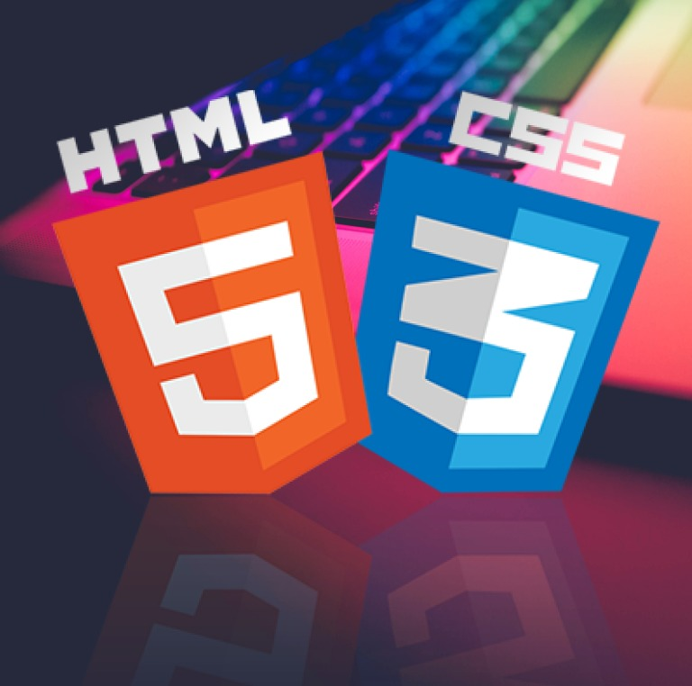

## TASK DESCRIPTION

You are required to design and produce an E-portfolio in HTML and complete the design process for it. For this assignment you will play the role of both the developer and the client.

Scenario: You are a website developer. A school student has approached you and requested that you design and produce an E-portfolio for them. They would like the portfolio to provide a platform which will enable the student to showcase their work, goals, and achievements. As well as the website, you will be required to submit a Design Folio, which details the processes you have undertaken to complete the website.

### Part A – Design Folio (20 marks) Your Design Folio should include the following:

1. Title page.

2.Contents page

3. Defining and analysing the problem - This will include the problem statement and all constraints (technical, operational, time, financial, ethical). This section should include a list of aims and objectives for the website. (5 marks)

4.Designing possible solutions: Generation of ideas must include at least a site map and storyboards. In the storyboards you should propose possible design layouts for the website. You should be including navigational elements and design aspects e.g., colours used for borders etc. Each storyboard should include a PMI chart to look at “plus, minus and interesting” aspects of each design idea. (5 marks)

5. Producing the solution: You should include screen captures of each of your pages that are part of your final design concept. The screenshots need to be annotated with any relevant design details or information e.g., size of font, colour used, alignment etc. (5 marks)

6.Evaluation: Compare your website to the list that you created in the defining and analysing the problem stage. How well did you cover each section? Completed PMI chart for your website. (5 marks)

### Part C – Option Topic – web page content (20 marks)

On your Option topic web page, you will be required to write about the following topics in detail (see marking criteria):

1. Introduction to the World Wide Web (WWW): Explain how the web works, the role of web servers, what are web browsers? (5 marks)
2. How is the world wide web different to the internet? (5 marks)
3. What it an intranet? How does it relate to the internet? (5marks)
4. What is an internet protocol? Compare HTTP, TCP/IP and FTP. (5 marks)

# Part 1

## Defining and analysing the problem

*This will include the problem statement and all constraints (technical, operational, time, financial, ethical). This section should include a list of aims and objectives for the website. (5 marks)*

### Problem Statement

The client, who is a school student, requires an E-portfolio to be developed using HTML and CSS. This website should showcase the client’s identity by containing their work, goals, and achievements. The client has also requested that the website to be used for educational purposes and should contain information about the internet.

The website needs to contain 5 webpages:

* A home page for information about the website,
* An about me page for information about the client,
* A page that informs and answers general questions about the internet,
* A blank page for the client’s future assessment task,
* And a page containing contact details of the client.

The developer was notified of this task on the 18th of March 2022 and has until the 28th of April to complete the website and a design folio outlining the process of developing the website.

#### Aims and objectives

|  |  |
| --- | --- |
| Aim | How will this be achieved |
| To create a website consisting of five webpages that has an aesthetically pleasing design and contains a smooth and user-friendly navigation system. | This will be achieved through the use of CSS to style the website. A consistent colour palate and structure will be used through out the website, and navigation elements will have the ‘transition’ property to make smooth animations, and to help the user recognise interactive/clickable features. |
| To include information about the client and the internet that is highly detailed, accurate and useful. The website should be structured in a way that allows the user to effortlessly find the specific information that they need. | The topic should be researched using tools such as the IST textbook, or reliable sources from the internet. Sources should be included for the user to factcheck or read further into the topic. Headings and subheadings should be used effectively to |
| To make the website accessible on a range of devices with different screen resolutions. When viewed on a large screen, the website will take advantage of the extra white space, while the website should still be viewable on mobile. | Percentages should be used instead of pixels in CSS to allow the website elements such images and whitespaces to resize with the webpage. The navigation and website layout should also change when the website is view on a thinner resolution such like a mobile phone. |

### Constraints

#### Technical

The developer of the website prefers to work on his desktop, however, has to work on his laptop or school computers when at school. To solve this, GitHub will be used to transfer work between devices.

#### Operational

#### Time

The task was given on the 18th of March 2022 and is due on the 28th of April. This means that almost 6 weeks was allocated for the task. This is a satisfactory length of time; however, it involves many different sections. To ensure that every part is completed, and is allocated the time required, a Gantt chart has been created to assist the developer in time management.

|  |  |  |  |  |  |  |
| --- | --- | --- | --- | --- | --- | --- |
| Task | Week 1 | Week 2 | Week 3 | Week 4 | Week 5 | Week 6 |
| Planning |  |  |  |  |  |  |
| * Analysing the problem |  |  |  |  |  |  |
| * Designing possible solutions |  |  |  |  |  |  |
| * Researching for option topic |  |  |  |  |  |  |
| Creating the website |  |  |  |  |  |  |
| * HTML |  |  |  |  |  |  |
| * CSS |  |  |  |  |  |  |
| Finishing Documentation |  |  |  |  |  |  |
| * Annotating screenshots |  |  |  |  |  |  |
| * Evaluation |  |  |  |  |  |  |
| Submission |  |  |  |  |  |  |
| * Final changes |  |  |  |  |  |  |
| * Submission |  |  |  |  |  |  |

#### Financial

The developer is on a low budget so buying stock image and icons is unaffordable. To solve this, the developer will use either material that is either free or licensed under Creative Commons.

#### Ethical

Avoid using copyrighted material and other people’s work without having the proper licencing or permission.

## Designing possible solutions