**DOCUMENATATION:**

**Firstly,** extract the zip folder provided.

**FOR TASK-1:**

* Open the command prompt, in the extracted zip folder (basically go there and **right click** and **open in terminal**.)
* (To be done on ubuntu).
* In the terminal, write this to open the server:
  + **python3 Task1_server.py**
* and then hit enter to run the server
* Then, open as many terminals as the number of players are (=3 generally).
* And then write this in each of them and press enter thereafter:
  + **python3 task1_client.py**
* This shall start the casino game…
* If everything is successful, it looks like:

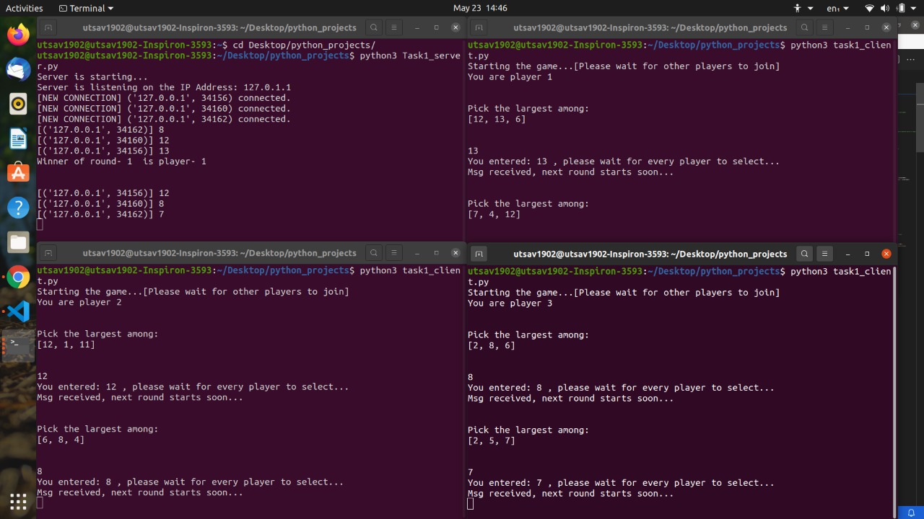

**FOR TASK-2:**

* Open the task2.c file in any IDE (preferably code-blocks)
* This task was done on windows, so you may consider opening it in windows.
* Then, simply run and compile the .c file and you shall see the terminal on which “enter number of timesteps” should be written.
* Enter all the values in space-separated 8 integers format.
* For the bonus task with one server and one client:
  + These files are preferred to run on visual studio if you face problems in code-blocks.
  + Start the server by compiling the task2_sever.cpp file and then do the same with task2_client.cpp file.
  + Then the client server interaction takes place accordingly and you should see something like:

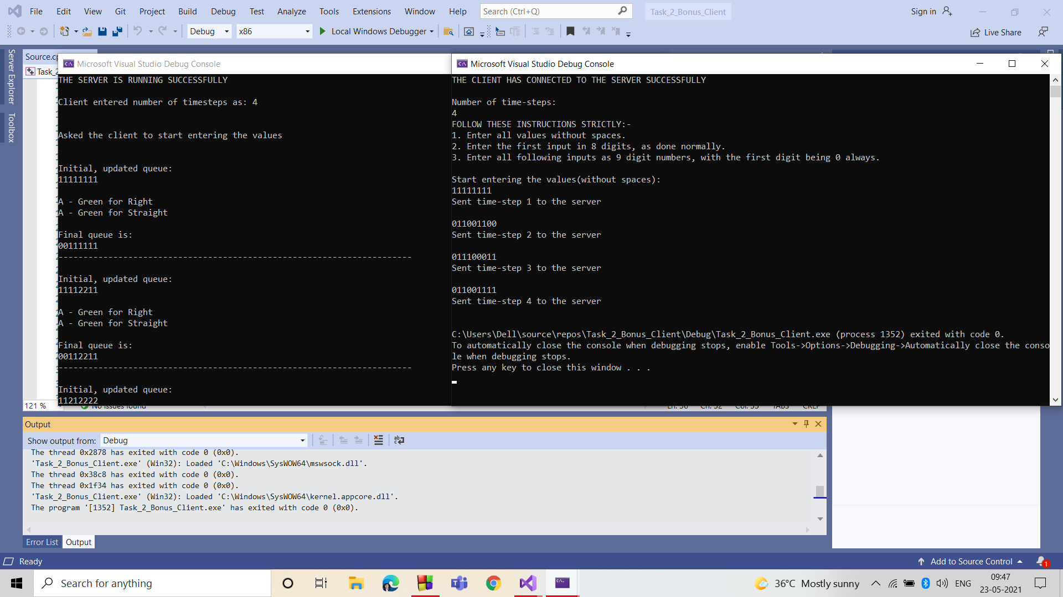

**FOR TASK-3 (part-1):**

* Again, this task was done in ubuntu, open the extracted folder and open a terminal in it.
* Type this in the terminal:
  + python3 Task3.py (and then hit enter)
* If everything works well, you should see the below pics, after the running the code:

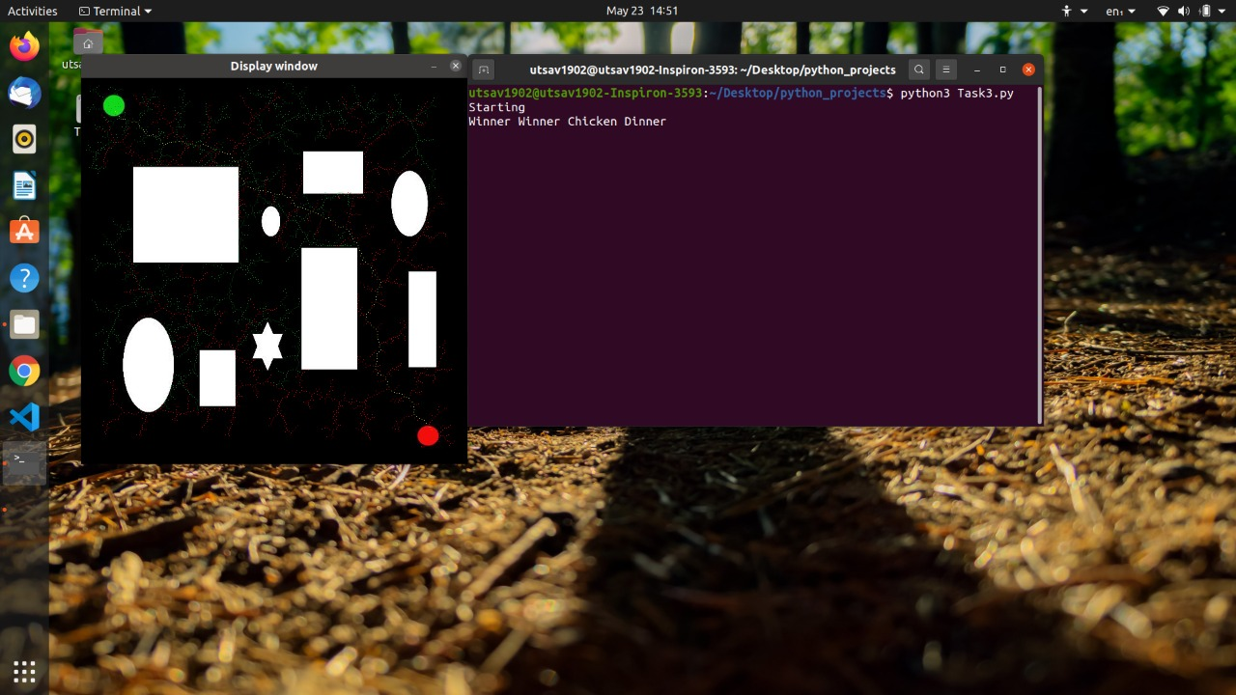

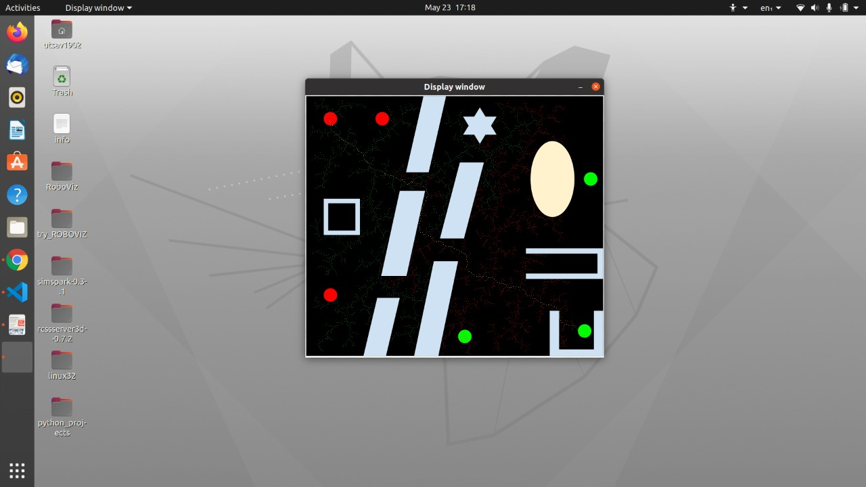

**NOTE:**

**YOU MAY FACE PROBLEMS IN TASK1 AND TASK2 LIKE FAILED TO BING TO PORT OR SO, FOR IT, OPEN THE PYTHON CODE FILE AND CHANGE THE IP ADDRESS TO YOUR IP ADDRESS (SEE THE IPV4 OR IPV6 ADDRESS ON YOUR DEVICE)**

**ALSO, FOR TASK3, KINDLY CHANGE THE ADDRESS OF THE IMAGE IN THE CODE ACCORDING TO YOUR END (MEANS THAT, FIRST DOWNLOAD THE IMAGES FROM THE TASK-ROUND PDF, AND COPY-PASTE THEIR ADDRESS IN THE img.imread(“ ”) line(line 9 most probably).)**