**ASSIGNMENT 2**

Name- Utsha Mishra

Q1 Write a program to calculate the sum of first 10 natural number.

**package** Assignment2;

**public** **class** Qustion1 {

**public** **static** **void** main(String[] args)

{

**int** sum =0;

**for**(**int** i=1;i<=10;i++)

{

sum = sum+i;

}

System.***out***.println("sum of the first 10 natural number is ="+sum);

}

}

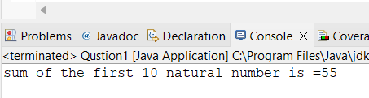

Q 2 Write a program that prompts the user to input a positive integer. It should then print the multiplication table of that number.

**package** Assignment2;

**import** java.util.Scanner;

**public** **class** Question2table {

**public** **static** **void** main(String[] args) {

Scanner s=**new** Scanner(System.***in***);

System.***out***.println("Enter a Positive Number:");

**int** n=s.nextInt();

**for**(**int** i=1;i<=10;i++)

{

System.***out***.println(n+ "*"+ i + "="+n*i);

}

}

}

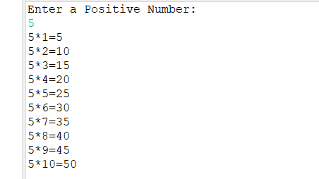

Q 3 Write a program that prompts the user to input an integer and then outputs the number with the digits reversed. For example, if the input is 12345, the output should be 54321.

**package** Assignment2;

**import** java.util.Scanner;

**public** **class** Question3ReversedNumber {

**public** **static** **void** main(String[] args) {

**int** num=0;

**int** rev=0;

System.***out***.println("Input your number and press enter:");

Scanner s = **new** Scanner(System.***in***);

num = s.nextInt();

//While Loop: Logic to find out the reverse number

**while**( num != 0 )

{

rev= rev * 10;

rev = rev + num%10;

num = num/10;

}

System.***out***.println("Reverse of input number is: "+rev);

}

}

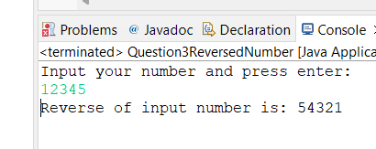

Q 4 Write a do-while loop that asks the user to enter two numbers. The numbers should be added and the sum displayed. The loop should ask the user whether he or she wishes to perform the operation again. If so, the loop should repeat; otherwise it should terminate.(while loop)

**package** Assignment2;

**import** java.util.Scanner;

**public** **class** Question4TwoNumber {

**public** **static** **void** main(String[] args) {

**int** a,b;

Scanner s=**new** Scanner(System.***in***);

String d;

**do** {

System.***out***.println("::::Add Two Numbers::::");

System.***out***.print("Enter First Number: ");

a=s.nextInt();

System.***out***.print("Enter First Number: ");

b=s.nextInt();

**int** c=a+b;

System.***out***.println("Addition Of The Two Numbers is:"+c);

System.***out***.println("");

System.***out***.println("You want perform addition again then write YES and to exit write NO");

d=s.next();

}**while**(d.equalsIgnoreCase("yes"));

System.***out***.println("===Program Terminated===");

}

}

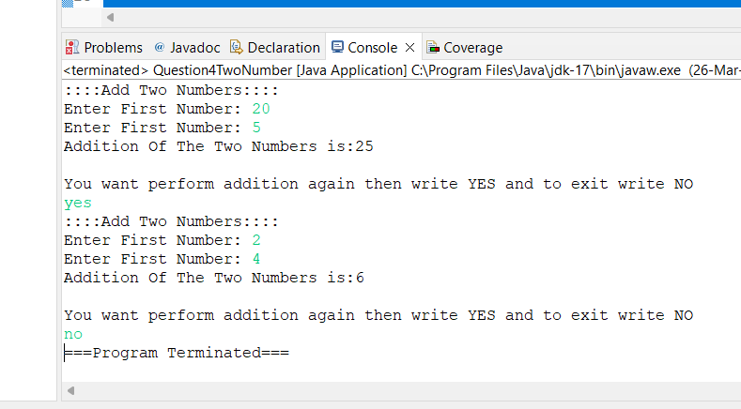

Q 5 Write a program to print out all Armstrong numbers between 1 and 500. If sum of cubes of each digit of the number is equal to the number itself, then the number is called an Armstrong number.  
For example, 153 = ( 1 * 1 * 1 ) + ( 5 * 5 * 5 ) + ( 3 * 3 * 3 )

**package** Assignment2;

**public** **class** Question5Armsstorng {

**public** **static** **void** main(String[] args) {

**int** n, count=0, a, b,c, sum=0;

System.***out***.print("Armstrong number from 1 to 500:");

**for**(**int** i=1; i<=500; i++)

{

n=i;

**while**(n > 0)

{

b = n%10;

sum=sum +(b * b * b);

n =n /10;

}

**if**(sum == i)

{

System.***out***.print(i+" ");

}

sum = 0;

}

}

}

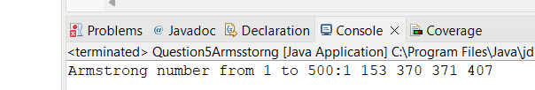

Q 6 Write a program to print Fibonacci series of n terms where n is input by user :  
0 1 1 2 3 5 8 13 21 .....

**package** Assignment2;

**public** **class** Question6Fibonacci {

**public** **static** **void** main(String[] args) {

**int** a=0,b=1,c,i,count=10;

System.***out***.print(a+" "+b);//printing 0 and 1

**for**(i=2;i<count;++i)//loop starts from 2 because 0 and 1 are already printed

{

c=a+b;

System.***out***.print(" "+c);

a=b;

b=c;

}

}

}

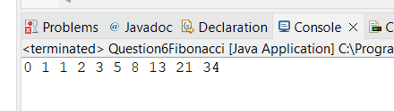

Q 7 Write a program to print following :  
i)  
  
**********  
**********  
**********  
**********

**package** Assignment2;

**public** **class** QustionPattern1 {

**public** **static** **void** main(String[] args) {

**for**(**int** i=1;i<=4;i++)//row

{

**for**(**int** j=1;j<=10;j++)//column

{

System.***out***.print("*");

}

System.***out***.println();

}

}

}

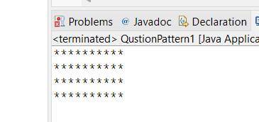

ii)

*  
**  
***  
****  
*****

**package** Assignment2;

**public** **class** QuestionPatterrn2 {

**public** **static** **void** main(String[] args) {

**for**(**int** i=1;i<=5;i++)

{

**for** (**int** j=1;j<=i;j++)

{

System.***out***.print("*");

}

System.***out***.println();

}

}

}

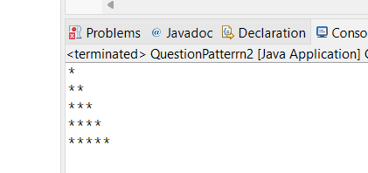

iii)    *  
      *   *  
     * *     *  
  *    *    *     *

iv)

  *  
      ***  
    *****  
  *******  
*********

v)  
  
        1  
      222  
    33333  
  4444444  
555555555

**package** Assignment2;

**public** **class** Question7Pattern5 {

**public** **static** **void** main(String[] args) {

**for** (**int** i = 1; i <= 5; i++)

{

**for** (**int** j = 5 - i; j >= 1; j--)

{

System.***out***.print(" ");

}

**for** (**int** k = 1; k <= 2 * i - 1; k++)

{

System.***out***.print(i);

}

System.***out***.println();

}

}

}

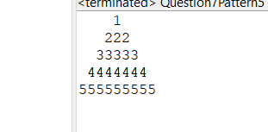

vi )     ABCDEEDCBA  
         ABCD  DCBA  
         ABC      CBA  
         AB         BA  
         A             A

**package** Assignment2;

**public** **class** Question7Patter6 {

**public** **static** **void** main(String[] args) {

**int** x=71, space=-1;

**char** z='F';

**for**(**int** i=1;i<=5;i++)

{x--;

**for**(**char** a='A';a<z;a++)

{

System.***out***.print(a);

}

space++;

**for**(**int** y=2;y<=space+1;y++)

{

System.***out***.print(" ");

}

**for**(**int** y=2;y<=space+1;y++)

{

System.***out***.print(" ");

}

z--;

**for**(**char** b=z;b>='A';b--)

{

System.***out***.print(b);

}

System.***out***.println();

}

}

}

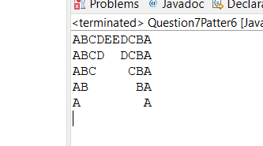

Q 8 Write a program in java to find the sum of the even and odd digits of the number which is given as input.

**package** Assignment2;

**import** java.util.Scanner;

**public** **class** Example8FindEvenOdd {

**public** **static** **void** main(String[] args) {

Scanner s=**new** Scanner(System.***in***);

System.***out***.println("Enter Number");

**int** a=s.nextInt();

**int** even=0,odd=0;

**do**

{

**int** p=a%10;

a=a/10;

**if**(p%2==0) {

even=even+p;

}

**else**

{

odd=odd+p;

}

}**while**(a!=0);

System.***out***.println("Sum Of The Even Numbers: "+even);

System.***out***.println("Sum Of The odd Numbers: "+odd);

s.close();

}

}

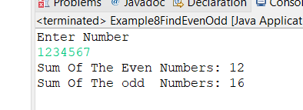

Q9 Write a program to check if given number is prime or not

**package** Assignment2;

**import** java.util.Scanner;

**public** **class** Question9PrimeNo {

**public** **static** **void** main(String[] args) {

Scanner s=**new** Scanner(System.***in***);

System.***out***.print("Enter Number:");

**int** a=s.nextInt();

**for**(**int** i=2;i<a;i++)

{

**if**(a%i==0)

{

System.***out***.print(" Enter Number is Not Prime Number:");

System.***out***.println();

**break**;

}

**else** **if**(i==a-1) {

System.***out***.println("Enter number is Prime Number");

**break**;

}

}

s.close();

}

}

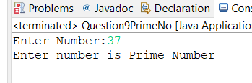

Q 10 write a program to print prime numbers between 2 to 20.

**package** Assignment2;

**import** java.util.Scannre;

**public** **class** Question10PrimeNo2 {

**public** **static** **void** main(String[] args) {

System.***out***.println("Prime Numbers Between 2 To 20");

**for**(**int** i=2;i<=20;i++)

{

**for**(**int** j=2;i<=20;i++)

**if**(i!=j&&i%j!=0)

{

System.***out***.print(i);

System.***out***.println();

**break**;

}

}

}

}

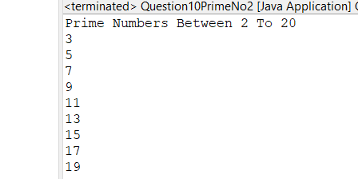

Q 11 Write program to find largest among three numbers

**package** Assignment2;

**import** java.util.Scanner;;

**public** **class** Question11MaxNum {

**public** **static** **void** main(String[] args) {

Scanner s=**new** Scanner(System.***in***);

System.***out***.print("Enter First Numbers: ");

**int** a=s.nextInt();

System.***out***.print("Enter Second Numbers: ");

**int** b=s.nextInt();

System.***out***.print("Enter Third Numbers: ");

**int** c=s.nextInt();

**int** result= ( a>b ? (a>c?a:c) : (b>c?b:c));

System.***out***.print("Largest Number Is:"+result);

}

}

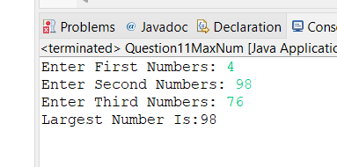

Q 12 Write a program to find sum of all integers greater than 100 and less than 200 that are divisible by 7

**package** Assignment2;

**public** **class** Question12SumDiv {

**public** **static** **void** main(String[] args) {

**int** a=0;

**for**(**int** i=100;i<=200;i++)

{

**if**(i%7==0)

{

a=a+i;

}

}

System.***out***.println("Sum Of The 100 To 200 Numbers that Divided By 7 Is: "+a );

}

}

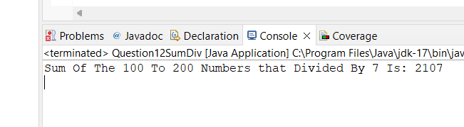

Q 13.    Write a Java program to print numbers between 1 to 100 which are divisible by 3, 5 and by both.  
Hint  
            System.out.println("\nDivided by 3: ");          
       for (int i=1; i<100; i++) {  
           if (i%3==0)  
           System.out.print(i +", ");              
       }

**package** Assignment2;

**public** **class** Question13Divby3and5 {

**public** **static** **void** main(String[] args) {

System.***out***.println("Print Numbers Divided by 3 and 5: ");

**for** (**int** i=1; i<100; i++) {

**if** (i%3==0&&i%5==0)

System.***out***.print(i +", ");

}

}

}

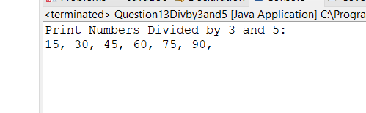

Q 14 create a menu driven application in java that show  
   "Add"        Add two number  
  "subtract"  Subtract two number  
  "Multiple"    Multiple two numbers  
  "Exit "           Exit  
  
Ask two numbers from user  and as per user choice perform necessary action using switch command

**package** Assignment2;

**import** java.util.Scanner;

**public** **class** Question14Switch {

**public** **static** **void** main(String[] args) {

{

Scanner s= **new** Scanner (System.***in***);

System.***out***.println("enter two number");

**int** a=s.nextInt();

**int** b=s.nextInt();

System.***out***.println("1 Add numbers");

System.***out***.println("2 Subtract numbers");

System.***out***.println("3 multiply numbers");

System.***out***.println("enter your choice ");

**int** choice=s.nextInt();;

//switch(1+1)

//switch(choice+2)

**switch**(choice)

{

**case** 1:

System.***out***.println(a+b);

**break**;

**case** 2:

System.***out***.println(a-b);

**break**;

**case** 3:

System.***out***.println(a*b);

**break**;

**default**:

System.***out***.println(" wrong choice");

**break**;

}

}

}

}

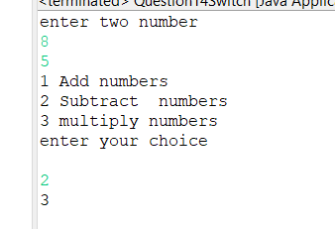

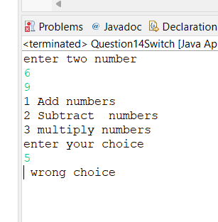

Q 15  Write a program to display first 1 to 20  even number on screen . Terminate the program when number 16 is found using break command .

**package** Assignment2;

**public** **class** Question15EvenAndBreak {

**public** **static** **void** main(String[] args) {

System.***out***.println("Even number is: ");

**for**(**int** i=1;i<=20;i++)

{

**if**(i%2==0&&i!=16)

{

System.***out***.print(i+", ");

}

**else** **if**(i==16)

{

**break**;

}

}

}

}

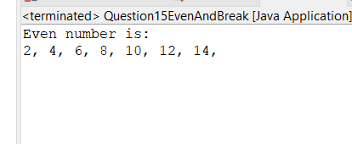

Q 16 Write a Java program that accepts two double variables and test if both strictly between 0 and 1 and false otherwise.  
Hint n1 > 0 && n1 < 1 && n2 > 0 && n2 < 1

**package** Assignment2;

**import** java.util.Scanner;

**public** **class** Question16Numbt0and1 {

**public** **static** **void** main(String[] args) {

Scanner s=**new** Scanner(System.***in***);

System.***out***.print("Enetr Number: ");

**double** a=s.nextDouble();

System.***out***.print("Enetr Number: ");

**double** b=s.nextDouble();

**if**((a>0&&b>0)&&(a<1&&b<1))

{

System.***out***.println("Enetered Numbers Is In between 0 To 1");

}

**else**

System.***out***.println("Enetered Numbers Is NOT In between 0 To 1");

}

}

