**ASSIGNMENT**

Name-Utsha Mishra

**Q-1wap to demonstrate ternary operator .define a variable marks  .ask its value from user and using ternary operator check if marks > 40 store "Pass" in result varible else store "Fail"?**

**package** day3assignment;

**import** java.util.*;

**public** **class** PassFail {

**public** **static** **void** main(String[] args) {

Scanner sc=**new** Scanner(System.***in***);

System.***out***.println("enter mark");

**int** mark=sc.nextInt();

String result = (mark > 40) ? "pass" : "fail" ;

System.***out***.println("your mark is "+mark+" then you are "+result+" in exam");

}

}

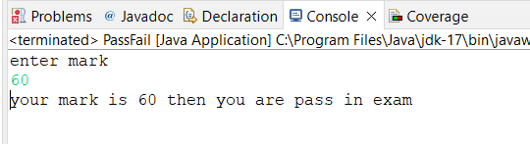

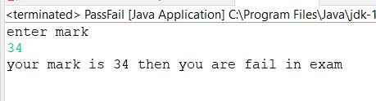

**Q 2 using ternary check if number entered by user is positive or negative .  
In case number is positive store "Positive number" else store negative number to Result variable**

**package** day3assignment;

**import** java.util.Scanner;

**public** **class** PositiveNegativeVlaue {

**public** **static** **void** main(String[] args){

Scanner sc=**new** Scanner(System.***in***);

System.***out***.println("enter number");

**int** number=sc.nextInt();

String result = (number >= 0) ? "positive": "nagative";

System.***out***.println("your number is "+result);

}

}

}

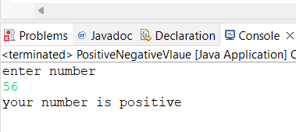

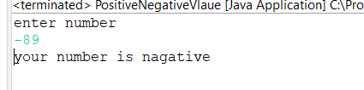

**Q 3 WAP to ask name ,age and salary of an employee and print on console?**

**package** day3assignment;

//Wap to ask name ,age and salary of an employee and display it

**import** java.util.Scanner;

**public** **class** EmployeeDetails {

**public** **static** **void** main(String[] args) {

//String is predefined class

// java.lang.String

String name;

**int** age;

**float** salary;

Scanner s= **new** Scanner(System.***in***);

System.***out***.println("enter name ");

name= s.next();

System.***out***.println("enter age ");

age= s.nextInt();

System.***out***.println("enter salary ");

salary=s.nextFloat();

System.***out***.println("name="+ name);

System.***out***.println("age="+ age);

System.***out***.println("salary="+ salary);

}

}

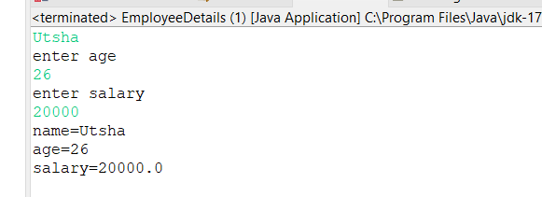

**Q 4- wap that ask two numbers from user and print greater number among two?**

**package** day3assignment;

**import** java.util.*;

**public** **class** MaxNumber {

**public** **static** **void** main(String[] args) {

Scanner sc = **new** Scanner(System.***in***);

System.***out***.println("enter 1st number");

**int** a=sc.nextInt();

System.***out***.println("enter 2nd number");

**int** b=sc.nextInt();

**if**(a>b) {

System.***out***.println(a+" is grater then "+b);

}

**else** **if**(a<b){

System.***out***.println(b+" is grater then "+a);

}

**else** {

System.***out***.println(a+" and "+b+" are equal");

}

}

}

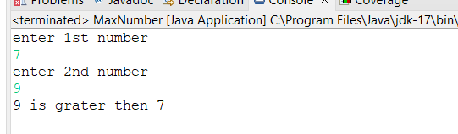

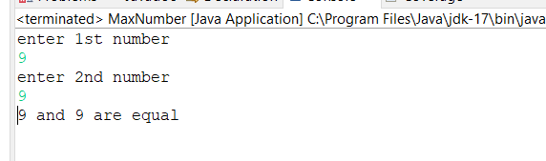

**Q 5 wap to ask product name and price of product from user and calculate discount i.e   
if price > 2000 then discount is 10 percent of price   
else   
discount is 7 % of price**

**package** day3assignment;

**import** java.util.*;

**public** **class** CalculateDiscount {

**public** **static** **void** main(String[] args) {

Scanner sc = **new** Scanner(System.***in***);

System.***out***.println("enter product name");

String product =sc.nextLine();

System.***out***.println("enter product price");

**int** price =sc.nextInt();

**if**(price>2000) {

System.***out***.println(" you will get 10% discount");

}

**else** {

System.***out***.println(" you will get 7% discount");

}

**double** discount;

**if**(price>2000) {

discount=price*0.1;

}

**else** {

discount=price*0.07;

}

**double** discount_is = price - discount;

System.***out***.println("Product: " + product);

System.***out***.println("Price: " + price);

System.***out***.println("Discount: " + discount);

System.***out***.println("Discounted price: " + discount_is);

}

}

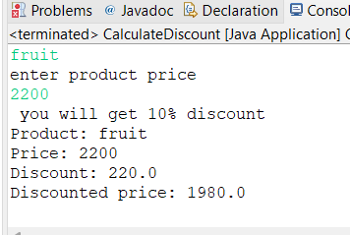

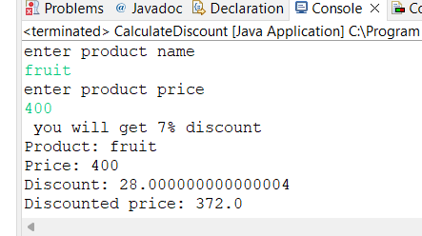

**Q 6   Wap to swap two numbers?**

**package** day3assignment;

//Swapping two Number

**import** java.util.Scanner;

**public** **class** SwappingTwoNumber {

**public** **static** **void** main(String[] args) {

**int** a,b,temp;

System.***out***.println("Enter any two number");

Scanner s=**new** Scanner(System.***in***);

a=s.nextInt();

b=s.nextInt();

temp=a;

a=b;

b=temp;

System.***out***.println("After Swapping "+a+" "+b);

}

}

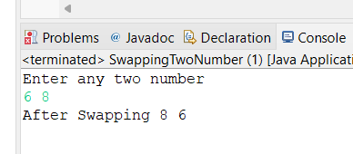

**Q 7  How to swap two numbers without using a third variable?**

**package** day3assignment;

//swap two number without using a third variable

**import** java.util.Scanner;

**public** **class** Swapping {

**public** **static** **void** main(String[] args) {

**int** a,b;

System.***out***.println("Enter any two number");

Scanner s=**new** Scanner(System.***in***);

a=s.nextInt();

b=s.nextInt();

a=a+b;

b=a-b;

a=a-b;

System.***out***.println("After Swapping "+a+" "+b);

}

}

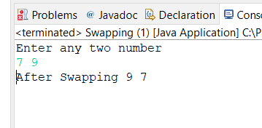

**Q 8 wap to check is number is even or odd?**

**package** day3assignment;

**import** java.util.*;

**public** **class** OddEven {

**public** **static** **void** main(String[] args) {

Scanner sc=**new** Scanner(System.***in***);

System.***out***.println("enter number for check even number or odd number");

**int** number=sc.nextInt();

**if**(number%2==0)

{

System.***out***.println(number+" is even number");

}

**else** {

System.***out***.println(number+" is odd number");

}

}

}

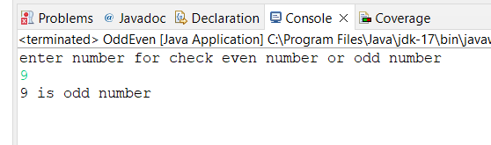

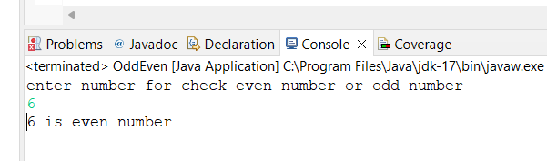

**Q 9  - A school has following rules for grading system:  
 a. Below 25 - F  
 b. 25 to 45 - E  
 c. 45 to 50 - D  
 d. 50 to 60 - C  
 e. 60 to 80 - B  
 f. Above 80 - A  
 Ask user to enter marks and print the corresponding grade**

**package** day3assignment;

**import** java.util.*;

**public** **class** Grading {

**public** **static** **void** main(String[] args) {

Scanner sc=**new** Scanner(System.***in***);

System.***out***.println("enter your mark");

**int** mark=sc.nextInt();

**if**(mark<100) {

**if**(mark<25) {

System.***out***.println("F");

}

**else** **if**(mark>=26&&mark<=45) {

System.***out***.println("E");

}

**else** **if**(mark>=46&&mark<=50) {

System.***out***.println("D");

}

**else** **if**(mark>=51&&mark<=60) {

System.***out***.println("C");

}

**else** **if**(mark>=61&&mark<=80) {

System.***out***.println("B");

}

**else** **if**(mark>=81) {

System.***out***.println("A");

}

}

**else** {

System.***out***.println("invalid mark");

}

}

}

**A-**

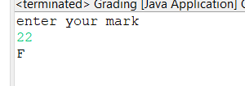

**B-**

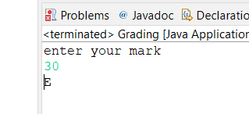

**C-**

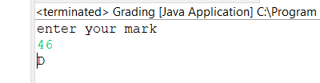

**D-**

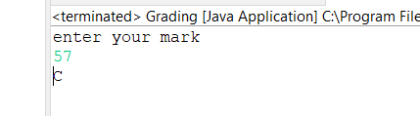

**E-**

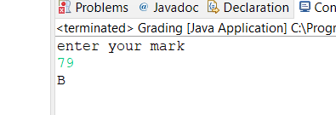

**F-**

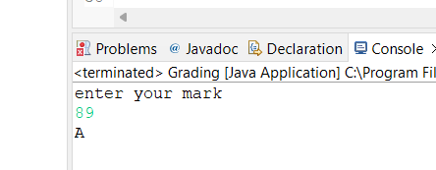

|  |
| --- |
| **Q  10-wap to check greater number among three numbers?** |
|  |
|  |

**package** day3assignment;

**import** java.util.*;

**public** **class** GreaterNumberCheck {

**public** **static** **void** main(String[] args) {

Scanner sc= **new** Scanner(System.***in***);

System.***out***.println("enter three number");

**int** a=sc.nextInt();

**int** b=sc.nextInt();

**int** c=sc.nextInt();

**int** max=(a>b)?(a>c?a:c):(b>c?a:c);

System.***out***.println("max number is "+max);

}

}

