**A short report on the development of android app for the Dublin bike stations**

(BIKESinDUBLIN)

*Student Name:*

*Student Number:*

*Github URL:*

# Application Purpose and Goal:

The purpose and goal of this application is to show the markers of various bikes stations around Dublin in Google Maps View and also list the stations in a recyclerType view and then display their information in a separate screen.

# **Major & Minor challenges and new things**:

Implementation the gson library from java was a little bit challenging as well as benefiting as it not just made the parsing easy also it helped me to move data from one activity to another.

It was a challenging task to have data from the api and since I had to use alternative libraries such as volley to put http GET requests into the api and get the data into json and decode them.

Displaying markers in google maps was also quite complicated, as the implementation of google maps along with multiple markers is a little bit difficult.

# Alternative libraries used:

* **GoogleMaps SDK**:With the Maps SDK for Android, you can add maps based on Google Maps data to your application.
* **Volley**: Volley is an HTTP library that enables and, most importantly, fasters networking for Android apps.
* **Gson:** Gson is a Java library for converting Java objects into their JSON representation. Converting a JSON string to an equivalent Java object can also be used. Gson can work with arbitrary Java objects including pre-existing objects of which you have no source code.

# **My Learning from App Development Assignment** :

Getting data from APIs using third-party libraries and viewing it in recycler view along with transferring data from one purpose to another in intents using the Serializable class (to encapsulate object data). It was a learning experience that I'm sure would help with the creation of android apps in the future.

Plus implementation of the Java gson library was a bit challenging as well as beneficial as it not only made the parsing easy but also helped me move data from one activity to another.

# Application Walkthrough:

The RenderMarkersActivity showing map view markers displaying Dublin Bike Stations.

It also shows the open stations list button.

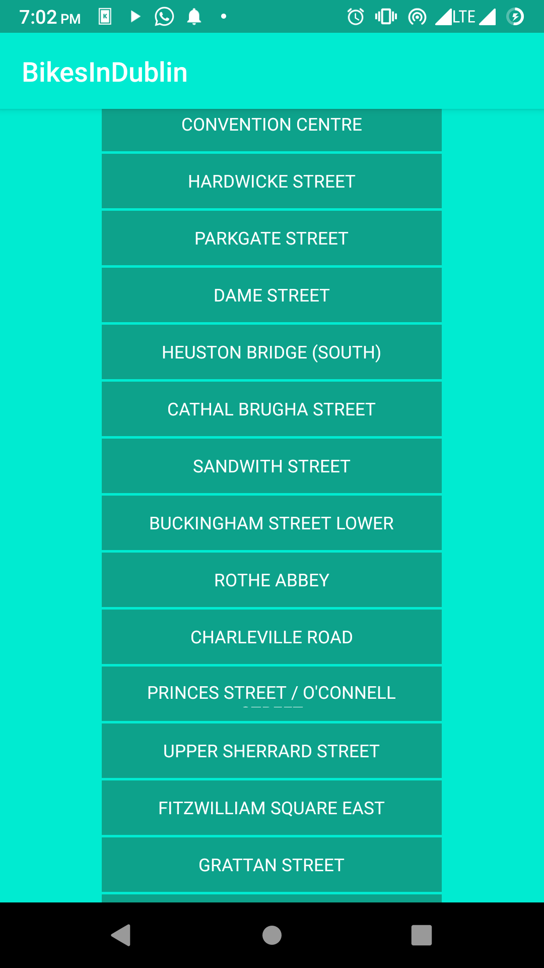The this screen shows the list of stations from the api’s data received in a recycler view.It is a simple and elegant list of all bike stations in Dublin.

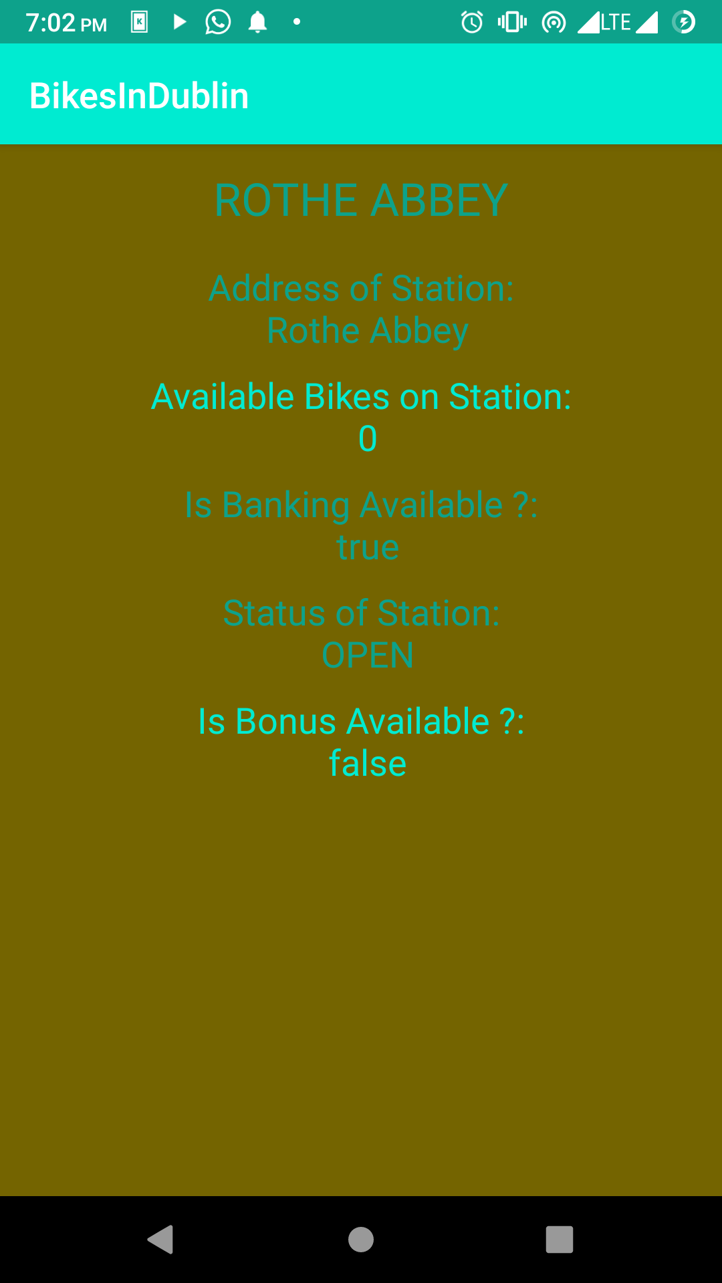This screen demonstrate the data in full from the maps and list.