**IN-MODULE ASSESSMENTS**

**Module Title :** Game Programming

**Module Code** **:** GD4113FP

**Project :** Create a game according to game specifications using game engine

**Duration :** 24 hours

**Objective**: Create a game using game engine

**Tools, Equipment and Materials:**

* Windows PC
* Unity game engine

**INSTRUCTIONS**

You are required to create a 3D shooting game for PC using a game engine and implement user inputs, 3D models and animations, user interfaces, audio and generate an executable file.

**REQUIREMENTS**

You are to document your game idea using the given “Game Idea Proposal” template.

# 1. Game play

The game play requires the main character in the game to destroy all on coming enemies that spawn continuously around the level.

Enemies will drop coins upon being destroyed. The character will then be able to collect the coins to purchase ammo in the game.

Implement a health recharge area where the character is able charge up when standing within the area.

Your game level should include a movable platform where the character can board and travel to different platforms in the level.

Define a win condition when the character defeated all the enemies and lose condition when character health is 0.

# 2. Controls and Camera

The game requires the player to be able to control the game character. The game character must be able to move, turn and shoot.

The game will need to allow the player to control the character in the game to move, turn and shoot.

Implement a 3rd person camera that follows the character in game with the ability to pan smoothly into position.

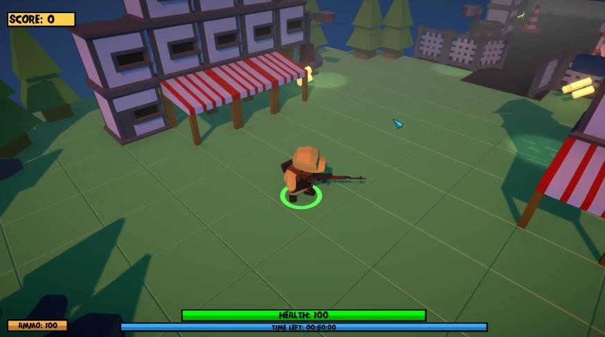

*Example of a 3rd person camera*

**3. 3D models and animation** The game must have the following:

* Player model with walking, idle, and death animation
* Enemy model with walking, idle, and death animation
* Coin model with spinning animation

# 4. User interface display

The game must be able to display on following screen sizes and aspect ratios.

* 1600 x1200 (4:3)
* 1920 x 1080 (16:9)
* 2560 x 1080 (21:9)

Implement in-game UI with the following information

* Time
* Coins collected
* Ammo left
* Number of lives
* Game win / lose test

The in-game user interface will have to show information using both text and visual representation.



*Example of a text and visual UI*

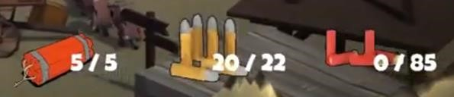

*Example of a text and visual UI*

Implement interactable UI where player can purchase ammo using coins.

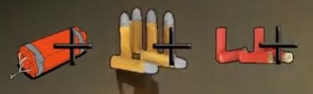

*Example of an interactable UI*

# 5. Background music and sound effects

You are to include background music for the game and sound effects for events (shoot, dead, collect coin, add ammo, recharge health)

Background music should stop when the game is paused and allow player to mute or change volume.

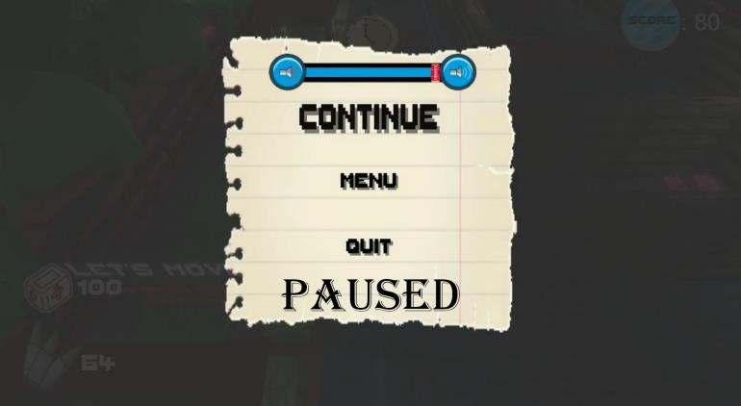

# 6. Post processing effects

Implement post processing by applying effects to simulate physical camera and film properties and to create stylised visuals.

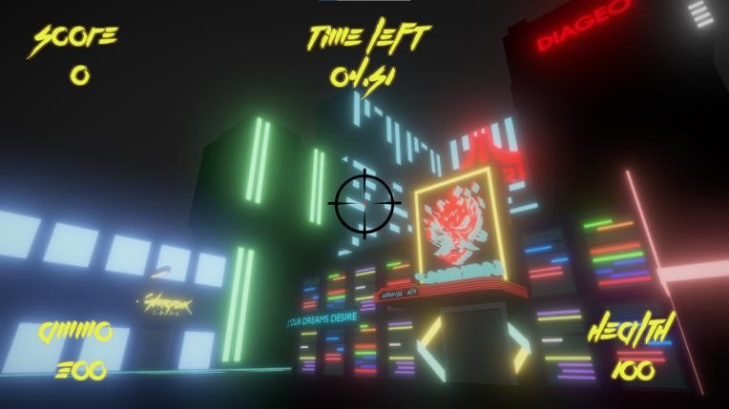

# 7. Executable file

Build an executable file and test to ensure all features are working.

**SUBMISSION INFORMATION**

Submit your completed work on **MyConnexion**

There will be **weekly milestone** to adhere to.

# Due end of first week (Prototype)

Features to be included in prototype

* User input
* Character movement
* Camera movement

* Game idea proposal – “**IndexNo_Name_GameIdeaProposal**” .doc
* Source code – “**IndexNo_Name_Prototype**” .zip

# Due end of second week (Alpha)

Features to be included in alpha

* 3D models with animation states
* User interface with 2D sprites

• Source code – “**IndexNo_Name_Alpha**” .zip

# Due end of third week (Beta)

Features to be included in Beta

* Background music
* Sound effects
* Win and lose conditions

• Source code – “**IndexNo_Name_Beta**” .zip

# Due end of fourth week (Final)

Features to be included in Final

* Presentation slide
* Post processing effect

* Presentation PPT – “**IndexNo_Name_Presentation**” .ppt
* Source code – “**IndexNo_Name_Final**” .zip
* Executable of the game – “**IndexNo_Name_Exe**” .zip

**\* Note that there is a 10% penalty for late submission**

**GAME IDEA PROPOSAL**

**Name:**

**Game title:**

**Shooter-shooter**

**GAME DESIGN**

**Description:**

|  |
| --- |
| Players try to fend off enemy that moving to him |

**CONTROLS AND CAMERA**

**List of inputs:**

|  |  |
| --- | --- |
| **Input** | **Functionality** |
| W, A, S, D | Movements (up, left, down, right) |
| space | shoot |
|  |  |
|  |  |

**Camera features:**

|  |  |
| --- | --- |
| **Feature** | **Description** |
|  |  |
|  |  |
|  |  |

**3D MODELS AND ANIMATIONS**

**List of models and animations:**

|  |  |
| --- | --- |
| **Model** | **Animation** |
|  |  |
|  |  |
|  |  |
|  |  |
|  |  |
|  |  |

**USER INTERFACE DISPLAY**

**List of user interfaces:**

|  |  |  |
| --- | --- | --- |
| **Information** | **Type of UI** | **Description** |
|  |  |  |
|  |  |  |
|  |  |  |
|  |  |  |
|  |  |  |

**BACKGROUND MUSIC AND SOUND EFFECTS**

**List of background music:**

|  |  |
| --- | --- |
| **Audio name** | **Description** |
|  |  |
|  |  |

**List of sound effects:**

|  |  |
| --- | --- |
| **Audio name** | **Description** |
|  |  |
|  |  |
|  |  |
|  |  |

**POST PROCESSING**

**List of effects:**

|  |
| --- |
|  |
|  |
|  |
|  |
|  |