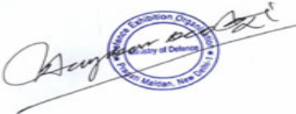
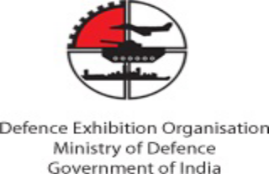
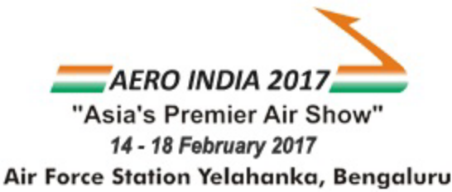
Dear Sir/Madam,

AERO INDIA 2017
“Asia’s Premier Air Show”
11TH INTERNATIONAL SHOW ON AEROSPACE, DEFENCE, CIVIL AVIATION, AIRPORT INFRASTRUCTURE AND DEFENCE ENGINEERING

REQUEST FOR ISSUE OF VISA FOR EXHIBITORS

We are pleased to inform you that “AERO INDIA 2017” is being organized by The Ministry of Defence (Govt. of India) from 14th to 18th February 2017 at Air Force Station, Yelahanka, Bengaluru, India.

We are inviting following official of “ Kallman Worldwide, Inc.” as an Exhibitor in our forth coming exhibition.

We hereby request you to kindly grant the VISA for this purpose to the following person. The details of
(Authorized Signatory)
Date : 11-Nov-2016
To,
The Visa Counselor
Embassy of India
United States
Name
(as in passport)
Sharon Jennifer Caswell
Nationality
Date of Birth
Passport Number
Date of Issue
Place of Issue
Valid up to
Passport Detail
United States
29/10/1958
445935328
10/10/2008
9/10/2018
New York, USA
Looking forward to your cooperation.
Thanking you and regards.
You may grant the necessary travel visa to undertake and facilitate this visit subject to complete paper documentation required by the Embassy of India.The above given exhibitor or visitor is being issued this visa recommendation letter on the basis of his/her registration on Aero India website.
Defence Exhibition Organisation
Ministry of Defence,Govt. of India
Hotel The Ashoka, Room No : 102 - 107, Diplomatic Enclave 50B, Chankyapuri,
New Delhi- 110021, India
Tel: +91 (11) 26871988, 26871989, Fax: +91 (11) 26871990.
www.aeroindia.in

