Project report
On
Student Management System
Created By
Uttam R. Gondaliya
BSC-IT-5
Under the Guidance of
PROF. NIDHI PARMAR

Submitted To
GEETANAJALI COLLEGE OF COMPUTER SCIENCE & COMMERCE

Affiliated To
SAURASTRA UNIVERSITY
For Academic Year
2025-26

Acknowledgement
The project on STUDENT MANAGEMENT SYSTEM is developed in PHP MYSQL Language at GEETANJALI COLLEGE OF COMPUTER SCIENCE & COMMERCE.
I would like to acknowledge that my project has been completed and I am ensuring that, in this accomplishment, I would like to express my special gratitude to all my teachers and specially to PROF. KISHORSINH VALA without their guidance and feedback it is not possible to complete this assignment.

INDEX
PARTICULARS | PAGE NO
Introduction
• Abstract | 1
• Purpose | 1
Project Profile | 2
SDLC Process Model | 3
Software Resources | 5
List of Modules | 6
Data Dictionary | 7
DFD
• Context Diagram | 15
• Level 1 Diagram | 16
E–R Diagram | 17
Use Case Diagram | 18
Testing – Test Cases | 19
Snapshots | 26
Limitations | 44
Future Enhancement | 44
Conclusion | 45

INTRODUCTION
Abstract:
The Student Management System is a web-based application developed using PHP and MySQL that helps efficiently manage student data. It allows administrators to add, update, delete, and view student details easily. The system streamlines tasks like attendance, grades, and course information management. It improves data accuracy and saves time by automating manual record-keeping. Admin can add students , parents and teacher data and make a User Role .

Purpose:
The main purpose of the Student Management System is to simplify and automate the management of student information in educational institutions. It helps administrators and teachers efficiently handle student records, attendance, and performance data. The system ensures accuracy, reduces paperwork, and makes information easily accessible whenever needed.

Page 1 Created by Uttam R. Gondaliya

Project Profile
Particulars | Details
Project Title | Student Management System
Development Software | Visual Studio
Front End Tool | PHP, Bootstrap
Back End Tool | MySQL Server
Academic Year | 2025–26
Developed By | Uttam R. Gondaliya

Page 2 Created by Uttam R. Gondaliya

Process Model
- The Waterfall Model
The Process Model used in our projects "Student Management System" is waterfall model.
The Waterfall Model is one of the oldest and most widely used software development life cycle (SDLC) models. It follows a linear and sequential flow, where each phase of the process must be completed before moving on to the next one. The main stages include Requirement Analysis, System Design, Implementation, Testing, Deployment, and Maintenance. This model is easy to understand and manage because of its step-by-step structure.
Although the Waterfall Model is simple and well-structured, it has some limitations. Once a phase is finished, it is difficult to go back and make changes. This makes it less flexible for projects where requirements might change during development. Therefore, it is most suitable for small projects with clear and fixed requirements. Despite its drawbacks, the Waterfall Model provides a disciplined and organized approach to software development and is still used in many industries today.
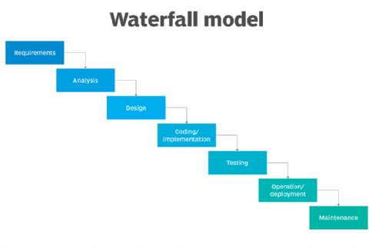
Page 3 Created by Uttam R. Gondaliya

- Reason the waterfall model in the software development cycle

  - Simple and Easy to Use:
The Waterfall Model is straightforward and easy to understand. Each phase has clear objectives and deliverables, making project management simple and structured.

  - Well-Defined Stages:
Every stage of development is clearly defined with specific milestones, which helps in better planning, documentation, and tracking of progress.

- Advantages of the waterfall model:

- This model is simple and easy to understand and use. In, this model phases are processed and completed one at a time and phases do not overlap.

- Waterfall model works well for smaller projects where sequence is very well understood.

Page 4 Created by Uttam R. Gondaliya
Software Resources
- Frontend Design Tool : Visual Studio Code
- Backend Design Tool: Xampp SQL Server
- Code-Behind Language :
- Frontend Language : Bootstrap , css , Js
- Backend Language : PHP

- Functionality
- Login
- Student Login
- Student can see his attendance
- See Exam Marks
- His own Profile
- Can See Notice
- Admin Login
- Add Teacher details
- Add Student details
- Add Parent details
- Create User Role (Students , Teachers , Parents )
- Teacher Login
- Take Student Attendance
- Set Exams
- Set Timetable
- Upload Student Marks
- Add Subjects And Classes
- Parents Login
- See their Student Attendance
- See Exam marks
- See notice
Page 5 Created by Uttam R. Gondaliya
List of Module
- Login module
- Student , teacher , admin , Parent Login
- Attendance Module
- Exam / Grade Module
- Search Update Student Parent Module

Page 6 Created by Uttam R. Gondaliya
Data Dictionary
1. Table: admin
Column Name | Data Type | Constraint
aid | int(11) | PRIMARY KEY, NOT NULL
fname | varchar(50) | NOT NULL
lname | varchar(50) | NOT NULL
email | varchar(100) | UNIQUE, NOT NULL
phone | varchar(20) | NULL
created_at | timestamp | NOT NULL, DEFAULT Current_Timestamp()

2. Table: attendance1
Column Name | Data Type | Constraint
id | int(11) | PRIMARY KEY, NOT NULL
student_id | varchar(50) | UNIQUE (with date), NOT NULL
class_id | varchar(50) | NOT NULL
date | date | NOT NULL
status | enum('Present','Absent') | NOT NULL
recorded_by | varchar(50) | NOT NULL
timestam | timestamp | NOT NULL, DEFAULT current_timestamp()

Page 7 Created by Uttam R. Gondaliya

3. Table: classroom

Column Name | Data Type | Constraint
hno | varchar(50) | PRIMARY KEY, NOT NULL
title | varchar(50) | NOT NULL
location | varchar(50) | NOT NULL
capacity | int(3) | NOT NULL
4.Table: exam
Column Name | Data Type | Constraint
id | int(11) | PRIMARY KEY, NOT NULL
subject | varchar(50) | NOT NULL
teacher | varchar(50) | NOT NULL
classroom | varchar(50) | NOT NULL
date | date | NOT NULL
stime | time | NOT NULL

Page 8 Created by Uttam R. Gondaliya

5. Table: examresult
Column Name | Data Type | Constraint
exam | int(11) | PRIMARY KEY (part 1), NOT NULL
student | varchar(50) | PRIMARY KEY (part 2), NOT NULL
marks | int(10) | NOT NULL
grade | varchar(10) | NOT NULL

6. Table: notice
Column Name | Data Type | Constraint
id | int(11) | PRIMARY KEY, NOT NULL
notice | varchar(1500) | NOT NULL
odience | varchar(100) | NOT NULL
date | datetime | NOT NULL

Page 9 Created by Uttam R. Gondaliya

Column Name | Data Type | Constraint
pid | int(11) | PRIMARY KEY, NOT NULL
fname | varchar(50) | NOT NULL
lname | varchar(50) | NOT NULL
contact | varchar(20) | NOT NULL
job | varchar(50) | NOT NULL
address | varchar(250) | NOT NULL
gender | varchar(25) | NOT NULL
nic | int(50) | NOT NULL
email | varchar(50) | UNIQUE, NOT NULL
7. Table: parent

Page 10 Created By Uttam R. Gondaliya
8. Table: student
Column Name | Data Type | Constraint
sid | varchar(25) | PRIMARY KEY, NOT NULL
fname | varchar(50) | NOT NULL
lname | varchar(50) | NOT NULL
bday | date | NOT NULL
address | varchar(250) | NOT NULL
parent | int(10) | NOT NULL
gender | varchar(10) | NOT NULL
classroom | varchar(25) | NOT NULL
email | varchar(50) | UNIQUE, NOT NULL

Page 11 Created By Uttam R. Gondaliya
9. Table: subject

Column Name | Data Type | Constraint
sid | varchar(50) | PRIMARY KEY, NOT NULL
title | varchar(200) | NOT NULL
description | varchar(500) | NOT NULL

10. Table: user

Column Name | Data Type | Constraint | Column Name
role | varchar(50) | NOT NULL | role
email | varchar(50) | PRIMARY KEY, NOT NULL | email
password | varchar(50) | NOT NULL | password

Page 12 Created By Uttam R. Gondaliya

11. Table: teacher
Column Name | Data Type | Constraint
tid | varchar(50) | PRIMARY KEY, NOT NULL
fname | varchar(50) | NOT NULL
lname | varchar(50) | NOT NULL
address | varchar(50) | NOT NULL
contact | varchar(50) | NOT NULL
bday | date | NOT NULL
skill | varchar(500) | NOT NULL
gender | varchar(25) | NOT NULL
email | varchar(50) | UNIQUE, NOT NULL

Page 13 Created By Uttam R. Gondaliya

12. Table: timetable
Column Name | Data Type | Constraint
id | int(11) | PRIMARY KEY, NOT NULL
class_id | varchar(50) | NOT NULL
classroom | varchar(50) | FOREIGN KEY → classroom(hno)
subject_id | varchar(50) | FOREIGN KEY → subject(sid)
day | varchar(20) | NOT NULL
start_time | time | NOT NULL
end_time | time | NOT NULL
teacher_id | varchar(50) | NOT NULL
created_at | timestamp | NOT NULL, DEFAULT current_timestamp()

Page 14 Created By Uttam R. Gondaliya

DFD [Data Flow Diagram]

- 0 level DFD (context Diagram)

Student Management System

login login
Parents
Student

Response response

Login check detail
Login
Student

User Da User Database
Response Reply
request Request
attendance
Response display Attendance1
request request
Exam result
Response display Exam Result
request Request
Notice
Response display Notice

Page 15 Created By Uttam R. Gondaliya

- 1 Level DFD

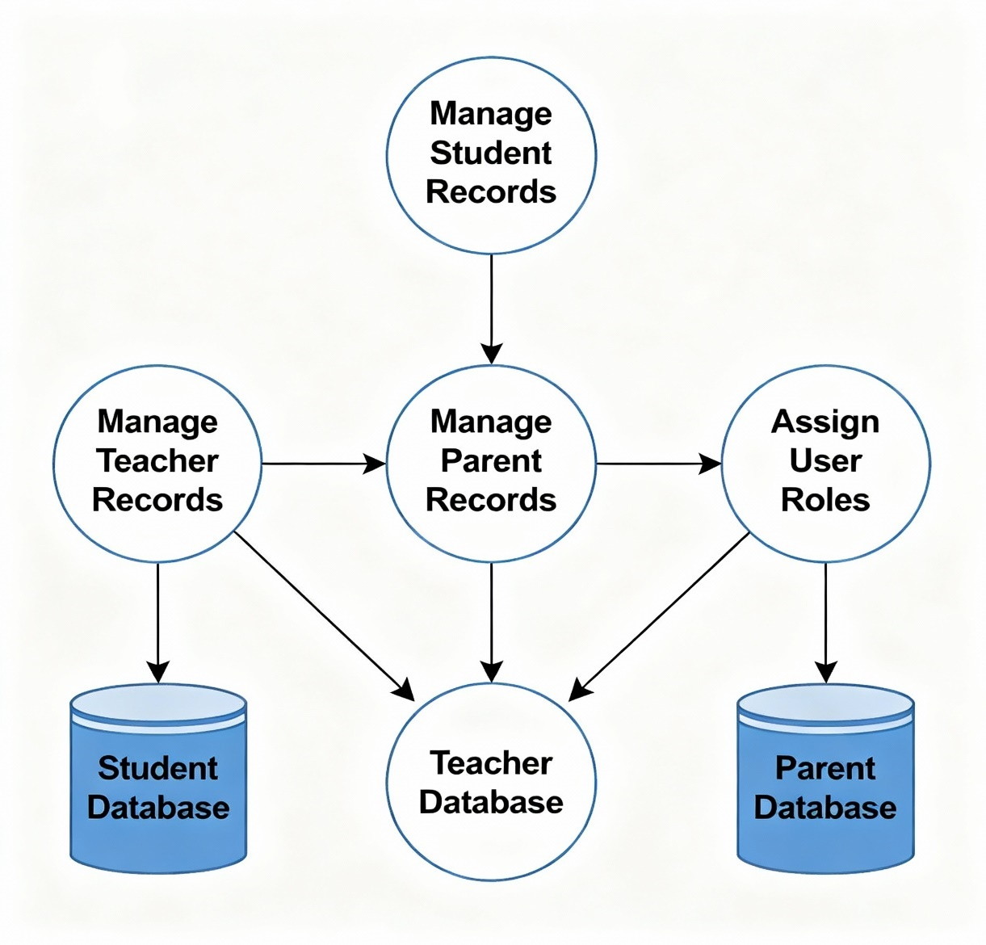

Page 16 Created By Uttam R. Gondaliya
ERD [Entity Relationship Diagram]
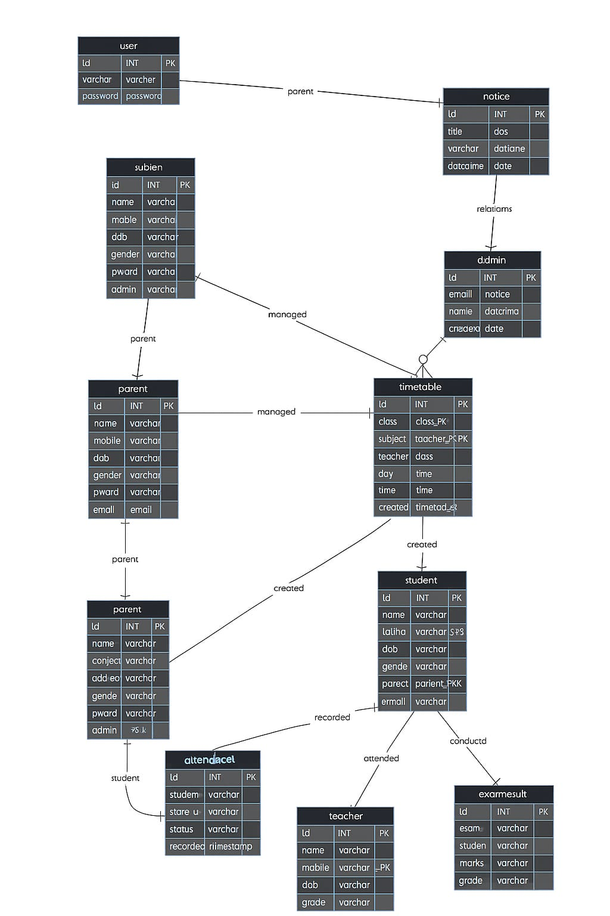
Page 17 Created By Uttam R. Gondaliya
Use case Diagram
Add Parents
Admin
Add Teacher
Add Student

Create User Role

Page 18 Created By Uttam R. Gondaliya
Test Cases
- Login
Sr. No | Module | Test Scenario | Test Steps | Result | Remarks
1 | Login | Check login with valid credentials | 1. Open login page 2. Enter valid email & password 3. Click Login | User redirected to correct panel based on role | Pass if redirected correctly
2 | Login | Check login with invalid credentials | 1. Open login page 2. Enter invalid email or password 3. Click Login | Error message displayed "Invalid credentials" | Pass if error shown
3 | Admin Panel | Add a new student | 1. Login as admin 2. Go to Add Student 3. Fill details 4. Submit | Student added to database and visible in list | Pass if student saved
4 | Student Panel | View exam results | 1. Login as student 2. Go to Exam Results section | Display student's exam results | Pass if correct results shown
5 | Teacher Panel | Take attendance for a class | 1. Login as teacher 2. Go to Attendance 3. Select class 4. Mark present/absent 5. Submit | Attendance recorded in database | Pass if attendance saved
6 | Parent Panel | View child attendance | 1. Login as parent 2. Go to Attendance section | Display child’s attendance | Pass if correct attendance shown
Page 19 Created By Uttam R. Gondaliya
- Admin
Sr. No | Module | Test Scenario | Test Steps | Result | Remarks
1 | Admin | Add Student Details - Valid | 1. Login as admin 2. Go to Add Student 3. Fill all required fields 4. Click Submit | New student added successfully and visible in student list | Pass if student saved correctly
2 | Admin | Add Student Details - Invalid | 1. Login as admin 2. Go to Add Student 3. Leave required fields empty 4. Click Submit | Error message displayed "Please fill all required fields" | Pass if error shown correctly
3 | Admin | Add Teacher Details - Valid | 1. Login as admin 2. Go to Add Teacher 3. Fill all required fields 4. Click Submit | New teacher added successfully and visible in teacher list | Pass if teacher saved correctly
4  Page 20 Created By Uttam R. Gondaliya | Admin | Add Teacher Details - Invalid | 1. Login as admin 2. Go to Add Teacher 3. Enter invalid email/phone 4. Click Submit | Error message displayed "Invalid input" | Pass if error shown correctly
5 | Admin | Add Parent Details - Valid | 1. Login as admin 2. Go to Add Parent 3. Fill all required fields 4. Click Submit | New parent added successfully and visible in parent list | Pass if parent saved correctly
6 | Admin | Add Parent Details - Invalid | 1. Login as admin 2. Go to Add Parent 3. Leave required fields empty 4. Click Submit | Error message displayed "Please fill all required fields" | Pass if error shown correctly
7 | Admin | Assign User Role - Valid | 1. Login as admin 2. Go to User Role assignment 3. Select user and role 4. Click Submit | User role assigned successfully and saved in database | Pass if role assigned correctly
8 | Admin | Assign User Role - Invalid | 1. Login as admin 2. Go to User Role assignment 3. Do not select a role 4. Click Submit | Error message displayed "Please select a role" | Pass if error shown correctly

Page 21 Created By Uttam R. Gondaliya
- Teacher
Sr. No | Module | Test Scenario | Test Steps | Result | Remarks
1 | Teacher | Add Subject - Valid | 1. Login as teacher 2. Go to Add Subject 3. Fill subject details 4. Click Submit | Subject added successfully and visible in list | Pass if subject saved correctly
2 | Teacher | Add Subject - Invalid | 1. Login as teacher 2. Go to Add Subject 3. Leave required fields empty 4. Click Submit | Error message displayed "Please fill all required fields" | Pass if error shown correctly
3 | Teacher | Add Class - Valid | 1. Login as teacher 2. Go to Add Class 3. Fill class details 4. Click Submit | Class added successfully and visible in list | Pass if class saved correctly
4 | Teacher | Add Timetable | 1. Login as teacher 2. Go to Add Timetable 3. Fill timetable details 4. Click Submit | Timetable added successfully | Pass if timetable saved correctly
5  Page 22 Created By Uttam R. Gondaliya | Teacher | Take Attendance Class-wise | 1. Login as teacher 2. Go to Attendance 3. Select class 4. Mark present/absent 5. Submit | Attendance recorded successfully | Pass if attendance saved
6 | Teacher | Send Notice | 1. Login as teacher 2. Go to Add Notice 3. Enter notice details 4. Click Submit | Notice added and visible to students/parents | Pass if notice sent correctly
7 | Teacher | Set Exam | 1. Login as teacher 2. Go to Set Exam 3. Fill exam details 4. Click Submit | Exam created successfully | Pass if exam saved correctly
8 | Teacher | Set Exam Result | 1. Login as teacher 2. Go to Upload Result 3. Select exam & student 4. Enter marks 5. Submit | Result uploaded successfully | Pass if result saved correctly

Page 23 Created By Uttam R. Gondaliya
- Student
Sr. No | Module | Test Scenario | Test Steps | Result | Remarks
1 | Student | View Profile | 1. Login as student 2. Go to Profile section | Student’s personal details displayed | Pass if correct details shown
2 | Student | View Attendance | 1. Login as student 2. Go to Attendance section | Attendance record of the student displayed | Pass if correct attendance shown
3 | Student | View Exam Marks | 1. Login as student 2. Go to Exam Results section | Exam marks uploaded by teacher displayed | Pass if correct results shown
4 | Student | View Notices | 1. Login as student 2. Go to Notices section | Notices uploaded by teacher/admin displayed | Pass if notices visible
5 | Student | View Timetable/Schedule | 1. Login as student 2. Go to Timetable section | Weekly timetable displayed | Pass if timetable correct
6 | Student | Profile Update - Invalid | 1. Login as student 2. Go to Profile 3. Enter invalid data 4. Submit | Error message displayed "Invalid input" | Pass if error shown correctly
7 | Student | Logout | 1. Click logout button | Redirected to login page | Pass if logout works
Page24 Created By Uttam R. Gondaliya
- Parent
Sr. No | Module | Test Scenario | Test Steps | Result | Remarks
1 | Parent | View Child Attendance | 1. Login as parent 2. Go to Attendance section | Attendance record of the child displayed | Pass if correct attendance shown
2 | Parent | View Child Exam Result | 1. Login as parent 2. Go to Exam Results section | Exam marks of the child displayed | Pass if correct results shown
3 | Parent | View Notices | 1. Login as parent 2. Go to Notices section | Notices uploaded by teacher/admin displayed | Pass if notices visible
4 | Parent | View Child Name | 1. Login as parent 2. Go to Profile/Child Info section | Child’s name and details displayed | Pass if correct child name shown
5 | Parent | Profile Update - Invalid | 1. Login as parent 2. Go to Profile 3. Enter invalid data 4. Submit | Error message displayed "Invalid input" | Pass if error shown correctly
6 | Parent | Logout | 1. Click logout button | Redirected to login page | Pass if logout works
Page 25 Created By Uttam R. Gondaliya
Screenshots

Login page
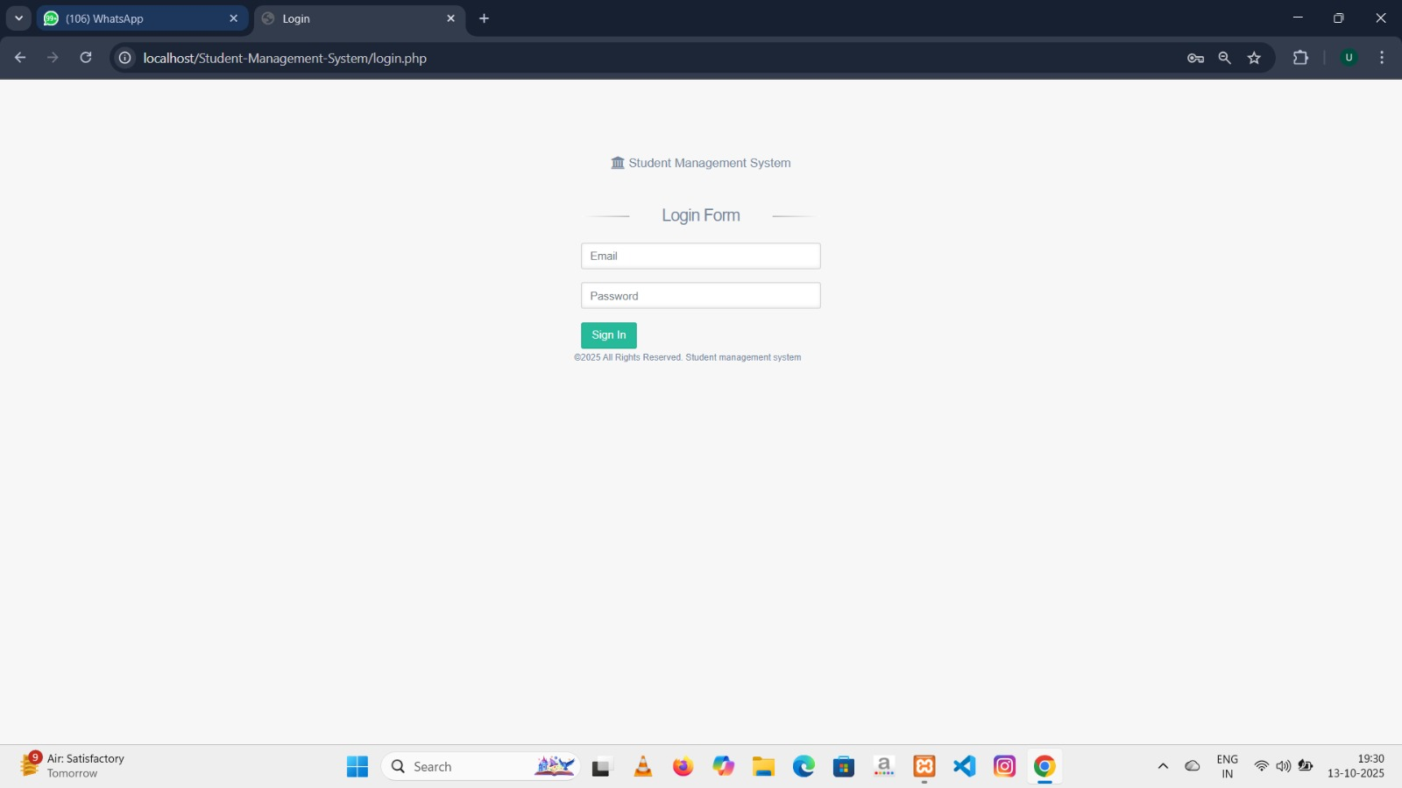
- This is login Page

Page 26 Created By Uttam R. Gondaliya

Add teacher
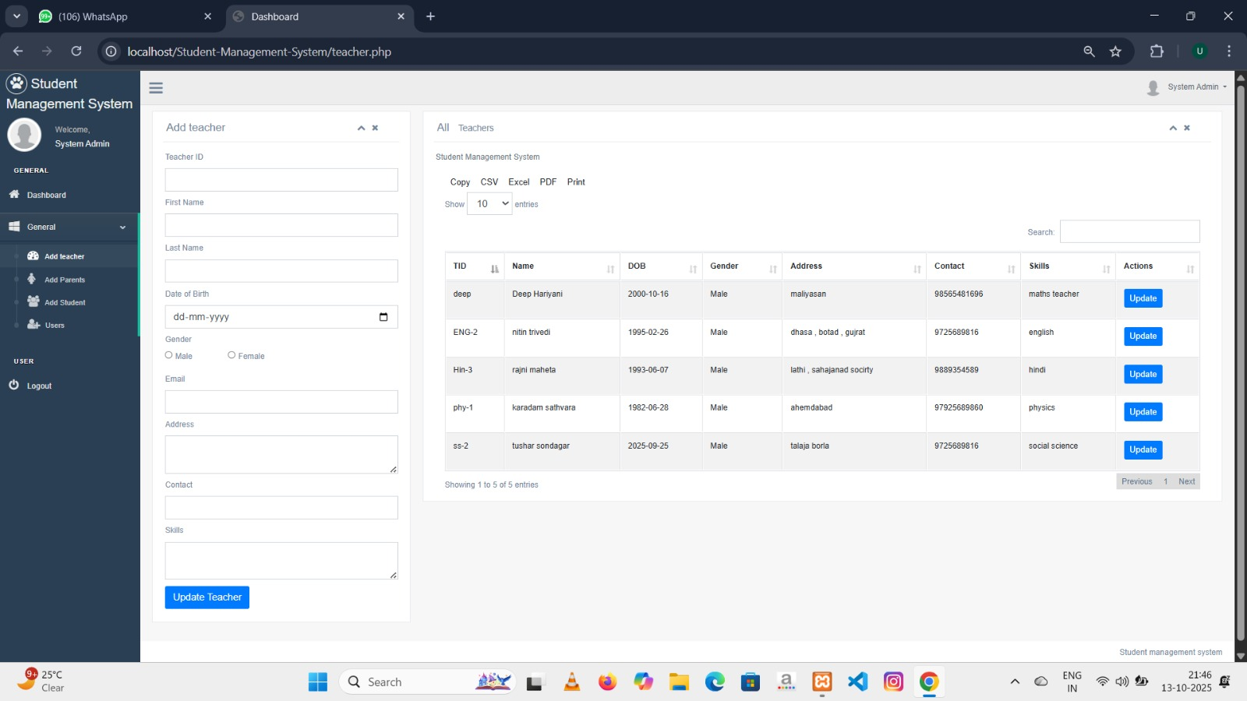
- This is the page for add teacher in admin panel , where admin can add teacher .

Page 27 Created By Uttam R. Gondaliya

Add Parent
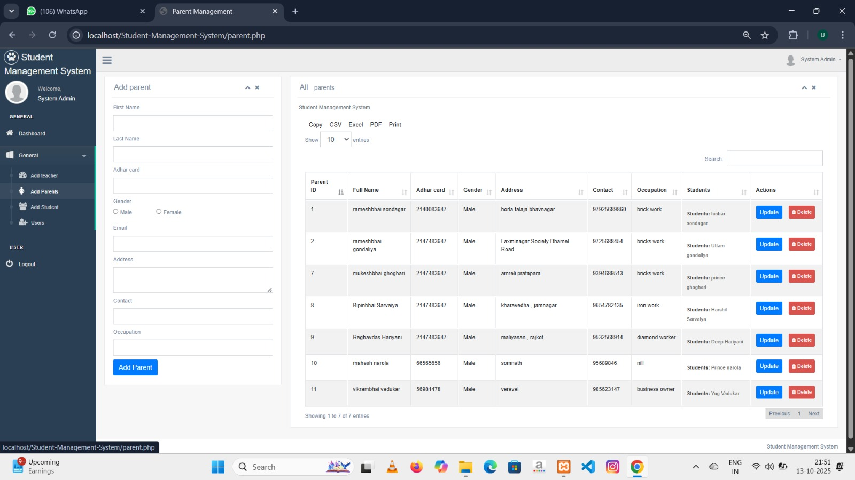
- This is a parent page for admin, where parent can add student data and it automatically gives name of child which is connected with child .

Page 28 Created By Uttam R. Gondaliya

User Role
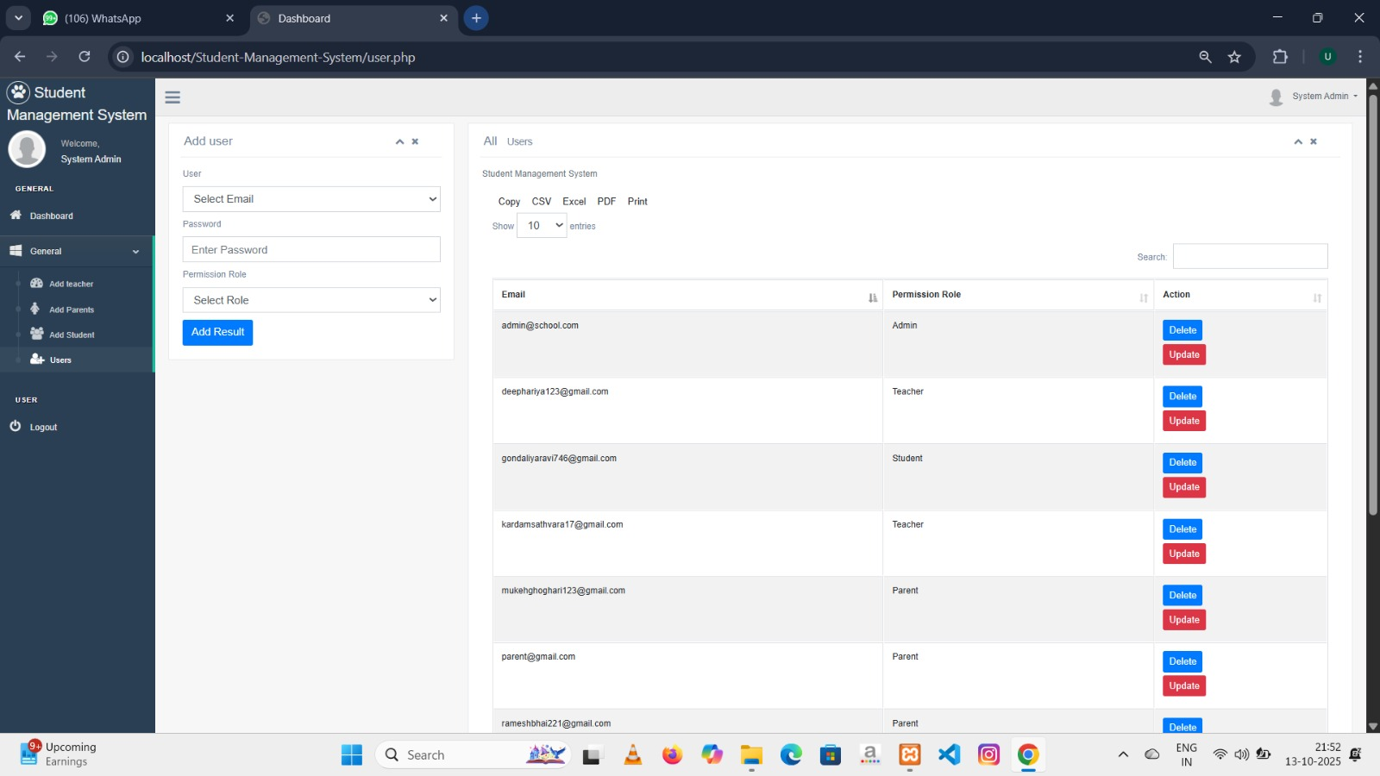
- This is a Page of User Role where admin can set a User role for Student , Teacher and Parent so the can login into System .

Page 29 Created By Uttam R. Gondaliya

Notice Student
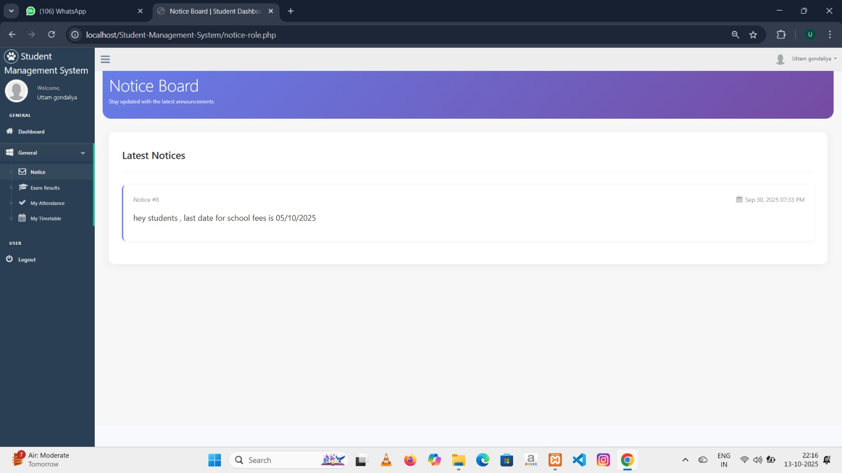
- This is Notice Section page in student panel , where student can see the important notices , which is send by teachers .

Page 30 Created By Uttam R. Gondaliya

Exam Result Student

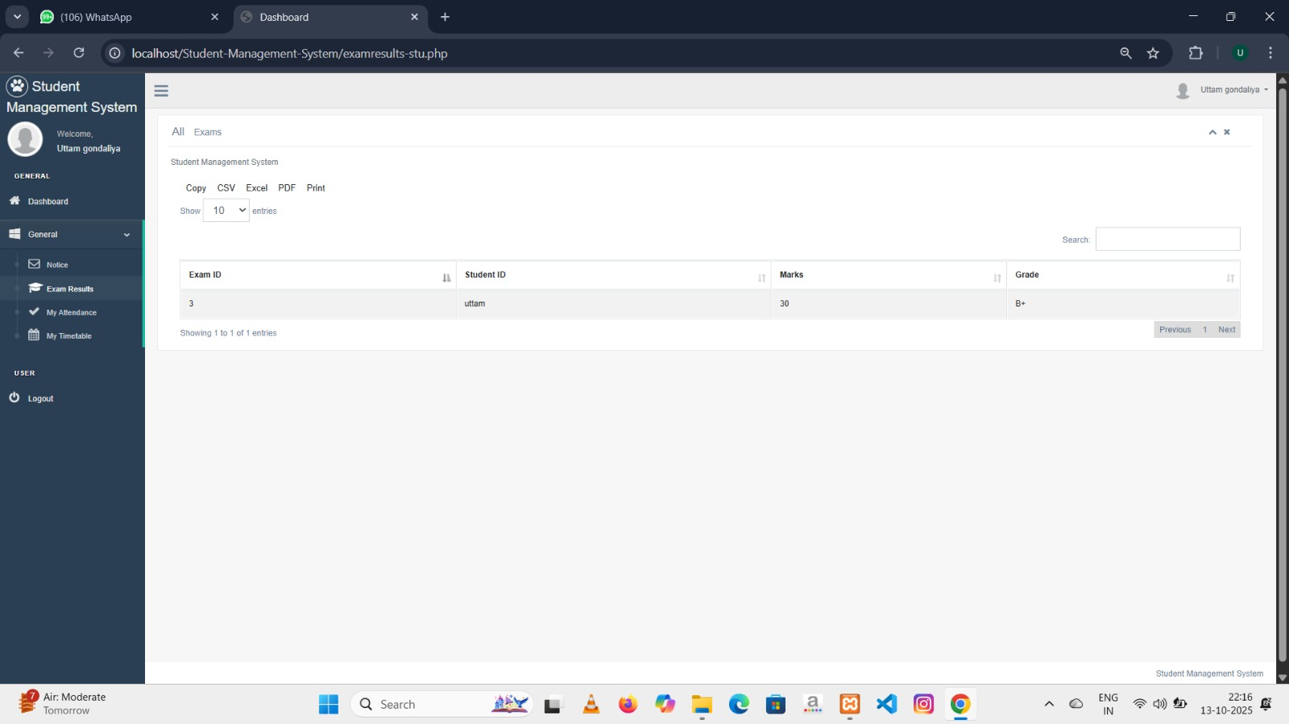
- This is a page for a Exam result show in Student p, which is Uploaded by teachers.

Page 31 Created By Uttam R. Gondaliya

Student Attendance
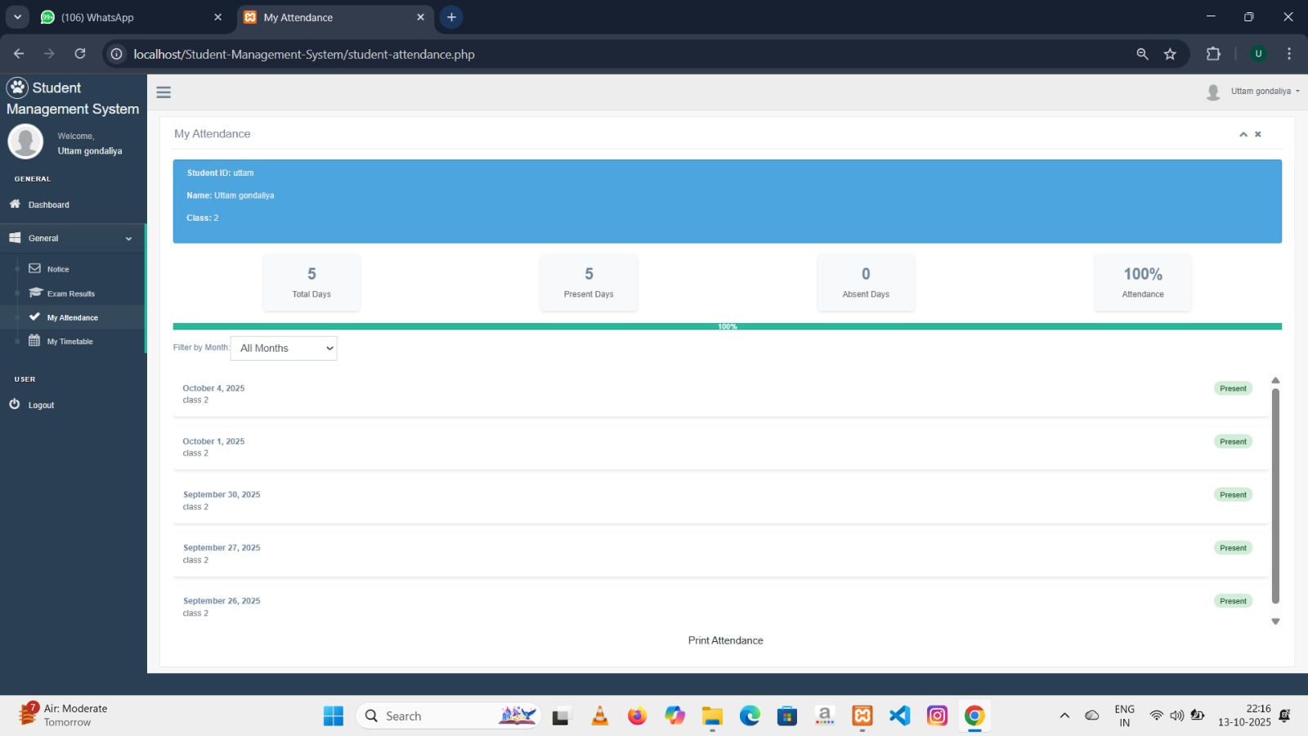
- This is a page for a studnt attendance , where it shows to student their attendance daily and also a monthly attendance report.
- How many days student present and how may days student absent .

Page 32 Created By Uttam R. Gondaliya

Student timetable

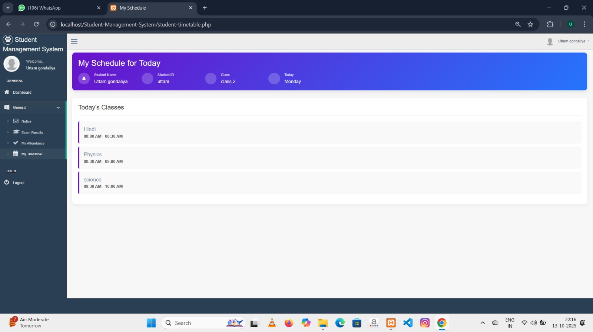
- This is a page for a student time table Where it shows regular schedule .

Page 33 Created By Uttam R. Gondaliya

Parent Child detail

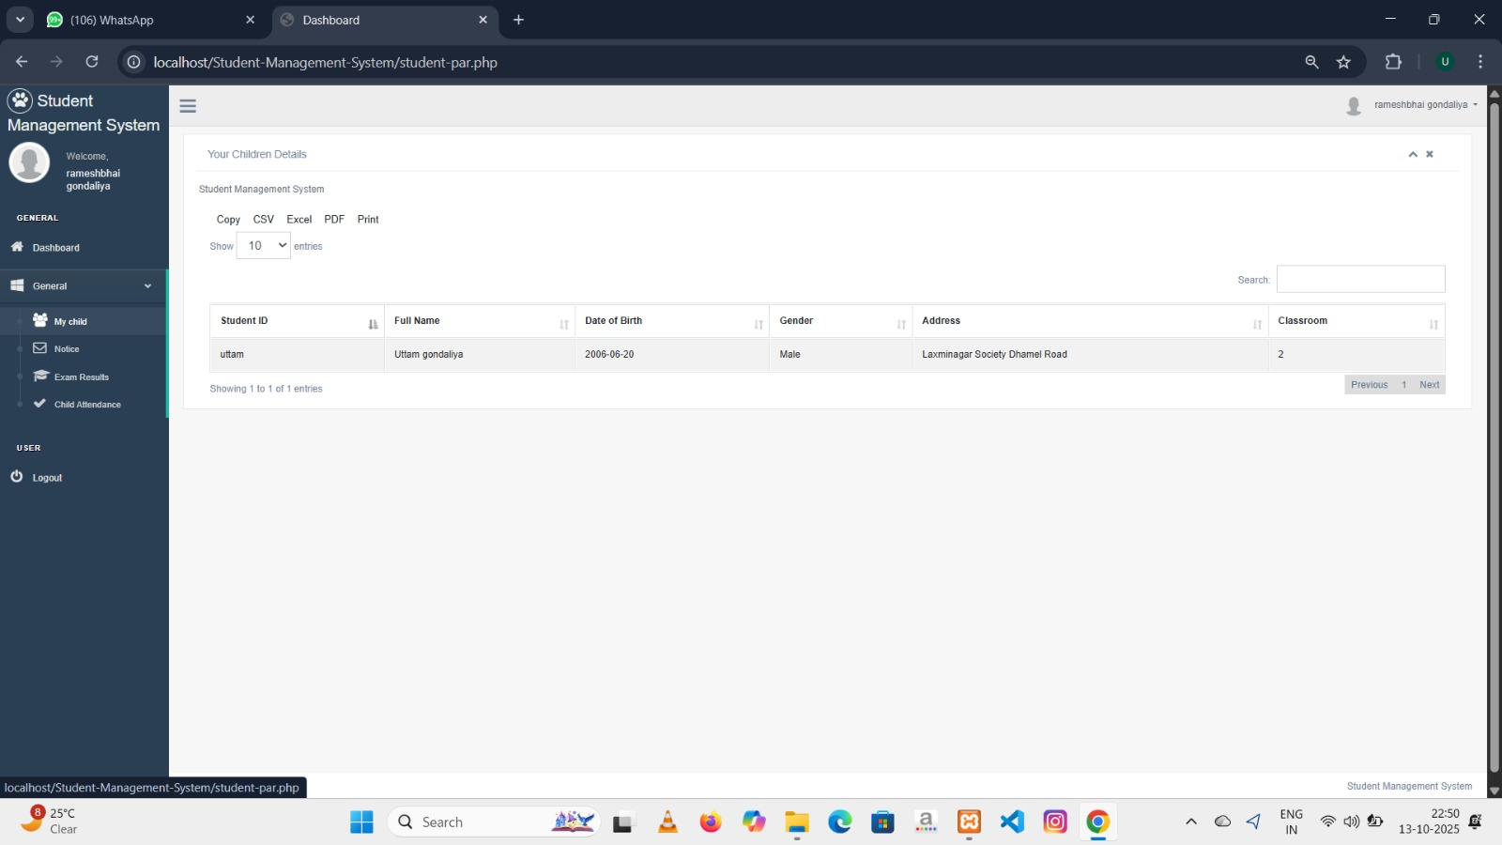
- This is a page where parents can see his child detail.

Page 34 Created By Uttam R. Gondaliya

Parent child result
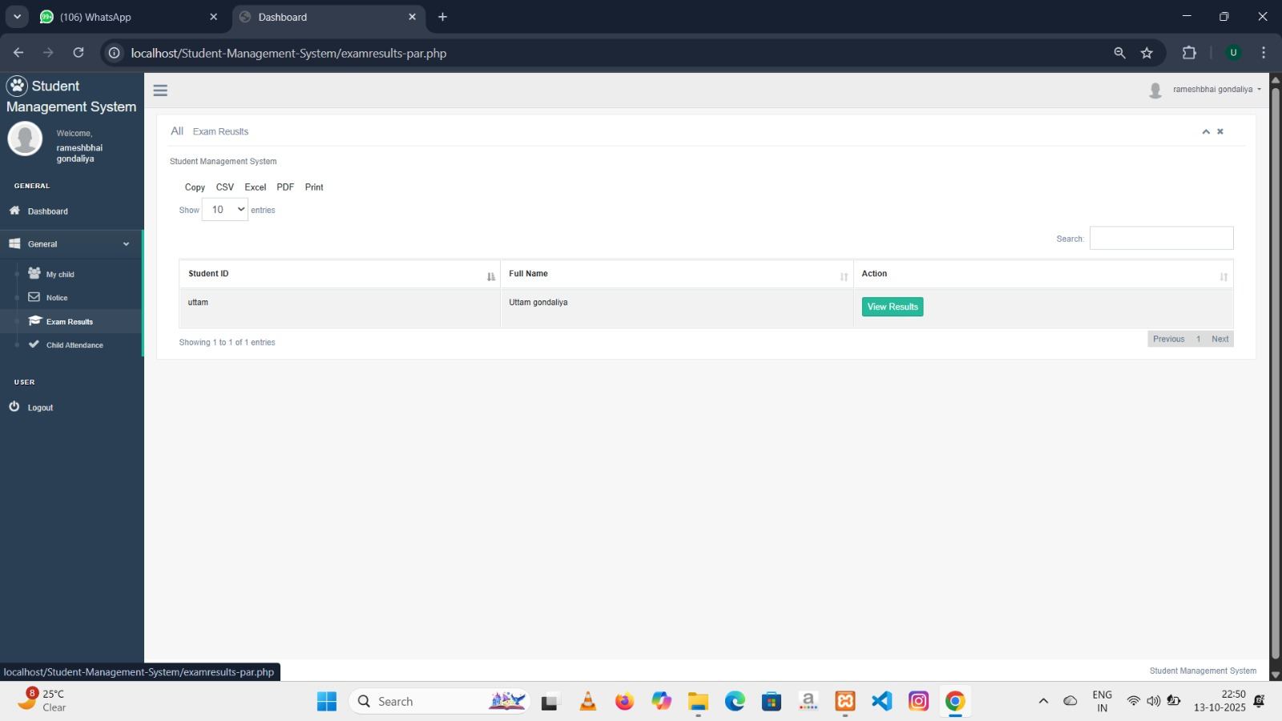
- This is the page where parents can see his child result.

Page 35 Created By Uttam R. Gondaliya

Child attendance

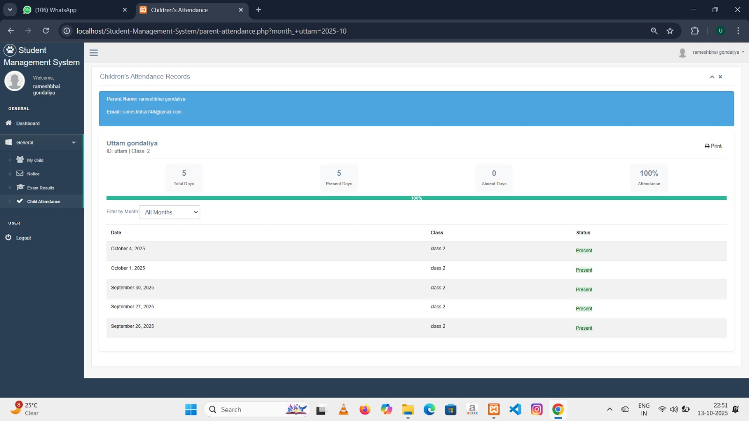
- This is a page where parents can see his child attendance and also can print it.

Page 36 Created By Uttam R. Gondaliya

Teacher Subject

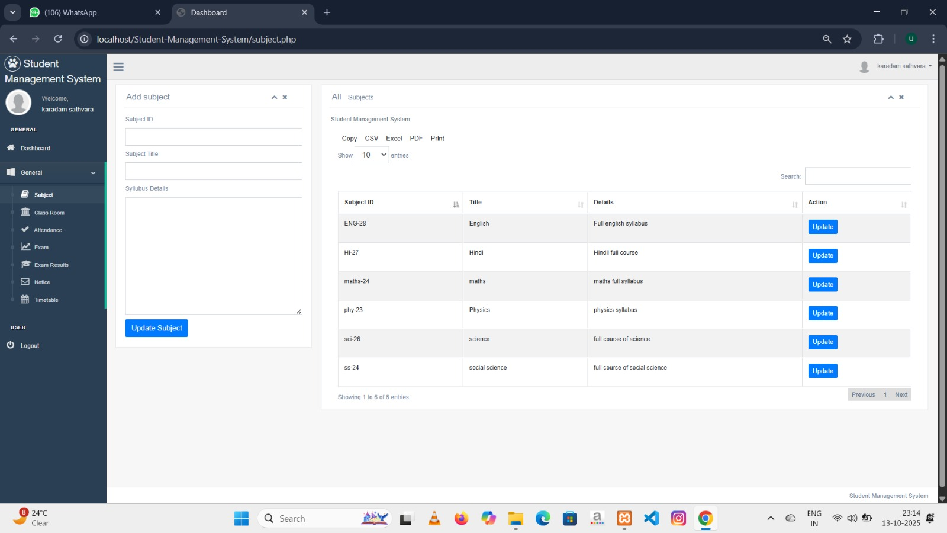
- Teacher Can add subject from this page.

Page 37 Created By Uttam R. Gondaliya

Teacher Class

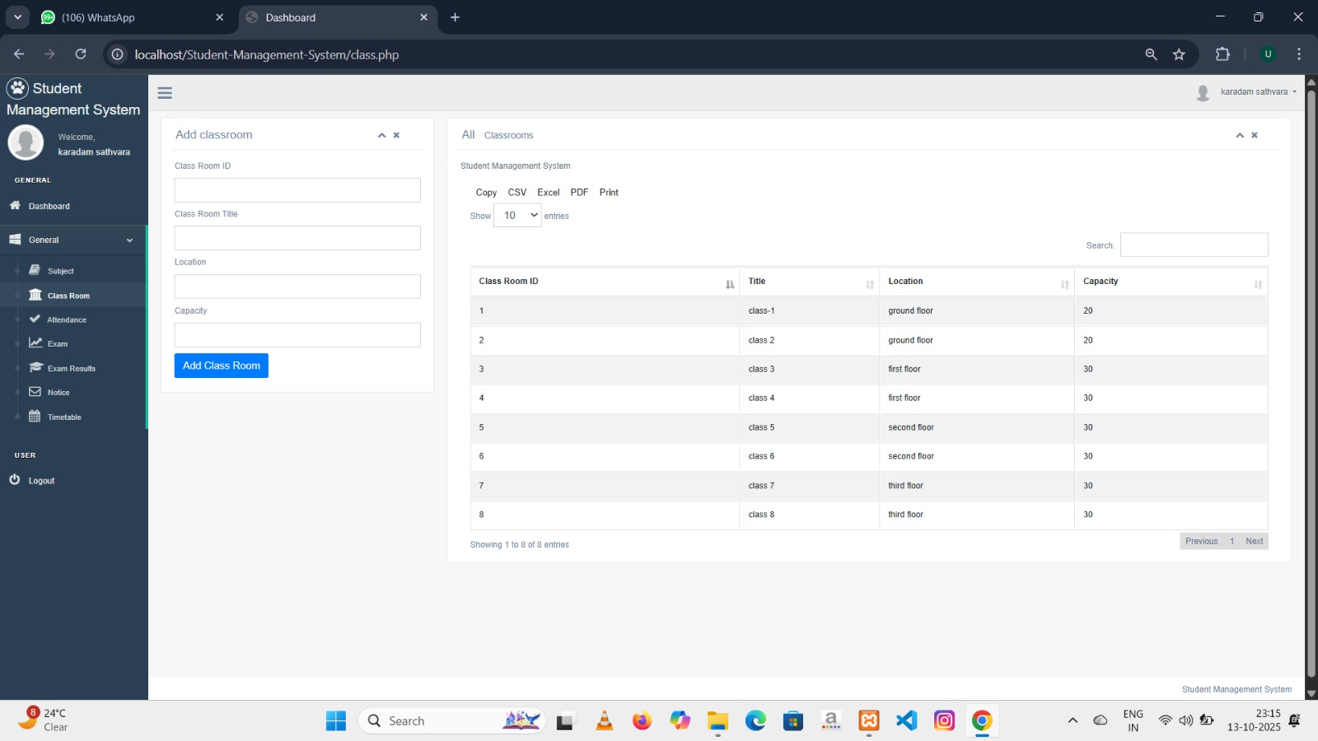
- Teacher can add Classes from this page.

Page 38 Created By Uttam R. Gondaliya

Teacher Attendance

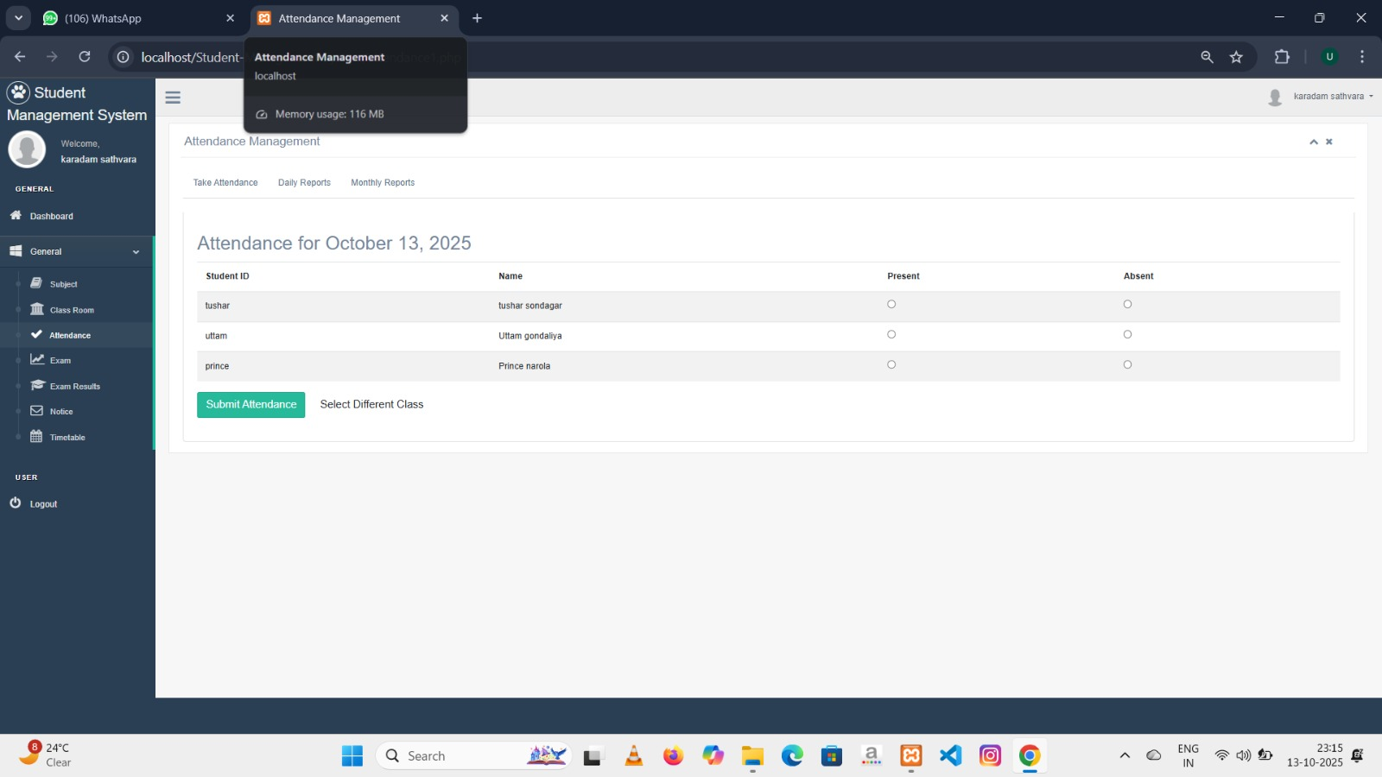
- This is a page where teacher first select the class then it shows the student of that class with present absent option then teacher select in option then submit .

Page 39 Created By Uttam R. Gondaliya

Attendance Report

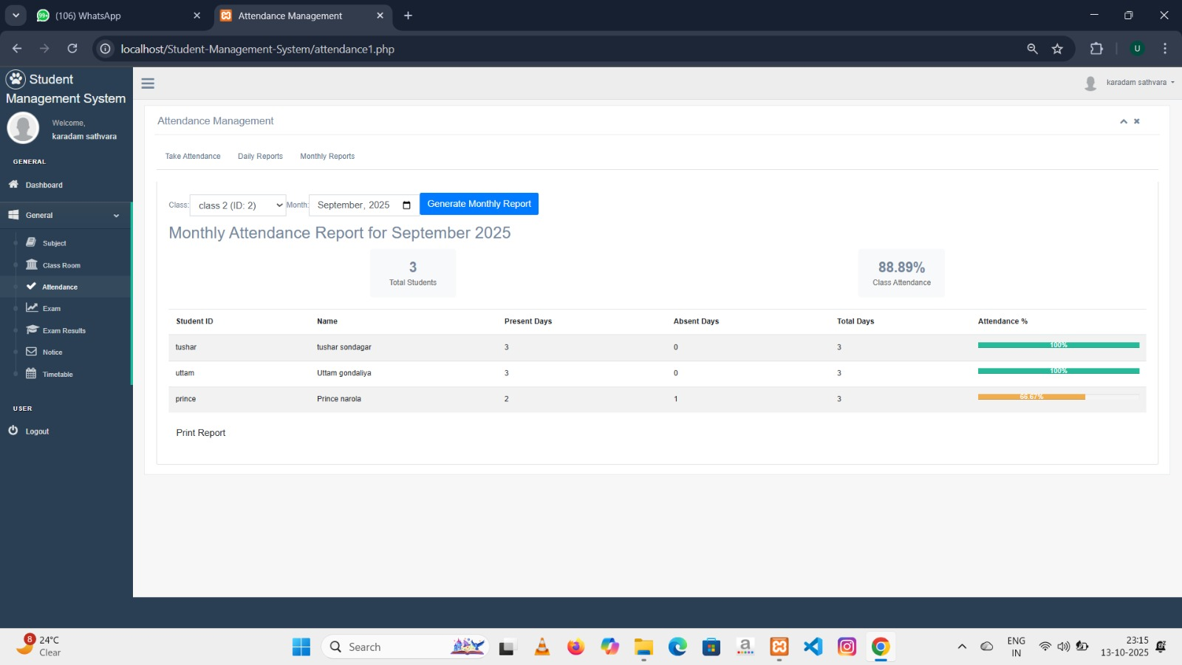
- This is a page where it shows monthly attendance report .

Page 40 Created By Uttam R. Gondaliya

Exam Set

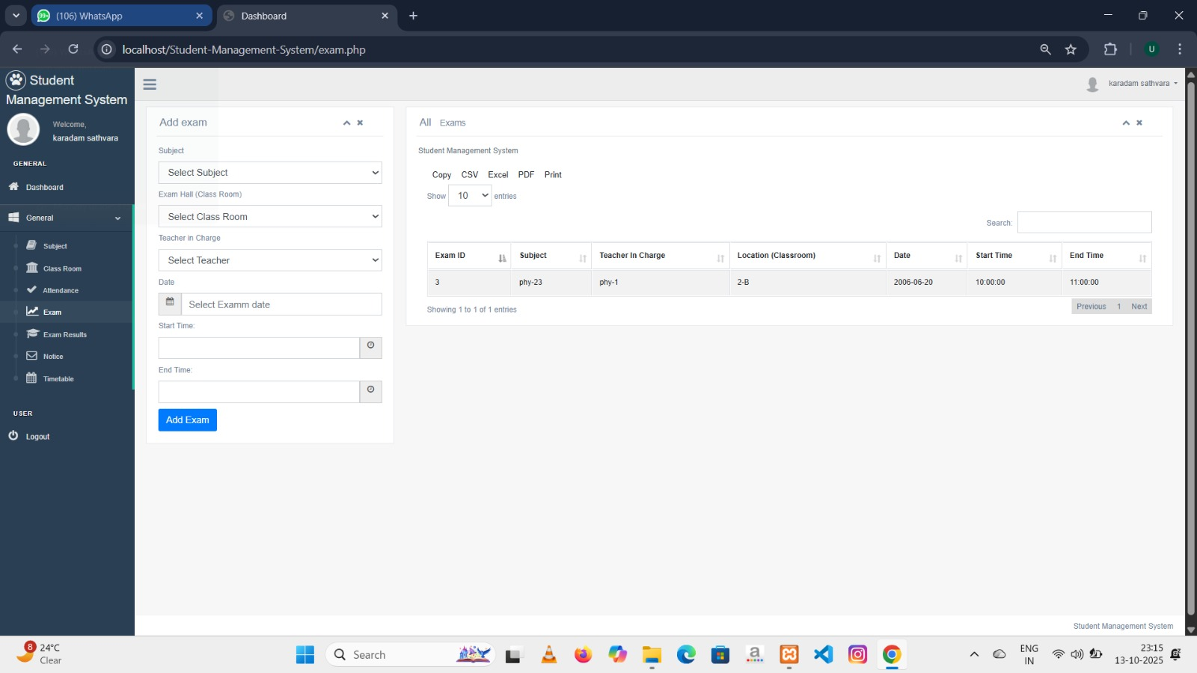
- Teacher can set Exam (Test) from this page .

Page 41 Created By Uttam R. Gondaliya

Exam Result

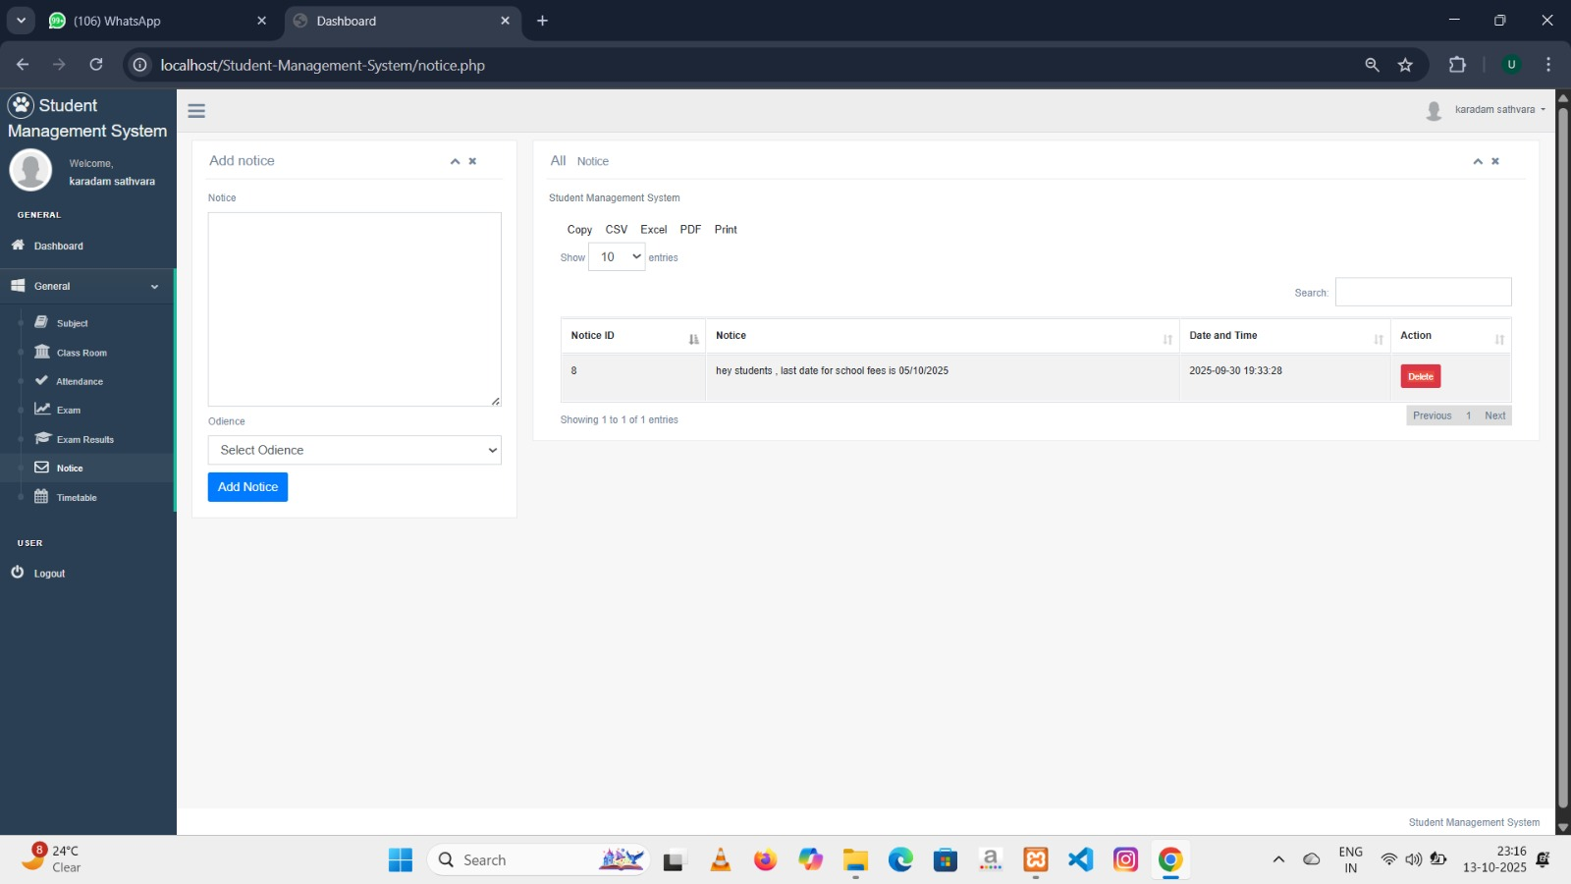
- This is a page where teacher can sent a notice to Student and Parents .

Page 42 Created By Uttam R. Gondaliya

Timetable

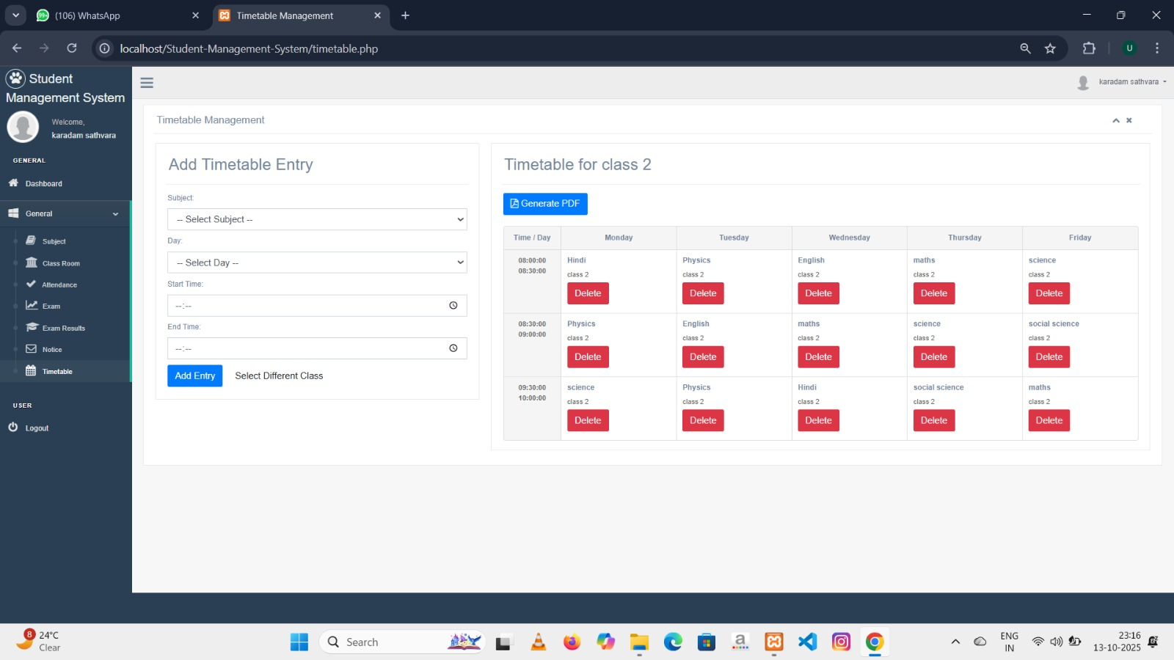
- This is the page where teacher can set a timetable for different class.
- First of all dropdown menu of class come then select class and then click submit button then create a time table.
- You can also generate timetable print.

Page 43 Created By Uttam R. Gondaliya
Limitations
Though we tried our best in developing this software but as limitation are major part of any software so are of our software. Some limitation of
innovator to investors portal are as follows: .
• If database gets big amount of data, it gets much time to load.
• Specific user roles are not provided in this software. That’s
why this can only be used by admin.

Future Enhancement
In the future, the Student Management System can be enhanced by integrating advanced technologies such as Artificial Intelligence (AI) and Data Analytics to automate attendance tracking, performance evaluation, and personalized learning recommendations. Cloud integration can be implemented to provide real-time access to data for students, teachers, and parents from anywhere. Additionally, features like biometric authentication, chatbot support for queries, and mobile application compatibility can improve user experience and system efficiency. These enhancements will make the system more intelligent, secure, and user-friendly for all stakeholders.

Page 44 Created By Uttam R. Gondaliya
Conclusion
Conclusion:
The Student Management System project successfully provides a digital solution for managing student-related information efficiently within an educational institution. It helps administrators easily handle student, teacher, and parent records through a centralized platform. The system automates key processes such as registration, attendance, examination management, and communication, thereby reducing manual work and improving accuracy. It ensures that data is well-organized and accessible, making the overall management process more efficient and transparent.
Overall, this project demonstrates how technology can simplify educational administration. By using PHP and MySQL, the system offers reliability, flexibility, and scalability for future improvements. It not only benefits the administration but also creates better communication between teachers, students, and parents. With future enhancements like mobile app support, AI-based analytics, and cloud integration, this project can evolve into a complete digital ecosystem for modern educational management.
Page 45 Created By Uttam R. Gondaliya
Page 45 Created By Uttam R. Gondaliya

