Enhancing Pavement Maintenance through Machine Learning: Predicting Freeze-Thaw
- Cycle Impacts
3

ABSTRACT:
- The project "Enhancing Pavement Maintenance Through Machine Learning: Predicting
- Impacts of Freeze-Thaw Cycles" aims particularly at countering the adverse effects of freeze-thaw
- cycles on pavement, a major cause of pavement degradation in the cold states of the U.S.A. By
- involving big data technology and other machine learning techniques, the study proposes to
- develop predictive models that will be able to predict the deterioration of pavement due to climatic
- effects, especially freeze-thaw effects. The ultimate intention of this project is to provide a data-
- based approach toward better and proactive maintenance for our infrastructure systems through
- integration of past climatic data with pavement conditions.
- Machine learning methods are used with Spark MLlib to analyze the factors that influence
- the conditions of the roads. Additionally, relevant visualizations were created to gain actionable
- and meaningful insights into patterns and trends.
- The project commenced at a very important phase, involving the collection of huge volumes
- of data, some cleaning and preparation of the dataset, and performing first exploratory analyses to
- identify trends that are presently being worked upon. The next steps involve extracting relevant
- features from the data, and evaluating several machine learning algorithms, in order to determine
- the most accurate and reliable predictive models that can be implemented later for setting
- requirements of planning and maintenance of the infrastructure, thereby reducing long-term costs
- and improving roadway safety in locations susceptible to extreme weather conditions.
- Key Words: Roads Longevity, Maintenance Prioritization, Road Conditions, PySpark,
- Databricks, Spark MLlib, Mongo DB.
22
23

INTRODUCTION:
- Pavement structures are very important for transportation systems in the US, but
- pavement durability and maintenance suffer most in cold regions where they experience constant
- freeze and thaw cycles. All these contribute to the loss of wear and tears in pavements, especially
- in areas where the temperature fluctuates a lot around freezing. Water freezes in pavement
- layers, resulting in internal pressure causing the weakening of material and degradation at a fast
- pace; thus, issue becomes a considerable economy affliction as repair costs incurred annually in
- the cold states average at $3.5 billion. Most of these costs cover pavements that have reactive
- instead of proactive maintenance strategies, thus affecting how resources get allocated into areas
- preventing long-term damage to pavements and into active improvements.
- This project leverages the Long-Term Pavement Performance (LTPP) program's vast
- dataset available through the Federal Highway Administration’s InfoPave portal. This dataset
- contains pavement performance data across climatic spectra from different points in the United
- States. By applying advanced data science and machine learning techniques, the project aims at a
- more accurate prediction of pavement deterioration as it pertains to freeze-thaw cycles. Although
- machine learning methods are proving to be successful in predicting other aspects of
- infrastructure forecasting, apparently they have not yet been fully exploited in optimizing
- maintenance strategies against freeze-thaw damage.

OBJECTIVE:
- The key objective of this project is to develop predictive models using machine learning
- which can predict failure in pavements based on historical climate trends and data regarding
- conditions of pavements. This is achieved by identifying the occurrence and place of damage
- relative to certain timeframes and locations thereby affording transport agencies the opportunity
- to optimize existing maintenance schedules while enhancing pavement life and reducing repair
- costs. It also seeks to liaise with AI in pavement management systems, expanding towards
- sustainability impact major paradigms of resource waste reducibility, further curbing carbon
- emissions, and enhanced structural resilience in the long term.
- It is topical because of the economic and environmental challenges that are facing the
- infrastructure of the U.S. The American Society of Civil Engineers' 2021 Infrastructure Report
- Card rated U.S. roads with a "D" and reported a gap of $786 billion between investments needed
- for highways and bridges and what is currently being spent. Simultaneously, climate change
- results in an increased frequency and greater intensity of freeze-thaw cycles. These cycles further
- increase the stress upon the already overburdened road network. This is what the team hopes to
- demonstrate through the project: how modern machine learning techniques and big data
- platforms along with datasets such as InfoPave can help in paving smarter, more economical, and
- climate-resilient management systems.
- As part of George Mason University’s AIT-614-002 course, this project provides a
- unique opportunity to gain hands-on experience with advanced tools like PySpark, NoSQL
- databases, and other big data technologies. In addition to developing technical expertise, students
- gain a deeper understanding of how data-driven insights can lead to meaningful improvements in
- infrastructure management. This work represents a step toward more intelligent, proactive
- solutions for the real-world challenges faced by today’s transportation systems.

METHODS:
- The project's methodology involves analyzing roads data from the Long term Pavement
- performance and InfoPavement dataset using machine learning techniques and big data tools. Data
- intake, preprocessing, descriptive analysis, predictive modeling, clustering, classification, and
- visualization were all steps in the process. Every stage was carefully planned to guarantee accurate
- evaluation and useful insights.

Preprocessing and Data Ingestion:
- The datasets were first imported from the InfoPave website download .accdb format into
- Microsoft Access for initial cleaning and preparation. The unnecessary columns (redundant
- MERRA_IDs and duplicate date features, e.g. month/year) were removed to streamline the data
- structure. The Query Designer of Access was used to join the relevant weather tables-
- MERRA_GRID_SECTION, MERRA_HUMID_MONTH, MERRA_PRECIP_MONTH,
- MERRA_SOLAR_MONTH, MERRA_TEMP_MONTH, and MERRA_WIND_MONTH-
- through inner joins corroborated by MERRA_ID and SHRP_ID, which are relational keys that
- link climate data to pavement testing sections. The cleaned data was then exported in Excel
- format for exploratory data analysis and further formatting.
- Data cleaning continued in Excel, nonetheless. Some nominal columns (MERRA_ID,
- SHRP_ID) were by default wrongly assigned numeric type, and hence they were changed to text
- type to safeguard against misleading statistical operations. The logic and precision make sense
- when translated into numbers, such as average temperature and wind velocity. The last cleaning
- was related to null values and was carried out with Access's find and replace tool, rendering data
- complete and consistent.
- The finalized datasets for this project consisted of climate data from NASA's MERRA and
- pavement performance data from the InfoPave database of the FHWA.. The datasets were
- filtered for only those sections with full temporal overlap, thus ensuring the analytical results
- would be sound. Data integration and processing for these combined datasets were then achieved
- using PySpark for efficient large-scale analysis. Feature selection brought out the most relevant
- variables for predictive modeling, which included monthly and yearly changes in temperature,
- precipitation, wind exposure, humidity data, and pavement cracking index. Such a structured
- data preparation pipeline served as a clean and trustworthy foundation for downstream machine-
- learning analysis.

Descriptive Analytics:
- The descriptive statistics were found for getting some understanding of the dataset. For key
- variables like Road Age, Condition Rating, and Average Daily Traffic, parameters such as mean,
- median, mode, and standard deviation were calculated. By focusing patterns and distributions
- across different magnitudes, these parameters paint a rudimentary picture of the dataset. To further
- investigate patterns in the data, scatter plots, bar graphs, and histograms were prepared. To identify
- any geographical variations in terms of road conditions, for example, distributions of traffic loads
- and road materials across the regions were investigated.
40
41

1
2

RELATED WORK:
4
- The challenge of pavement deterioration due to freeze-thaw cycles is an age-old challenge
- for transportation agencies. Early investigations were conducted using empirical and deterministic
- models, which often failed to consider complex environmental interactions. Introduction of the
- Mechanistic-Empirical Pavement Design Guide (MEPDG) was an improvement; nevertheless,
- traditional regression approaches were rendered ineffective in regions having severe freeze-thaw
- impacts. The latest developments suggest the application of machine learning (ML) for predicting
- pavement performance, with studies proving methods to be accurate, such as support vector
- machines, convolutional neural networks, and ensemble algorithms like Random Forest and
- Gradient Boosting. However, much of the modeling concerning freeze-thaw effects is still limited,
- with only a handful of studies, such as Zhang and Liu (2022), that focused on frost-related
- performance deterioration using advanced ML tools.
- Machine Learning and Pavement Performance Prediction: A Survey and exploratory
- applications. Regression analysis and other traditional statistical models have been widely used by
- researchers for estimating pavement deterioration due to traffic hazards, environmental conditions,
- and material characteristics. In fact, machine learning algorithms are holding interest in the current
- contemporary setting due to their efficiencies in handling complex datasets and getting closer
- predictions.
- Lately, deep learning methods have been applied in analyzing pavement distress images with
- the ability to classify cracks, potholes, and surface deformation. Other authors have also included
- climate data for predicting seasonal variations in pavement conditions. Overall, however,
- interesting research tends to focus on the generic disease of pavements without specifically looking
- at freeze-thaw cycles.
- This work will be principally different since it will concentrate on optimizing ML models
- developed for specifically predicting freeze-thaw failures in pavement thus, it will improve the
- prediction efficacy in ML models for this application by using high-resolution environmental
- variables and historical pavement data. Not only will comparisons of different ML approaches be
- undertaken but the ideal model will be chosen based on practical applications within management
- systems of pavements.
- At the same time, the advent of big data technologies has affected the way pavement
- engineering looks at climate change. Currently, a lot of researchers have involved high-
- performance computing paradigms such as Hadoop and Spark to process large datasets from
- programs such as LTPP; however, applications specifically focusing on freeze-thaw effects remain
- few and far between. Studies on climate effects underlined the growing importance of adaptive
- pavement strategies, to be prepared for changes in the environment. Filling those gaps, our research
- integrates high-resolution MERRA climate data with LTPP performance metrics in a big data
- pipeline, designed with PySpark and MongoDB, targeting freeze-thaw effects through specialized
- ML models and a variety of algorithms for advancing pavement management system predictions
- as the climate continues to evolve.
43
44
45
46

SELECTED DATASET:
2
- Our chosen data set originated from the InfoPave website and holds data from 1980 to the
- present year. By restricting the location to states in the northern parts of the United States that are
- particularly cold, we produced more refined datasets our other data filters, such as performance
- data and climate data, for which InfoPave conducted automatic filtering for states that had this
- information. After the application of these filters, the resulting states in the dataset include Illinois,
- Iowa, Washington, and Wisconsin. This is our initial dataset, but more states may come on board
- through changes in filters as the project progresses. We have not selected the construction data
- about the road in terms of the joints/bonds that it used, since this does not bear on the research
- question of this study requiring knowledge of what materials the pavements are made from.
- InfoPave created the data bucket into two separate files: one contains the data on such matters as
- coordinates, analysis, precipitation, and temperature. In contrast, the other captures much more
- specific and understanding weather-related details - about precipitation, temperature, humidity,
- wind, solar, and climate data - from MERRA, which is modern-era retrospective analysis for
- research and applications.
- The dataset consists of various tables that vary in the number of records, and some categories
- tend to show null rows during a joint. We want to select data relevant to the weather and climate
- of each of the selected sites. One such table is the CLM_VWS_PRECIP_MONTH, which has
- more than 16,000 records and brings data regarding the monthly precipitation in each of the
- selected sites. We will focus on the columns from Virtual Weather Station: Precipitation Annual,
- Precipitation Month, Temperature Annual, Temperature Month, Wind Annual, Humidity Annual,
- Humidity Month. Also, there are AC Distress Survey Ratings, AC Pavement Cracking Indices,
- JPCC Distress Survey Ratings, PCC Pavement Cracking Indices, and Section Level IRI. These
- features will allow comparing the weather data with road quality measurements. We have climate
- data in two places: the CLM VWS tables and the MERRA tables, which could be merged with the
- more detailed information from MERRA. Section coordinates, together with the location, will be
- considered, as this plays a huge portion in our research question.
29

30 DEVELOPMENT TECHNOLOGIES/PLATFORMS:
31
- Using big data and machine learning techniques to analyze the existing data allows for
- developing prediction models for road deterioration because of freeze-thaw cycles. It will
- investigate historical pavements that are registered in the FHWA InfoPave database along with
- data on weather from MERRA and Virtual Weather Station.
- The volume of data to be processed and stored demands an efficient mode of data storing and
- processing, whereas the proposed system implements Apache Hadoop (HDFS, in this case) as a
- Big Data Platform along with MongoDB as its NoSQL database. This ensures scalable data
- handling with faster processing speed and flexibility to deal with both structured and unstructured
- data.
- For the prediction and analysis part, two Big Data engines will come into play: PySpark and
- Spark MLlib. PySpark is responsible for cleaning, filtering, and transforming data while
- distributing data processing. After that, introduces Spark MLlib, which is meant for teaching
- machine-learning models such as Random Forest Regression, Decision Trees, and GBT regressors
- that will analyze how environmental conditions lead to pavement damage and provide early
- warning so that transportation agencies can maintain the roads before a significant deterioration.

  - For better user experience this system plans to provide an API, which would seamlessly be
  - integrated into their existing road management software. The visual dashboard will make
  - predictive insights available to the users so that decision-makers have a clearer picture of how
  - things are affecting, deciding on road processes, and determining schedules for repair. Another
  - function in the automated maintenance scheduling feature will rank roads according to current
  - model forecasts in real time. So, the technical requirements of this project are completely met by
  - Apache Hadoop (HDFS), MongoDB, PySpark, Spark MLlib. It will strengthen the maintenance
  - planning, thus reducing the cost of repairs and subsequently increasing the resilience of the road
  - networks against freeze-thaw damages.
10

11 EXPERIMENTAL RESULTS AND ANALYSIS:
12
- Having cleaned the dataset through Microsoft Access, one can ascertain that all necessary
- steps were taken to remove errors or inconsistencies. Initially, pre-processing actions were
- implemented to prepare the data for analysis. This included the organization of the data, treatment
- of missing values, and finally, transformed into a way useful for further processing. After this,
- summarizing the data paved a way to delve deeper into valuable insights and visualizations for
- graphical representation. The image attached can be referred to for such a representation showing
- a table formed on the significance of different meteorological measures, including MERRA ID,
- year, month, relative humidity, precipitation, evaporation, cloud cover, shortwave radiation,
- precipitation departure, average temperature, mean wind velocity, state code, elevation, latitude,
- and longitude. This table can be termed as the very basic foundation to our analysis since it will
- be used to find correlations of different variables against each other and to identify possible
- patterns/trends in the dataset.
25
- 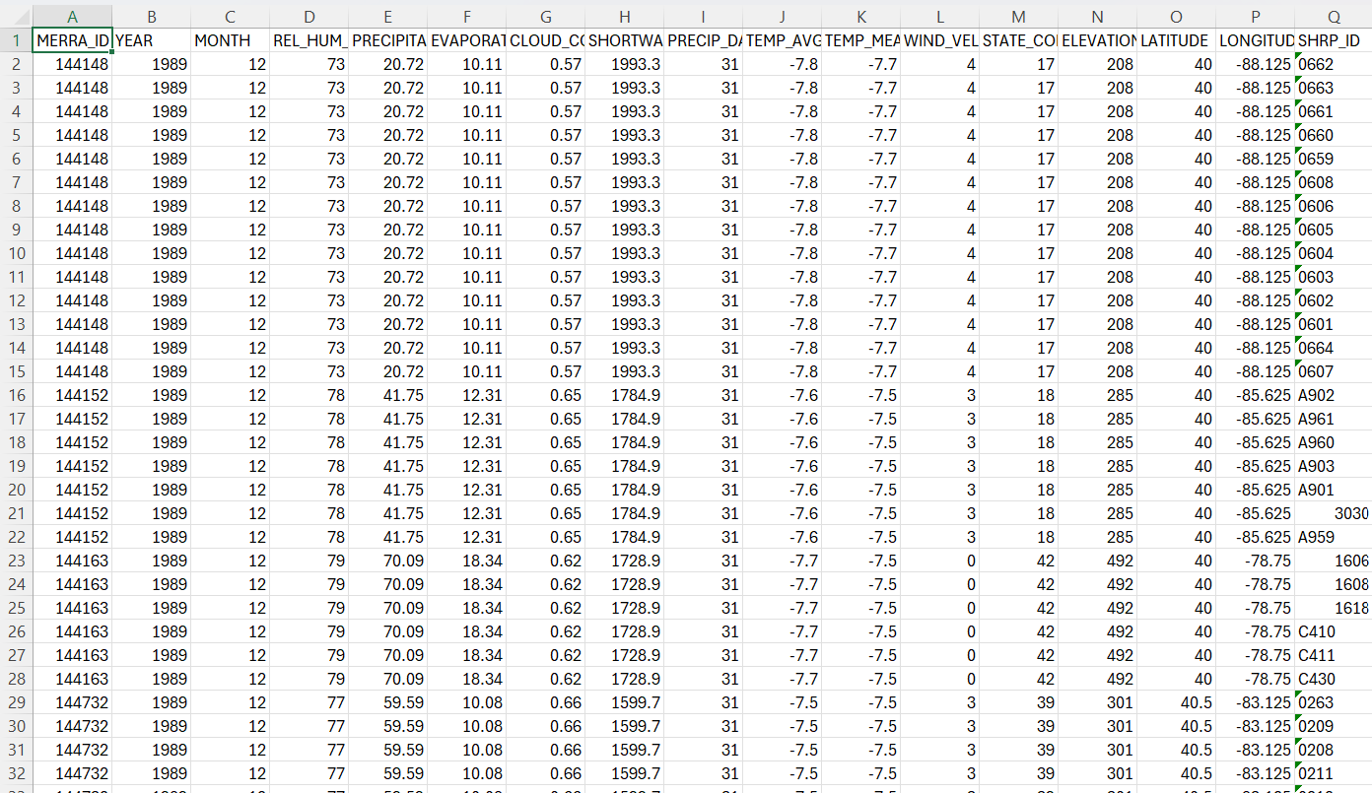
- Figure 1: Preview of the cleaned and preprocessed dataset loaded in Databricks
28

  - The evaluation of the Decision Tree model trained using data imported via MongoDB,
  - completing steps including cleaning the data, converting into LabeledPoint RDD format, and
  - partitioning the dataset into training and test sets, were part of the evaluation of the Decision
  - Tree model trained using imported data from MongoDB. The training of the model was
  - completed at an impressive speed of 5.83 seconds. The overall evaluation time was 74.88
  - seconds. Judging from the inferred R² score of 0.9773, it can be deduced that the model is very
  - good at prediction, for this means that about 97.73% of the variance within the target variable
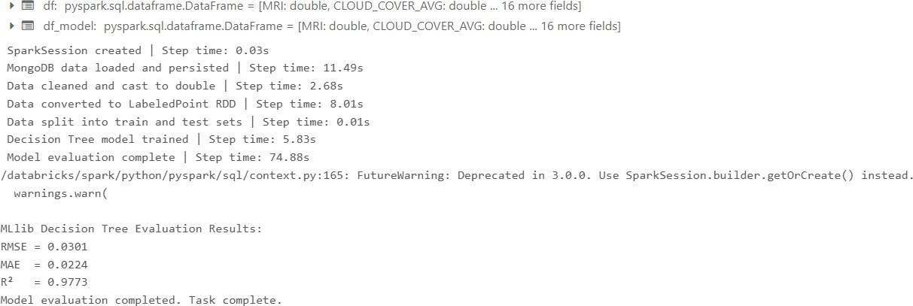
  - can be accounted for by it.

9
  - Figure 2: The evaluation metrics for Decision Tree Model
11
- The evaluation of a Random Forest model trained on the same dataset. which had gone
- through the same data preparation, revealed an even better performance with an R² score of
- 0.9911 after a training time of 16.01 seconds and a total evaluation time of 71.70 seconds. With
- this score, nearly 99.11% of the variance in the dependent variable would be explained by the
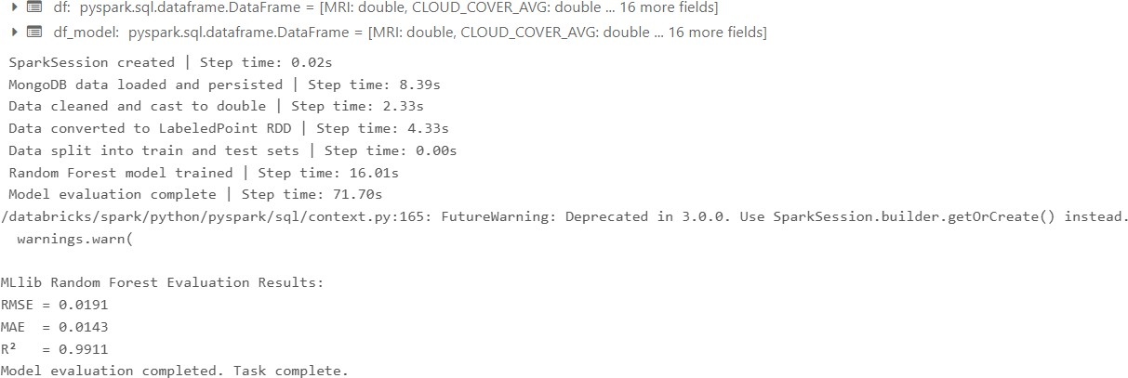
- model.

17
18 Figure 3: The evaluation metrics for Random Forest Model
19
- The results of a GBT regressor model, Gradient Boosted Tree model was trained for an
- extended period of 463.54 seconds after feature assembly, scaling, data sampling, and
- vectorization. The model has completed its predictions in 1.30 seconds, and the evaluation
- metrics showed a very high R² score of 0.9964, indicating that the model explains about 99.64%
- of the variance in the target variable, thereby showing a very high degree of predictive strength.

- 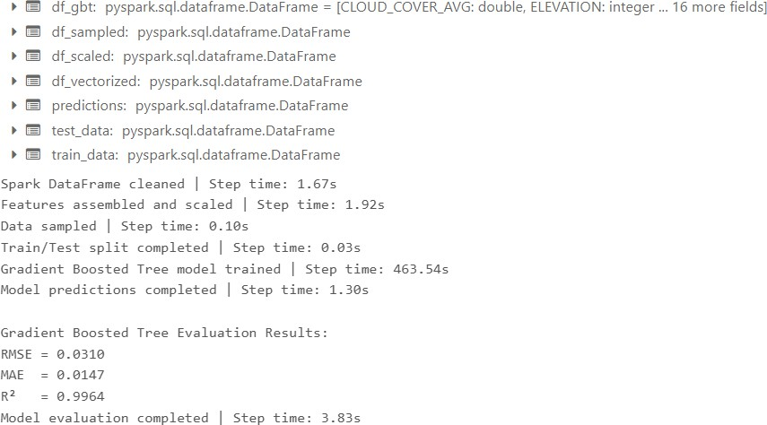
- Figure 4: The evaluation metrics for GBT regressor Model
3
- In summary, all models were good, but the Random Forest model was best for balancing high
- accuracy and relatively short training time. The GBT regressor provided excellent predictive
- strength, despite being rather lengthy in training time. When it came to prediction quality, it was
- competitive with the Decision Tree model that had the fastest training time and made it a good
- option for applications that require quick model deployment.
9
- The visualization below compares the actual variance in Mean Roughness Index (MRI)
- measurements with a set of prediction values from three machine learning models, namely
- Decision Tree, Random Forest, and GBT regressor, against Relative Humidity. The actual spread
- of MRI values correlating to ranges of Relative Humidities from 40% to 90% fluctuated among
- 0.5 and approximately 3.5. The MRI predictions by Decision Tree (orange), Random Forest
- (yellow), and GBT (purple) almost mimic the distribution of actual MRI data, meaning the
- models described above can express the variability in MRI concerning humidity levels. The
- Random Forest model does appear to be marginally ahead of the other two models in terms of
- prediction density and alignment with the actual data points.

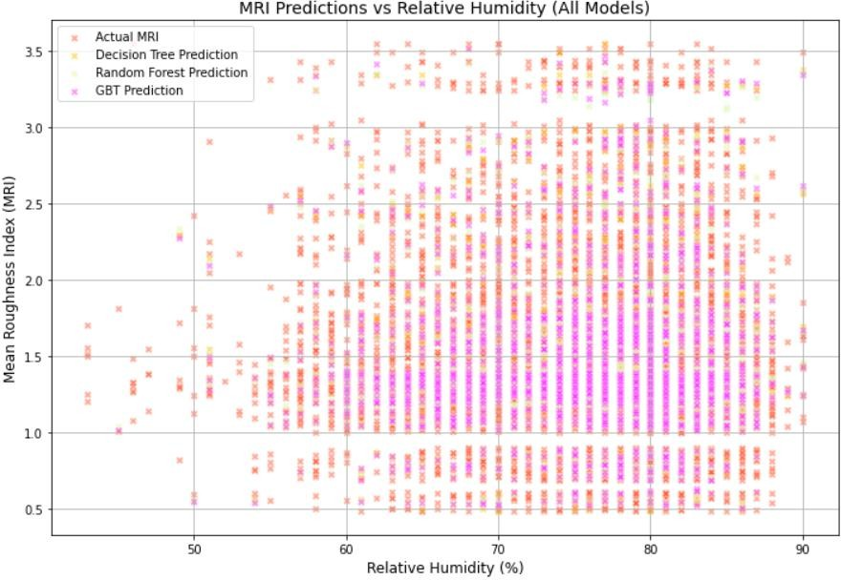
1
  - Figure 5: Results for Actual MRI, Decision Tree, Random Forest, GBT regressor for
  - Predicated MRI vs Relative Humidity
4
- The visualization below investigates the relationship of MRI with Wind Velocity. Actual
- MRI values range from zero to five m/s in scattered wind velocities, where MRI also ranges
- from approximately 0.5 up to about 3.5. The trend observed in the first visualization is seen
- again in that the Decision Tree, Random Forest, and GBT predictions mostly matched that of the
- actual MRI data. Regarding this last observation, however, the Random Forest model seems to
- have a slightly better alignment with the actual data points, suggesting that it possesses
- marginally better accuracy in prediction.
12
13

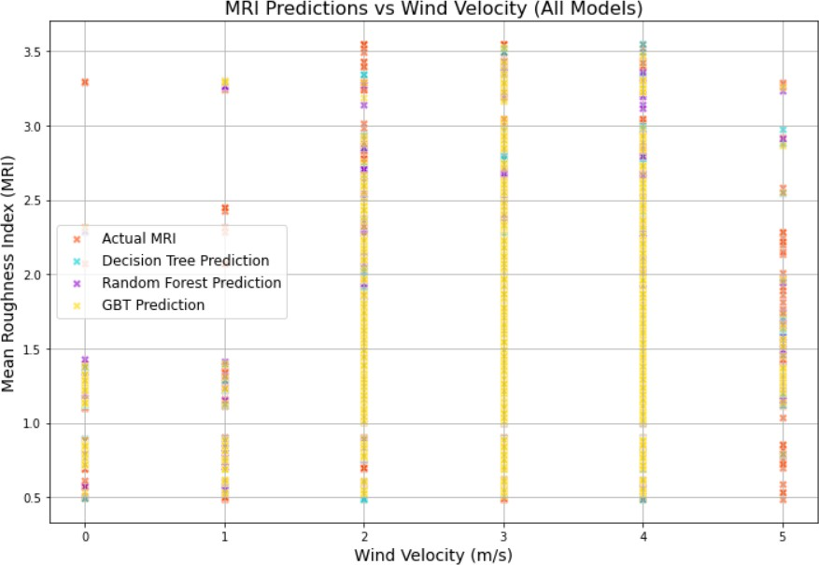
1
  - Figure 6: Results for Actual MRI, Decision Tree, Random Forest, GBT regressor for
  - Predicated MRI vs Wind Velocity
4
- The visualizations below compare MRI data with Shortwave Surface Average. Actual MRI
- data points stretch across the entire range of Shortwave Surface Average values between 1000
- and 8000 W/m², with MRI values existing between around 0.5 and 3.5. The distribution patterns
- of the actual MRI data are potentially captured in both Decision Tree and Random Forest
- models, as demonstrated by similar point density and shape. However, the GBT model again has
- been found to suffer scaling issues on the x-axis, where Shortwave Surface Average values were
- incorrectly transformed into a range from approximately -1.5 to 1.5 W/m² instead of 1000-8000
- W/m². All the models maintain a general vertical distribution of MRI values, yet Decision Tree
- and Random Forest are preferred for producing better predictions as they preserved the
- horizontal distribution of data as accurate.

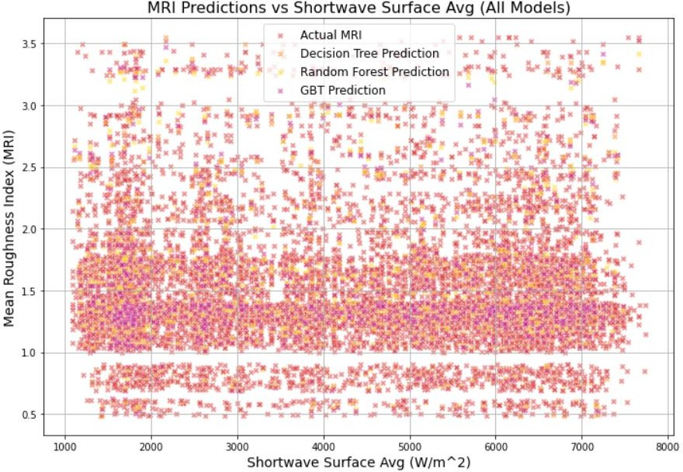
1
  - Figure 7: Results for Actual MRI, Decision Tree, Random Forest, GBT regressor for
  - Predicated MRI vs Shortwave Surface Avg
4
- The ensemble visualizations below depict the behavior of Mean Roughness Index (MRI)
- values to Evaporation binned values three models having different patterns of evapotranspiration.
- compares the average MRI value with evaporation (Binned, Refined Models). The actual MRI
- data points were plotted against binned midpoints of evaporation, and MRI values ranged
- between approximately 1.35 and 1.55. Predictions from Refined Decision Tree (blue), Random
- Forest (purple), and GBT Regressor (yellow) models were all seen to closely follow actual MRI
- data. The Random Forest model appears to have a slightly better alignment with the actual data
- points than the other two models, indicating a marginally higher predictive.

  - 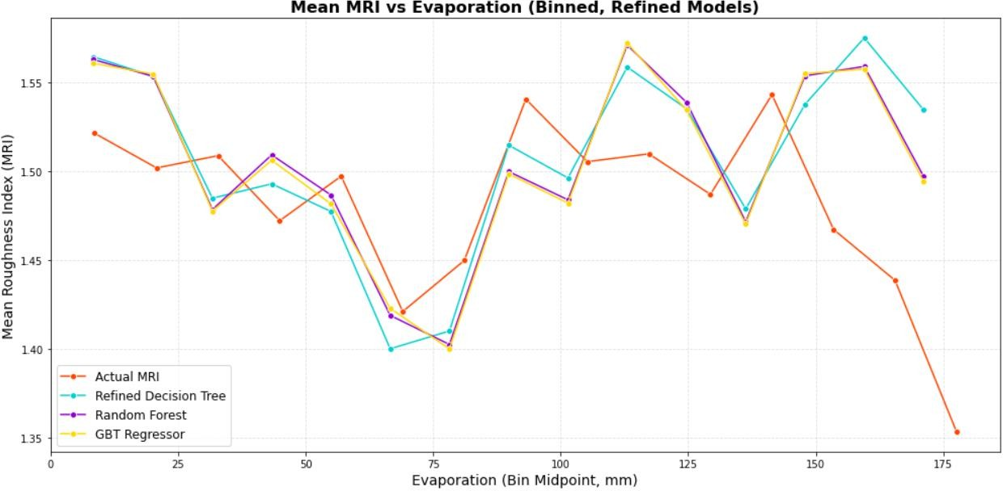
  - Figure 8: Results for Actual MRI, Decision Tree, Random Forest, GBT regressor for
  - Predicated MRI vs Evaporation
4
- The visualization below depicts the box plots comparing actual Mean Roughness Index
- (MRI) values with MRI values predicted by two machine learning algorithms: Decision Tree and
- Random Forest, as per cloud cover ranges. The box plots on top exhibit the distribution of the
- actual MRI values, whereas box plots in the middle and lower portions are their predictions made
- by the Decision Tree model and Random Forest model, respectively. The actual MRI data points
- are spread at approximating values of about 0.5 and 3.5 across ranges of cloud cover. The
- Decision Tree model (orange), Random Forest model (yellow), and GBT model (purple) have
- predictions that closely fit the actual distributions of MRI data, meaning that all three models
- capture the variability in MRI according to differences in cloud cover. However, the predictions
- made with the Random Forest model are, however, slightly better than those made with the other
- two, in terms of prediction density and correlation to the real data points.
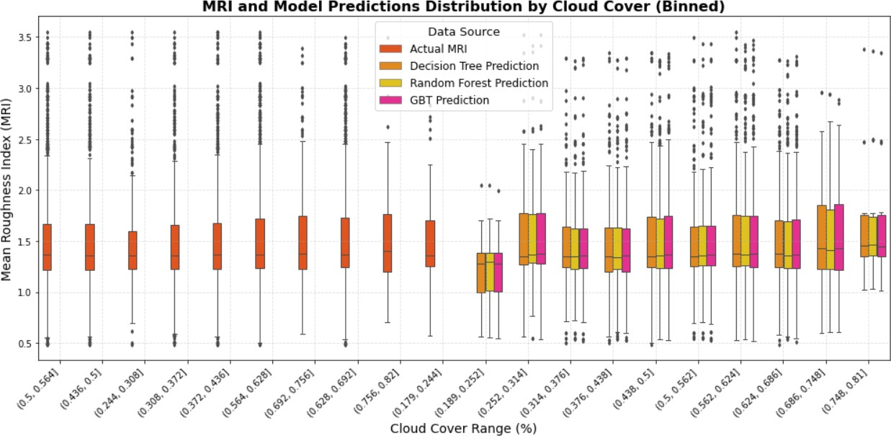
16

17
- Figure 9: Results for Actual MRI, Decision Tree, Random Forest, GBT regressor for
- Predicated MRI vs Cloud Cover

  - The scatter plots below display comparisons of actual Mean Roughness Index (MRI)
  - values with the predicted MRI values by three different machine learning models, namely
  - Decision Tree, Random Forest, and GBT regressor, at various elevation levels. To start with, the
  - first scatterplot shows real data on MRIs, analyzing the relationship between MRI and elevation.
  - In reality, MRI data point distribution spreads throughout varying elevations, with apparent
  - values in the 0.5 to 3.5 range for MRI. Close similarity between scatter patterns for predictions
  - from the Decision Tree model and actual MRI indicates good prediction capability. Real MRI
  - values fit correctly in prediction by the Random Forest model. This also implies that its
  - predictive accuracy is high. However, GBT regressor prediction outputs a scatter distribution
  - without any clear linear correlation with real MRI values during higher elevations, indicating
  - possible overfitting or sensitivity to input features.
  - 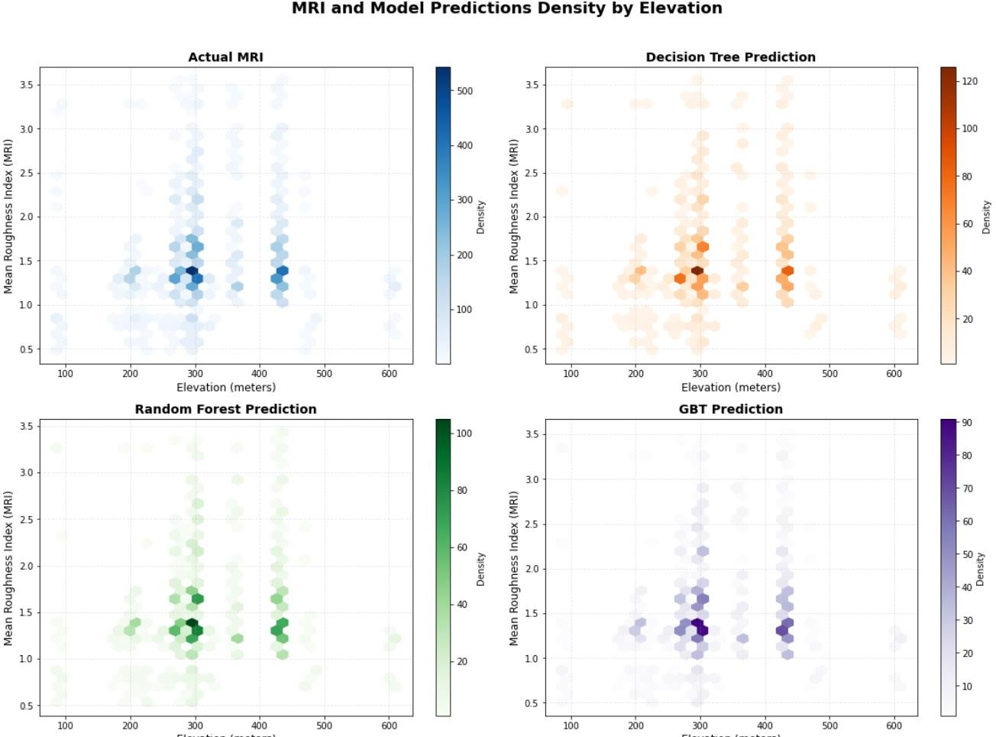
13
- Figure 10: Results for Actual MRI, Decision Tree, Random Forest, GBT regressor for
- Predicated MRI vs Elevation
16
- The actual and predicted MRI values were assessed using two individual scatter plots and
- heatmap visualizations generated through three machine learning models, namely, Decision
- Tree, Random Forest, and GBT regressor, each model representing a particular geographical
- location. As seen in the top scatter plot, the MRI is represented in terms of actual distribution
- across latitudes and longitudes where color indicates value. The heatmaps below indicate the
- predicted MRI values for the Decision Tree model and Random Forest model, respectively, with
- the intensity of color representing the predicted value of MRI. These visualizations focus on the

- geospatial distribution of MRI at different points in space. There are different values of MRI, and
- some small areas have higher values of a certain MRI. The MRI heatmap predicted by the
- Decision Tree model is highly consistent with the actual distribution of MRI values, which tells
- us that the model can perform effectively geospatial prediction. The Random Forest model
- corresponds well with the actual MRI distribution, corroborating its high predictive accuracy.
- The GBT regressor model's MRI heatmap shows some correlation with the actual distribution,
- but it's far less aligned than the other models, indicating slightly weaker geospatial prediction
- accuracy.
9
- 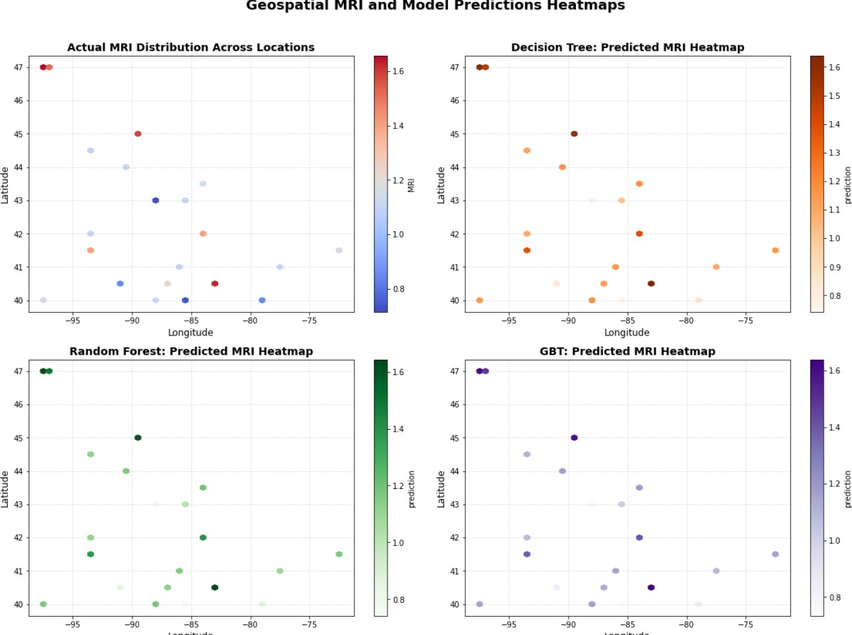
11
- Figure 11: Results for Actual MRI, Decision Tree, Random Forest, GBT regressor for
- Predicated MRI Heatmap
14
- The visualization below shows the relationship between the Mean Roughness Index (MRI)
- and the average temperature for three types of machine learning models: Decision Tree, Random
- Forest, and GBT regressor. captures actual MRI values across predicted temperatures. The
- change between actual MRI values relates to a change in temperature. As temperature increases,
- a general trend just appears to be very visible in the values. Model predictions follow the trend of
- actual MRI values closely; they often divert, however. Actual MRI values were reflected in very
- close alignment within the temperature range of the Random Forest model predictions, showing

- strong performance in predictive ability. Predictions from the model built from the GBT
- regressor also reflected the actual MRI values very well, thus having high predictive strength.
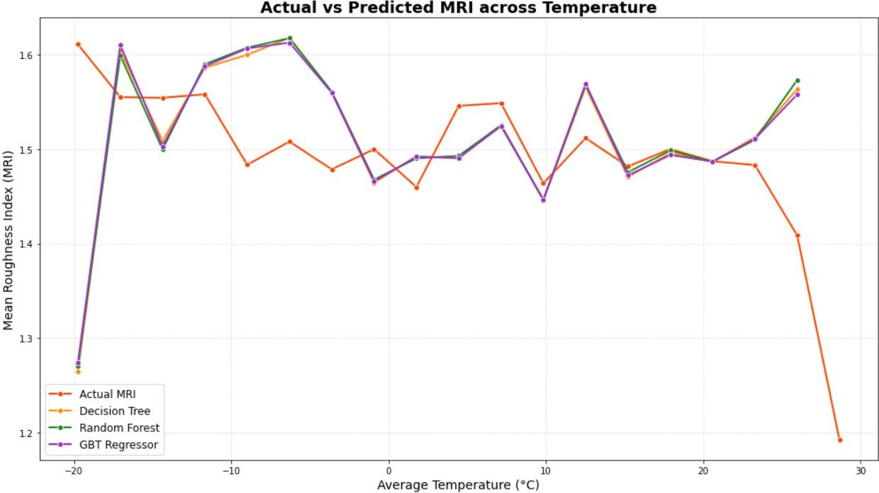
3

4
- Figure 12: Results for Actual MRI, Decision Tree, Random Forest, GBT regressor for
- Predicated MRI vs Temperature
7

8 DEEPER ANALYSIS:
9
- It does very well in setting a foundation for freeze-thaw pavement degradation but then leaves
- the theoretical and methodological framework skimping. Forming physical mechanisms, such as
- ice lens development, volumetric expansion, and thaw deterioration, should be indicated to
- measurable environmental variables. One could theoretically enrich one's work by including
- cumulative damage models, Miner's rule for example. This is already to give the data science
- aspect of the study a better methodology through defining feature engineering more accurately
- (e.g. frequency and intensity of freeze-thaw events), broadening model validation (cross-
- validation, temporal and spatial testing), and making hyperparameter optimization more
- transparent. The study should explore more advanced ensemble approaches like stacking or
- boosting, use of pavement management systems, decision-making thresholds, cost-benefit
- analysis, and spatio-temporal maintenance planning.
21
- On the other hand, the study could also benefit from a wider perspective on economic,
- environmental, and technical considerations. These include measuring savings from the costs and
- reduced emissions due to predictive maintenance, developing resilience metrics, and optimizing
- budgets. On the technical side, there is the need to address whether the infrastructure can be scaled
- up and whether it lends itself to real-time applications. This is against the background of possible
- integration with IoT and edge computing in real-time decision-making. Limitations such as the
- quality of data, model interpretability, and adaptability to regional variability need to be
- understood and future direction stated, for example, modeling on a material-specific level, multi-

- modal data fusion, uncertainty quantification, and human-AI collaboration. Finally, having
- projections and scenario-based planning against climate change would add greatly to the paper's
- relevance and utility in its practical application to freeze-thaw challenges.
4

5 DISCUSSION:
6
- This research study has been successful in putting forward appropriate advances concerning
- the employability of machine learning techniques in forecasting pavement deterioration resulting
- from freeze-thaw cycles. Through the comprehensive understanding of climate conditions coupled
- with pavement performance data, essential patterns have emerged that allow for association with
- the critical relationship between the environment and pavement degradation.
- The results show that the pavement was affected by freeze-thaw cycles using the method of
- measurement (MRI). When comparing three machine learning models that include Random Forest,
- Decision Tree, and GBT regressor, we found Random Forest and GBT regressor to perform most
- excellently, delivering the best combination of explanatory power (R² score) and prediction
- accuracy (lowest RMSE and MAE). This is in furtherance of earlier studies, which favored the
- idea that ensemble methods such as Random Forest are better suited for capturing the complicated
- non-linear relationships that characterize pavement deterioration processes.
- The regional analysis of climate data exhibits unique patterns pertaining to different
- geographies, where northeastern states show evident trends of high combined precipitation and
- cloud cover with low temperatures whereas northern plains have lesser precipitation but greater
- evaporative rates with extreme low temperature. An important factor here is that freeze-thaw
- cycles tend to perform differently across these regions, thus making a case for having specific
- models designed to capture the peculiarities of operations rather than a blanket model.
- There were several technical problems associated with this project, especially regarding data
- harmonization and handling missing values. These approaches were all summarized under data
- pre-processing that includes sophisticated imputation strategies with temporal feature engineering
- and, although it addressed most of these problems, interesting avenues stem from the exploitation
- of further improvements for the future research. The planned interventions for these problems are
- in line with model training results, which are indicative of using well-optimized distributed
- computing frameworks for large-scale implementation.
- This research can certainly be broadened to incorporate other states and richer pavement
- performance metrics. Incorporating real-time weather sources could make these models predictive.
- Next, implementing more advanced deep learning methods built for spatiotemporal data would
- probably improve accuracy in predicting these complex freeze-thaw effects.
36
37 CONCLUSION:
38
- In this research, the most accurate predictors of pavement distress by freeze-thaw cycles
- were able to guide the transportation sector in scheduling proactive preventive maintenance. Based
- on the use of various technologies involving big data (like Hadoop, MongoDB, and PySpark), this
- study used advanced machine learning tools in developing the analytical framework for processing
- climate data and pavement performances on a large scale.
- Our conclusions demonstrate random forest models and GBT regressor prevalent-
- mathematically considered best performance on MRI and fuel endurance ratings with consistency
- across different states and different climatic conditions. In performance mapping, RF regression

- trees thus far provided the best performance for MRI and EPA, as RF: variable, configuration, and
- sampling impact were present, accounting for potential inbuilt randomness.
- Advantages: The project uses a data-intensive mechanism for predicting pavement degradation,
- thus facilitating resource allocation and maintenance planning in a strategic manner. The models
- are trained using historical climate data to enhance evaluation of environmental effects on
- pavement quality and thereby augment predictive accuracy. This, in turn, allows for maintenance
- to be undertaken proactively so that the transportation agencies can plan their schedules to
- maximize the comfort of users and to enhance pavement life, thus reducing overall repair costs.
- AI use in pavement management thus promotes sustainable development by conserving resources
- utilization and minimizing carbon footprints. Altogether, these predictions will gain significant
- financial advantages, saving cold-weather states billions of dollars in maintenance and repair
- endeavors.
- Limitations: The project ran into a few hurdles more so regards data harmonization and missing
- value treatment, so advanced imputation techniques were needed to explain some parts of model
- complexity. The analysis involved a few northern states of the U.S, thus more data could be
- included to enhance the generalizability of these models. It also creates the opportunity for
- improvement in predictive accuracy as real-time weather data integration is missing. Lastly, the
- resources required for using frameworks like Hadoop and PySpark will be considerable and could
- limit applications at a broader or poorer scale.
- Future Work: Eventually, the project could include future improvements involving a bigger
- dataset that could span across several more states and an even wider array of pavement
- performance metrics to further increase model accuracy and applicability. As real-time weather
- data are included, the models' predictability is augmented for improved maintenance planning
- interventions timing. Advanced deep learning methods for spatiotemporal data would also improve
- the prediction of complex phenomena such as freeze-thaw cycles. The development of integrated
- decision-support systems will allow transport agencies to efficiently implement those predictive
- models in real life. Another important aspect of future models that should be considered is the
- impact of climate change on freeze-thaw patterns; thus, they should also incorporate changing
- climate conditions to keep them relevant and precise over the long term.
30
- This project illustrates how intertwined use of big data analytics and domain knowledge
- in pavement engineering could bring a transformation to the infrastructure management practice.
- With the climate changing and likely further increasing in both the frequency and severity of
- freeze-thaw cycles, these tools will mean even more significance. Future work would require the
- extension of the current analysis to include other geographies, additional environmental parameter
- retrieval, and the building of more integrated decision-support systems for transport agencies.
- This research sheds light over a paradigm, to permanently seal the gap between data science and
- civil engineers towards sustainable, resilient, and possibly cheap pavement infrastructure
- maintenance in unfavorable environmental conditions.
- Analysis of a very large dataset created using technologies such as Hadoop, PySpark, and
- Spark MLlib brings forth several meaningful trends and patterns related to pavement conditions,
- freeze-thaw cycles, and environmental end effects. Feature engineering techniques designed to
- capture freeze-thaw interactions allowed us to model complex relationships that traditional
- modeling techniques may overlook. By integrating pavement performance data with MERRA
- weather, we gained valuable insights into deterioration patterns across various regional climatic
- zones. This provided a great opportunity for us to become familiar with current industry-standard

- technologies in Big Data Analytics, and we hope to use these skills across disciplines in the years
- to come in our projects through George Mason University and our career.
3

4 ACKNOWLEDGEMENTS:
5
- We are sincerely thankful to Dr. Liao Lindi for her invaluable suggestions and information
- which influenced this effort considerably. We also appreciate George Mason University and the
- faculty of AIT-614-002 for providing these tools and learning opportunities. The developers of the
- InfoPavement portal deserve our gratitude for providing the great dataset on which we based our
- research. We acknowledge our team members Sonal Ashok Kumar Masid, Srinija Tummalapally,
- Uttam Yeramalla, and TarunDeep Krishnakumar, whose cooperation and commitment were
- pivotal to the success of this project.
13

14

REFERENCES
2
- 1. Cetin, B., Cetin, K., & Edil, T. B. (2021). Environmental impacts on the performance of
- pavement foundation layers. Retrieved from https://rosap.ntl.bts.gov/view/dot/
5
- 2. Piotr Mazurowski (2022). Freeze-thaw weathering: How it affects subgrade soils. Tensar
- International. Retrieved from
- https://www.tensarinternational.com/resources/articles/freeze-thaw-weathering-and-
- degradation-effect-on-road-pavements
10
- 3. Machine learning applications in road pavement management (2024). Retrieved from
12 https://www.mdpi.com/2412-3811/9/12/213
13
- 4. Salour, F., & Erlingsson, S. (2013). Impact of groundwater level on the mechanical
- response of a flexible pavement structure – A case study at the Torpbruk test section
- along county road 126 using a Falling Weight Deflectometer. Procedia - Social and
- Behavioral Sciences, 104, 208-217. https://doi.org/10.1016/j.sbspro.2013.11.113
18
- 5. Zhang, L., & Liu, Q. (2022). "GBT regressor modeling for frost damage prediction in
- flexible pavements." Journal of Infrastructure Systems, ASCE, 28(3), 04022010.
- https://ascelibrary.org/doi/abs/10.1061/(ASCE)IS.1943-555X.0000689
22
- 6. Hassan, R., Lin, O., & Thom, N. (2022). "A comprehensive review of artificial
- intelligence applications in pavement engineering." Automation in Construction, 133,
- 104005 https://www.sciencedirect.com/science/article/pii/S2214509523003108
26
- 7. Federal Highway Administration. (2023). "Best Practices for AI Integration in Pavement
- Management Systems." FHWA-HRT-23-XXX. https://highways.dot.gov/turner-fairbank-
- highway-research-center
30
31 8. AI and Machine Learning in Pavement Management https://www.mdpi.com/2412-
32 3811/9/12/213
33
- 9. Dong, Q., & Huang, B. (2021). "Real-time Pavement Maintenance Decision Support
- System Using IoT and Machine Learning." Journal of Transportation Engineering, Part
- B: Pavements, 147(2), https://ascelibrary.org/doi/abs/10.1061/JPEODX.0000215
37

