A REPORT OF SIX WEEKS INDUSTRIAL TRAINING

At

CSDT IT Solution

SUBMITTED IN PARTIAL FULFILLMENT OF THE REQUIREMENT FOR THE AWARD

OF THE DEGREE OF

**BACHELOR OF ENGINEERING**

(Computer Science & Engineering)



MAY-JUNE, 2019

**SUBMITTED BY:**

NAME: **UTTAM KUMAR**

UID: **17BCS3036**

DEPARTMENT OF COMPUTER SCIENCE &ENGINEERING

CHANDIGARH UNIVERSITY, GHARUAN, MOHALI

**Certificate by company**

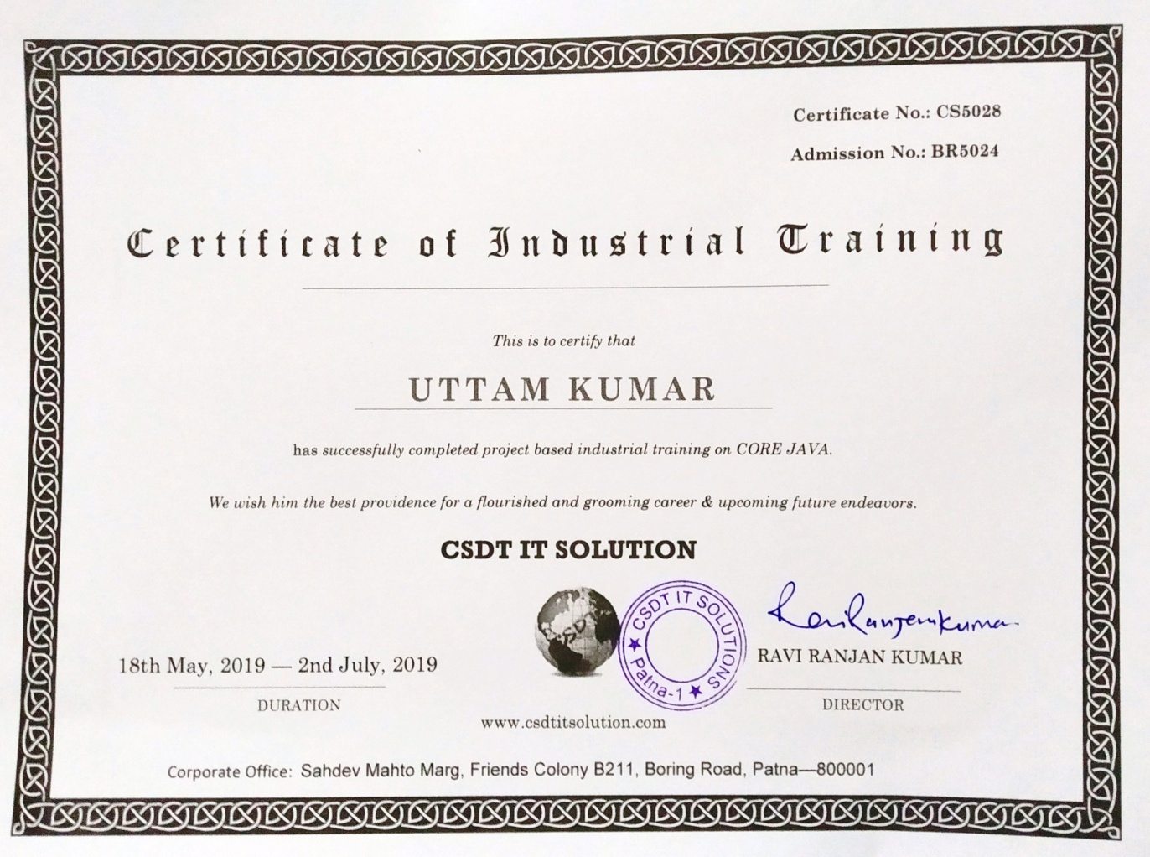

**CHANDIGARH UNIVERSITY, GHARUAN, MOHALI**

**CANDIDATE'S DECLARATION**

I “UTTAM KUMAR” hereby declare that I have undertaken six weeks industrial training at “Name of **Company/ Industry / Institute**” during a period from 18th May 2019 to 2nd July 2019 in partial fulfillment of requirements for the award of degree of B.E (COMPUTER SCIENCE & ENGINEERING) at CHANDIGARH UNIVERSITY GHARUAN, MOHALI. The work which is being presented in the training report submitted to Department of Computer Science & Engineering at CHANDIGARH UNIVERSITY GHARUAN, MOHALI is an authentic record of training work.

Signature of the Student

 The six weeks industrial training Viva–Voce Examination of__________________ has been held on ____________ and accepted.

 Signature of Internal Examiner Signature of External Examiner

**CONTENTS**

**Topics Page No**

**Certificate by company…………….....................................................2**

**Candidate’s declaration……………………….......................................3**

**Abstract…………………………………………………………………........5**

**Acknowledgment……………………………………………………………..6**

**About the company…………………………………………………………..7**

**List of figures and tables…………………………………………………….8**

**Definitions and abbreviations……………………………………………….9**

**Chapter 1 INTRODUCTION………………………………………………..10**

**1.1 Introduction……………………………………………………….10**

**1.2 Background study………………………………………………..10**

**1.3 Software and Hardware Requirements………………………….10**

**Chapter 2 TRAINING WORK UNDERTAKEN…………………………..11-14**

**2.1 Java Core Programming…………………………………………..11**

**2.2 Swing……………………………………………………………….11**

**2.2.1 Topics under Swing……………………………………..12**

**2.2.2 JDBC……………………………………………………...13**

**2.3 Project……………………………………………………………....14**

**2.3.1 Objective of project…………………………………..….14**

**2.3.2 Covered areas/modules……………………………..…...14**

**Chapter 3 RESULT AND DISCUSSION…...........................................15-19**

**3.1 User interface of software…………………………………………15**

**Chapter 4 CONCLUSION AND FUTURE SCOPE………………………..20**

**4.1 Conclusion………………………………………………………….20**

**4.2 Limitations……………………………………………………….…20**

**4.3 Future Scope……………………………………………………..…20**

**REFERENCES…………………………………………………………………21**

**ABSTRACT**

Nowadays, Pharmacy management system is one of the most essential tools that are mostly used in medical store in India; it is mostly used to manage pharmacy related activities such as medical inventory, record keeping, sales management, purchase management as well as managing the drug stock and information of the expired medicines. Many pharmacies in India are still operating manually; they don’t have adequate software to manage their daily activities. It needs the pharmacist assistant to check the expired date of the medicine twice a week, and it can take a lot of time to find out whether certain medicine are out of stock. In this project, I tried to develop a computerized Pharmacy management system. My main intention is to allow this application to be used in most retailing pharmacies in India, where a small point of customization will be required to each pharmacy in the implementation period. This system is designed to overcome all challenges related to the management of medicine that were used to be handled locally and manually. Pharmacy management system has its own significance to the retail pharmacy shops in India. Using this system, it will help us to records all transaction made at the daily sales, recognize all customers, suppliers, balance stock, etc. It will manage all activities around the shop that increases productivity and maximize profit, it will also minimizing the risk of losing track of all the sales and purchases because all transactions are recorded to the system.

**ACKNOWLEDGMENT**

Apart from the efforts I put into this project, the success of any project depends largely on the encouragement and guidelines of many others. I take this opportunity to express my gratitude to the people who have been instrumental in the successful completion of this project. I would like to show my greatest appreciation to my trainer Ravi Ranjan Kumar, who guided me all the way from the very beginning to the completion of project. I can’t say thank you enough for his tremendous support and help. I felt motivated and encouraged every time I attended his lectures. Without his encouragement and guidance this project would not have materialized. The guidance and support received from all who contributed and who are contributing to this project, was vital for the success of the project. I am grateful for their constant support and help.

**ABOUT THE COMPANY**

**CSDT IT Solution** is a software development company which offers a wide range of end-to-end IT solutions for various businesses and clients. It provides custom software solutions, professional website designs, ERP software development, web application development, ecommerce website development, mobile app development and high-end corporate training services. It provides clients with Innovative and Cost-Effective IT Solutions to meet the changing nature of today’s business challenges. We deliver Customer Satisfaction!

CSDT IT Solution is a Unit of PRIYA IT Solution LLP. It specializes in Software Development, Website Designing and Development, Graphics Designing, Logo Designing, Domain Registration, Web Hosting, SEO and SMO Service, E-Commerce website development and in Advanced Industrial Training. CSDT professionals expertise from design to development. We combine this knowledge with innovative thinking and in-depth planning to approach new challenges with our overall business objectives in mind. We help our customers by ensuring that our designed projects or software development is delivered and managed efficiently.

### CSDT IT Solution professionals expertise in

* [Software Development](http://www.csdtitsolution.com/Software-Development-Company-Patna.htm)
* [Web App Development](http://www.csdtitsolution.com/website-development-company-Patna.htm)
* [Web Designing](http://www.csdtitsolution.com/Web-Designing-company-Patna.htm)
* [E-commerce Website Development](http://www.csdtitsolution.com/ECommerce-Solution-Patna.htm)
* [Mobile App Development](http://www.csdtitsolution.com/About-csdt-it-solution.htm)
* [Logo Designing](http://www.csdtitsolution.com/logo-designing-company-Patna.htm)
* [Graphics Designing](http://www.csdtitsolution.com/About-csdt-it-solution.htm)
* [Domain Registration](http://www.csdtitsolution.com/Domain-Registration-company-patna.htm)
* [Web Hosting](http://www.csdtitsolution.com/Web-Hosting-company-Patna.htm)
* [SMS Service](http://www.csdtitsolution.com/About-csdt-it-solution.htm)
* [Digital Marketing](http://www.csdtitsolution.com/Digital-marketing-service-Patna.htm)
* [Industrial Training](http://www.csdt.co.in/)

They provide services to a wide spectrum of clients ranging from startups to large retail companies. They are actively engaged in Government projects along with the business projects. We have completed Patna Zoo project within specified time and that too at affordable cost.

Currently their branches are in Patna (Bihar), Ranchi (Jharkhand) and Bhopal (M.P) and they are soon going to extend with Pan India for better visibility and trust.

It is one of the fastest emerging IT company providing products and services in Web Development, Software Development, Mobile Application Development, Web Designing and much more all under one roof. They adopt advanced technology that helps to boost functionality and productivity of your business.

**LIST OF FIGURES**

**Figure Page No**

Figure 2.1: AWT and SWING class hierarchy………………………………..12

Figure 2.2: Hierarchy of Java Swing API……………………………………..12

Figure 2.3: Designing of registration form GUI…………………………… ....13

Figure 2.4: Tables of registration form………………………………………..14

Figure 2.5 GUI of form after database connectivity…………………………..14

Figure 3.1: Admin login window……………………………………………...16

Figure 3.2: Dashboard………………………………………………………....16

Figure 3.3: Product Entry……………………………………………………...17

Figure 3.4: Sell Product window………………………………………………18

Figure 3.5: Suppliers & Customers details…………………………………….18

Figure 3.6: Sale and Stock records…………………………………………….19

**ABRIVIATIONS**

**IDE**- Integrated Development Environment

**PMS**- Pharmacy Management System

**MYSQL**- My Structured Query Language

**AWT**- Abstract Window Toolkit

**GUI**- Graphical User Interface

**JDBC**- Java Database Connectivity

**CHAPTER 1: INTRODUCTION**

**1.1 Introduction**

This project is concerned about developing a Pharmacy Billing and Management System that will be used for retail and wholesale pharmacies. The purpose of this project is to manage all data derived for a pharmacy to maintain their business through the system rather than recording their data manually which is more risk to the business to maintain and to avoid loss. The industrial training syllabus was mainly focused on learning the basics of core java to develop windows applications with the help of Swing GUI. It includes learning the basic conditional statements syntax, loop statements, methods, and object oriented programming concepts and their implementation on programs using optimal data structures. The ultimate project of the training was to make an Information System with an interface to process the database.

**1.2 Background Study**

Pharmacy management system is a system that consists of data entry, retrieval and monitoring stock, sale, customer records, debtor’s and management administrator’s records and determination of minimum quantity of each drug. Pharmacy management deals with managing the medicine stock and selecting the suitable medicine needed by the customers. String searching technique also applied in this system. This technique is referring by drugs name, drug code and description of drugs. Besides that, the system also provides two types of methods which are Quantity and Expire date of drugs. This system enable administrator to control and monitor the drugs stock effectively

**1.3 Hardware and Software Requirements**

**Software or tools**

The tools that I have used in developing this System are:

* Notepad++
* NetBeans IDE
* Adobe Photoshop
* Google Chrome
* Microsoft word for project documentation
* MYSQL

**Hardware Requirements**

* Personal computer/Laptop (minimum 4GB of RAM)
* Hard disk (300GB, 500GB .etc.)
* Processor 1.5GHZ( minimum)

**CHAPTER 2: TRAINING WORK UNDERTAKEN**

The syllabus of industrial training included learning the concepts of Core Java and making an Information Management System application using Swing with help of JDBC connectivity.

**Training work undertaken:**

**2.1 Core Java programming**

* **History of Java**
* **Basic syntax**
* **Conditional and Loop statements**: if-else, nested if-else, loops, nested loops
* **Class and Object**: Creation of classes and objects
* **Methods:** Defining and calling
* **Array**: 1-dimensional, multi-dimensional
* **String**: Various pre-defined methods
* **Access Modifier**: public, protected, private, default
* **Constructor**: Default, parameterized
* **Inheritance** : Single, Multi, Hierarchical
* **Polymorphism**: Method overloading Vs overriding
* **Static, final, super, this keywords**
* **Data Abstraction**
* **Interfaces**
* **Wrapper Class**
* **Exception Handling**
* **File Handling**
* **Package**
* **Enum**
* **Multithreading**

**2.2 Swing**

Java Swing is a lightweight Java graphical user interface (GUI) widget toolkit that includes a rich set of widgets. It is part of the Java Foundation Classes (JFC) and includes several packages for developing rich desktop applications in Java. Swing includes built-in controls such as trees, image buttons, tabbed panes, sliders, toolbars, color choosers, tables, and text areas to display HTTP or rich text format (RTF). Swing components are written entirely in Java and thus are platform-independent.

Unlike AWT, Java Swing provides platform-independent and lightweight components. The javax.swing package provides classes for java swing API such as JButton, JTextField, JTextArea, JRadioButton, JCheckbox, JMenu, JColorChooser etc.

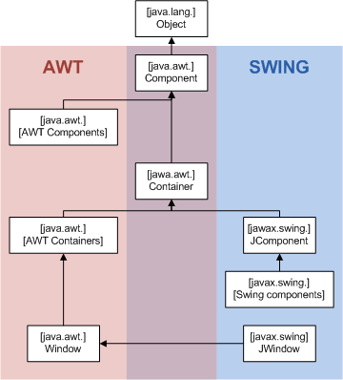

Figure 2.1: AWT and SWING class hierarchy

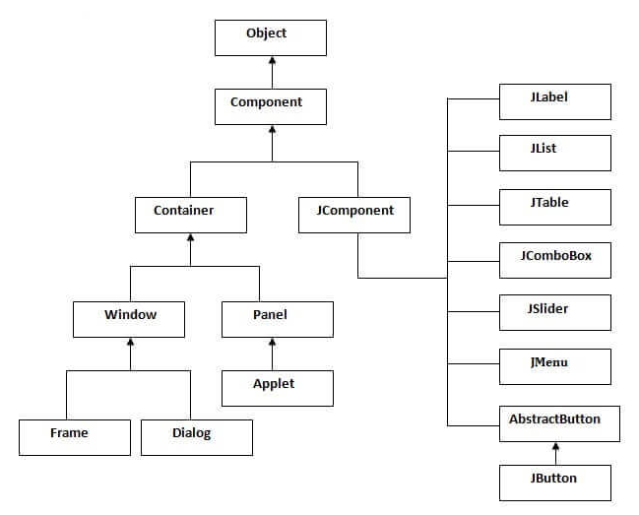

Figure 2.2: Hierarchy of Java Swing API

**2.2.1 Topics under Java Swing**

JFrame, JButton, JLabel, JTextField, JTextArea, JPasswordField, JTable, JMenuItem, JPanel, JSeparator, JDialog

After learning how to create a GUI using Java Swing with the help of NetBeans’ in-built GUI builder, my first task was to develop a simple registration form.

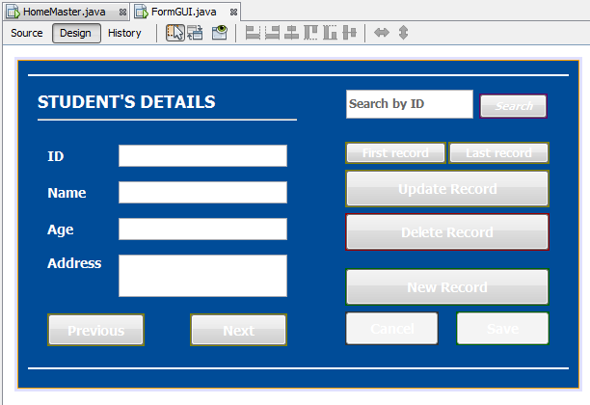

Figure 2.3: Designing of registration form GUI

The registration form application has basic features like saving new registration entry, updating details, deleting and searching information. The application was later connected with database to actually work as it was supposed to work.

**2.2.2 Java Database Connectivity (JDBC)**

Java Database Connectivity (JDBC) is an [application programming interface](https://en.wikipedia.org/wiki/Application_programming_interface) (API) for the programming language [Java](https://en.wikipedia.org/wiki/Java_(programming_language)), which defines how a client may access a [database](https://en.wikipedia.org/wiki/Database). It is a Java-based data access technology used for Java database connectivity. It is part of the [Java Standard Edition](https://en.wikipedia.org/wiki/Java_Standard_Edition) platform, from [Oracle Corporation](https://en.wikipedia.org/wiki/Oracle_Corporation). It provides methods to query and update data in a database, and is oriented towards [relational databases](https://en.wikipedia.org/wiki/Relational_database). A JDBC-to-[ODBC](https://en.wikipedia.org/wiki/ODBC) bridge enables connections to any ODBC-accessible data source in the [Java virtual machine](https://en.wikipedia.org/wiki/Java_virtual_machine) (JVM) host environment. JDBC allows multiple implementations to exist and be used by the same application. The API provides a mechanism for dynamically loading the correct Java packages and registering them with the JDBC Driver Manager. The Driver Manager is used as a connection factory for creating JDBC connections. JDBC connections support creating and executing statements. These may be update statements such as SQL's CREATE, INSERT, UPDATE and DELETE, or they may be query statements such as SELECT. Additionally, stored procedures may be invoked through a JDBC connection.

After creating tables through NetBeans’ Services, a connection was established between the registration form and tables

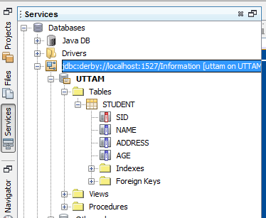

Figure 2.4: Tables of registration form

After connecting the tables with application, I was able to insert, update, delete and search records or information of students on the application.

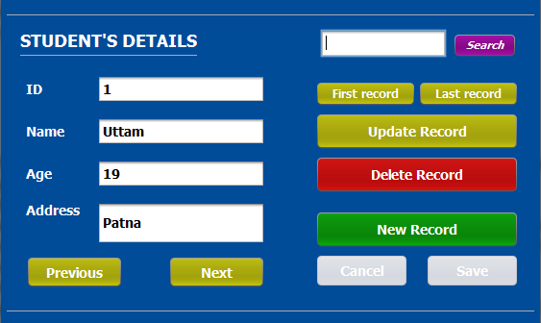

Figure 2.5 GUI of form after database connectivity

Apart from the registration form, other mini windows applications were also created like Calculator.

**2.3 Project**

After being equipped with the knowledge of Core Java and GUI building using Swing, my task was to create a Pharmacy Billing Information Management system as my final project of the training. Pharmacy management system is a system that consists of data entry, retrieval and monitoring stock, sale, customer records, and management administrator’s records and determination of quantity of each drug/product. String searching technique also applied in this system. This technique is referring by drugs name. Besides that, the system also provides two types of methods which are Quantity and Expire date of drugs.

The number of customers is quickly increases due to the increase of demand of drugs in many areas. This situation makes the pharmacist to be busy and use a lot of time to manage and control their business records. Pharmacy management deals with managing the medicine stock and selecting the suitable medicine needed by the customers.

The modules involved are medicine management module, medicine search module, selling process module, medicine list module, customers’ and suppliers’ entry module, user authenticate module, medicine sales module, medicine purchase module, and reports of sale, purchase and stock products.

The following are among of the problems that lead to propose creation and development of Pharmacy Management System Software:

* Discrepancies of stock items.
* It hard to determine stock balance.
* Hard and Time consuming on preparation of daily, weekly, monthly, and yearly reports.

**2.3.1 Objective of the project**

* To provide easily accessibility of customers management
* To provide easily accessibility of sales reports
* To provide easily accessibility of purchase reports
* To provide easily accessibility of stock reports
* To minimize human errors

**2.3.2 Pharmacy Management System covered the following areas:**

* Product management
* Customers management
* Suppliers management
* Purchases management
* Sales management
* Stock management
* And reports management

**CHAPTER 3: RESULTS AND DISCUSSION**

Once the GUI and the tables of the Pharmacy management system were developed, they were then connected using Java Database Connectivity modules.

**3.1 User Interface of software**

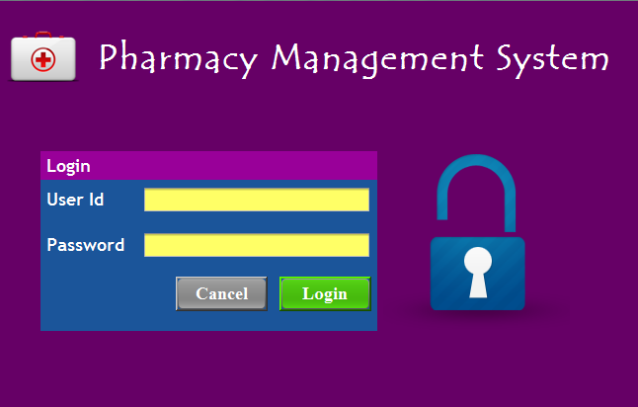

Figure 3.1: Admin login window

Admin Login window allows administrator to open the dashboard of application by entering valid user id and password.

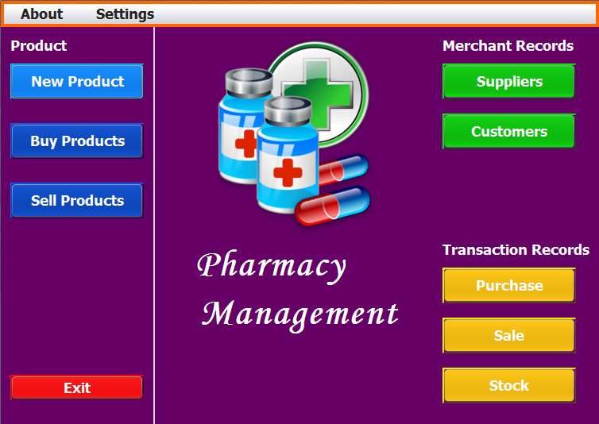

Figure 3.2: Dashboard

Dashboard of the management system provides various options to perform different tasks.

New Product: To enter, update or delete information of a product.

Buy Product: To buy products from suppliers.

Sell Product: To sell products to the customers.

Customers: To see old customers' information or to enter, update or delete the information.

Suppliers: To see old suppliers' information or to enter, update or delete the information.

Besides the ones mentioned, it also provides buttons for direct access to transaction record windows like purchase records, sale records, stock product records.

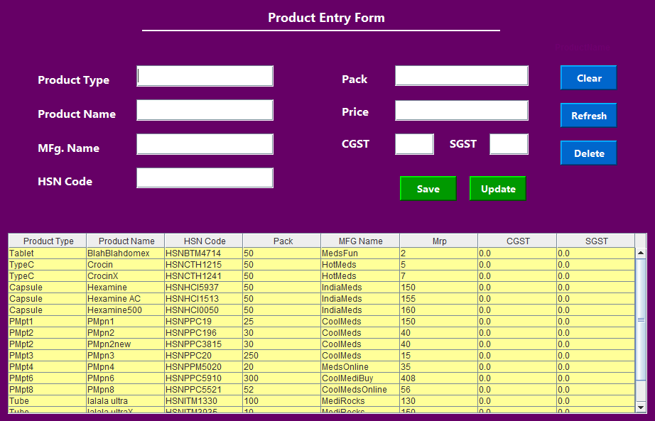

Figure 3.3: Product Entry

Product Entry from allows administrator to enter new product/medicine information into the database. The details include product’s name, its type, code, price, etc.

This window also allows admin to update or delete the details of product.

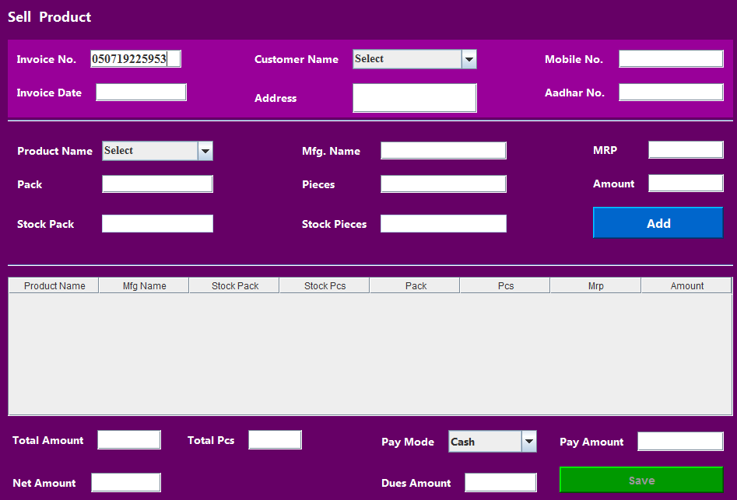

Figure 3.4: Sell Product window

Sell Product window allows admin to select the customer and from the database and the product he/she wants to buy. After adding all the products into the list, net amount is displayed.

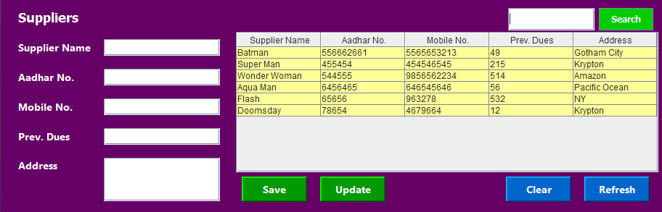

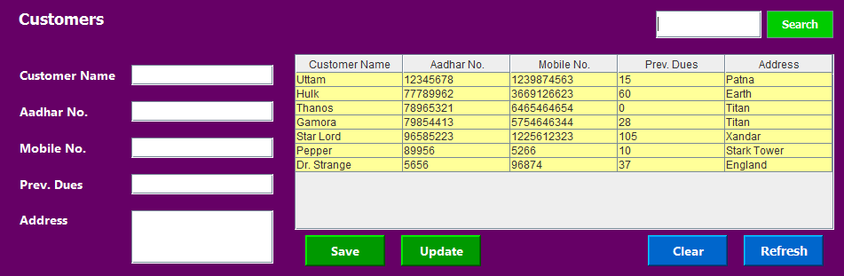

Figure 3.5: Suppliers & Customers details

Suppliers and Customers details are entered in the Suppliers and Customers form respectively. Admin can also update the details, or search using Customer’s or Supplier’s name in the search bar.

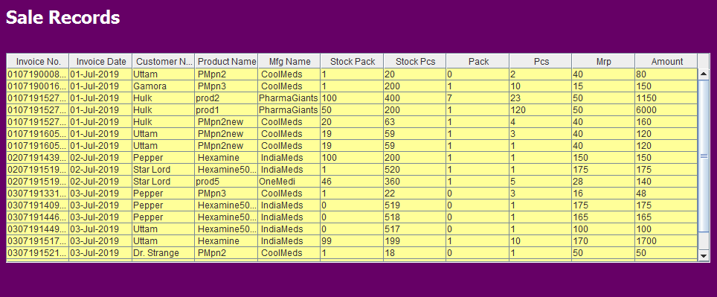

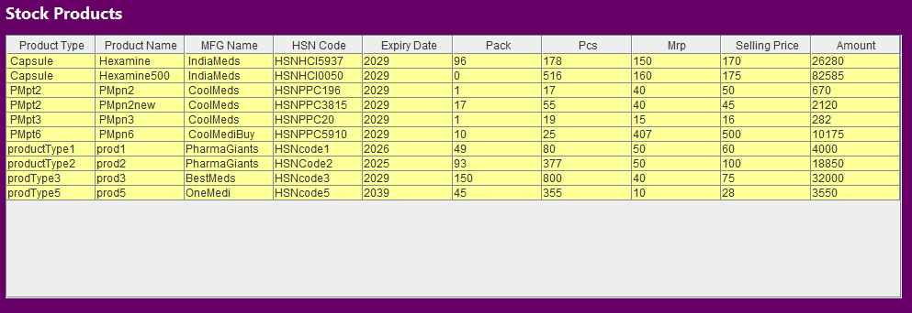

Figure 3.6: Sale and Stock records

Every time a product is sold, the data of sale is entered in Sale records table and same for purchases. Stock products keep on updating itself depending on the purchase and sale to keep the administrator updated about how much items of any particular medicine is left in stock.

**CHAPTER 4: CONCLUSION AND FUTURE SCOPE**

**4.1 Conclusion**

Pharmacy management system is actually a software which handle the essential data and save the data and actually about the database of a pharmacy and its management. This software helps in effectively management of the pharmaceutical store or shop. It provides the statistics about medicine or drugs which are in stocks which data can also be updated and edited. It works as per the requirement of the user and have options accordingly. It allow user to enter manufacturing as well as the expiry date of medicine placing in stock and for sales transaction. The main purpose is effectively and easily handling of pharmacy data and its management.

**4.2 Limitations**

A number of limitations were encountered in the course of preparing this research work. One of such was in the creation of the tables in the database of the system. Due to the size of the system, many tables had to be created to accommodate all the data required in the management system. Also, implementing security features on the system was among of challenges to make sure that people will not be able to access information without authorization from system administrator.

**4.3 Future Scope**

Even though this application (Pharmacy Management System) is very much capable of handling and managing the data, it still needs a few new features to become ready to be out there in actual pharmacy stores. First of all, the database it uses it in-built database service of the IDE, which causes the portability problem. To make the system run on other computers we need to install the IDE on the computer too, but we this problem can be tackled by using a different database server instead of IDE services. It would be much easier for the user to use the application if it was in executable file format. Another major problem that arises is that this application has no feature of printing the bill; this application should be capable of generating and printing the bill that could be provided to the customers.

**REFERENCES**

[1]Sudi Ahmad Sijali. Pharmacy Management System, *State University of Zanzibar School of Business, 2015*

[2] Barbara Griggs*. Green Pharmacy: The History and Evolution of Western Herbal Medicine, Second Edition. Viking press, (1982)*

[3] History*, Fourth Edition. Trade paperback, Pharmaceutical press (2008)*

[4] George A. Bender*. Great moments in Medicine, Cambridge University press(1967)*

[5] Java Swing Tutorial, <https://www.javatpoint.com/java-swing>

[6] Java Swing Applications, <https://examples.javacodegeeks.com/desktop-java/swing/>

[7] Java for complete Beginners, <https://www.homeandlearn.co.uk/java/java.html>