**Relevance of Precision tree in Decision Making for Jogger Shoe Company**

*A project report submitted in fulfilment of the requirement for the*

BAN 630 – Optimization Methods for Analytics

Submitted by

Alpa Arun Singh - ah8445

Priyanka Shah - mt8964

Uttara Dabbiru **-** py4642

Master of Science in Business Analytics

California State University, East Bay

Under the guidance of

**Dr. Zinovy Radovilsky**



**COLLEGE OF BUSINESS AND ECONOMICS**

**CALIFORNIA STATE UNIVERSITY, EAST BAY**

**Table of Contents**

**Title Page No**

Summary 3

Introduction 4

Data Model 6

Data Analysis (without Precision Tree) 7

Data Analysis (with Precision Tree) 8

Optimal Decision Tree 11

Solution Results and Analysis 12

1. Risk Profile (Probability Chart) 12

2. One Way Sensitivity Analysis - Strategy Region Graphs for Sell Design price 13

3. One Way Sensitivity Analysis - Strategy Region Graph for probability of Approval of New Design 15

4. One Way Sensitivity Analysis - Strategy Region Graphs for probability of Approval of Improve Design 16

5. One Way Sensitivity Analysis - Tornado Graph for Sell Design price, probability of Approval of New Design and Approval of Improve Design 17

6. Two-way Sensitivity Analysis - Strategy Region of Sell Design Price and probability of Approval of New Design 18

7. Two-way Sensitivity Analysis - Strategy Region of probability of Approval of New Design and probability of Improve Design. 20

Conclusion 21

Bibliography 22

Appendices 23

# Summary

The Jogger Shoe Company wants to examine three options whether to continue with Original shoe design, Introduce Improvised shoe design or Introduce New shoe design. This project is about the decision to be taken by the company to identify what can be their better product (shoe) design which receives higher revenue with the highest Probability. For this decision to make, several parameters are considered by the company like the Cost, Price, Demands, the chances of Approval and Reject, etc.

The approach used to get the optimal decision we have used a decision making under uncertainty method using Excel add-in by Palisade called “Precision Tree”. Since the Joggers Shoe company wants to introduce a New product (shoe) or continue Original shoe design under uncertainty the Decision Tree method.

Based on the optimal solution from the analysis, Introducing the New shoe design will be the best decision which will generate the maximum profit.

# Introduction

**Decision Making at Joggers Shoe Company**

**Company**

Joggers is an American multinational corporation engaged in the design, development, manufacturing, worldwide marketing and sales of footwear, accessories, and services. The headquarters of the company is near Beaverton, Oregon, in the Portland metropolitan area. The Joggers shoe is a top reputed Shoe brand in the fashion Industry.

The company's primary business activity is to Improve its existing shoe designs, Introduce New shoe designs to attract customers, and Sell the shoe design if generating a low profit. After a product (shoes) is designed, the Category Product Team evaluates whether the New idea will be accepted in the market. They also perform other activities such as preparing a product definition report which outlines the target customers, the desired product features and the proposed price.

**Problem**

The Jogger Shoe Company’s chief operating officer asked a company’s business analyst to examine three options. The first option, Improvise their existing original shoe design by incorporating a new kind of lacing system (according to its marketing research people) that would make it more popular. Further, this design would be evaluated by the Category Product Team whether it will be accepted in the market. The Improved shoe design may be approved (0.7 chance) or rejected (0.3 chance) by the Category Product Team. If the Improvised design is approved, the product is released in market with a unit price of $350 while the Original design is for $250 per unit. The customer demands on this product are calculated if the product has a high demand or a low demand. If the Improvised design is rejected, then the company would decide to upgrade the design i.e., make changes as per the feedback given by the Category Product Team and release in the market for $400 per unit or sell that design to another company for $2080000.

The second option, Introduce a New design with advanced features in running shoes. The New style would incorporate a new kind of lacing system, Gel cushioned insole and breathable material with a unit price of $400 per unit. If the New Design is approved (0.6 chance) by the Category Product Team, the product is released in the market (and the customer demands are calculated). If the New Design is rejected (0.4 chance) the company would decide to upgrade the design ($400 per unit) i.e., make changes as per the feedback given by the Category Product Team and release in the market for $400 per unit or sell the design to another company for $2,080,000.

The third option, continue with the original design. If the Original Design has a low demand in the market, then the company decides to sell the Design to another company for $2080000.

Designs are updated only when the Category Product Team rejects the actual design. There is a fixed cost of $1,080,000 for changing over to the new style and $980,000 for Improving Design and $880,000 to update the Design (for both Improved design and Introducing a New Design). The annual demand for all the above-mentioned demands is uncertain. It could be low with the average of 7000 units of sale per year, or high with the average of 15,000 per year. Based on historical data, the data analyst was able to obtain the probabilities of demand: 0.4 for low demand and 0.6 for high demand.

Given this scenario, the company wants to determine what could be the best decision to attract more customers and maximize the payoff.

# Data Model

Based on the problem statement, we created a data model using excel. The model consists of 5 decisions: Original Design, Improve Original Design, Introducing New Design, Sell the design and Update Design. We collected the information of cost, price per unit, chance of approved/rejected design, low & high demand average from Joggers Shoe Company as shown in figure 1. We calculated net revenue for low/high demand using price*average demand formula as shown in figure 2.

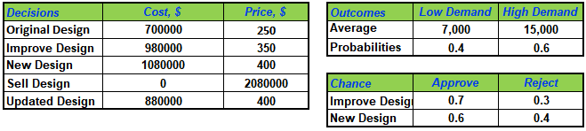

*Figure 1: Input table*

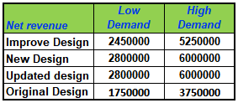

*Figure 2: Net revenue table*

## Data Analysis (without Precision Tree)

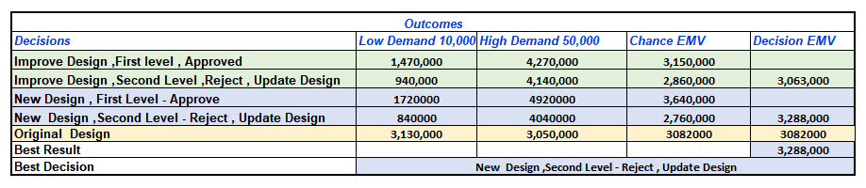

*Figure 3: Spreadsheet Formulation to calculate EMV.*

**There are four different methods**: Average payoff criterion, Extreme optimistic criterion, Extreme pessimistic criterion, Expected monetary value (EMV) to find the best decision by choosing between two or more payoff/cost outcomes.

In this problem statement, we are using Expected monetary value (EMV) to choose the best decision. The best decision from the above table is to introduce a New Design because this decision has the higher EMV $3,288,0000. Using Excel brings the challenge. Excel has the capabilities to calculate the EMV, but it lacks in graphical representation. To overcome this, we have used Excel add-in by Palisade called “Precision Tree”. Precision Tree not only enables to draw and label a decision tree, but it also performs the folding-back procedure automatically and then allows to perform sensitivity analysis on key input parameters.

## Data Analysis (with Precision Tree)

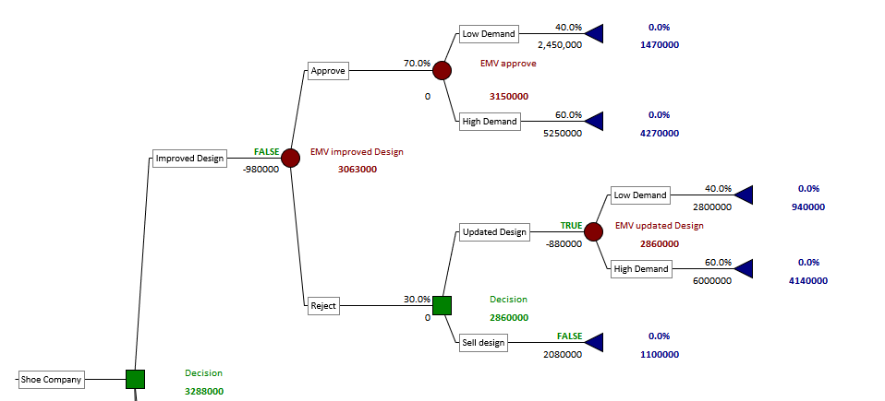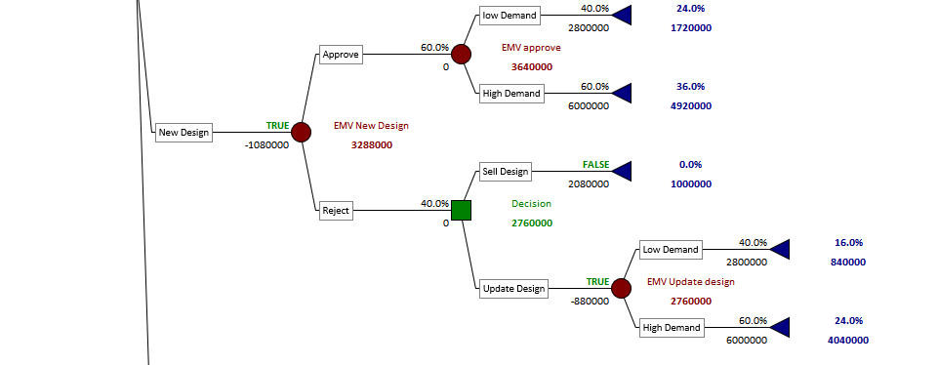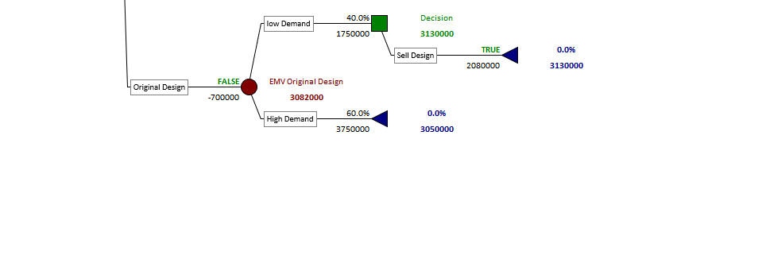

*Figure 4: Decision Tree with Precision Tree*

The above decision tree for the product designs of Joggers Show Company enunciates the following observations:

1. **Original Design cost is $700,000:**

Jogger’s Original Design of running shoes has been popular for a long time and to make this design of shoes cost $700,000. The EMV for Original Design is $ 3,082,000. The probability of low demand is estimated to be 40% and the probability of high demand of original design of shoes is 60%. If a product gets low demand from customers, the company experiences net revenue $1,750,000. So, Company will result in selling the design to another company for $2,080,000, thereby generating a payoff of $3,130,000. While the product gets high demand, it would lead to a Net Revenue of $3,750,000 resulting in generating payoff of $3,050,000.

1. **Improve Original Design cost is $980,000:**

The Improved Original Design of running shoes cost $980,000. The EMV for Improve design is $3,063,000. The probability of approving the Improve design is 70% by the Category Product Team. The EMV for approval of Improved design is $3,150,000. If design is approved and the company observes low demand with a chance of 40%, the payoff will be $1,470,000. If design is approved and the company observes high demand with a chance of 60%, the payoff will be $4,270,000.

The probability of rejecting the design is 30% by the Category Product Team. If design is rejected and the company chooses to update the design with updating design cost of $880,000. The EMV for updated design is $2,860,000. According to customer demand, if a company observes low demand with a chance of 40%, the payoff will be $940,000 and if company observes high demand with a chance of 60%, the payoff will be $4,140,000. On the other hand, if the design is rejected and the company chooses to sell the design to another company where the payoff will be $1,100,000.

1. **Introduce New Design cost is $1,080,000:**

To introduce a New design of running shoes cost $1,080,000. The EMV for launching a New design is $3,288,000.

The probability of approving the design is 60% by the Category Product Team. The EMV for the approval of New design is $3,640,000. If design is approved and the company observes low demand with a chance of 40%, the payoff will be $1,720,000. If design is approved and the company observes high demand with a chance of 60%, the payoff will be $4,920,000.

The probability of rejecting the design is 40% by the Category Product Team. If design is rejected and the company chooses to update the design with the updating design cost of $880,000. The EMV for updated design is $2,760,000. According to customer demand, if a company observes low demand with a chance of 40%, the payoff will be $840,000 and if company observes high demand with a chance of 60%, the payoff will be $4,040,000. On the other hand, if the design is rejected and the company chooses to sell the design to another company, the payoff will be $1,000,000.

## Optimal Decision Tree

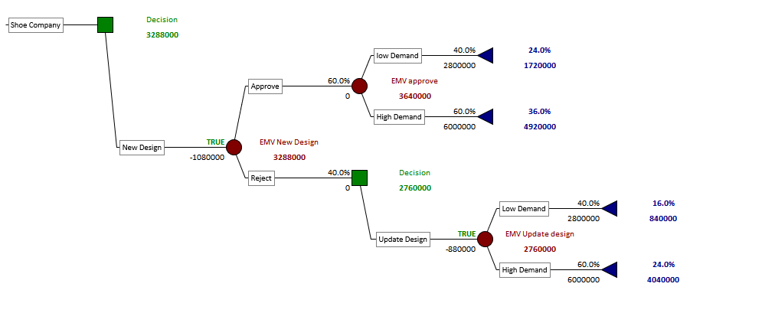

*Figure 5: Optimal decision tree*

After running the precision tree, the following are noted from the Optimal Decision Tree:

* The best decision is to launch a New design of shoes (EMV = $3,288,000). There is a 60% chance of approving the New design. The company experiences low demand (40% chance), with a payoff of $1,720,000. If the launch of New design shoes is approved with 60% and the company experiences high demand (60% chance), the payoff will be $4,920,000.
* If the New design shoes is rejected with the chance of 40%, the next best decision is to update the design according to feedback given by the Category Product Team. The cost for updating the design is $880,000. The company experiences low demand from customers (40% chance), with a payoff of $840,000. On the other hand, the company experiences high demand from customers (60% chance) with a payoff of $4,040,000.

# Solution Results and Analysis

## Risk Profile (Probability Chart)

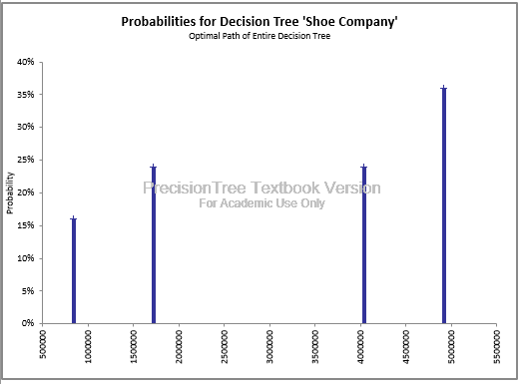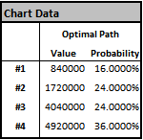

*Figure 6. Probability Chart for optimal path of entire decision tree*

With the above obtained Risk Profile – the probability chart for the optimal path for the entire decision tree representing Payoffs on the X-coordinate and Probabilities on the Y-coordinate. Based on the optimal solution the optimal decision will always produce positive payoff results.

* With a probability of 36%, the payoff will be $4,920,000, when New shoes design is approved by the Category Product Team and the company experiences high demand from customers.
* With a probability of 24%, the payoff will be $4,040,000, when New shoes design is rejected by the Category Product Team, the design is updated as per the feedback provided and the company experiences high demand from customers.
* With a probability of 24%, the payoff will be $1,720,000, when New shoes design approved by the Category Product Team and company experiences low demand from customers.
* With the probability of 16%, the payoff will be $840,000, when New shoes design is rejected by the Category Product Team, the design is updated as per the feedback given and the company experiences low demand from customers.

## One Way Sensitivity Analysis - Strategy Region Graphs for Sell Design price

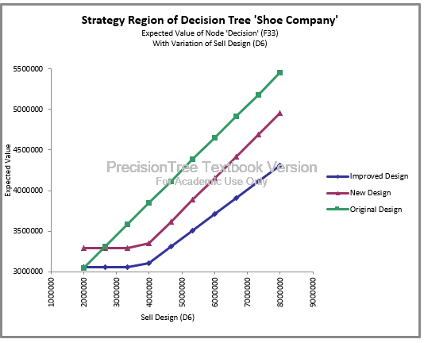

*Figure 7: One way sensitivity analysis strategy report for Sell design price vs EMV.*

The Strategy Region of Decision Tree when Price of Sell Design is taken as input gives:

* The Optimal decision of Improving the design remains insensitive to the price variations of the Sell design between $2.0-$3.3 million.
* The Optimal decision for New Design is insensitive to the price variations of the Sell Design between $2.0-$3.3 million. The EMV goes up as the price of the Sell Design increases.
* The best decision for the company is to go for New design if the price of the Sell Design is below $2.6 million.
* If the price of the Sell Design is above $2.6 million then the best Decision for the company is to continue with the Original design. The EMV for Original design goes up as the price of the Sell Design increases.

## One Way Sensitivity Analysis - Strategy Region Graph for probability of Approval of New Design

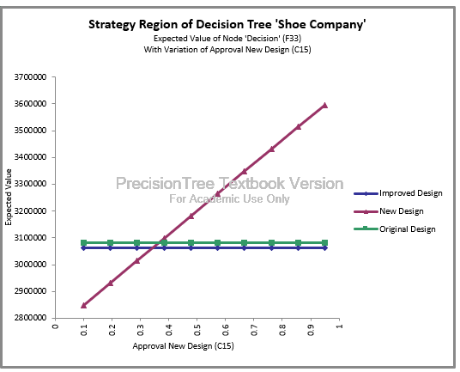

*Figure 8: One way sensitivity analysis strategy report for probability of approving New Design vs EMV*

The Strategy Region of Decision Tree when Approval of New Design is taken as input gives:

* The Optimal decision of Improving the design remains completely insensitive to any variations in the probabilities of Approval of New Design.
* The Optimal decision for Original Design remains completely insensitive to any variations in the probabilities of Approval of New Design.
* The best decision for the company is to go with the Original Design if the approval of New Design probability is below 0.38.
* The Best decision for the company is to go with the New Design if the Probability of the New Design Approval is above 0.38. EMV of the New Design goes up as the probabilities of the New Design Approval increases.

## One Way Sensitivity Analysis - Strategy Region Graphs for probability of Approval of Improve Design

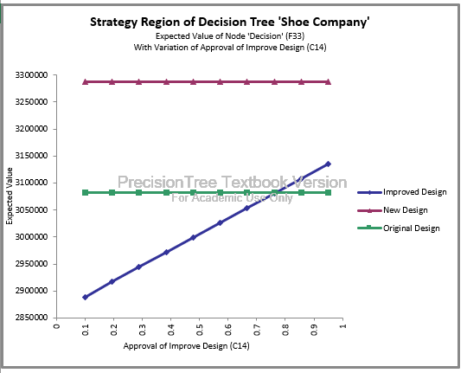

*Figure 9: One way sensitivity analysis strategy report for probability of approving Improve Design vs EMV.*

The Strategy Region of Decision Tree when Approval of Improved Design is taken as input gives:

* The Optimal decision of launching New design remains completely insensitive to any variations in the probabilities of Approval of Improved Design. The best decision for the company is to go with the launching New Design at any variation of the approval of New Design probability.
* The Optimal decision for Original Design remains completely insensitive any variations in the probabilities of Approval of Improved Design

## One Way Sensitivity Analysis - Tornado Graph for Sell Design price, probability of Approval of New Design and Approval of Improve Design

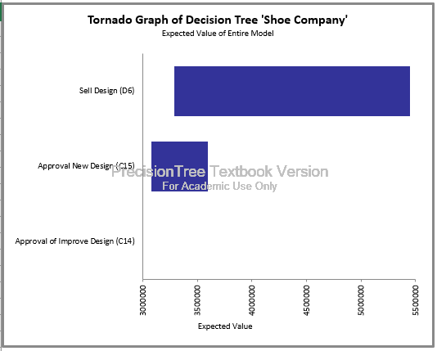

*Figure 10: One way sensitivity analysis Tornado graph*

* The Tornado graph shows the most influential parameter for one-way sensitivity analysis is the amount of money from selling designs to other companies, which produces the highest variation of EMV.
* The second influential parameter is the approving of the New design of shoes.

## Two-way Sensitivity Analysis - Strategy Region of Sell Design Price and probability of Approval of New Design

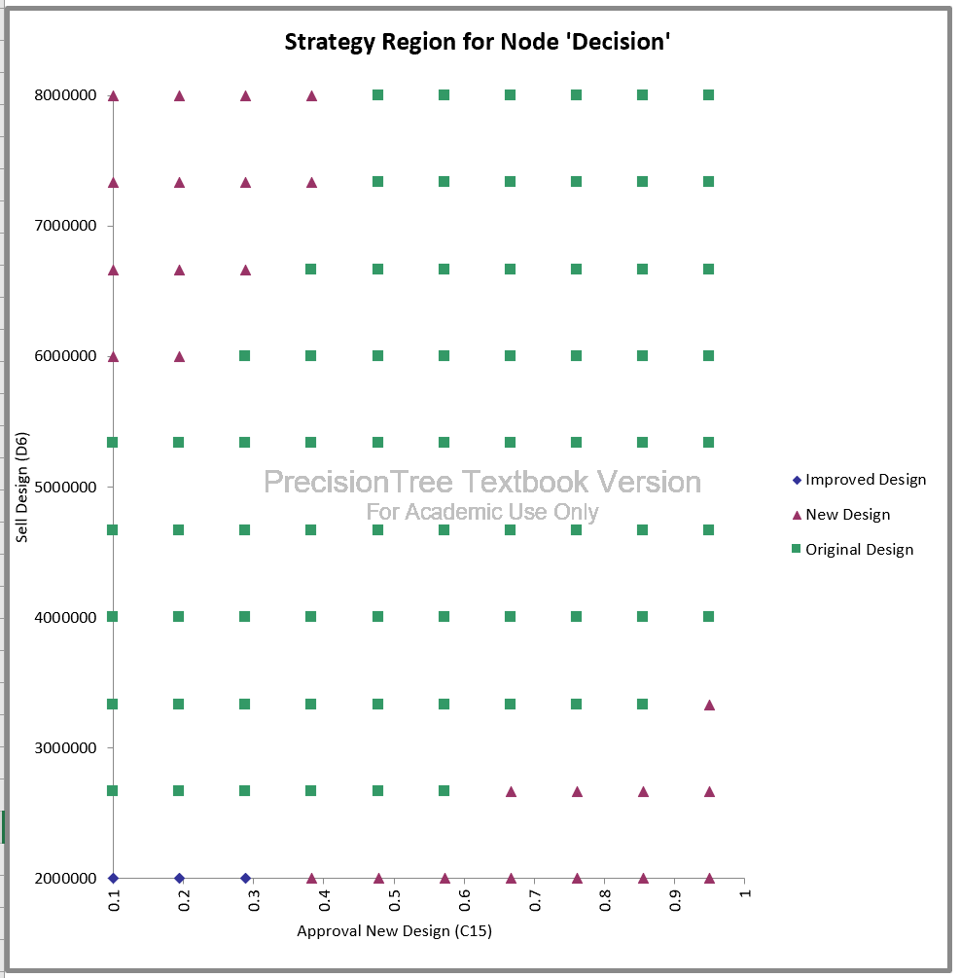

*Figure 11: Two-way sensitivity analysis strategy report for probability of approving New Design vs Sell Design Price*

**The Strategy Region for Decision having inputs as**

a. Probability of approving New Design range from 0.1 - 0.95.

b. Sell Design Price from $2.0 million - $8.0 million

* If the Sell design price is $2.0 million & probability of approving New design is less than 28% Introducing Improved Design would be the optimal decision.
* As the probability of approving New Design exceeds 38% and Sell Design price is $2.0 million then New Design decision would be the optimal decision. Also, when the Selling Design price exceeds $6 million, and probability of New Design increases diagonally.
* Continuing Original Design decision is insensitive to the probability of approving New Design when the Sell Design price is between $4.0million to $5.3million
* Original Design decision becomes sensitive to probability of approving New design as Sell Design price exceeds $6.0 million.

## Two-way Sensitivity Analysis - Strategy Region of probability of Approval of New Design and probability of Improve Design.

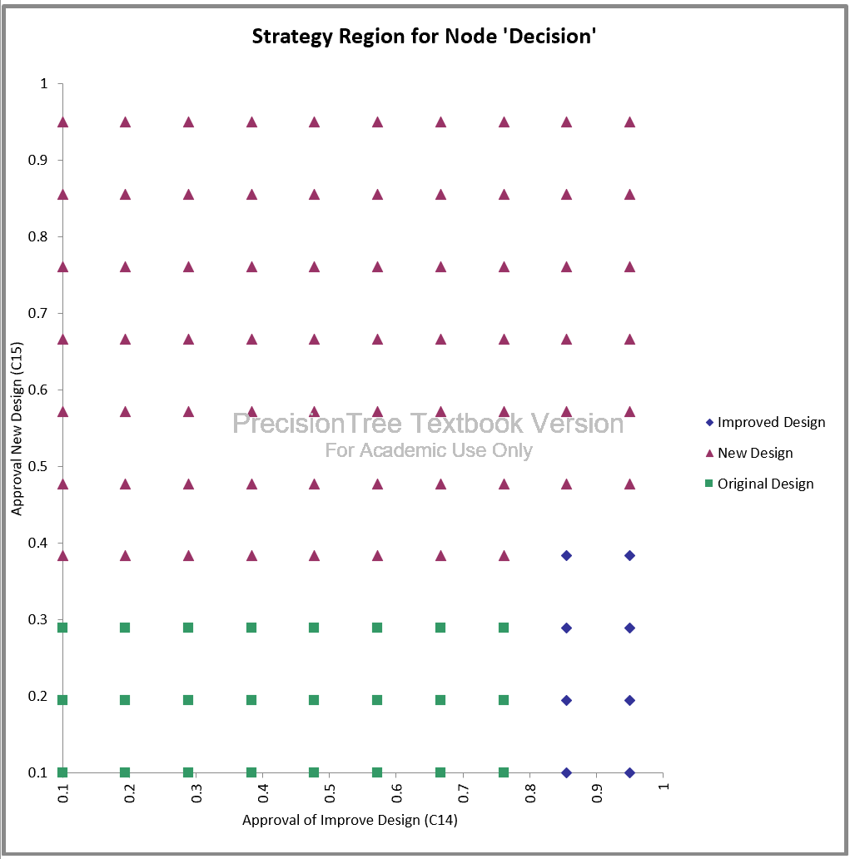

*Figure 12: Two-way sensitivity analysis strategy report for probability of approving Improve Design vs probability of approving New Design Price*

**The Strategy Region for Decision having inputs as**

a. Probability of approving Improve Design.

b. Probability of approving New Design.

* Introducing a New Design decision is optimal when probability of approving New Design exceeds 47% and probability of approving Improve Design is insensitive.
* Introducing Improved Design is optimal when Probability of Improve design exceeds 85% and probability of approving New design is less than 38%.
* Continuing with Original Design is preferred when probability of approving Improve design is less than 76% and probability of approving New Design is less than 28%

# Conclusion

Based on the Data Analysis with the precision tree, it can be concluded that Introducing a New Design would be the best decision. There is a 36% probability of getting a $4.92 million payoff when New design is approved and has high demand in the market; 24% of probability it will give a $1.72 million payoff if demand is low. With the probability of 16%, the payoff will be $0.84 million if New design is rejected and then upgraded and has low demand in the market, and the 24% probability payoff will be $4.04 million with high demand.

Optimal decision Introducing New design is sensitive to selling price, If the Sell Design Price is above $2.6 million.

Optimal decision Introducing New design is sensitive to Approval of New design, If the Probability of getting the approval for New Design is below 38%.

The Optimal decision is insensitive to the probability of getting approval for Improved design.

# Bibliography

EMV – Expected Monetary Value

Improved Design - Improved Original Design

# Appendices

* + - 1. Problem Statement is referred from: Practical Management Science - Wayne L.Winston | S. Christian Albrigt.
      2. Data Model and Analysis referred from: Dr Zinovy Radovilsky – Course Lecture Materials and Videos.