Week 12 Exercise
Docker

LAB University of Applied Sciences
Bachelor of Engineering, Mechanical Engineering (Industrial Information technology)
2026
Unubold Luvsandagva
Contents
Getting started with Docker 1
Full Docker Workshop 2
Part 2: Update the application. 2
Part 3: Share the application 3
Part 4: Persist the DB 3
Part 5: Use bind mounts 3
Part 6: Multi container apps 4
Part 7: Use Docker Compose 5
Part 8: Image-building best practice 6
What I learned from this exercise 6
What remains unclear 6

Getting started with Docker
In this task I followed the getting started tutorial from docker which includes installing Docker Desktop, make my first container by cloning official Docker “Getting Started to-do app” application, make changes to the app and push the image to Docker Hub.
To clone the app and push the image to Docker Hub I used following commands on CLI.
1. git clone https://github.com/docker/getting-started-todo-app (to clone the app)
2. docker build -t <myusername>/getting-started-todo-app . (to build the project)
3. docker push <myusername>/getting-started-todo-app (to push the image to Docker Hub)
Ps: Before this, I have created an account on Docker Hub and created public repository called “getting-started-todo-app”.
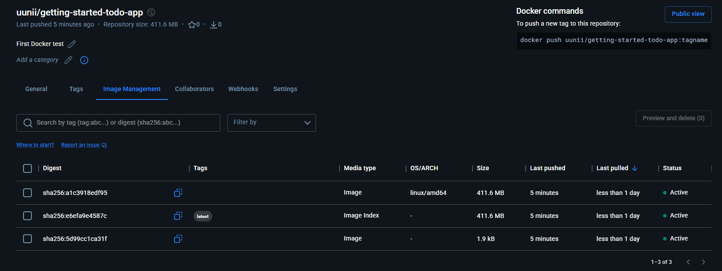
Screenshot after pushing the first project to Docker Hub:

Full Docker Workshop
In this task I followed full “Docker Workshop” guide following CLI instructions
Part 1: Containerize an application.
1.I cloned the application by running
git clone https://github.com/docker/getting-started-app.git on CLI, and created “Dockerfile” with following contents:
FROM node:24-alpine
WORKDIR /app
COPY . .
RUN npm install --omit=dev
CMD ["node", "src/index.js"]
EXPOSE 3000
2.Built the image by running command:
docker build -t getting-started .
3.Run the container using command:
docker run -d -p 127.0.0.1:3000:3000 getting-started 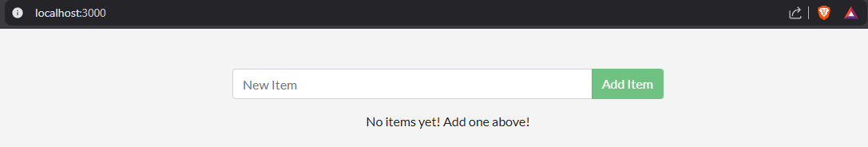
4.Running command: docker ps shows list of containers

Part 2: Update the application.

Commands used in this part:
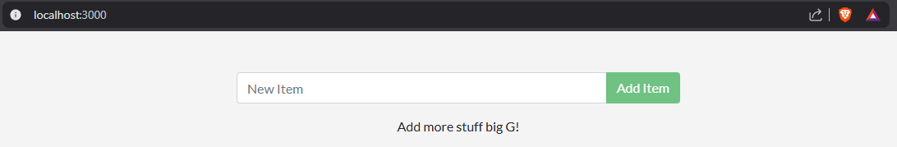
1. docker build -t getting-started . (to build updated version of image)
2. docker stop <the-container-id> (to stop the previous container with its ID we saw in part one with docker ps command)
3. docker rm <the-container-id> (to remove the container once its stopped)
4. docker run -dp 127.0.0.1:3000:3000 getting-started (to start the updated app)

Part 3: Share the application

Commands used in this part:
1. docker login <my username> (self-explanatory)
2. docker tag getting-started <my username>/getting-started (to give the image new name)
3. docker push <my username>/getting-started (to push the image to my Docker Hub repository)
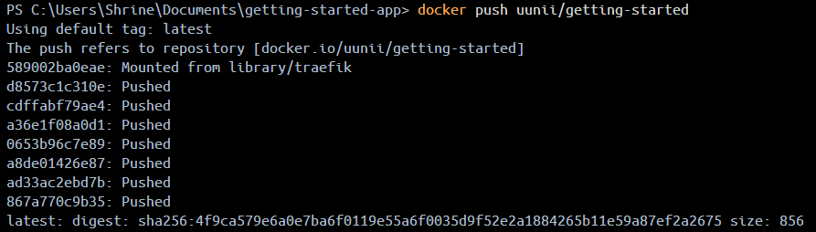

Part 4: Persist the DB

Commands used in this part:
1. docker volume create todo-db (create a volume)
2. Stop and remove the container again like we did in part 2.
3.docker run -dp 127.0.0.1:3000:3000 --mount type=volume,src=todo-db,target=/etc/todos getting-started (starts the container but with mounting volume using –mount, which will capture all files created at the path, now even after stopping and removing the container, all added to-do list entries will stay.

Part 5: Use bind mounts

Commands used in this part:
1.Stop and remove the running container once again like before.
2. In Windows Powershell, run:
docker run -dp 127.0.0.1:3000:3000 `
-w /app --mount "type=bind,src=.,target=/app" `
node:24-alpine `
sh -c "npm install && npm run dev"
3.After making changes to the app, the changes will apply almost immediately because the bind mount.
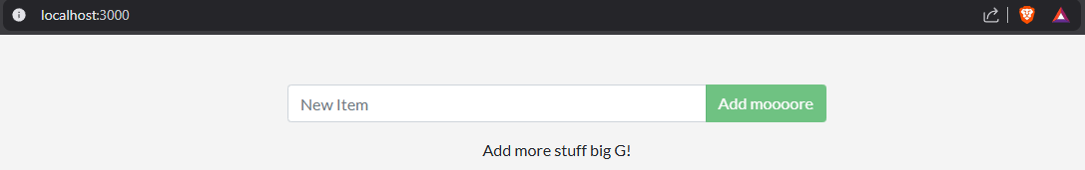

Part 6: Multi container apps

Commands used in this part:
1. docker network create todo-app (to create network)
2. Started MySQL container and attached it to network using this command on Powershell:
docker run -d `
--network todo-app --network-alias mysql `
-v todo-mysql-data:/var/lib/mysql `
-e MYSQL_ROOT_PASSWORD=secret `
-e MYSQL_DATABASE=todos `
mysql:8.0
Screenshot of the Database
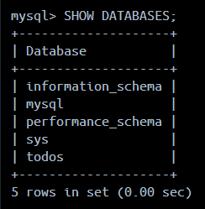
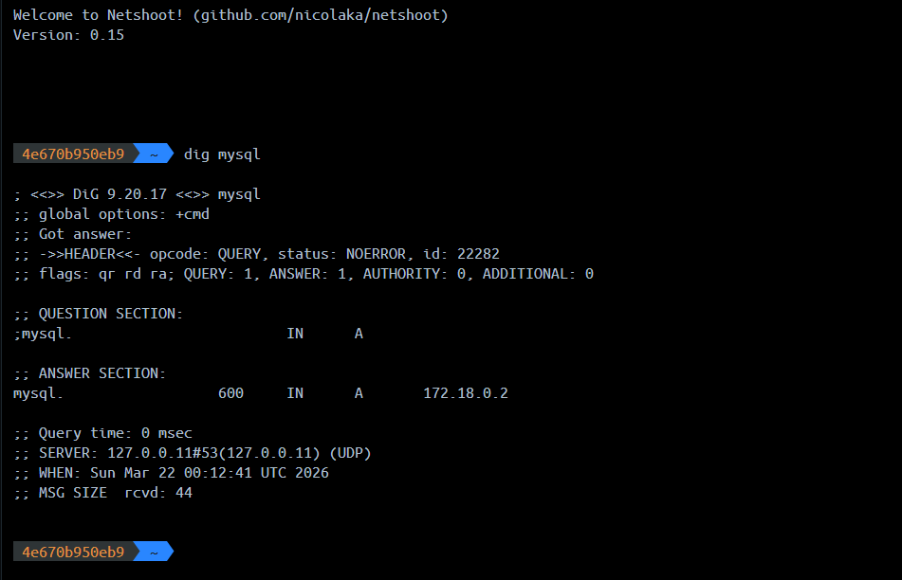
3. docker run -it --network todo-app nicolaka/netshoot (to start a new container using nicola/netshoot image)

4.In Powershell, start the container using command:
docker run -dp 127.0.0.1:3000:3000 `
-w /app -v ".:/app" `
--network todo-app `
-e MYSQL_HOST=mysql `
-e MYSQL_USER=root `
-e MYSQL_PASSWORD=secret `
-e MYSQL_DB=todos `
node:24-alpine `
sh -c "npm install && npm run dev"
5.After adding items in the app, I can see the items in database using command:
docker exec -it <mysql_ID> mysql -p todos
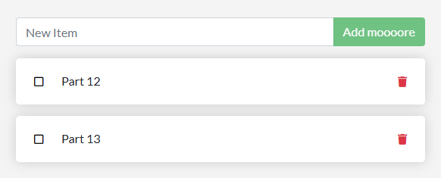
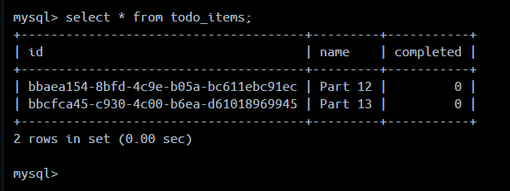

Part 7: Use Docker Compose

After creating compose.yaml file and defining the name and image of the first service I used following commands
1. docker compose up -d (to start up the application stack)
Screenshot of app running
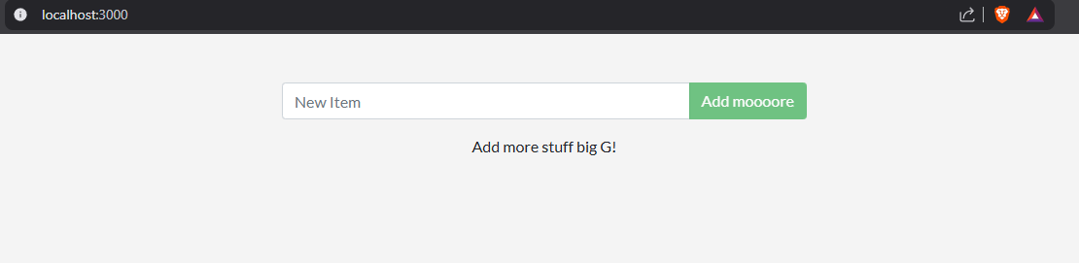

Part 8: Image-building best practice

After updating the Dockerfile to copy package.json by adding
COPY package.json package-lock.json ./ line to it, built a new image using
docker build -t getting-started .
Now when I make change to the app and build the image again its much faster than before since it using previously cached layers. Pushing and pulling this exact image will also be faster.

What I learned from this exercise

By the end of workshop, I know basic thing for how to build a multi-container application for my local computer, to run node.js and mysql databases together, by using docker I don’t need to install them on my pc, just need to write a yaml file and run docker. It handles the downloading, networking and data storage automatically.

What remains unclear

The workshop was focuses on development which makes the actual public release untouched, it runs on my pc with localhost, and I can share them with docker hub but it will stull only run their localhost as well, now I want to learn more about how to push my container to a cloud provider such as AWS or Azure.

