Abstract—In this paper, we propose a novel method of commercial product antenna pattern design using the deep neural network. Our design method is based on the hybrid scheme of both the generative and discriminative model. The advantage of the proposed method is that we can easily create an antenna of a commercial product without in-depth knowledge of the RF theory or antenna design methodology. The designer needs to provide only the designed radiation pattern and reflection coefficient. The neural network used is trained based on the unsupervised learning, which outputs the antenna pattern with the desired radiation characteristics. With the generative model, we generate the pattern and the discriminative network evaluates and outputs the desired antenna pattern. We use the same 8-layer LSTM (long short-term memory) for generator and discriminator to construct a neural network. We use numerical methods to better validate the discriminator's work by high frequency structure simulator (HFSS).

A Novel Antenna Pattern Design Using Generative Adversarial Network
Kwi Seob Um and Seo Weon Heo, Member, IEEE
Hongik University, Seoul, Republic of Korea
seoweon.heo@hongik.ac.kr

Introduction
Antenna is a crucial element in the commercial product design since it is the first stage to input the weak signal and the final interface to efficiently transmit the high-power signal. Though it is a field studied for a long time, however, it is still difficult to design an antenna with good radiation characteristics unless the engineer has a long-time experience and in-depth knowledge of this field. In this work we use unsupervised learning to generate antenna patterns based on the Generative Adversarial Network (GAN) [1]. Our purpose is to provide an easy way to design an antenna of a desired characteristics with little domain knowledge.
The application of deep neural network (DNN) is widely deployed recently. However, not many research works reported in the application of it to the RF and antenna circuit design. The neural network architecture we use in this work is based on the GAN published in 2014 by Goodfellow [1]. The GAN is composed of the generator and the discriminator network. The former generates the antenna pattern using the previous experience learned by the training data, whereas the latter discriminative network determines whether the generated output has a desired characteristic or not. When these two networks are trained together, the GAN generates the output with a desired characteristic.
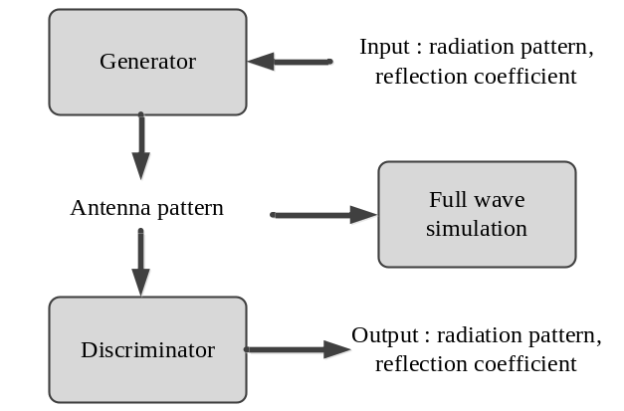
Fig. 1. Overall network of antenna pattern design using GAN architecture.
Recently, GAN technology has been used in a variety of areas such as image-to-image translation [2], face recognition [3], speech enhancement [4], fake image [5] and fake video [6-7]. In this work, we propose a novel antenna pattern design methodology using GAN. The generator in GAN model generates the antenna pattern. The discriminator in GAN model matches the characteristics of the antenna to what user want. We use the high frequency structure simulator (HFSS) to verify the performance of the discriminator output.

Neural Network architecture

Generative Adversarial Network
In Fig. 1 we showed the overall flow of antenna design method using the GAN architecture. First, the generator network generates the antenna pattern based on the previous training results. The input of the generator is the desired radiation pattern and reflection coefficient. The generator provides a portion of the antenna pattern. Portions of these antenna patterns may overlap other portions. The integral part of the antenna is the antenna pattern. Second, the output of generator becomes the input of the discriminator network. Then the discriminator determines whether the characteristics of antenna pattern has the desired radiation characteristics. The discriminator’s output shows the radiation pattern and reflection coefficient. Finally, the full wave simulation using the HFSS simulator is processed. The input to this part is the same generator output as the discriminator. HFSS calculates the electric and magnetic fields using a numerical method called the finite element method (FEM). This calculates the error between the discriminator outputs.

Long Short-Term Memory (LSTM)
LSTM cells are used when creating generators and discriminators. LSTM cells are recurrent neural networks (RNNs) that has additional forgetting function. [8]. The RNN cell uses the output as an additional input. The additional input from the output can be thought memory function. This provides high performance in sequential data for machine learning. In addition, the forgetting function has the same effect as starting at the end of the sequence data. Our network uses 8-layer LSTMs for each generator and discriminator. There are 512 hidden units in the LSTM cell.
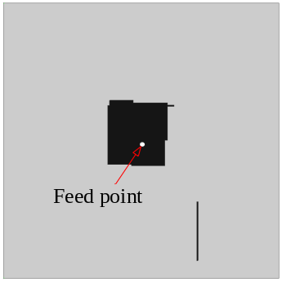
Fig. 2. Antenna pattern by method of neural network

Training mechanism
Training takes place in three stages. First, the generator generates the antenna pattern with the desired radiation pattern and reflection coefficient. The discriminator receives the antenna pattern as input and generates the field and the reflection coefficient. Second, for training discriminator, full wave simulation is used to calculate the radiation field and reflection coefficient by antenna pattern as input. Errors are calculated between the wave simulation and the discriminator output. Apply a gradient descent to the discriminator. Third, for a training generator, the error is calculated between the discriminator output and the generator input. In short, the generator input is the desired radiation pattern and the desired reflection coefficient. Then apply a gradient descent to the generator. Repeat steps 1,2 and 3 until the network converges.
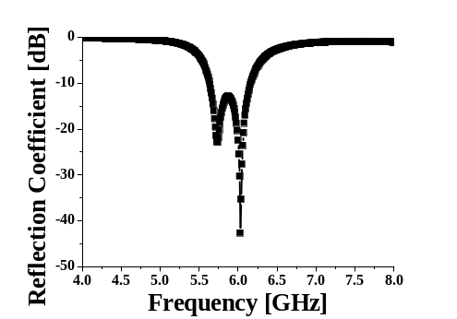
Fig. 3. Reflection coefficent of the antenna

Simulation Result
To verify our antenna patterning neural network by using GAN, we set up system parameters as follows. The target frequency is 5.8 GHz, which is ISM band for WIFI or personal use, and ground area of 70 mm x 70 mm. The substrate is Taconic TLY with a permittivity of 2.2 and a loss tangent of 0.0009.
Fig. 2 shows trained antenna pattern for zenith direction (theta = 0 deg). The pattern is shown in black. The basic antenna that radiates to zenith direction is a microstrip patch antenna. Although not seen in the figure, fig. 2 has additional patches and parasitic elements. In fig. 3 and 4, we show the trained antenna characteristics of reflection coefficient and radiation pattern, respectively. As shown in fig. 3, the reflection coefficient at 5.8 GHz is lower than -10 dB. As shown in fig 4., the radiation direction is the zenith.

Conclusions
In this paper, a novel antenna pattern design method using GAN is presented. Our neural network, as a GAN, has a generator for antenna patterning and a discriminator for verifying the characteristic output of the generator-generating antenna pattern. We used a full wave simulation by HFSS, to verify that verify discriminator works well. The difference between HFSS and discriminator output, which obtains the radiation pattern and reflection coefficient, is used for error calculation. Our method does not need a training data since HFSS output can be used as a ground truth value. Our method lessens the burden of full RF knowledge to design the commercial product antenna pattern.
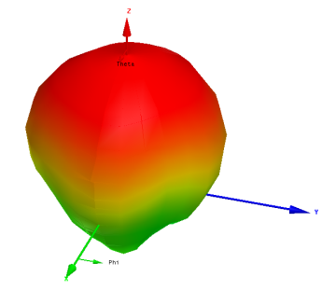
Fig. 4. Radiation pattern of the antenna
References
- I. Goodfellow et al., “Generative adversarial nets,” Advances in Neural Information Processing Systems, pp. 2672-2680, 2014.
- Z. Yi, H. Zhang, P. Tan and M. Gong, “Dualgan: Unsupervised dual learning for image-to-image translation,” Proc. IEEE Int. Conf. Comput. Vis. (ICCV), pp. 2868-2876, Oct. 2017.
- L. Tran, X. Yin and X. Liu, “Disentangled representation learning GAN for pose-invariant face recognition,” Proc. IEEE Conf. Comput. Vis. Pattern Recog., pp. 1283-1292, 2017.
- S. Pascual, A. Bonafonte and J. Serra, “SEGAN: Speech enhancement generative adversarial network,” arXiv eprint arXiv:1703.09452, 2017
- H. Y. Le et al., “GAN-D: Generative adversarial networks for image deconvolution,” Int. Conf. on Info. and Commun. Tech. Conv. 2017.
- J. Walker et el., “The pose knows: Video forecasting by generating pose futures,” Int. Conf. on Computer Vision 2017.
- C. Spampinato et al., “VOS-GAN: Adversarial learning of visual-temporal dynamics for unsupervised dense prediction in videos,” arXiv eprint arXiv:1803.09092, 2018.
- K. Greff et al., “LSTM: A search space odyssey,” IEEE Trans. Neural Net. and Learn. Syst., vol. 28, no. 10, pp. 2222–2232, Oct. 2017.

