**Branchometer Software Manual**

1. **How to set up the software**
   1. Download Branchometer.zip
   2. Unzip Branchometer.zip and place anywhere on computer, so by now you should have the folder name Branchometer.
   3. Double click on the file named ‘Branchometer.exe’ in the folder, then the software should start.
2. **The overview of the software**

The software is designed to do semi-automatically morphological measurements of two-dimensional binary image. The quantitative measurements are area, contour length, junction thickness, branch thickness, terminal thickness, branch length, branch spacing, branch angle, and fractal dimension. The result is shown in both graphical representation and text files which can be used to make further analysis in other software. The figure below is the GUI of the software.

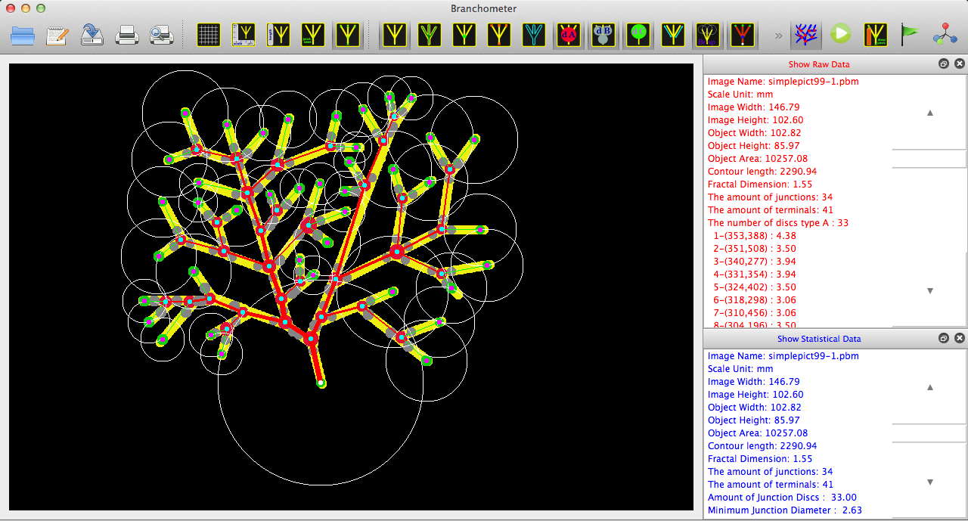

1. **How to use the software**

***Steps to use the software***

* 1. *Open an image file*

Click on  to open an image file, then an Open-File Dialog should appear. Select a pbm file, then the selected image will be shown on the screen

After an image is shown, you are able to do the followings:

* Show/hide grid

Click on  or select menu View->Show Grid to show grid with scale in millimeter unit.

* Show/hide Object Length

Click on  or select menu View->Show Object Length to show the height and width of the figure. Its measurement will be changed according to scale set by user.

* Show/hide image

Click on  or select menu Display->Picture to show image and if you want to hide the image, just click on the icon again.

* Show/hide skeleton by

Click on  or select menu Display->Skeleton to show skeleton and if you want to hide the skeleton, just click on the icon again.

* Show/hide junctions

Click on  or select menu Display->Junction to show junctions and if you want to hide the junctions, just click on the icon again.

* Show/hide terminals

Click on  or select menu Display->Terminal to show terminals and if you want to hide the terminals, just click on the icon again.

* Show/hide contour

Click on  or select menu Display->Contour to show contour and if you want to hide the contour, just click on the icon again.

* Show/hide Junction Cross

Click on  or select menu View->Show Junction Cross to show junction position. If you want to hide junction cross, just click on the icon again.

* Show/hide Junction Label

Click on  or select menu View->Show Junction Label to show junction number. If you want to hide junction number, just click on the icon again.

* Set Color

You are able to change the color of each component on the image such as skeleton, junction by moving the cursor over the component, then click. A submenu will appear, then choose ‘Set Color’. The Color Dialog will come out, then pick the new color and press ‘OK’. The color of the selected component will be changed as desired.

You are also able to click all of the icons mentioned above to show all components at the same time.

* 1. *Set Object Scale*

After the image selected is displayed on the screen, you are able to set the scale of objects

Click on  or select menu Edit 🡪 Set Object Scale, or select menu Set Object Scale after right click on display area. At this point the mouse will be changed to pointing hand shape which means you can start measuring the scale, then move the mouse to the starting point of the scale and click, after that move mouse to the end of the scale and double click, a red line will then appear with the dialog as the figure below, then click ‘OK’

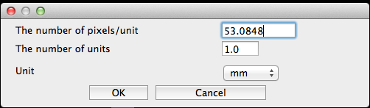

* 1. *Detect junctions on the image*

Click on  to automatically detect junctions on the image. The cross with will be shown on the junction of the image

* 1. *Process*

Click on  to process and analyze the image based on the junction detected automatically. The progress bar may appear in case of big and complicated image, wait until it is done. After the process ended, you are able to click the following toggle icons to show additional components

* Show/Hide Disc A

Click on  or select menu Display->Disc A to show Disc A and click again if wanting to hide them

* Show/Hide Disc B

Click on  or select menu Display->Disc B to show Disc B and click again if wanting to hide them

* Show/Hide Disc C

Click on  or select menu Display->Disc C to show Disc C and click again if wanting to hide them

* Show/Hide Branch Length (Euclidean Line)

Click on  or select menu Display->Branch Length to show Branch Length and click again if wanting to hide them

* Show/Hide Branch Length (Skeleton track)

Click on  or select menu Display->Skeleton Track to show Branch Length (Skeleton track ) and click again if wanting to hide them

* Show/Hide Branching space

Click on  or select menu Display->Branch Spacing to show Branching space and click again if wanting to hide them

In case some junctions are missing or can’t be detected, you can detect them manually by clicking on  to turn on edit mode, then move the cursor closet to the undetected junction, then click, a submenu as the figure below will appear, then select ‘Add/Repair Junction’, then you will see a cross symbol on the junction you just selected.



then let the software repair it by clicking 

After finishing making the measurements (by clicking ), user is able to

1. Select menu Process->Clean Ultimate Branch in order to delete ultimate branches whose length is less than or equal to the value predefined in ‘Minimum Ultimate Branch Length’ (The minimum ultimate branch length must be set before doing this process by selecting menu Edit->Clean Settings, then define the minimum ultimate branch length. In order to check the ultimate branch length, you can show report by selecting menu View->Show Raw Data.

2. Select menu Process-> Clean Terminals in order to delete the terminals whose diameter less than the value predefined in ‘Minimum Terminal Diameter’ (The minimum terminal diameter must be set before doing this process by selecting menu Edit->Clean Settings, then define the minimum terminal diameter. In order to check terminal diameter, you can show report by selecting menu View->Show Raw Data.

3. Select menu Process->Delete Redundant Branches in order to delete redundant branches

4. Click on  or select menu Process->Tree Construction to process tree structure so that branch order will be calculated. Select menu Display->Tree or click  to show tree structure and the branch order if it is successfully calculated (some images which cannot be formed a tree, branch order calculation will fail). You can set the coordinates of the tree root by turning on edit mode, then move the cursor closet to the desired a terminal (dc center), then click, a submenu as the figure below will appear, then select ‘Select Root’, then click on  again to update the new root with new branch order.



* 1. *Show Data*
* Select menu View->Show Raw Data to show raw data in a window dock.
* Select menu View->Show Statistical Data to show statistical data in a window dock.
  1. *Write measurement result to text files*

Click on  then the Save-File Dialog will appear, press ‘save’, then wait for a few seconds to ensure that the text files are completely written. There are 3 types of text files - 1) .res file keeps raw measurement data 2) .sta file keeps statistical data such as min, max, mean, standard deviation of each measurement, and 3) .csv file keeps statistical data for all file you have saved.

* 1. *Settings.*

There are a few settings which may be needed before doing analysis.

* + 1. Display Setting

You can adjust the position of image display, by specify the beginning of X and Y position for image display. Selecting menu Edit->Display Settings, then the figure below will appear. This setting should first be set after GUI appearance.

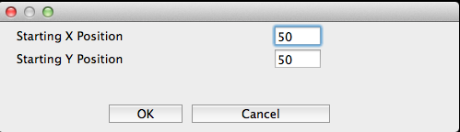

* + 1. Set Files and Directory Name

Select menu Edit-> Files and Directory Names Settings, then an input dialog as the figure below will appear.

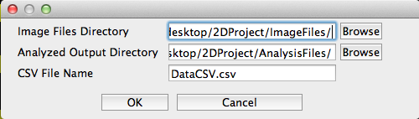

* Image Files Directory is the directory which keeps image files.
* Analyzed Output Directory is the directory which keeps analyzed output in text file (.res, .sta, .cvs)
* CSV File Name is file name specified to keep statistical data for all files which are being saved.
  + 1. Clean Settings

Select menu Edit->Clean Settings, then an input dialog as the figure below will appear.

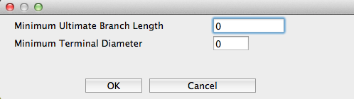

Minimum Ultimate Branch Length is minimum length representing a threshold which effects the result when you want to delete ultimate branch length in the menu Process-> Clean Ultimate Branches. It means the lengths which are less than or equal the specified threshold will be deleted and all the result will be updated.

Minimum Terminal Diameter is minimum diameter of terminal representing a threshold which effects the result when you want to delete terminal in the menu Process-> Clean Terminals. It means diameter which are less than or equal the specified threshold will be deleted and all the result will be updated.

**Additional Icons**

 🡪 Save image captured from the screen

 🡪 Print image captured from the screen

 🡪 Print preview of captured image