**UWIRAGIYE Jean Paul Feb 8th, 2024  
Reg No: 2209000041**

**Module: Internet programming and Web Optimization**

**Session : Weekend**

**ASIGNMENT 2**

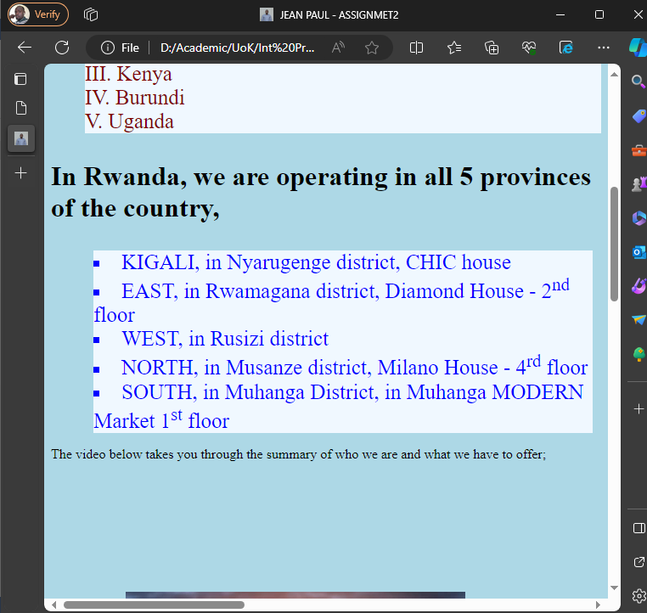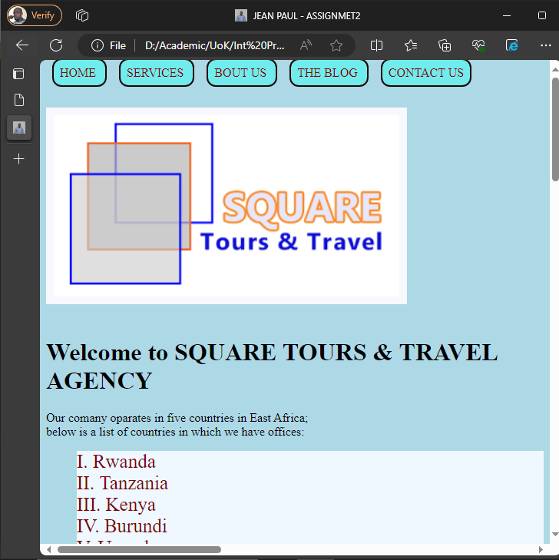 **(1) (2)**

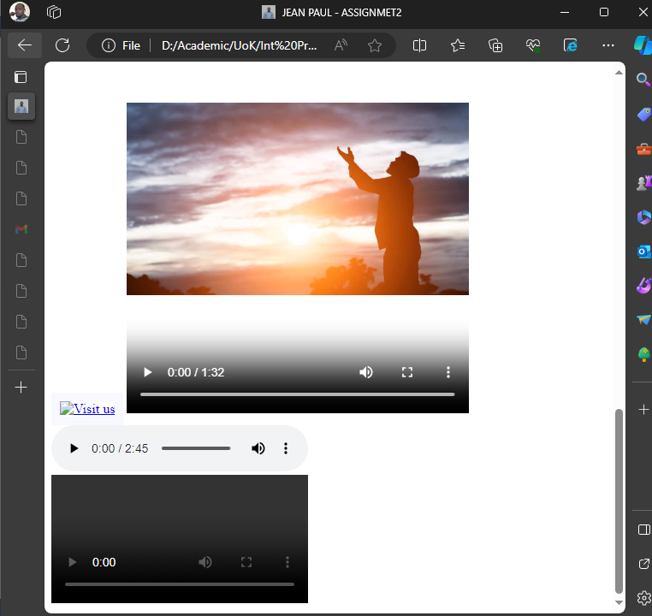 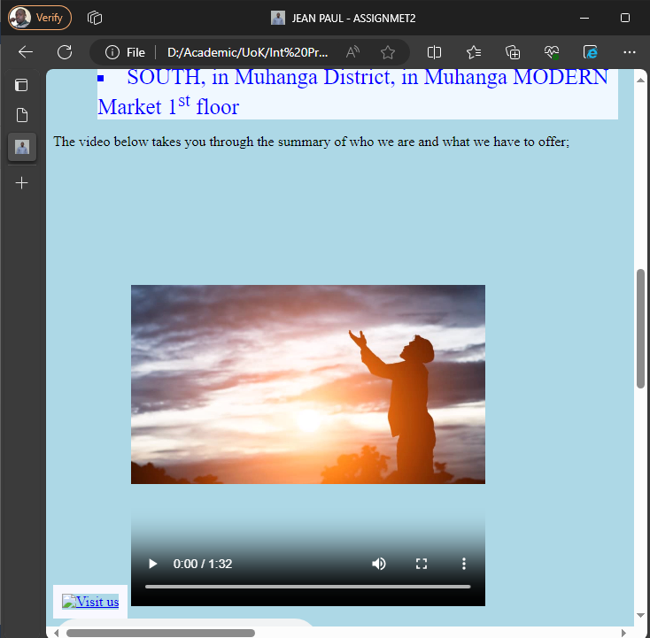

**(3) (4)**

**HTML CODES**

**<!DOCTYPE html>**

**<html lang="en">**

**<head>**

**<meta charset="UTF-8">**

**<meta name="viewport" content="width=device-width, initial-scale=1.0">**

**<title> JEAN PAUL - ASSIGNMET2</title>**

**<link rel="icon" type="jeanpaul-photo/png" href="jeanpaul-photo.png" />**

**<link rel="stylesheet" type="text/css" href="assignment2.css">**

**<style>**

**.list{**

**/* color: blue; */**

**justify-content: left;**

**text-align: left;**

**font-size: 25px;**

**background-color: aliceblue;**

**}**

**#ol{**

**list-style-type: upper-roman;**

**list-style-position: inside;**

**margin: auto;**

**color: maroon;**

**}**

**ul {**

**list-style-type: square;**

**list-style-position: inside;**

**margin: 10px;**

**color:blue;**

**}**

**a.s{**

**color: maroon;**

**font-weight: 50px;**

**text-decoration: none;**

**padding: 8px;**

**border: 1px solid rgb(31, 2, 2);**

**border-radius: 12px;**

**display: inline-flexbox;**

**border-width: 2px;**

**margin: 8px;**

**background-color: rgb(113, 236, 236);**

**}**

**img{**

**image-orientation: flip;**

**border: 10px solid ghostwhite;**

**box-shadow: inset;**

**width: 450px;**

**.p{**

**margin: 0;**

**padding: 0;**

**display: flex;**

**justify-content: center;**

**align-items: center;**

**height: 100vh;**

**background-color: #f0f0f0;**

**}**

**.video-container {**

**position: relative;**

**width: 50px;**

**height: 20px;**

**}**

**video {**

**width: 100px;**

**height: 60;**

**object-fit: cover;**

**}**

**.poster {**

**position: absolute;**

**top: 0;**

**left: 0;**

**width: 100%;**

**height: 100%;**

**background: url('images.jfif') no-repeat center center;**

**background-size: cover;**

**cursor: pointer;**

**}**

**}**

**</style>**

**</head>**

**<body>**

**<a href="index.html" class="s"> HOME </a>**

**<a href="Services.html" class="s"> SERVICES </a>**

**<a href="About.html" class="s"> BOUT US </a>**

**<a href="Blog.html" class="s"> THE BLOG </a>**

**<a href="ContactUs" class="s"> CONTACT US </a>**

**<!--Apply internal style to HTML list and anchor tag-->**

**<br><br><br>**

**<img src="Square.png" alt="Reach your Destination as you please!"> <marquee behavior="scroll" direction="left"></marquee>**

**<h1>**

**Welcome to SQUARE TOURS &amp; TRAVEL AGENCY**

**</h1>**

**<p>**

**Our comany oparates in five countries in East Africa;<br/>below is a list of countries in which we have offices:**

**</p>**

**<ol id="ol">**

**<!--Use of CSS by calling the Id**

**While list uses class-->**

**<li class="list">Rwanda</li>**

**<li class="list">Tanzania</li>**

**<li class="list">Kenya</li>**

**<li class="list">Burundi</li>**

**<li class="list">Uganda</li>**

**</ol>**

**<H1><p>In Rwanda, we are operating in all 5 provinces of the country,</p></H1>**

**<ul>**

**<!--Use of CSS by name of tag-->**

**<li class="list">KIGALI, in Nyarugenge district, CHIC house</li>**

**<li class="list">EAST, in Rwamagana district, Diamond House - 2<sup>nd</sup> floor</li>**

**<li class="list">WEST, in Rusizi district</li>**

**<li class="list">NORTH, in Musanze district, Milano House - 4<sup>rd</sup> floor</li>**

**<li class="list">SOUTH, in Muhanga District, in Muhanga MODERN Market 1<sup>st</sup> floor</li>**

**</ul>**

**<p>**

**The video below takes you through the summary of who we are and what we have to offer;**

**</p>**

**<a href="Visit.html"><img src="images.jfif" alt="Visit us"></a>**

**<video src="LA PERVENCHE INTRO.mp4" controls width="400px" height="500px"> </video>**

**<audio controls autoplay>**

**<source src="Michel Teló - Ai Se Eu Te Pego - .mp3" type="audio/mp3">**

**</audio>**

**<div class="video-container">**

**<video controls>**

**<source src="Awaireness Campain.mp4" type="video/mp4">**

**</video>**

**<div class="poster"></div>**

**</div>**

**</body>**

**</html>**