Digital Process Support – Internal Systems
Internal Requests Workflow Automation System
University of West Attica – MSc in ICT
Panagiotis Zois – Project Analyst
November 2025

1. Executive Summary
This project presents the design of a digital workflow automation system developed to optimize internal request and approval processes within a university environment. The objective was to replace manual, paper-based procedures with an integrated platform that enhances efficiency, transparency, and traceability of approvals.

2. Objectives
- Automate repetitive internal workflows (student requests, approvals, notifications).
- Reduce processing time and administrative overhead.
- Improve communication between departments.
- Enable centralized data logging and reporting.

3. Methodology
The project followed a systems-analysis approach:
1. Requirements elicitation from typical user roles (Student, Secretariat, Admin).
2. Modeling of use cases and process flows using Draw.io.
3. Database schema design (ERD) using relational principles.
4. UI prototyping and user testing using Figma (conceptual).
Tools Used: Draw.io, Figma, Microsoft Word, Microsoft Excel.

4. System Architecture Overview
The “Digital Process Support System” is composed of three layers:
- User Interface Layer: Forms for submitting requests and viewing status.
- Process Logic Layer: Handles routing, approvals, and notifications.
- Data Layer: Stores users, requests, and approval history.

5. Diagrams
The following diagrams illustrate the core system design components:

5.1 Use Case Diagram
Illustrates user interactions and system functionality.

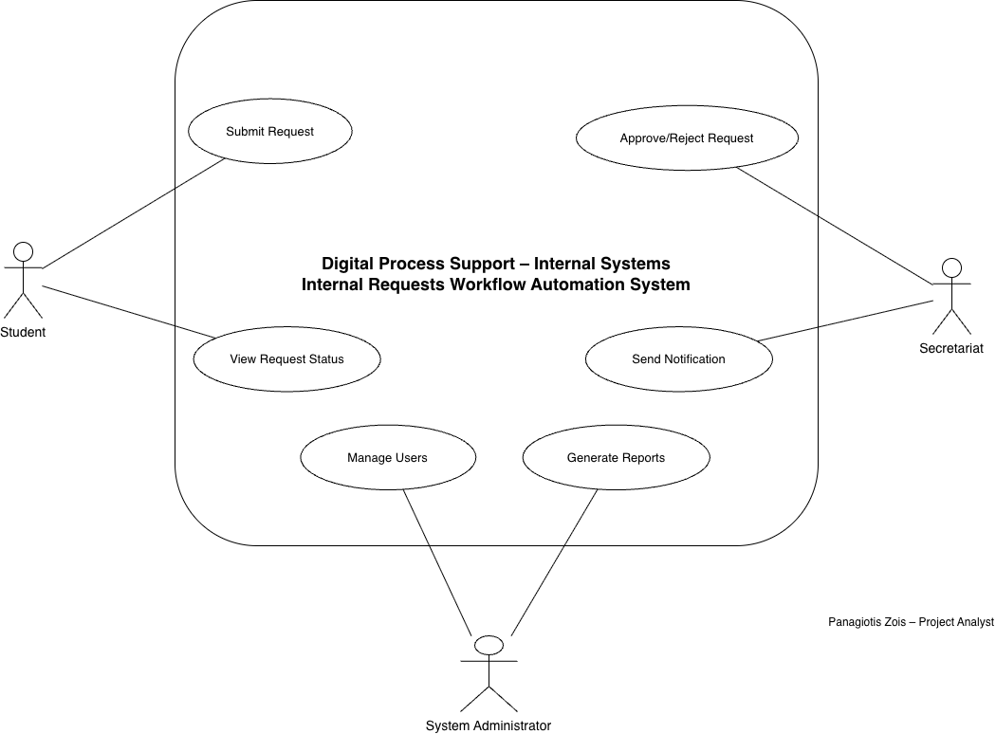

5.2 Process Flowchart
Depicts the workflow for request submission and approval within the system.

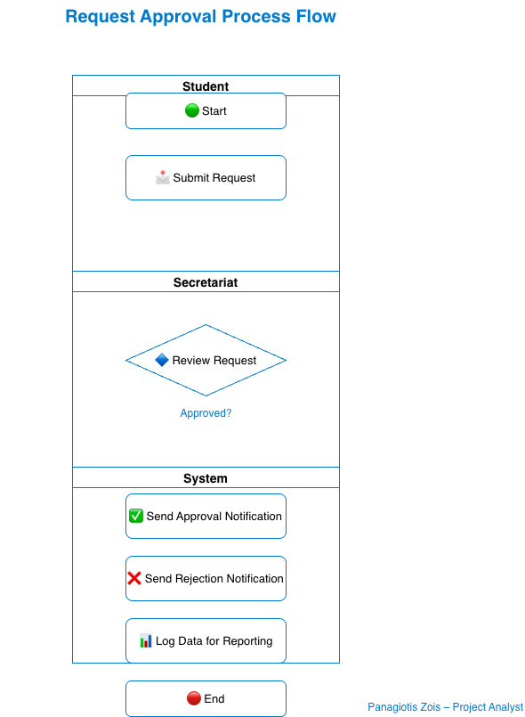

5.3 Entity-Relationship Diagram (ERD)
Represents the database schema linking users, requests, approvals, and statuses.

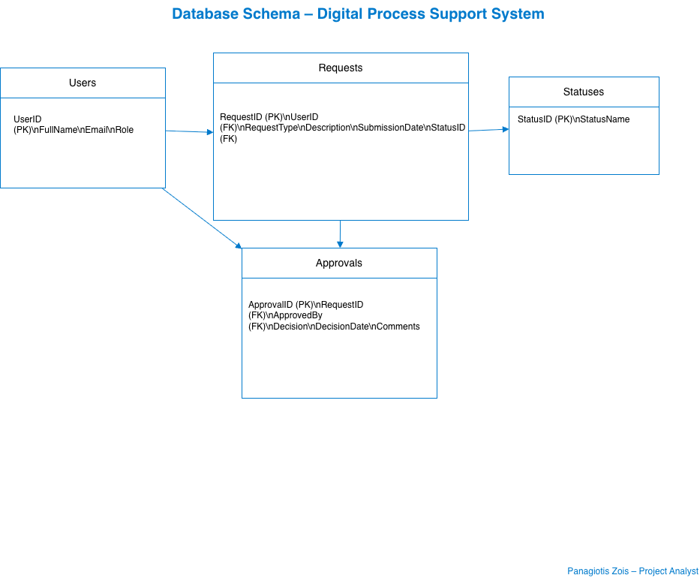

6. UI Prototype (Figma)
The following screens represent the conceptual user interface designed in Figma:
- Login Screen

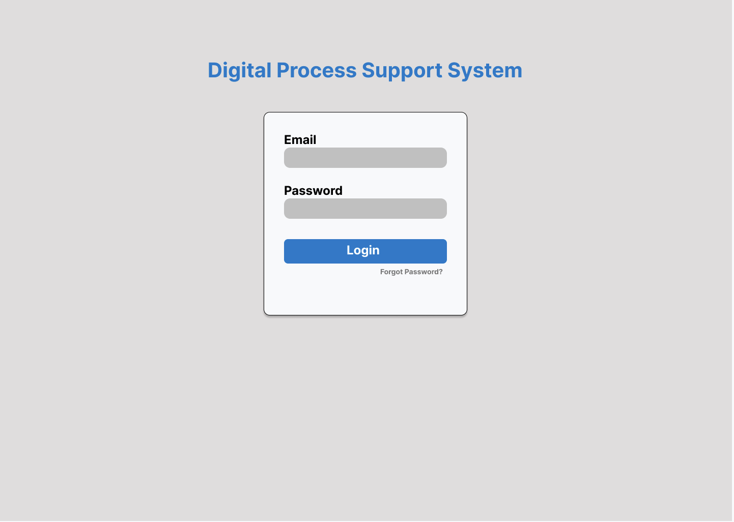

- Dashboard (Student Home)
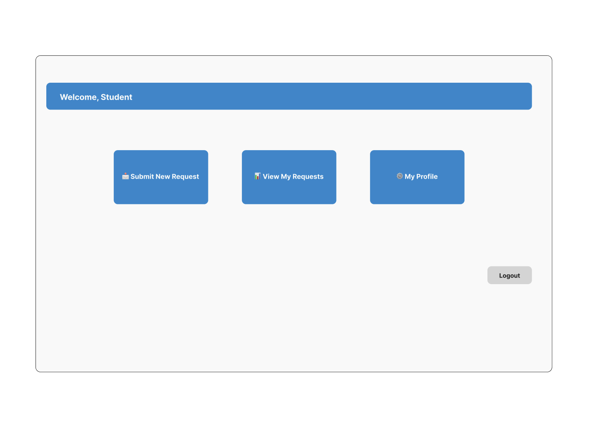- Request Form
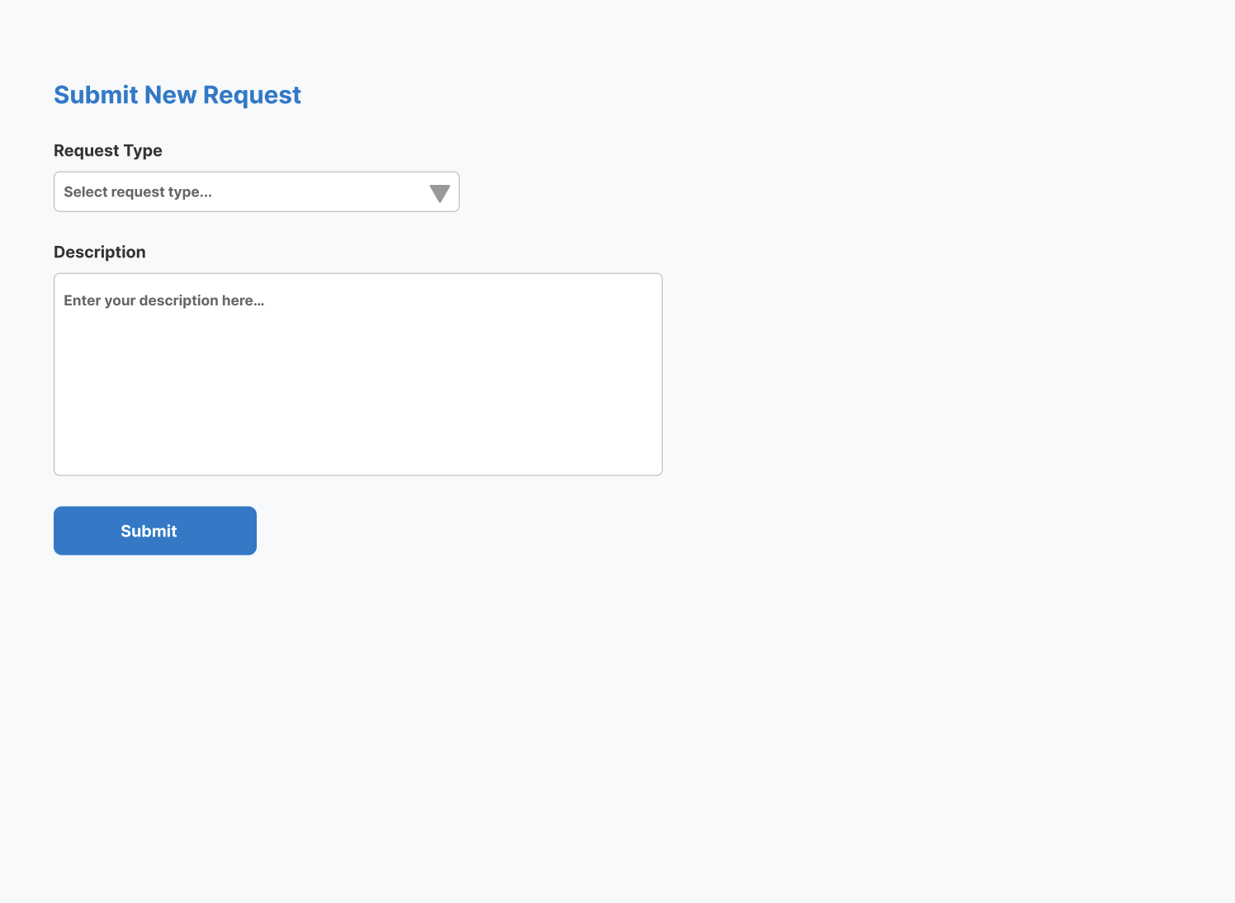

7. Testing & User Feedback
Test cases were conducted to validate functionality and user experience. Example results:
Test Case | Expected Result | Outcome
Submit request form | Request recorded successfully | ✅ Pass
Secretariat approves | Status changes to Approved | ✅ Pass
Notification sent | Email delivered to student | ✅ Pass

8. Conclusions & Future Improvements
The project successfully demonstrated how digital process support systems can streamline university operations. Future improvements could include integration with authentication services (LDAP), advanced reporting dashboards, and role-based access control.

9. References
- UML and Process Modeling Guidelines – OMG Standard
- SAP Workflow & Approval Automation Documentation (for benchmarking)
- Diagrams.net / Figma Official Guides

10. Reporting & KPI Monitoring (Power BI Extension)

10.1 Objective
To simulate a management-level reporting layer, a Business Intelligence dashboard was developed using Power BI. The objective was to provide visibility into workflow performance, approval efficiency, and request volume trends.

10.2 Data Source
The dashboard is based on the relational database schema designed for the system (Users, Requests, Approvals, Statuses).
For reporting simulation purposes, sample data was generated including:
- 50+ request records
- Submission dates
- Decision dates
- Approval status
- Request types

The dataset structure follows the SQL schema implemented in MySQL.

10.3 Key Performance Indicators (KPIs)
The following KPIs were implemented:
- 📊 Requests by Status (Approved / Rejected / Pending)
- ⏱ Average Processing Time (Hours)
- 📈 Requests per Month
- 👤 Requests per Request Type
- 📌 Approval Rate (%)

10.4 Dashboard Overview
The Power BI dashboard provides:
- A summary KPI section for executive overview
- A bar chart visualizing request distribution by status
- A line chart showing monthly trends
- A card visual displaying average processing time
- Filtering capability by request type and date

(👉 Εδώ θα βάλεις screenshot του Power BI dashboard)

10.5 Business Value

The reporting layer enhances the system by:
- Providing real-time performance monitoring
- Identifying process bottlenecks
- Supporting data-driven decision making
- Improving administrative transparency

