Download Git and clone repository
The repository can be found under the url https://github.com/Uwe-Wan/BBG.git
Maybe you want to install source tree and or tortoiseGit to have a git client.

Download Android Studio
For this go to https://developer.android.com/studio
Make sure that Android is installed. For this go to File → Settings → Search for SDK → install Android 10.0
Restart after doing this.
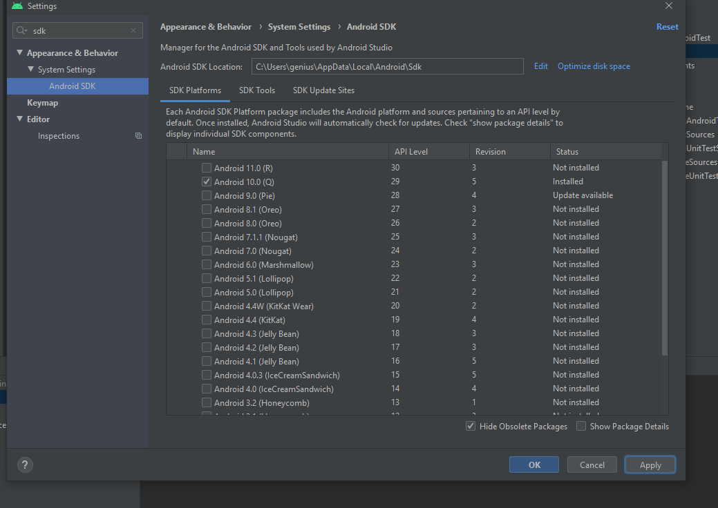
After opening the project, first of all build it by double clicking on the left hand to build.
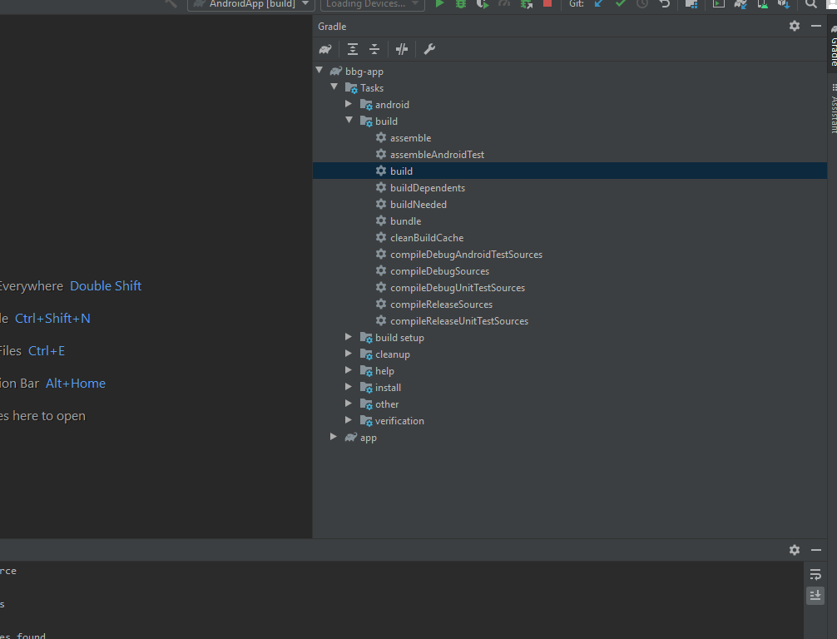
Then run the emulator. For this go to Tools → AVD Manager and add a virtual device. Setup a phone device, e.g. Pixel 4

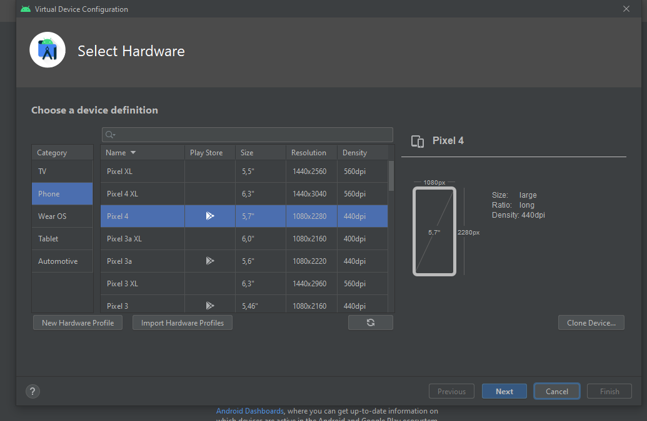
Download an arbitrary Android version (e.g. the newest one) since the App shall be able to be run on Android 6.
Use standard in next window and finish.

Download Docker
If using windows go to https://docs.docker.com/docker-for-windows/install/
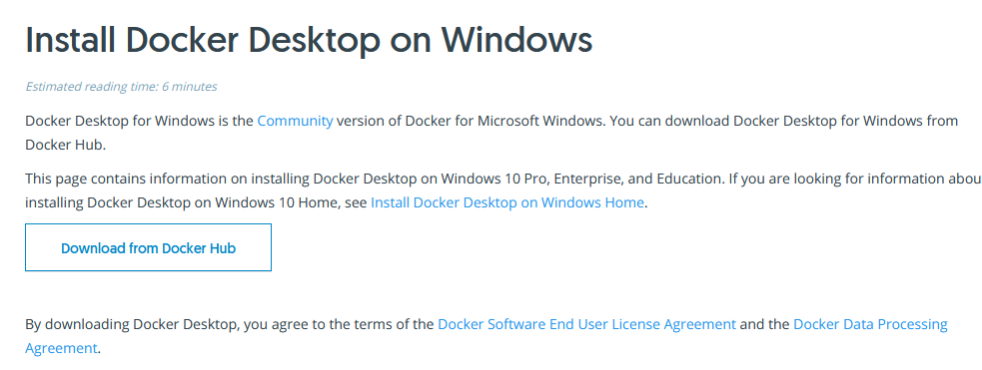
You might need to activate Hyper-V before docker is able to work. See https://docs.microsoft.com/de-de/virtualization/hyper-v-on-windows/quick-start/enable-hyper-v

Download PostgreSQL
Download from https://www.postgresql.org/
Should listen to port 5432.
Ask Uwe for the password for the postgres superuser. Its name should just be postgres.
Probably download a GUI client as well. E.g. pgAdmin from https://www.pgadmin.org/download/
This link is helpful for establishing a connection to the database:
https://examples.javacodegeeks.com/core-java/sql/java-jdbc-postgresql-connection-example/

