Ivy League scientists have called it the most powerful pain reliever on the planet.

Doctors are having astounding success using it to treat “untreatable pain”…

They’re giving it to the folks whom they’d given up hope on…

And they’re shocked to see that after their patients use this…

Their suffering and aches virtually vanish overnight.

This pain reliever is also completely non-habit forming, has no side effects, is 100% natural, and starts working in as little as 30 minutes…

And it’s now finally legal in the United States for the first time since 1937…

Which is the year that three of the richest Americans in history spent millions of dollars in an attempt to BAN this blessing from every day citizens like you and me (more on that in a minute).

It’s not marijuana…

But it is something top scientists are calling the biggest breakthrough in pain-relief since the discovery of Aspirin.

In the last year, it’s been featured extensively on Dr. Oz, NBC, CNN, The Today Show, ESPN, and dozens of other major news sources…

-Logo Graphics of Each Show or Channel Mentioned Above-

And today tens of thousands of people say it’s helped with their neuropathy, chronic pain, joint pain, back pain, arthritis and more.

Former NLF and MLB Stars, Army Veterans, and Dr. Sanjay Gupta of CNN say it can make your discomfort and soreness just “disappear”…

And this natural breakthrough has also been shown to aid with numerous other conditions and health challenges as well.

In fact, what I’m about to share with you is SO effective that the U.S. Government has actually patented it (Patent #6,630,507)…

And inside the patent, which was done by the Department of Health and Human Services…

The government states that this incredible pain-relieving secret…

* Can act as an anti-epileptic and anti-seizure…
* Is a powerful antioxidant…
* Can limit damage in cases of stroke, trauma, and the treatment of degenerative diseases like dementia…
* Can help with the treatment of glaucoma…
* Protects against cellular damage…
* And so much more.

Now I’m going to tell you what this natural elixir for pain relief is right inside this short video…

And I’ll also show you all of the science behind how it works…

While sharing the specific clinical, and double-blind studies that back everything I’m saying up.

But before I do that, I do want to warn you…

The drug companies who control American medicine do NOT want you to know about this.

They’re afraid that because this proven pain-relieving miracle is just as effective as their prescription medications…

Yet 100% Safe, 100% natural, 100% non-habit forming,…

And dramatically inexpensive…

If this breakthrough goes mainstream…

It will cost them BILLIONS in lost profits.

As a result of all this…

I can’t guarantee how long this solution will remain available to the public…

Or that it won’t end up getting BANNED by big money lobbyists…

Just like it did in 1937.

That’s why it’s vital you watch this presentation in its entirety…

Because while this solution can provide IMMEDIATE relief from the agonizing pain you’ve been suffering from for years…

It may not be available for long.

Okay, so let me go ahead and give you all of the details right now.

Hi my name is Adam…

I’m a pastor who lives with my wife and four beautiful children…

And the medicinal plant I’m talking about is Hemp.

Now you might be thinking it’s crazy that a pastor and family man would be telling everyone he knows to start using a plant that’s the cousin of marijuana…

But the truth is…

Hemp is one of the most health-rich plants on all of God’s green earth…

Given to us by nature to help with pain and dozens of other ailments…

It’s also legal in all 50 states…

And it’s impossible to get “high” off of hemp...

Because it doesn’t contain THC, which is the psychoactive chemical in “pot” that gets people “stoned.”

More importantly is that fact that scientists have now isolated the single most powerful natural compound inside of hemp…

And folks who use this special compound are seeing even their worst cases of pain start to fade away in as little as 30 minutes.

In fact, that’s what happened to one of my close friends Aaron…

And I want to share his story quickly with you.

-PICTURE-

Back in the 90s Aaron was a Division 1 college quarterback…

During which time he had some amazing games…

But also took one heck of a beating.

This physical punishment continued after Aaron graduated too…

As he made his way onto numerous NFL practice squads, and also spent time playing in the Arena football league.

By the time Aaron retired from football in 2005…

His body was in shambles.

Aaron suffered from shoulder injuries, a bad back, destroyed knees, and swollen wrists.

Plus Aaron’s hips were so bad that he had to get hip replacement surgery.

What really made Aaron scared though was the fact that he was only in this 30s…

If things were this bad now, what would they be like in his 50s…60s…70s…and beyond?

To make matters worst, Aaron was using painkillers on a daily basis…

Which were wrecking his liver, and making him go through his days feeling like a drugged out zombie.

Maybe you can relate to some of this…

Perhaps it hurts every time you bend over to pick up the paper…

Maybe you can’t play tennis, or the piano, or swing a golf club anymore without feeling terrible pain…

Or maybe you’re one of those people who is dependent on painkillers to get by every day.

If any of those things describe you or someone that you know…

Then this next part will really excite you.

You see: Aaron was MISERABLE…

And he thought his life was ruined.

But then Aaron discovered the all-natural hemp extract I’ll be sharing inside this presentation…

And suddenly, almost overnight, Aaron’s pain was GONE!

Within days Aaron says he felt 15 years younger…

He had his youthful speed and agility back…

And today Aaron even plays competitive beach volleyball…

Where he’s frequently seen dropping to one knee and jumping back up….

Diving and leaping…

And running around for hours at a time.

Aaron does this all without any of the constant arm, hip, and back pain he’d suffered from for over a decade…

And if this hemp extract can work for a former NCAA Division 1 Quarterback like him…

You better bet it can work for you too.

Of course what you’re probably asking is “well yeah, but how *DOES it work?”*

So let me go ahead and answer that question for you right now…

You see, the discovery of Hemp’s incredible healing powers all started in 1992…

With a man named Dr. Raphael Mechoulam, who’s a professor of medicinal chemistry at The Hebrew University of Jerusalem in Israel.

Dr. Mechoulam and his team were studying the brain….

And they discovered a special kind of neurotransmitter inside the brain called a “cannabinoid.”

Well as you can maybe guess, cannabinoids are also found in cannabis and hemp…

And as Dr. Mechoulam and his team continued to research this special neurotransmitter…

They were SHOCKED to find out that there was actually an entire network of cannabinoids and cannabinoid receptors in the human body.

This network is called the Endocannabinoid System…

And today thousands of studies show that the Endocannabinoid System is just as important as your digestive system…or your endocrine system…or your lymphatic system…when it comes to human health.

Here’s why…

The Endocannabinoid System works by bringing your body into a state of balance.

This is known as “homeostasis” which is just a fancy way of saying your body is in harmony…

And when the systems in our body are in balance, we’re healthy.

For example, when your temperature is at 98.6 degrees it’s good…

But if your body temperature gets too high or too low (growing out of balance), it can be deadly.

Well, what the Endocannibinoid System does is help to keep all of our body’s hormones in balance as well…

And this is super important because when our hormones are out of balance, things go terribly wrong.

For example if your adrenal glands aren’t in balance…

Then you produce too much adrenaline (a hormone) which can make you anxious, fatigued, and even overweight.

And that’s just one example…

Hormonal imbalance is associated with literally hundreds of major conditions and health challenges you face.

You see: your hormones are basically the “governors” of your body…

Each one is in charge of a few essential functions…

And combined they’re responsible for your overall state of health.

For example…

Melatonin is a hormone that controls whether you feel tired or alert…

Serotonin is a hormone that controls your mood, appetite, and sleep…

Thyroxin is a hormone that controls your thyroid and the speed of your metabolism…

Norepinephrine is a hormone that controls your heart and blood pressure…

Insulin is a hormone that allows your body to absorb glucose…

And these are just a few of the literally hundreds of hormones that are governing our bodies every day.

Well what’s so incredible about the Endocannibinoid System is that studies show it controls virtually ALL of our hormones in our body.

In other words…

If all of these hormones are individual “governors” that affect the different states of your body…

The Endocannibinoid System is like the President.

It’s the chief executive that controls everything…

And has ultimate control over each individual hormone.

That includes a hormone called Enkephalin…

Which is responsible for whether or not the human body feels pain.

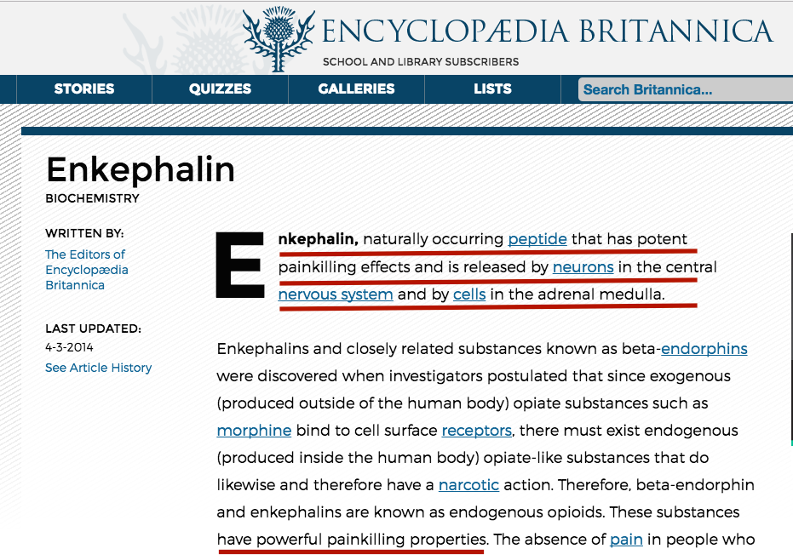

Enkephalin is so powerful that many experts call it the body’s natural painkiller[1]…

And today many of the most powerful pain drugs on the market, including opiates, simply mimic what Enkephalin does naturally[2].

Well what’s so great is that the Endocannibinoid System actually regulates Enkephalin too…

Stimulating this pain-stopping hormone, so that the pain you’ve been suffering from forever begins to vanish…

And doing it naturally, and without the dangers of addictive synthetic drugs.

Okay, so what does all of this have to do with hemp?

Well inside of the hemp plant there are many different types of cannabinoids…

Including a very special one called “cannabidiol”, or CBD for short.

Commercially, CBD is most often consumed as an oil extract and is 100% legal in all 50 states...

It’s considered to be the most powerful cannabinoid that there is…

And hundreds of studies show CBD binds to different hormonal receptors throughout the body…

Helping to protect against skin rashes and infections…promote calm and restful sleep…help regulate blood sugar…improve digestion…promote strong bones…eliminate inflammation…and so much more.

CBD also regulates Enkephalin, the natural painkiller I just told you about…

Which makes it incredibly effective as a tool to help with knee pain, arthritis, muscle spasms, shoulder pain, joint pain, headaches, backaches, and virtually every other kind of pain.

And if you’re at all skeptical…

Just look at the results of these major studies.

In a study by 2,495 patients published in Fibromyalgia Today[3]…

100% of patients using CBD to treat their fibromyalgia (muscle pain) reported less pain or discomfort after being on CBD therapy for at least 30 days.

This included their chronic pain, neuropathic pain, headaches, and migraines….

As well as Irritable Bowel Syndrome and Spinal Cord Injury.

Meanwhile in a 2008 meta-analysis published in the Journal of Therapeutics and Clinical Risk Management[4]…

It was concluded that: “numerous randomized clinical trials have demonstrated safety and efficacy” for CBD when it comes to peripheral neuropathic pain, rheumatoid arthritis, and cancer pain…

Leading to the conclusion that CBD “shows great promise” for treatment of pain.

Then there’s a November 2016 study published in the journal of Experimental Biology[5]….

Where it was found that CBD is “generally free from the adverse effects associated with NSAIDs”…

While acting as a powerful “anti-inflammatory” that can be used as a “treatment for chronic inflammation.”

And in another recent study published in the International Journal of Pain[6]…

Which was a randomized, double-blind, and placebo controlled…

63 patients with neuropathic pain were given CBD…

While 62 were given a placebo (sugar pill).

Scientists found that those taking CBD had a dramatically higher reduction in pain intensity, improvements in neuropathic pain and better sleep…

And during a follow up 52 weeks later…

Those taking CBD continued to experience much less pain and feel much better…

Plus their tolerance didn’t increase, nor did they form any dependency on CBD.

Isn’t that amazing?

And that’s seriously just scratching the surface…

A 2014 study in the International Journal of Biochemistry and Cell Biology[7] concluded that there was great “efficacy of cannabinoid compounds in the treatment of neuropathic pain.”…

Another recent study published in the European Journal of Pharmacology[8] found that CBD dramatically reduced chronic pain after injury...

And that there was great potential for “therapeutic use of cannabidiol [CBD] in chronic painful states…

The list goes on and on.

In fact, even the mainstream media has started to take notice.

Dr. Oz has called CBD’s “the future of chronic pain management”…

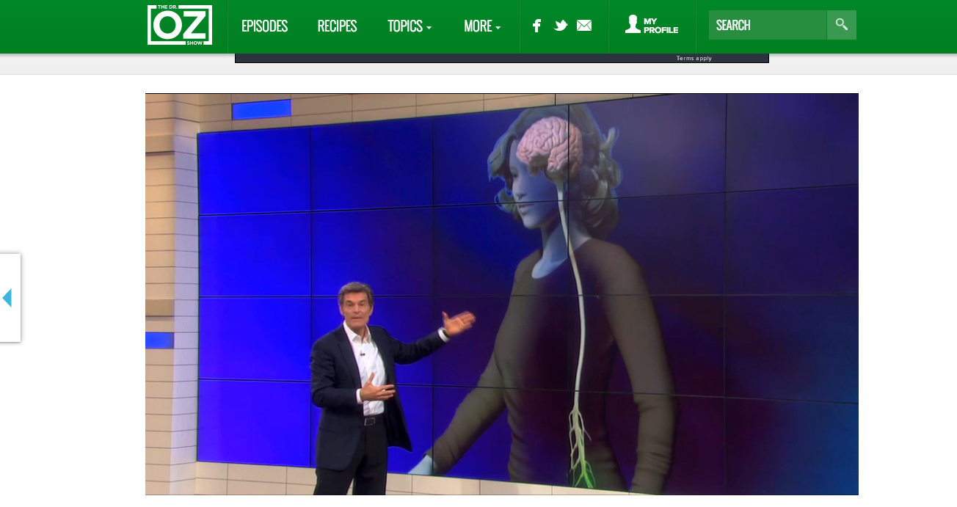

Dr. Sanjay Gupta of CNN says it’s a miracle that can help with everything from pain management to seizures…

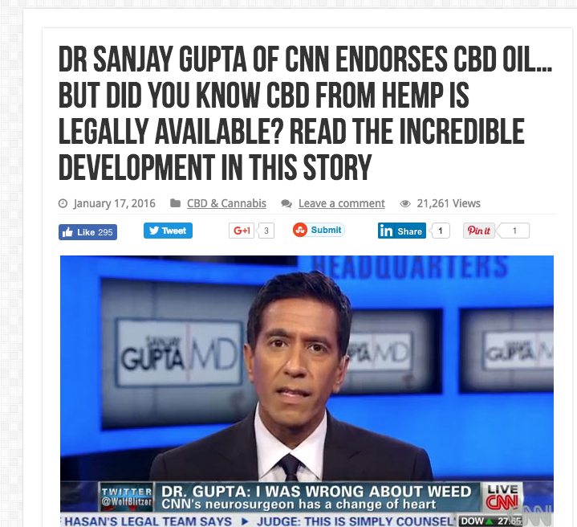

Two time World Series champion David Wells swears by CBD as well.

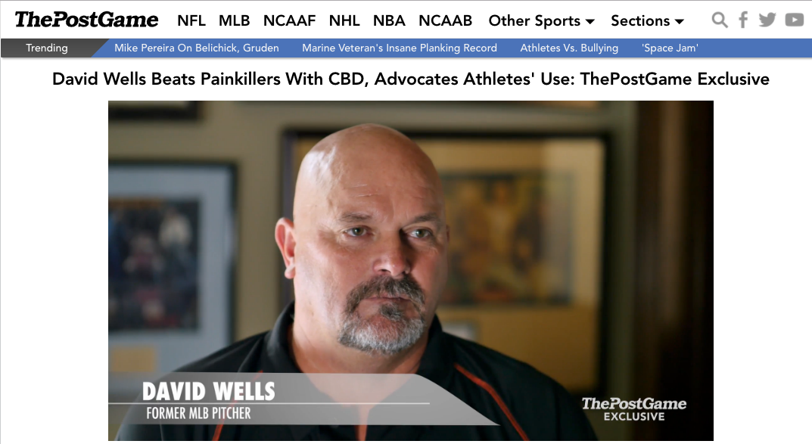

After a 20 year career and 3,439 innings pitched…

Wells suffered from shoulder pain, back pain, and joint pain that was so severe…

He’d become addicted to prescription painkillers.

But after he discovered CBD oil…

He was able to conquer his pain for good while also beating his horrible addiction.

Okay so by now you’re probably convinced that the CBD is nothing short of a miracle when it comes to managing your chronic pain.

You also know that it’s 100% non-habit forming…

Doesn’t get you “high”…

And has literally hundreds of additional benefits…from better sleep to less anxiety…to anti-inflammation to better digestion…from helping with glaucoma to aiding Type 2 diabetics.

So with all of this being said…

You’re probably wondering: “why on Earth was hemp banned by the government for over 70 years?”

And you’re also probably curious about where to find the best form of this healing CBD oil right now…

So that you can start trying out this health breakthrough for yourself…and share it with your loved ones too.

Well to answer the first question: why did the government ban hemp if it was so good for you?

The answer is the same as it always is: they caved into powerful elites whose financial interests were at odds with the American people.

You see: societies have used hemp thousands of years…

And up until the 1930s hemp was also a very popular “cash crop” in America that was used to make clothing, paper, and other products.

But in the 1930s Publishing Magnate William Randolph Hearst…industrialist Lamont DuPont…and U.S. Secretary of Treasury Andrew Mellon all joined together in an effort to make hemp illegal.

Why?

Well Dupont was working on a new process to make paper from wood…

Meanwhile Hearst was the largest owners of forests in the U.S…

And paper is of course made from wood.

Additionally both Hearst and Dupont had financial interests in synthetic fiber and petroleum…

Both of which competed directly against hemp clothing.

So they did what the ultra-greedy have been doing since the beginning of time…

They pressured Andrew Mellon and the government to make the possession or transfer of Hemp in the United States illegal without a permit.

And then they made sure that permits were very hard to find.

Everyday Americans went along with this because Hearst and Dupont associated hemp with marijuana – even though the two are entirely different…

And for the next 77 years, hemp was shut off from every day Americans like you and me.

In February, 2014 all of that changed however…

When President Obama signed the 2014 Farm Bill…

Which contained a special amendment to legalize the production of industrial Hemp in the United States.

What’s more, the U.S. Government went a step further and even patented CBD Oil, which is the healthiest part of Hemp…

Saying that CBD…

* Protects the brain and supports healthy blood and oxygen flow…
* Acts as a neuroprotectant that can limit damage in cases of stroke or trauma, and treat degenerative diseases including dementia…
* Protects the cells of the nervous system and brain…
* Has an anti-anxiety effect…
* Supports the nutritional health of aging bodies…

And so much more.

This patent is also remarkable because it’s the first time since the 1930s that ANY Government Agency has recognized the medical benefits of a natural compound…

And this patent also means what while CBD is currently available to the general public and at incredibly affordable prices…

That may not be the case for long.

And that brings us to your second question…

Which is where you can find the best form of CBD Oil right away…

So you can begin experiencing its hundreds of benefits immediately?

I was asking myself the same thing when I first started hearing about CBD all over the news…

And I did have a bit of a leg-up here…

Because one thing I didn’t mention already is that besides being an active Pastor in my church…

I’ve also been a manufacturer of premium, all natural health supplements for the better part of a decade.

Using the remedies that God’s given us through nature, to help us all live and feel better.

This means I’ve got great relationships with health experts all over the world…

Which was extremely helpful as I set out to find the best form of CBD available today.

This urgency behind my search was also a bit personal, by the way.

My father-in-law (who is also in the church) had suffered from intense joint pain for as long as I’ve known him…

So I wanted to something that would make him feel better too…

So that he could reclaim his life.

I wanted him to be able to join me, my wife, and our four young children when we went on family hikes…

So that he could skip along with his grandsons and granddaughters, climb up rocks with them, and basically be a big kid…

And do all of it without wincing in pain every 5 minutes….

Or feeling like he needed to lay down and rest as soon as we got home.

So I began ordering CBD products from everyone in the industry I knew of…

And the great news was that they WORKED!

Within a matter of days my father-in-law’s pain levels were lower than they’d been in three decades…

While personally I noticed I was sleeping better…

Feeling calmer and more focused…

And I even noticed my blood pressure went down.

So that was the good part…

But I was also frustrated to find out that almost everyone selling CBD oil did it in liquid form…

Where you were responsible for putting several drops underneath your tongue.

Not only does this taste nasty…

It also makes it hard to get the dose right, which is very frustrating.

So I went to work…

Hitting the lab, and drawing on all of my years as an expert in the health supplement space.

Finally, what I came up with was a way to capture the power of CBD oil inside of a small, liquid gel capsule.

Each capsule contains 10mg of 100% Pure Quality CBD Oil, which is more than enough for most folks…

And each capsule is about the size of a small BB – which makes it very easy to swallow.

I’m telling you, these gel capsules have been a blessing for so many folks…

And I’m proud that because of my experience and know-how in this industry…

I’m one of the only people on the planet who can make these gel caps.

Plus once I’d figured all of this out…

I even went a step further…

And added 490 milligrams of pure hemp oil into each gel capsule too.

You see while CBD is the most powerful cannabinoid of all…

Hemp oil has hundreds of additional and amazing benefits.

It actually has the highest amount of Omegas 3, 6, and 9 of any plant…

Which makes it great for your heart, your joints, and your brain.

And because these crucial Omegas are coming from a plant, rather than a fish…

With Hemp Oil you don’t have to worry about mercury, or that fishy taste afterwards.

I’m calling this product GREEN RELIEF…

It’s made right here in the United States, in an FDA Compliant Facility…

And you have my word that it’s the best, most ultra-grade form of CBD Oil that you can find on the market.

So now let me tell you how you can get your very own supply of GREEN RELIEF today…

So that you can begin to free yourself from discomfort, aches, and pain within a few short days.

Originally my plan was to retail GREEN RELIEF for $149 a bottle, which is extremely reasonable in my opinion.

After all once you start using this all-natural breakthrough…

The relief you get could be just as powerful as if you were using a prescription opiate painkiller…

But with GREEN RELIEF there are zero of the side effects, and it’s not habit forming.

In fact, if anything GREEN RELIEF has hundreds of side-benefits…

Like better sleep, better mood, lower blood pressure, a healthier immune system, anti-cancer properties, etc.

And because prescription painkillers can cost a FORTUNE each month…

I figured pricing GREEN RELIEF at just $149 was completely reasonable…

Especially when it can make all of your pain fade away.

Plus that’s not even getting into all of things that GREEN RELIEF can give you, and that you can’t put a price tag on…

Like being able to go out and enjoy 18 rounds of golf again without experiencing any soreness in your shoulders or back…

Or go a ball game and sitting for hours in those hard seats…yet not feeling any aches in your body afterwards…

Or simply dancing the night away with your spouse…as you both glide gracefully and unhindered by any discomfort at all.

These are all realities once you begin using GREEN RELIEF…

Which is why $149 seems like a heck of a deal to me.

And YET…

Be that as it may…

You’re actually not going to be asked to invest anywhere close to $149 for your own bottle of GREEN RELIEF today.

You see…

Because I actually oversee the production of GREEN RELIEF myself…in a state of the art facility…

I can produce each bottle at a lower cost than most other folks in the industry can.

It’s definitely still not “cheap” for me…

But at the same time, this does gives me a big advantage when it comes to pricing.

And as a result of that, I’ve decided to pass my savings onto you…

So that you can order your very own bottle of GREEN RELIEF right now not for $149…or even $99…

But instead, just a one time investment of $69.

Plus I’ll also include your shipping and handling for free, which is a $9.99 value...

So go ahead and place your order now by clicking the button you see beneath this video screen…

And secure your very own supply of GREEN RELIEF for $80 off the regular price of $149.

When you do click that button you’re seeing right now…

You’ll go to my 100% Secure, Private, and Confidential Checkout Page…

Where you’ll just enter your shipping details…

And submit your order.

It only takes 2 minutes to do this…

And as soon as you’re finished…

My team will go to work packaging up your GREEN RELIEF and shipping it out to you.

Then your order will arrive in 3-5 business days.

Each bottle of PRODUC NAME has 30 Capsules inside…

And for many folks, just one of these capsules a day will bring you major relief.

But if you do suffer from really severe pain, I’ve got good news for you too...

You see, because CBD Oil is non-habit forming, completely natural, and has zero side-effects…

You can take as many capsules per day as you need to conquer your pain.

Heck – one of my friends who was in a bad auto accident takes 6 capsules a day…

And since he started, he says he can move around the house without discomfort for the first time since the wreck.

Plus to help those folks who are in pain out even more…

If you do want to order additional bottles of GREEN RELIEF on the checkout page…

I’m actually going to give you an even bigger discount.

In fact as you’ll see on the next page…

You also have the option to add 6 bottles of GREEN RELIEF to your order for just $49/bottle…

That’s another $20 off the single bottle price…

And a savings of $600 overall.

Now I’m going to be pretty much losing money if you do decide to take that option…

But that’s okay because honestly as a Pastor…

My efforts and focus are on helping my fellow man…

Not on profits.

So if your pain is really bad…whether it’s your joints, your nerves, your back, whatever…

I encourage you to take advantage of this special offer to get 6 bottles of GREEN RELIEF for a discount of $100/bottle….

By clicking the button you see below this video now and completing your order.

You can do this with confidence because your investment today is also being covered by my 180 Day, 100% Money Back Guarantee.

It works like this…

You simply click the button below the video right now, and choose how big of a discount on GREEN RELIEF you want.

Then you place your order, and you get your supply of blessed GREEN RELIEF to your front door in the next few days.

After that you have a full 6 Months (that’s HALF A YEAR) to decide for yourself if this is for you or not.

I’m positive that you’ll be thrilled with GREEN RELIEF because that’s what’s already happened for thousands of folks across the world…

They love that they can stand in the kitchen, cooking for their loved ones and feel great while doing it…

That they can take up jogging again, without any knee pain whatsoever…

That their diabetic nerve pain is finally gone!

I’m positive it will be the same way for you…

But if for any reason I’m wrong, and you don’t absolutely LOVE GREEN RELIEF…

You can get a full, 100% money back refund at any point in the next 180 days.

Plus, you don’t even have to ship back your order…

It’s yours to keep as my way of saying “thank you” for putting your faith in me.

Just call or email my support team at any time…

And we’ll refund your full investment – no questions asked.

So legitimately there’s absolutely zero risk here…

And you have so much to gain.

You’ve seen the science behind why CBD is the biggest health breakthrough of the century…

You’ve seen how it’s helped pro-athletes turn back the clock after their bodies have taken YEARS of beatings…

How Dr. Sanjay Gupta and Dr. Oz both say this is the future of pain treatment.

I mean heck….

You know this is good when the government actually puts a patent on it…

The first time they’ve done so for a natural ingredient in over 80 years!

CBD works, and it can make your life so much better…

But it’s on you to take action right now.

Please don’t wait…

Because I can’t guarantee how long this special deal will last…

And I’d hate for you to miss out on this miracle to your health.

The bottom line is this…

If the government caves in to the big money lobbyists in the pharmaceutical industry…

Or decides that it wants to monopolize control of CBD Oil for itself – so it can profit while we suffer…

Then CBD could be impossible to find almost overnight.

Plus, there’s no reason for you to suffer with pain a moment longer, when the possibility of total relief is right here waiting for you.

That means if you’re ready to experience the life changing power of GREEN RELIEF…

And to conquer your joint pain, your fibromyalgia, your osteoarthritis…or any other form of pain you’re dealing with…

Then you must click the button beneath this video screen right now…

And secure your very own supply of GREEN RELIEF for up to $100 off the normal retail price per bottle.

This presentation is now finishing….

And the choice is yours.

You can keep paying hundreds of dollars a month for synthetic and dangerous painkillers that are addictive and have their own horrible side effects…

You can keep popping Aspirin, or Advil, or Tylenol…even though these have been linked to liver damage and cancer…

You can keep living your life in a constant battle with pain…

You can keep letting conquerable pain cause you to miss out on the experiences with family and friends that make life great…

Or you can click the button you see below this video right now…

Secure your own supply of GREEN RELIEF in easy to swallow liquid gel caps…

Be protected by a 180 Day Money Back Guarantee that removes all of the risk…

And feel the pure joy as all of your pain and discomfort finally disappears.

Only you can decide…

But I will be praying that you make the right choice for your health.

God Bless,

Pastor Adam Hagaman

Nampa, Idaho

-8 Second Pause-

Hey are you still with me?

No problem – maybe you still need a few things cleared up from my presentation…

So what I’ll go ahead and do right now is answer some of the most common questions folks ask me…

That way you can make your investment in GREEN RELIEF today with 100% peace-of-mind.

**Question 1: So how exactly does CBD oil make my pain go away again?**

So remember that CBD stands for cannabidiol…

And it’s the most important cannabinoid in the Endocannabinoid System.

The Endocannabinoid System is what controls all of your hormones in your body…

And this includes Enkephalin…

Which is the hormone that experts call the body’s “natural painkiller.”

In fact, Enkephalin is so powerful that most commercial opiates are based off of it…

But what CBD does is regulate the release of Enkephalin into your system naturally…

So that you get extremely powerful and effective pain relief…

Without any fear of addiction, or damage to your body.

**Question 2: What else does GREEN RELIEF help with?**

The research behind CBD is staggering…

And even the government has patented this miracle for a variety of uses…

Saying that it:

* Protects the brain and supports healthy blood and oxygen flow…
* Acts as a neuroprotectant that can limit damage in cases of stroke or trauma, and treat degenerative diseases including dementia…
* Protects the cells of the nervous system and brain…
* Has an anti-anxiety effect…
* Supports the nutritional health of aging bodies…
* Can help with the treatment of glaucoma…
* Can act as an anti-epileptic and anti-seizure…

So while all commercial and pharmaceutical pain-killers have bad side effects, CBD actually only has good side BENEFITS. And since it’s all-natural and non-habit forming, it’s impossible to “take too much”.

**Question 3: Are you 100% Positive that CBD Won’t Make Me “High?”**

Yes.

It’s scientifically impossible to get “high” off of CBD and here’s why…

First of all, the CBD in GREEN RELIEF comes from industrial hemp, not cannabis…

Which is why it’s legal in all 50 states.

Secondly, it’s the THC in cannabis that gets people high…

But CBD is simply an ultra-healthy compound found within the same plants…

It has zero psychoactive effects on you whatsoever.

Question 4: How long will it take to get my order of GREEN RELIEF once I’ve placed it?

The moment you place your order, my team will go to work shipping it out to you.

From there it’ll just take 3-5 business days…

And once you start using GREEN RELIEF…

You could start feeling relief in as little as 30 minutes!

**Question 5: How much GREEN RELIEF should I take each day?**

So each bottle comes with thirty 10mg liquid gel capsules.

I’d say you simply start with one, allow 30-60 minutes, and see how you feel.

If you’re pain is really severe, you simply take as many additional gel capsules as you need each day…

Because unlike Advil or other painkillers, GREEN RELIEF is 100% natural and there are no dangerous side-effects or harm to your liver or body.

Plus if you do decide to take several capsules a day…

I’ve made it very affordable to do so by offering my 6 bottle discount.

**Question 6: How does that 6 bottle discount work again?**

It’s great!

If you suffer from severe pain, and think that it might take more than one capsule a day of GREEN RELIEF to get the ultimate relief you need…

You simply order 6 bottles on the checkout page…

And you get them at a rate of just $49/bottle…

Which is a huge savings of $100/bottle off the normal retail price.

This is also a great option if you want to order for family and friends, or want to stock up in case the government bans CBD again…

And you’ll be 100% protected when you do this because your order comes with my 180 Day, 100% Money Back Guarantee.

**Question 7: What are the terms of this guarantee again?**

This is one of the best guarantees in the supplement industry.

Because I know you may not have tried CBD before…

I want you to feel 100% confident when you make your investment today.

In order to make that happen…

Your order comes with a full 180 day money-back-guarantee.

That means if you change your mind about your investment for any reason…

You have an entire 6 months to get a full refund – with zero questions asked.

It’s simple: you just call or email my team and they give you your money back…

And you don’t even need to return any product – it’s yours to keep!

Question 8: How long will this offer be available?

It’s hard to say…

My concern is that generally whenever a natural remedy for health challenges really, truly works…

Big medicine and the pharmaceutical industries rush to get it banned immediately.

I think there’s a very real danger this happens with CBD too…

Because once this gets out, it’s going to cut into the sales of all kinds of painkillers – both prescription and over-the-counter.

Then there’s the fact that the government has a patent on CBD too…

Which means they could always decide they want to use it as a source of revenue…

And ban others from providing it to the public…

While raising the prices dramatically.

All of which means I don’t think you should wait even one day on this decision…

Especially since you’re going to be protected by that full 180 Day, 100% Money Back Guarantee, and can feel relief from even chronic pain with the very first Green Relief capsule you take.

Question 8: Okay, I’m ready to experience the wonderful benefits of GREEN RELIEF. What now?

This is the simplest part…

Just click the button you see below the video right now…

And you’ll go to my secure checkout page.

It only takes about 2 minutes to place your order…

And once you’re finished, we’ll start shipping out your supply of GREEN RELIEF to you.

Plus shipping and handling is included for free…

Which means ordering has never been easier.

So go ahead and click the button now…

And I can’t wait to hear about your experience using GREEN RELIEF.

God Bless,

Adam

1. <http://www.discoveriesinmedicine.com/Com-En/Endorphin-and-Enkephalin.html>
2. <https://www.britannica.com/science/enkephalin>
3. <http://www.fibrotoday.com/cbd-remarkably-effective-for-fibromyalgia-survey-finds/>
4. <https://www.ncbi.nlm.nih.gov/pmc/articles/PMC2503660/>
5. <https://www.ncbi.nlm.nih.gov/pubmed/27435265>
6. <https://www.ncbi.nlm.nih.gov/pubmed/17997224>
7. <https://www.ncbi.nlm.nih.gov/pubmed/25150831>
8. <https://www.ncbi.nlm.nih.gov/pubmed/17157290>