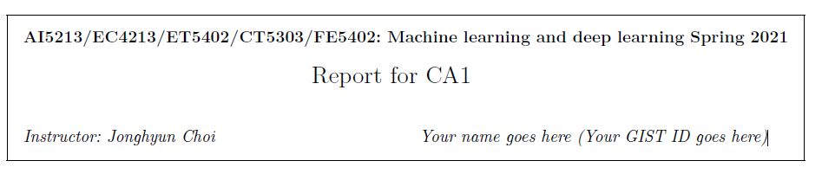

**Report1 : Describe model your have used (1. architecture overview and 2. any specialty of this model.)**

I used Convolution Neural Network model.

Our architecture includes 4 convolution layer and 2 fully connected layer

After every convolution layer, I used Batch Normalization, ReLu Activation Function to detach non -linearlity and maxpooling.

Convolution layer output channel is getting bigger and bigger to capture the image feature.

**Report2 : Report both the training and testing accuracy in a plot (x: epoch, y: accuracy).**

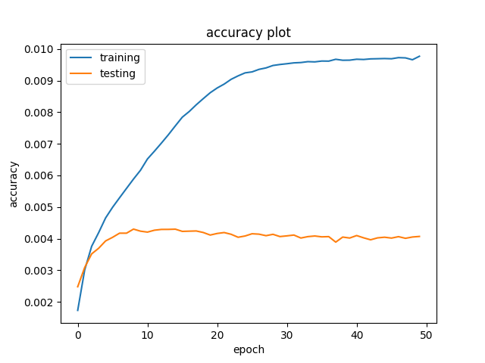

Training accuracy is too high. Test accuracy is lower than the Training accuracy

Overfitting in my architecture. it is hardly fit the train data

**Report3 : Discuss any ideas to improve the accuracy (e.g., new architecture, using new layers, using new loss)**

There is problem that more fitting the train data.

To overcome the overfitting and improve the accuracy, I will use data augmentation technique.

Data augmentation is a technique that slightly variate to original data to generate diverse data.

For example, Rotate the image, Flip the image, Resize the image.

And we need to hyperparameter tuning. We don`t know our batch size and learning rate is optimal to our model. So we tune the hyperparameter using the hyperparameter search method.