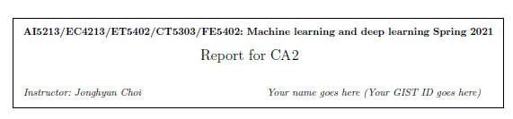

**Report1 : Describe model your have used (1. architecture overview and 2. any specialty of this model.)**

I used the same network with CA1, that is 4 convolution layer and 2 fully connected layer.

To solve the noisy label problem, I apply three special techniques.

**First**, I did data preprocessing, To data preprocessing, measure the Perceptual similarity metric of images in each class. Delete the images that are far from the averages score. As a result, it remains not a noisy label.

**Second**, Doing a data augmentation, To see a another image data, I try to use data augmentation skill in each batch images. For example, flip, Rotation, Normalize, Crop…

**Third**, Doing cross validation, we want to see whole data and generalize to other unseen data

**Report2 : Report both the training and testing accuracy in a plot (x: epoch, y: accuracy).**

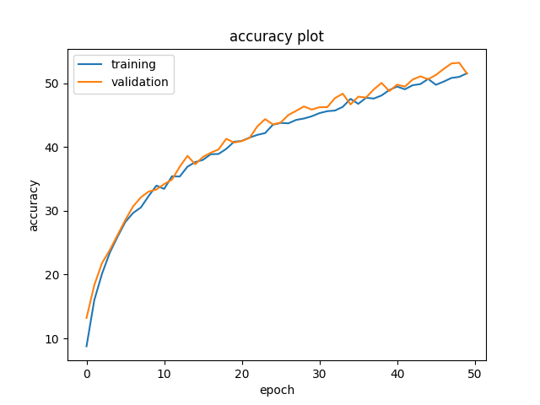

There is not overfitting problem, because I used 5-fold cross-validation.

But training accuracy & test accuracy didn`t going higher.

I had tried to increase epoch size, accuracy is not dramatically changed

**Report3 : Discuss any ideas to improve the accuracy (e.g., new architecture, using new layers, using new loss)**

I increase epoch size and train, there didn`t change accuracy.

I think my architecture is too small, so I will increase architecture size.

Doing semi supervised learning, unsupervised learning part is using auto-encoder architecture.

Train images without a label, and then extract latent vector to use by network initialization.