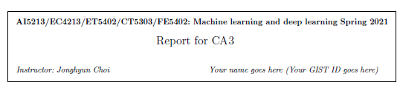

**Report1 : Describe model your have used (1. architecture overview and 2. any specialty of this model.)**

I used the same network with CA2, that is 4 convolution layer and 2 fully connected layer.

To solve the long-tail distribution problem, I apply two special techniques.

**First**, using focal loss that is suitable for long-tail distribution problem. Focal loss is focus on hard-classified example, so they well distinguish small sample of data.

**Second**, Doing ensemble, single model is not generalize to dataset, multiple model can be more generalize to data because it is reflect many opinions.

**Report2 : Report both the training and testing accuracy in a plot (x: epoch, y: accuracy).**

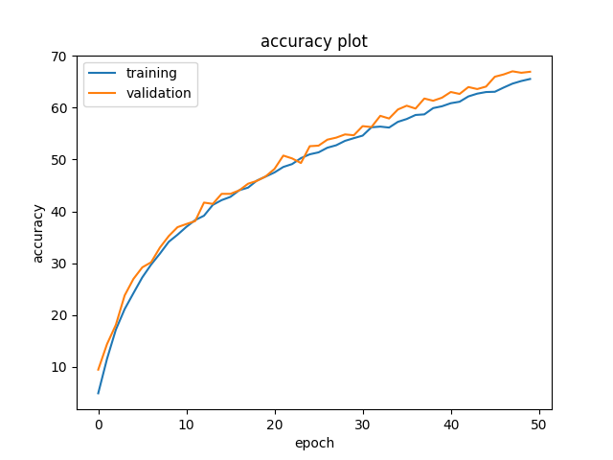

training accuracy & test accuracy didn`t going higher.

I had tried to increase epoch size, accuracy is not dramatically changed

**Report3 : Discuss any ideas to improve the accuracy (e.g., new architecture, using new layers, using new loss)**

focal loss is doing great to imbalance data, but ensemble is not doing best

because there are mixing the not good model and I use one kind of model not diverse that just adjust hyper parameter

so. My ensemble is not great everydays.

IF I have a time, I will make diverse model and ensemble together.