0Phishing prevention System
A Capstone Project
Presented to the Faculty of the
College of Information Technology Education
PHINMA University of Iloilo

In Partial Fulfillment
of the Requirements for the degree
Bachelor of Science in Information Technology

By:
Jullius Valdevieso
Joshua Torres
Jull Angelo Layno

MARCH 2026

Approval Sheet
In partial fulfillment of the requirements for the Bachelor of Science in Information Technology, this Capstone Project entitled Phishing prevention System prepared and submitted by Jullius Valdevieso, Joshua Torres and Jull Angelo Layno who are hereby recommended for corresponding final evaluation.

Ryan C. Valeriano
Adviser

Approved by the Panel of Evaluators with a grade of PASSED

Dr. Arnold M. Fuentes, Ph. D, MPA, MMIT
Chairman

Accepted in partial fulfillment of the requirements of the degree Bachelor of Science in Information Technology

Seth dA. Nono, MSCS
CITE, DEAN OF DEANS

ACKNOWLEDGEMENT
First and foremost, I want to thank and praise God, whose blessings and guidance helped me to walk this path. I couldn't have accomplished this goal without His wisdom and grace.
I want to also express sincere thanks to my family, who have been my solid support system. I am the person I am now because of their sacrifices, support, and love.
To my fellow students, I am thankful for your support, encouragement, and motivation, which have made this journey more meaningful.
I am very thankful to my community for the inspiration, support, and sense of belonging that have inspired me to pursue achievement.
Lastly, I am thankful for my school and the educators who have assisted me throughout my academic journey. Their dedication and commitment to knowledge have been instrumental in my growth and success.

Abstract
Phishing attacks pose a significant threat to individuals and organizations, leading to financial losses, reputational damage, and emotional distress. By understanding the risks associated with phishing and implementing preventative measures, both individuals and organizations can reduce vulnerability to these cyber threats. Phishing scams have cost organizations millions of pesos, either through tricking individuals into transferring money or by using stolen credentials to access sensitive accounts.This study focuses on the development of a Phishing Prevention System designed to detect potentially malicious URLs from emails or messages, allowing users to verify whether a link is phishing-related or safe. The objective is to provide a user-friendly, accessible tool that strengthens online security awareness and reduces the likelihood of falling victim to phishing scams. The research utilizes data from documented phishing incidents, combined with URL analysis techniques, to identify suspicious patterns and behaviors commonly used in phishing attempts. The system is tested through various phishing and legitimate URL samples to evaluate its accuracy, reliability and ease of use. This abstract highlights the project’s objectives, methodology, and expected outcomes, emphasizing the importance of improving cybersecurity awareness, empowering users to identify threats, and mitigating the risks of phishing attacks within educational and organizational environments.

Chapter I
Introduction to the Study

The internet has revolutionized our lives, but this increased connectivity has also created new opportunities for cybercrime. Phishing, a prevalent and evolving threat, exploits human vulnerability to trick individuals into revealing sensitive information. This poses a significant challenge to individuals and organizations worldwide, resulting in substantial financial losses and reputational damage. While technological defenses play a crucial role, they are not enough. Human error remains a weak link, making user awareness and vigilance paramount.
This study focuses on the development of a Phishing Prevention System that allows users to input or paste URLs from emails or messages to verify whether they are malicious or safe. By simulating real-world phishing attempts through collected samples, we aim to evaluate the system’s ability to accurately detect threats and provide timely warnings. This research will also explore how varying phishing techniques and different URL-based tactics influence detection accuracy and user trust. By providing a reliable verification tool alongside promoting awareness, the project seeks to strengthen individual and organizational cybersecurity against phishing attacks.

Technical Background of the Study
Phishing is one of the most common and harmful types of cybercrime. It targets people and businesses by taking advantage of how people act instead of how systems work. Phishing attacks have grown increasingly complex as digital communication and online transactions continue to expand, resulting in monetary losses, data breaches, and eroded customer confidence. Since many phishing efforts can still avoid detection and reach unwary users, traditional security measures like spam filters and antivirus software are sometimes insufficient.
A Phishing Prevention System uses contemporary technology to automatically identify and stop phishing attempts. Important ideas and technologies used in these systems include:
- Machine Learning (ML): To find patterns that differentiate between real and phishing information, ML algorithms examine large datasets of URLs and emails. Through ongoing learning and adaption to novel attack strategies, the model gradually increases its accuracy.
- Data Analytics: By processing and interpreting vast amounts of data from multiple emails, data analytics technologies allow the system to identify irregularities and questionable patterns that can point to phishing efforts. These insights aid in enhancing decision-making when recognizing risks and improving detection accuracy.
- URL and Email Analysis: The system can evaluate a website's validity and identify potentially dangerous links before visitors engage with them by looking at domain names, SSL certificates, and link structures.
- User Education and Awareness: In addition to technological detection, the system raises cybersecurity awareness by educating users about phishing threats and helping them spot phony links or messages.

Statement of the Problem
Phishing, which takes use of human weaknesses rather than system flaws, is still a significant cybersecurity issue. Many phishing attacks continue to bypass filters in spite of advanced security measures, resulting in monetary loss, data breaches, and reputational harm.
Employers frequently use outdated detection techniques and insufficient educational initiatives, leaving employees vulnerable to misleading messages and fake websites.
Common problems include:
- Ineffective Detection: Traditional filters fail to identify new or modified phishing attacks.
- Low User Awareness: Many users cannot recognize phishing attempts.
- Lack of Automated Analysis: Few systems automatically analyze URLs or emails for phishing signs.
- No Real-Time Alerts: Most systems do not warn users immediately when threats appear.
This study seeks to address the growing threat of phishing attacks by developing a Phishing Prevention System that integrates modern technologies such as machine learning, data analytics, and real-time URL analysis. The goal is to create a system that accurately detects malicious URLs, prevents users from accessing phishing websites, and promotes cybersecurity awareness. By automating the detection process and providing instant feedback, the system aims to reduce successful phishing attempts, minimize data breaches, and strengthen the overall security posture of individuals and organizations.

Objective of the Study
The main objective of this research is to create, develop, and evaluate a Phishing Detection System that employs machine learning to identify malicious URLs and raise user awareness of phishing risks. The system's goal is to offer a user-friendly, accurate, and automatic way to stop phishing attacks.
The specific objectives of this study are as follows:
- To design and develop an intelligent phishing detection system using machine learning: By analyzing extracted data such domain structure, unusual link patterns, and email keywords or suspicious phrases, this goal aimed to develop a system that could categorize both URLs and email contents as authentic or phishing. To achieve high detection accuracy, the system used supervised learning algorithms that were trained using verified datasets
- To develop a user-friendly web-based interface for phishing detection: The system featured a user-friendly and easily navigable interface that allowed users to enter URLs or email texts for analysis, view detection results, and receive immediate alerts when suspicious or harmful content was identified. The purpose of this feature was to make cybersecurity tools easier to access and understand for users without a technical background.
- To evaluate the system’s performance and reliability: The study assessed the accuracy, precision, recall, and overall efficiency of the phishing detection model using datasets containing both legitimate and malicious URLs and email samples. The evaluation determined how effectively the system could detect phishing attempts in real-world scenarios.
- To strengthen cybersecurity measures for individuals and organizations: This system was implemented with the goal of providing a practical and preventive tool against phishing attacks, thereby contributing to safer online transactions, enhanced data protection, and greater trust in digital communications.

Significance of the Study
This study is important because it aims to improve how classroom observations are conducted and how teaching performance is evaluated. By developing a digital observation tool, the research seeks to make the process more efficient, fair, and helpful for both teachers and administrators. Ultimately, it hopes to create better learning experiences for students and support the continuous improvement of education.
- Teachers The system gives teachers structured and easy-to-understand feedback about their teaching performance. This helps them see what they are doing well, discover areas that need improvement, and apply new strategies to make their classes more engaging and effective.

- Students When teachers improve their methods with the help of observation feedback, students benefit from lessons that are more interesting, interactive, and easier to understand. This can lead to better participation, motivation, and learning outcomes.

- Client The system helps administrators monitor classroom performance and teaching quality through reliable and consistent data. This makes it easier for them to plan teacher training, review the curriculum, and make well-informed decisions that support overall school improvement.

- Proponents For the researchers, this study serves as a valuable learning experience. It allows them to understand the needs of educators and administrators, as well as the challenges of creating a digital observation system. The insights gained will guide future improvements, ensuring the system stays useful, user-friendly, and relevant to modern educational goals.

Scope and Limitation of the Study
This study focused on the design, development, and evaluation of Phishing Prevention System that uses URL and email content analysis to detect and report phishing attacks. The system detected risky URLs and suspicious email contents by using machine learning algorithms, data analytics, and real-time scanning. Its purpose is to give users an effective and easy-to-use platform for identifying and avoiding internet risks including:
- Phishing Detection: The system examined URLs and email contents to determine their legitimacy as either genuine or phishing attempts, relying on domain characteristics, structure, and behavioral patterns.
- Machine Learning Integration: The study used supervised learning algorithms that were trained on verified phishing and authentic datasets to increase detection accuracy and flexibility.
- User Interface Development: A straightforward and user-friendly web-based interface was created, enabling users to scan links or emails, obtain quick detection results, and see alerts for questionable actions.
- Data Analytics: Implementing analytics tool to analyze large words related to phishing, scans patterns, and improve detection.
The system will be used in a business such as printing services, computer shops, and study hubs. The scope includes development, testing, and evaluation of system in a real word environment.

Limitations of the study
While the study aims to address several aspects of phishing detection there are some limitations:
- Limited detection scope: The system is focused mainly in email contents and URLs and doesn’t cover other phishing methods such as vishing.
- No File scanning feature: The system doesn’t have the ability to scan files or attachments, that may also contain phishing contents.
- Controlled testing environment: Testing was conducted with controlled conditions using specific phishing and URLs that may differ from real word environment.
- Dependence on behavior: The system only detects and alerts user showing results but the final decision depends on user judgement.
- User and Environmental Factors: Results may have been influenced by differences in user awareness, technical skills, and responsiveness to security alerts during testing.

Definition of Terms
1.Machine Learning – A branch of artificial intelligence that enables computers to learn from data and make predictions or decisions without being explicitly programmed.
2.URL (Uniform Resource Locator) – The web address used to access a specific website or resource on the internet. In this study, URLs are analyzed to detect possible phishing links.
3.Cybersecurity – The practice of protecting systems, networks, and data from digital attacks, unauthorized access, or damage.
4.Email Content Analysis – The method of scanning and evaluating email messages to detect suspicious words, links, or patterns that indicate phishing attempts.
5.Real-Time Detection – The capability of the system to identify and alert users about phishing threats instantly as they occur.
6.User Awareness – The level of understanding and alertness of users toward potential cybersecurity threats like phishing emails or websites.

CHAPTER II
Review of Related Literature
This chapter presents various local and international studies related to phishing detection and prevention systems. It focuses on existing technologies, methods, and strategies that researchers have used to detect and prevent phishing attacks, including the use of machine learning, data analytics, and user awareness programs.
Local Studies
In the Philippines, several studies have been conducted to strengthen cybersecurity awareness and develop systems that help users detect and prevent phishing attacks. These local initiatives emphasize the growing importance of cybersecurity education and the application of machine learning technologies in protecting Filipino users from online threats.
According to Dela Cruz and Santos (2021), the increasing number of phishing incidents targeting social media and banking users in the country highlights the need for real-time detection systems. Their study introduced a simple web-based platform that scans suspicious links shared through emails and instant messages. Results showed that automated detection significantly reduced user exposure to fraudulent sites.
Meanwhile, Mendoza (2020) developed a browser-based anti-phishing plugin designed for local online banking users. The system used URL pattern recognition and a blacklist of known malicious domains to alert users before accessing risky websites. The study concluded that lightweight browser tools can improve user safety without affecting browsing performance.
In another related project, Villanueva et al. (2022) created a phishing awareness mobile application aimed at students in higher education institutions. The app simulated phishing attempts and measured users’ responses to test their awareness levels. Findings revealed that user training and interactive simulations effectively improved the ability to identify phishing attempts.
These local studies demonstrate that awareness programs and machine learning-based tools play a vital role in reducing phishing incidents in the Philippines. They also support the development of systems like the Phishing Prevention System, which integrates automated detection with educational features to provide comprehensive protection for users.

Synthesis of the Studies
Based on the reviewed local and foreign studies, researchers have developed different methods to detect and prevent phishing attacks using both technological and educational approaches. Foreign studies emphasized the use of machine learning algorithms, data analytics, and real-time URL analysis to accurately identify phishing websites and malicious links. These studies demonstrated that automated detection techniques significantly improve efficiency and reduce false positives in phishing detection systems.
qMeanwhile, local studies focused on awareness programs, browser tools, and mobile applications to educate users about phishing threats. These initiatives highlighted that technical solutions alone are not enough — user awareness and behavior also play a major role in reducing the success of phishing attacks.
Despite these advancements, many existing systems still face challenges such as limited real-time scanning, lack of integrated awareness tools, and difficulty in adapting to new phishing techniques. To address these gaps, the current study — the Phishing Prevention System — aims to combine machine learning-based URL and email analysis with user awareness features. This integration provides a proactive and educational approach to cybersecurity, offering both prevention and learning in one unified platform.

References
Dela Cruz, L. M., & Santos, R. J. (2021). Development of a real-time phishing link scanner for Filipino users. Philippine Journal of Information Technology and Computing, 9(2), 33–40.
Mendoza, A. C. (2020). Browser-based anti-phishing plugin for online banking users. Journal of Computing Innovations, 7(1), 55–63.
Villanueva, P. R., Garcia, M. T., & Lopez, J. L. (2022). Phishing awareness and response training using mobile simulation. Asia Pacific Journal of Information Systems, 14(3), 102–110.

CHAPTER III
METHODOLOGY
The objective of this study is to design and implement a “Phishing Prevention System” that can detect and prevent phishing attacks by analyzing URLs and Email contents while keeping records of phishing attempts for awareness and monitoring purposes. This chapter explain the research methodology that is used in the development of the system. The research strategy, data gathering approaches, system design, development tools, and assessment method that is used to accomplish the goals is explained in this chapter.
The research will adopt a systematic approach to provide the effective development and implementation of the proposed system. Initially, a thorough review of existing phishing detection systems will be conducted to identify gaps and areas for improvement. Based on this review, the methodology will proceed with the design phase, where the architecture and components of the phishing detection system will be defined.
To gather valuable insights on user needs and system functionality, surveys and interviews will be conducted with selected students, faculty members, and IT professionals. These respondents will provide important data on common phishing experiences, awareness levels, and user expectations regarding email and URL security. Their feedback will guide the development process to ensure the system meets practical security needs and provides a user-friendly experience.
After development, the system will go through extensive testing to assess its accuracy, usability, and performance. The system's detection accuracy will be tested using a variety of email samples, both authentic and fraudulent. Additionally, user testing will be used to assess the system's usability and efficacy in warning users of possible phishing risks.
To ensure that the project is completed in an organized and effective manner, this chapter offers a clear grasp of the research methodologies and procedures that will direct the study. By using this approach, the research hopes to create a trustworthy, accurate, and instructive Phishing Detection System that promotes cybersecurity awareness and data safety.

Research and Development Stage
The Research and Development (R&D) stage is a important phase in the creation of the “Phishing Prevention System.” During this stage, the development process will be guided by insights and feedback gathered from respondents, including employees in the business These responders will offer insightful feedback on the system's operation, design, and usability, guaranteeing that the finished product is useful and efficient in spotting and stopping phishing scams.
The R&D phase will start with an examination of information obtained from questionnaires and interviews. The answers will assist in identifying the most common phishing indicators, including suspicious email content, misleading statements, and false links. This phase will also determine the challenges faced by users when identifying phishing attempts, highlighting areas where the new system can provide improvements such as automation, real-time detection, and enhanced accuracy.
The system design stage will move forward based on the research findings. Email content analysis, URL inspection, machine learning filtering, and record keeping are some of the primary elements of the suggested system design. The system can gradually increase its detecting capacity thanks to the incorporation of machine learning technologies. Every time an email or URL is examined, the outcome is recorded in a database, regardless of whether it is phishing, suspicious, or safe. With each use, the system becomes smarter and more adaptable thanks to this stored data, which helps it learn from prior detections.
The system will be constructed in phases during the development period, with frequent testing and assessment to guarantee that every function operates precisely and effectively. The testing stage will confirm the responsiveness of the system interface, the consistency of machine learning outcomes, and the dependability of phishing detection.
The system's overall performance and design will be improved by including test user and respondent feedback throughout the process. After the prototype is finished, it will go through additional user testing to make sure the system is clear, easy to use, and capable of identifying phishing attempts using URL analysis and email content.

Research Design
This study uses a quantitative research design to measure how effectively the Phishing Prevention System detects phishing URLs and emails using a machine learning–based approach.
Since the study’s objectives are to assess the system’s accuracy and efficiency in identifying phishing attempts, a quantitative approach is appropriate. Data is collected by inputting URLs and emails into the system and recording whether the system correctly classifies them as phishing or safe.
The study focuses on numerical measurements, including:
- The number of URLs/emails correctly identified as phishing or safe by the system.
- The system’s detection accuracy and error rate.
- Improvements in the system’s detection performance over time as it learns from more data.
This quantitative design allows the researchers to statistically evaluate the effectiveness of the system in detecting phishing attacks and improving its predictive capabilities.

Model Use
In this project, we are using a prototype model. This model follows an iterative process where a prototype of the system is created, tested, and refined based on performance data and user feedback, ensuring the system effectively detects phishing URLs and emails.
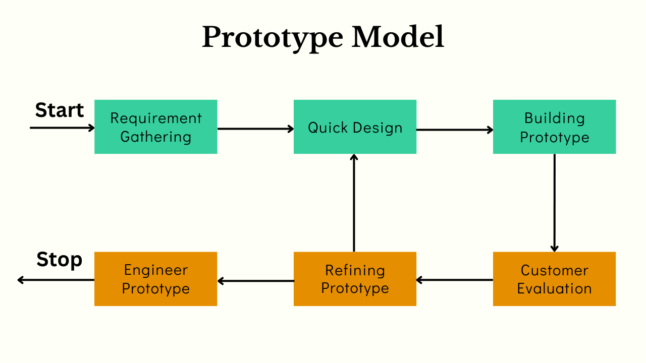

Figure 1. Prototype Model
This prototype model includes:
- Requirement Gathering – Identify system requirements, common phishing patterns, and features needed for accurate detection.
- Quick Design – Develop the interface and system flow for URL/email input, analysis, and reporting of phishing detection results.
- Prototype Development – Build a functional system capable of detecting phishing URLs/emails using a learning algorithm.
- User Evaluation – Test the prototype with employees by allowing them to input URLs/emails, while the system records numerical data on detection accuracy and performance.
- Refinement – Modify and improve the system based on detection results and user feedback, ensuring higher accuracy and more reliable phishing prevention over time.
Following this model ensures the system is effective, user-friendly, and capable of learning to detect phishing attacks, with performance that can be measured and analyzed quantitatively.
Data Collection Techniques
To gather the information needed in developing the Phishing Prevention System for Study Hub, different data collection techniques were used. These methods helped the researchers understand the real experiences, needs, and challenges of the Study Hub team, especially in dealing with phishing attempts that affect their daily operations. The following techniques were applied:
- Survey
Surveys were given to the Study Hub staff to collect measurable information about their awareness and experiences with phishing. The questions were designed to understand how familiar they are with phishing, how they usually respond to suspicious emails or messages, and what features they think would be useful in a prevention system. The results helped identify the most needed functions that the system should focus on.
- Interview
Interviews were conducted with selected members of the Study Hub team, particularly those who often handle online communication and data. This allowed the researchers to gather more detailed and personal insights on the phishing issues they encounter, how they deal with them, and what improvements they want to see in terms of security. The open-ended questions encouraged them to share real experiences and suggestions that may not appear in survey responses.

Justification for Selecting Protype Methodology
The decision to adopt Protype over other SDLC models, such as Agile, was based on several critical factors:
Criteria | Protype Model | Agile Model
Flexibility | High – allows frequent adjustments based on user feedback and test results | Moderate – changes occur during sprints but may require more structured planning
User Involvement | High – users interact with early versions of the system and provide feedback for refinement | Continuous but less hands-on with early visual prototypes
Development Speed | Faster initial development through quick prototypes | Requires organized sprint planning before development
Risk Management | Early identification of design and usability issues through prototype evaluation | Risks managed incrementally after each sprint
Project Suitability | Ideal for systems requiring visual validation and accuracy testing, like phishing detection | Best for projects with evolving functional requirements but less focus on prototype testing

System Architecture and Design
Overview
The Phishing Prevention System was created to help identify possible phishing attempts by carefully analyzing the content of emails, including their links and words. The system checks for suspicious URLs, misleading phrases, and unusual sender information that might trick users into giving away personal data. Instead of blocking emails, it focuses on alerting users and marking suspicious messages to help them recognize potential threats and stay safe online.
System Architecture
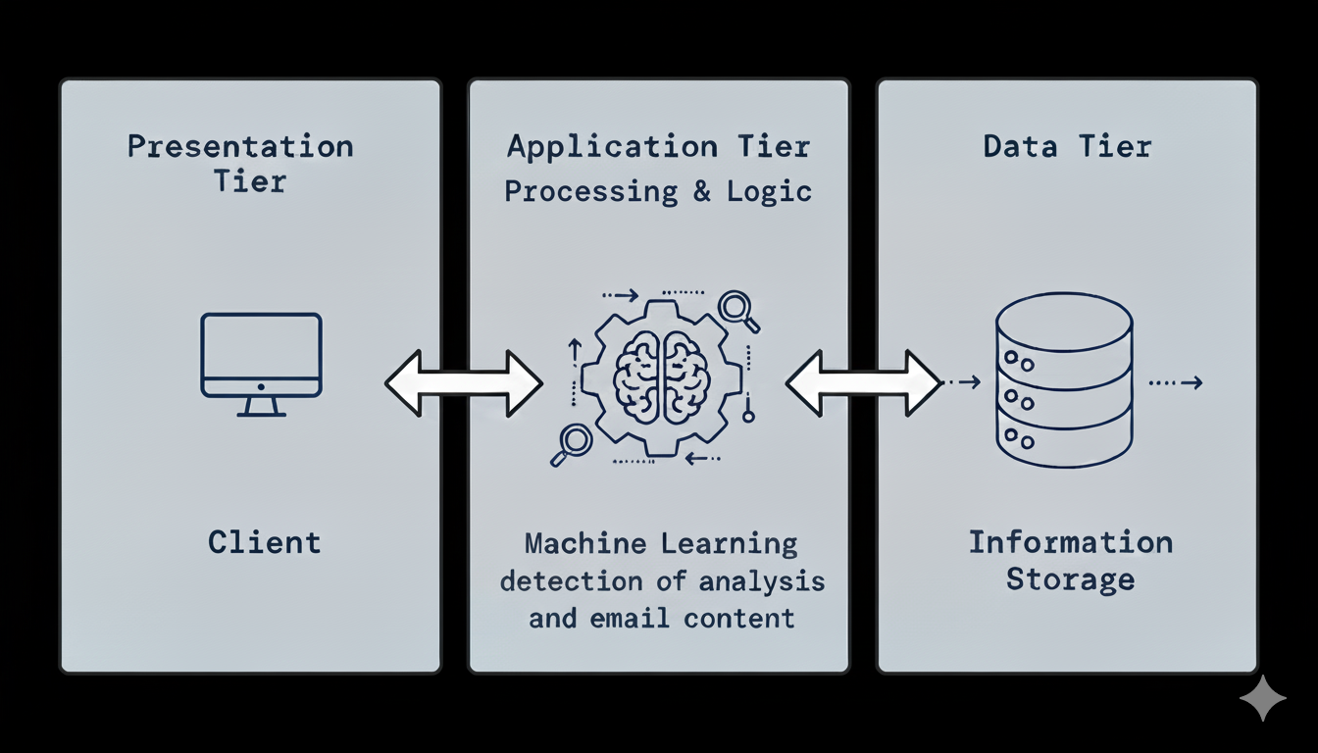
Figure 2. Three Tier Architecture
The system architecture is divided into three main layers:
- Presentation Tier (Presentation Layer) - This is where users interact with the system. It allows them to upload or view email content, check phishing detection results, and see alerts for suspicious messages. The interface presents the findings in a clear and simple way, helping users quickly identify emails that may be dangerous.
- Application Tier (Application Layer) - This is the “brain” of the system. It uses machine learning to analyze email content, including links, text, and sender details, to detect possible phishing attempts. The system processes the email data, checks for suspicious patterns, and classifies each message as safe or potentially harmful. This layer also connects the user interface and the database, ensuring smooth communication between them.
- Data Tier (Data Layer) - This part handles storing all important data, such as email samples, analysis results, and system logs. It keeps the data organized and secure, so the system can easily access it when needed for further analysis or reporting. Backup and security features are also in place to protect the stored information from loss or unauthorized access.
System Components and Modules
Login Page
Figure 1 shows the login page where the admin or user enters their username and password to access the system.
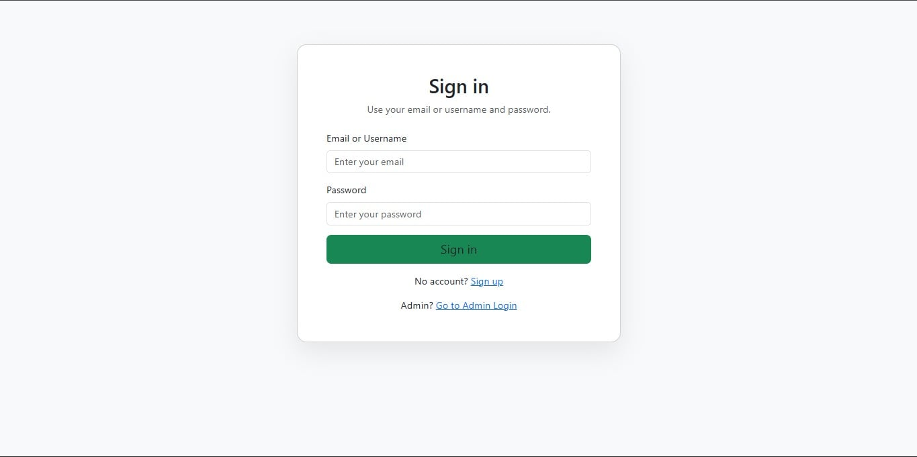
Admin Dashboard
Figure 2 displays the Admin Dashboard, which serves as the central control panel for system administrators. It provides access to key features such as user management, system monitoring, and administrative tools for maintaining and overseeing system operations.
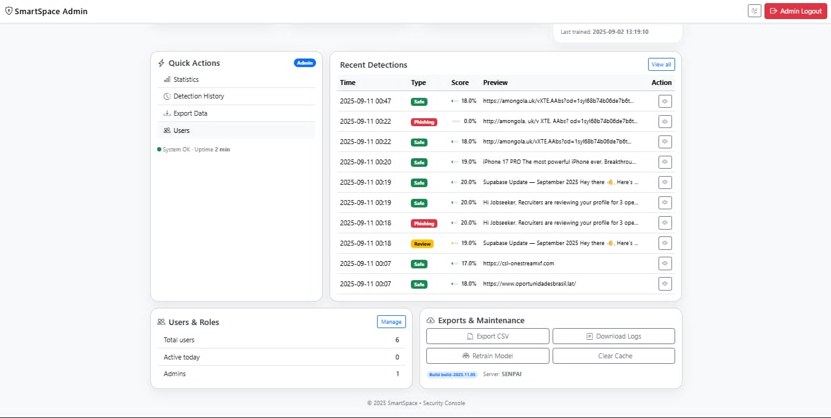

Homepage
Figure 3 shows the Home Page of the Phishing Prevention System. After logging in, users are directed to this dashboard where they can analyze email content for possible phishing. The page also provides quick detection statistics and a sidebar menu for easy navigation to other features of the system.
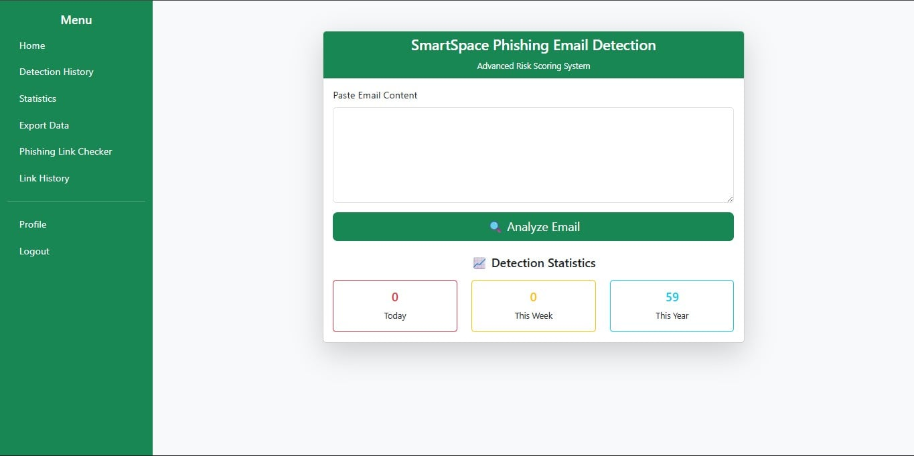
Detection History
Figure 4 shows the Detection History page, where users can view a record of all analyzed emails. It lists the email content, the phishing result, detection type, and the timestamp, allowing users to easily track past detection activities.
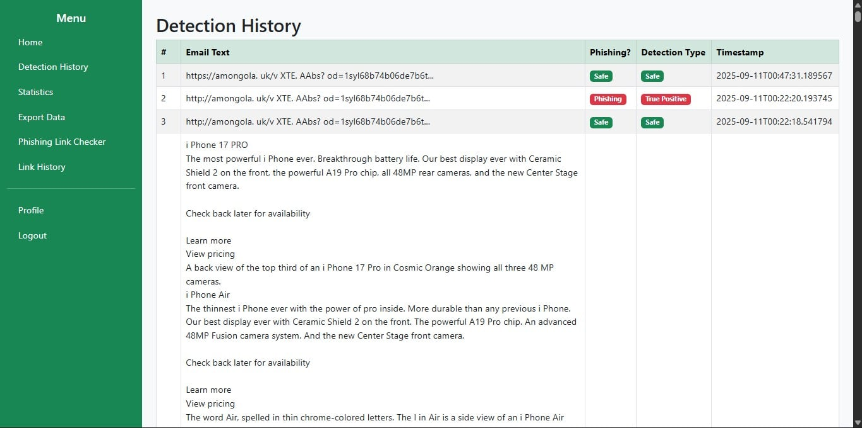

Statistics Page
Figure 5 presents the Statistics page, which provides a visual overview of phishing detection performance. It displays the total counts of phishing, true positive, false negative, and safe emails, along with charts that show daily detection trends and the distribution of detection types.
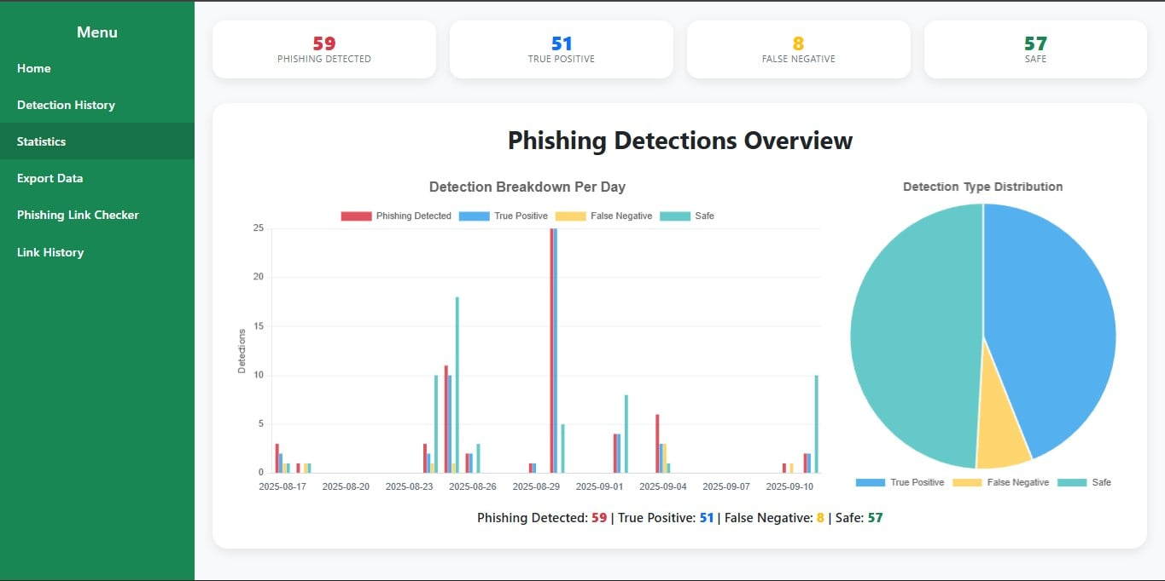
Export Phishing Detection Data
Figure 6 shows the Export Data page, where users can download all phishing detection records in CSV format for reporting or backup purposes.
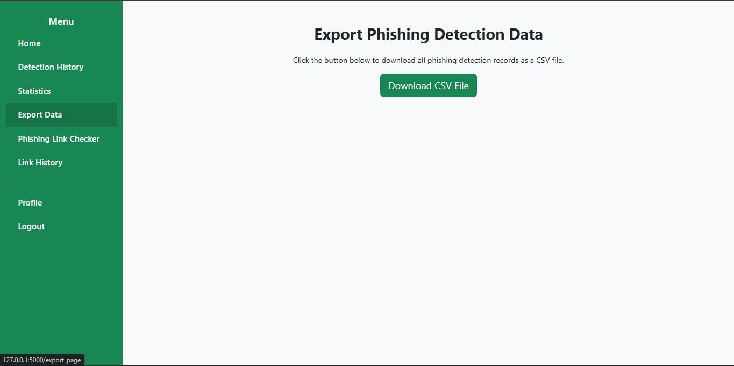
Link Checker Page
Figure 7 shows the Phishing Link Checker page, where users can paste URLs to analyze if they contain phishing threats. It provides a per-URL result with the score and reasons for the detection.
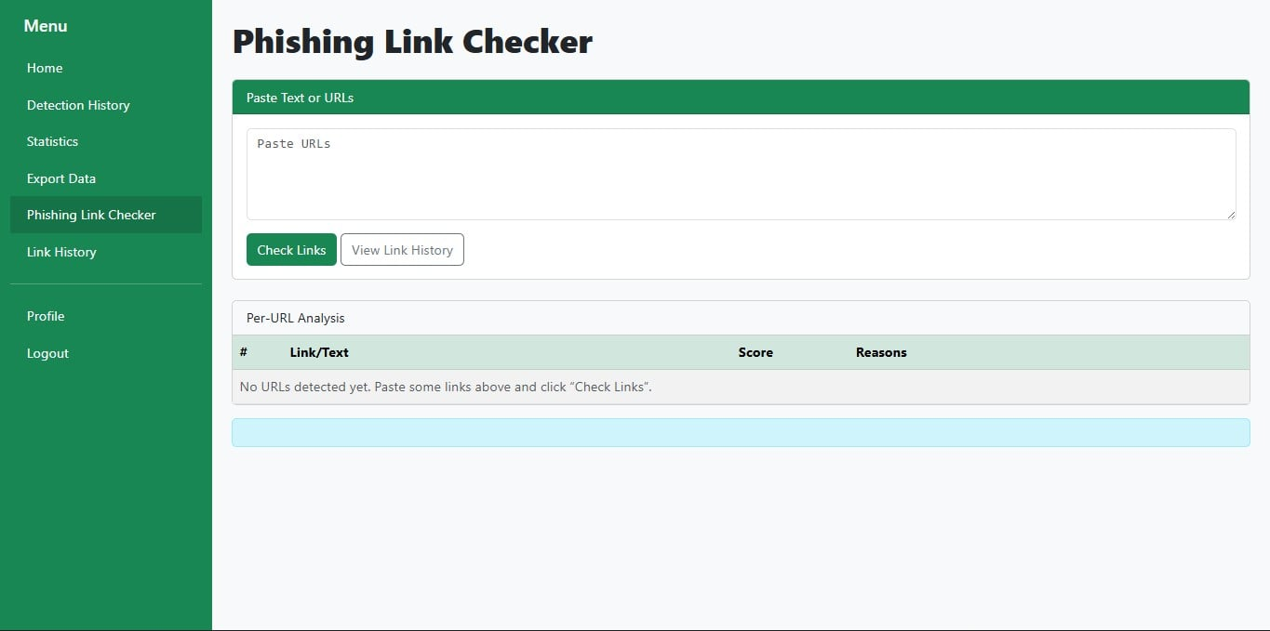

Profile Page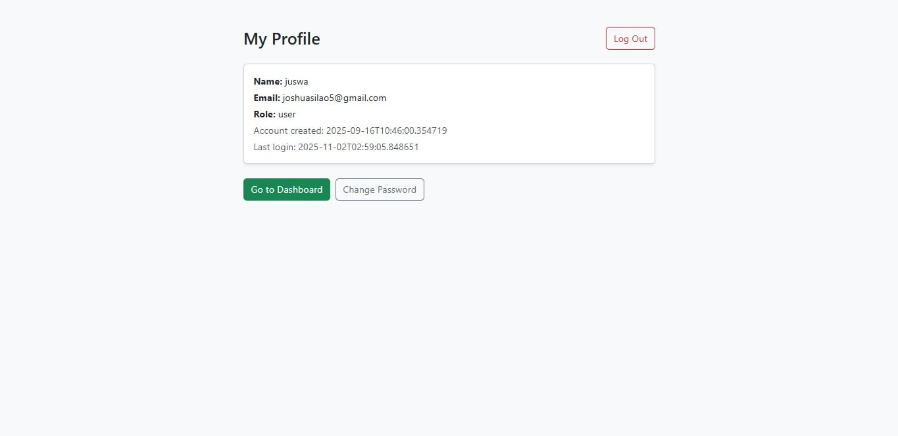
Figure 8 shows the Profile page, where users can view and manage their account information.
Use Case Diagram
Monitor system performance
Update and retrain model

Manage detection logs
Generate phishing report
View Detection Results
Analyze email and URLs for phishing indicators
Upload Email and URLs Content

Admin
User

Figure 9. Use Case Diagram
The diagram shows how each part of the system works together. The User can enter or upload email content to check if it contains signs of phishing and view the results after analysis. The Administrator manages the system by keeping detection records, updating the machine learning model, and monitoring overall performance. The Machine Learning Model serves as the system’s main processor, analyzing email content and identifying possible phishing attempts. All these components work together to help users detect and avoid phishing emails effectively.
Data Flow Diagram
Input Email/ URLs
View and Update system
Phishing Prevention System
Admin
User
Figure 1. DFD Level 0
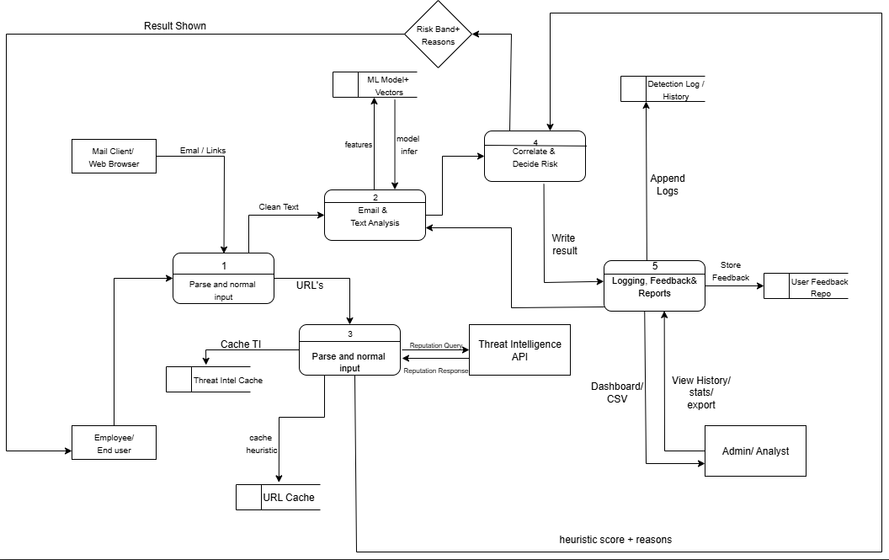

Figure 2. DFD LEVEL 1
The figures above show the way information flows through the system. Figure 3 shows the overview of the entire system. Figure 4 shows what happens inside the system and how data moves between processes.
The Context Diagram and Data Flow Diagram (DFD) are important in understanding how the Phishing Prevention System works. The Context Diagram gives a simple overview of the system, showing how it connects and exchanges data with users, administrators, mail clients, and the Threat Intelligence API. On the other hand, the DFD provides a deeper look into the system’s internal flow—how information is processed, analyzed, and stored to detect phishing threats. Together, these diagrams clearly illustrate how data moves from input to detection, helping ensure that the system is well-structured, efficient, and reliable in preventing phishing attacks.

Security Consideration
The security mechanisms implemented in the Phishing Prevention System are the following:
- Secure Login for Users – The system uses a secure login process to confirm the identity of each user. This helps prevent unauthorized individuals from accessing accounts or system features.
- Protected Passwords – User passwords are not stored as plain text. Instead, they are converted into a secure format (hashed) so that even if someone gains access to the database, they will not be able to read the actual passwords.
- Monitoring and Activity Tracking – The system keeps a record of important actions such as login attempts, scanning history, and reported incidents. These logs help track unusual behavior, identify security issues, and support investigation if a problem occurs.

Technological Stack
These are the list of all the tools, platforms, and technologies used in the development Stage:
- Frontend: HTML5, Boostrap5
- Backend: Python, scikit, joblib, re
- Machine Learnin: TfidfVectorizer, Multinomial Naïve Bayes, Pandas
- Database: JSON files

Data Gathering Techniques
Survey Questionnaire for System Assessment

The survey is designed to gather feedback from users regarding their experience and satisfaction with the Phishing Prevention System. The information collected from this survey will help evaluate the system’s effectiveness, usability, and overall performance. The results will also guide future improvements to better meet user needs in detecting and preventing phishing attempts.

Please rate the following statements based on your experience with the system:
(1 – Strongly Disagree, 2 – Disagree, 3 – Neutral, 4 – Agree, 5 – Strongly Agree)
A. Usability
1. The system is easy to navigate and user-friendly.
- 1
- 2
- 3
- 4
- 5
2. The layout and design are clear and intuitive.
- 1
- 2
- 3
- 4
- 5
3. I was able to use the system with minimal or no assistance.
- 1
- 2
- 3
- 4
- 5
B. Functionality
4. The system performs the intended functions accurately.
- 1
- 2
- 3
- 4
- 5
5. Features of the system meet the requirements of Phishing Detection.
- 1
- 2
- 3
- 4
- 5
6. The system provides reliable and consistent results.
- 1
- 2
- 3
- 4
- 5
C. Efficiency
7. The system processes data quickly and efficiently.
- 1
- 2
- 3
- 4
- 5
8. It reduces the time and effort needed to conduct classroom observations.
- 1
- 2
- 3
- 4
- 5
9. The system is responsive and free from major errors.
- 1
- 2
- 3
- 4
- 5
D. Usefulness
10. The system improves the process of classroom observation compared to the traditional method.
- 1
- 2
- 3
- 4
- 5
11. The generated reports are clear and helpful for analysis.
- 1
- 2
- 3
- 4
- 5
12. The system supports better decision-making based on observation data.
- 1
- 2
- 3
- 4
- 5

E. Overall Satisfaction
13. I am satisfied with the overall performance of the system.
o 1
o 2
o 3
o 4
o 5
14. I would recommend using this system for classroom observation.
o 1
o 2
o 3
o 4
o 5
15. I would continue using this system in future evaluations.
o 1
o 2
o 3
o 4
o 5
Chapter IV
Result and Interpretation
This chapter shows the outcomes of the development and testing phase of the Phishing Prevention System. It explains the key findings and evaluates whether the system meets its intended objectives, such as detecting phishing links, detecting phishing emails, and ensuring user security. The he results are based on system performance, accuracy tests, and feedback gathered during the testing and implementation stages. This chapter also discusses how the system addresses the problems identified in earlier chapters and supports the overall goal of minimizing phishing-related risks through effective detection and prevention mechanisms.
Summary of the data sources and analysis method used
The data used for analysis in this study was gathered from various sources, including system logs, detection reports, and user testing sessions. Primary data sources include the Phishing Prevention System’s backend database, which recorded all detected phishing attempts, URLs scanned, and system responses during the testing phase. Additional data was obtained from user evaluations to gather feedback on the system’s accuracy, reliability, and overall performance.
For analysis, both quantitative and qualitative methods were applied. Quantitative data, such as the number of phishing links accurately detected, false positives, and detection speed, were analyzed to assess the system’s efficiency and effectiveness. Qualitative feedback from users was reviewed to evaluate the system’s functionality and ease of use. Together, these methods provided a comprehensive understanding of how well the system performs in identifying and preventing phishing threats under real-world conditions.

Task Manager:
Gantt Chart / Project Timetable – Phishing Attack Detection System
Week | Task |  | Programmer | UX/UI Designer | Documenter
1 | Project planning & requirements gathering |  | ✅ | ✅ | ✅
2 | Research & system design planning |  | ✅ | ✅
3 | Use Case & DFD creation |  |  | ✅ | ✅
4 | Database design & schema creation |  | ✅
5 | UI wireframes & mockups |  |  | ✅ | ✅
6 | Frontend development begins |  |  | ✅
7 | Backend development begins |  | ✅
8 | Integration of frontend and backend Integration of frontend and backend |  | ✅ | ✅
9 | System testing & debugging |  | ✅
10 | User testing & feedback collection |  |  |  | ✅
11 | Final revisions (code + UI + content) |  | ✅ | ✅ | ✅
12 | Documentation finalization & formatting |  |  | ✅ | ✅
13 | Final project submission | ✅ |  | ✅ | ✅

✅ Legend:
- ✅ = Active role/task in that week

Presentation of results
After the Phishing Prevention System's successful development and deployment, a number of tests and assessments were carried out to ascertain its dependability and performance. The system's capacity to detect, stop, and prevent phishing attacks while protecting user data and preserving system effectiveness was evaluated. System performance monitoring, user testing, and simulated phishing scenarios were used to collect data. The outcomes demonstrated that the system minimized user exposure to fraudulent links, successfully detected and stopped a variety of phishing tactics, and offered real-time alerts for questionable activity. Overall, the results show that the Phishing Prevention System was successful in raising user knowledge of phishing hazards and improving online security.

Chapter v
Summary, Conclusion, And Recommendation
Summary
This study aimed to design and develop a Phishing Prevention System that helps protect users from online scams and phishing attacks. The system uses machine learning and smart analysis of both URLs and email contents to detect suspicious activities. Users can paste any email message or link into the system, which then scans and checks whether it is safe or potentially harmful. The project was developed through several stages, including gathering requirements, designing the system, developing its features, testing its performance, and evaluating its results. Findings showed that the system accurately detected phishing attempts and helped reduce the risk of users being tricked by fake websites or emails. Feedback from users also showed that the system is easy to use, reliable, and effective. Overall, the Phishing Prevention System achieved its main goal of providing a secure and practical way to identify and prevent phishing attacks while promoting awareness of online safety.

Conclusion
Based on the findings, the Phishing Prevention System is an effective and reliable tool for detecting and preventing phishing attacks. It minimizes user exposure to online scams by analyzing URLs and email contents using machine learning techniques. This helps users identify and avoid potential threats more quickly and accurately. Feedback from users confirmed that the system is easy to use and provides a convenient way to check the safety of suspicious links and emails. The system also highlights the importance of combining machine learning with practical cybersecurity tools to address real-world online threats. Overall, the Phishing Prevention System achieved its intended purpose and makes a valuable contribution to promoting safer online experiences and strengthening protection against phishing attacks.
Recommendations
Based on the development and evaluation of the Phishing Prevention System, the following recommendations are suggested to further improve the system and expand its use:
- File Attachment Scanning – Add a feature that scans email attachments for potential malware or hidden phishing threats to provide better security for users.
- Improved UI/UX – Enhance the system’s interface to make it more user-friendly, modern, and easier to navigate for all users.
- Browser Extension Integration – Develop a browser extension to allow real-time phishing checks while users are browsing or reading emails online.
- Offline Mode (Limited Features) – Allow the system to perform basic phishing checks even without internet access.
- Two-Factor Authentication (2FA) – Add an extra layer of security during login to protect user accounts from unauthorized access.

