# # Task 1

number = int(input("Enter a number: "))

if number % 5 == 0:

print("Input number is a factor of 5")

else:

print("Input number is not a factor of 5")



# # Task 2

numbers = [int(input("Enter a number: ")) for _ in range(10)]

for num in numbers:

if num % 2 == 0:

print("%d is even" % num)

else:

print("%d is odd" % num)

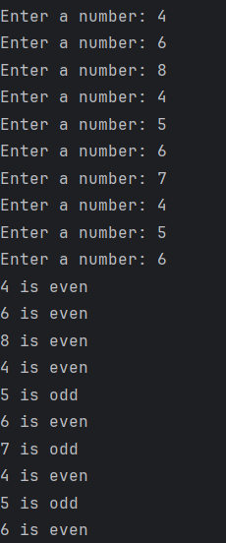

# # Task 3

poem = """

In realms of code where circuits gleam,

A dance of minds, a digital dream.

Silicon whispers, circuits hum,

In the heart of algorithms, futures drum.

Lines of logic weave tales untold,

In the binary language, stories unfold.

Bits and bytes, a cosmic art,

Artificial minds, a symphony's start.

"""

print(poem)

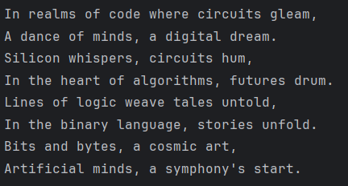

# # Task 4

def calculate_area(length, width):

return length * width

def calculate_volume(length, width, height):

return length * width * height

length = float(input("Enter the length of the rectangle: "))

width = float(input("Enter the width of the rectangle: "))

height = float(input("Enter the height of the rectangle: "))

area = calculate_area(length, width)

volume = calculate_volume(length, width, height)

print("Area of the rectangle: %.2f square units" % area)

print("Volume of the rectangle: %.2f cubic units" % volume)

print("Cleaning Starts...")

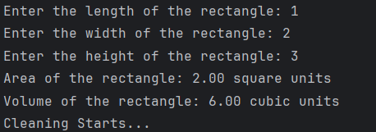

# # Task 5

def add(x, y):

return x + y

def subtract(x, y):

return x - y

def square(x):

return x ** 2

def cube(x):

return x ** 3

num1 = float(input("Enter the first number: "))

num2 = float(input("Enter the second number: "))

operator = input("Enter the operator (+, -, square, cube): ")

if operator == '+':

result = add(num1, num2)

elif operator == '-':

result = subtract(num1, num2)

elif operator == 'square':

result = square(num1)

elif operator == 'cube':

result = cube(num1)

else:

result = "Invalid operator"

print("Result: ", result)

