# LAB-1

# Name: Uzair Qaiser

# Roll no: 21F-9162

# Section: 6B

# Task1:

CODE:

<html>

<head>

<h1>UXAIR</h1>

</head>

<body>

<h1>UZAIR QAISER</h1>

<p>My name is Uzair Qaiser.<br>My roll number is 21F-9162<br>I am a student of CS in FAST University </p>

</body>

</html>

ScreenShot:

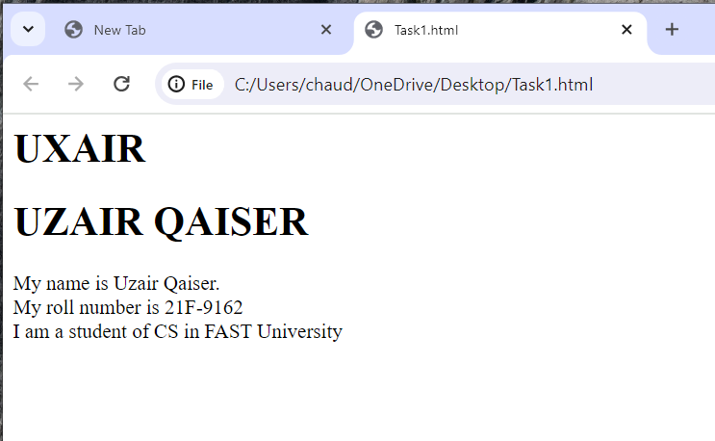

# Task2:

CODE:

<html>

<head>

<h1>UXAIR</h1>

</head>

<body><p>

<b>This text is bold</b><br>

<strong>This text is strong</strong><br>

<big>This text is big</big><br>

<i>This text is italic</i><br>

<em>This text is emphasized</em><br>

This is computer output<br>

This is <sup>superscript</sup><br>

This is <sub>subscript</sub>

</p>

</body>

</html>

ScreenShot:

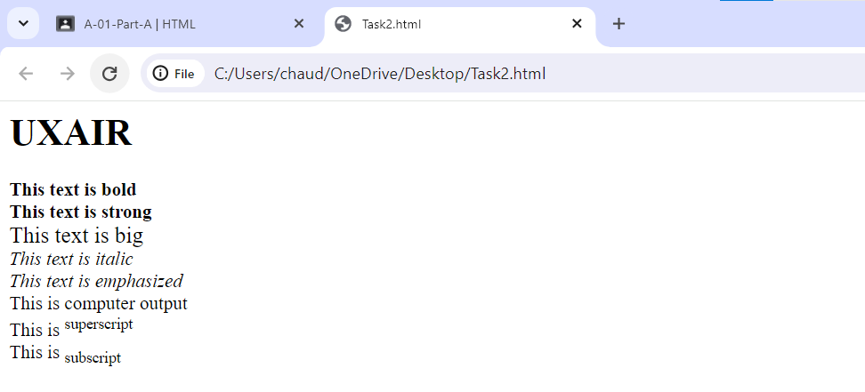

# Task3:

CODE:

<html>

<head>

</head>

<body>

<img src="C:\Users\chaud\OneDrive\Desktop\New folder\National_University_of_Computer_and_Emerging_Sciences_logo.png" width="1000" height="1000">

</body>

</html>

Screenshot:

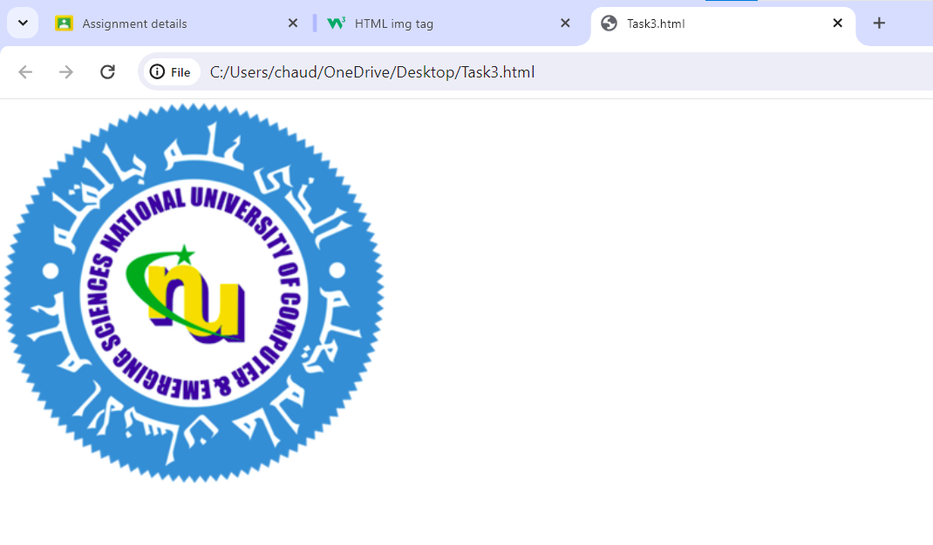

# Task4:

CODE:

<html>

<head>

</head>

<body>

<a href="https://cfd.nu.edu.pk/" target="_blank"><img src="C:\Users\chaud\OneDrive\Desktop\New folder\National_University_of_Computer_and_Emerging_Sciences_logo.png" width="1000" height="1000"></a>

</body>

</html>

ScreenShot:





# Task5:

CODE:

<html>

<head>

<h1>HTML Lists</h1>

</head>

<body>

<h3>Unordered List</h3>

<p>We have books on variety of Languages.<br>

<ul>

<li>Oracle</li><li>JAVA</li><li>HTML</li><li>CSS</li>

</ul>

<br>

<h3>Ordered List</h3><br>

Follow these steps to install JAVA.

<ol start="1">

<li>Download Software</li><li>Extract to Folder</li><li>Execute the file</li>

</ol>

</p>

</body>

</html>

ScreenShot:

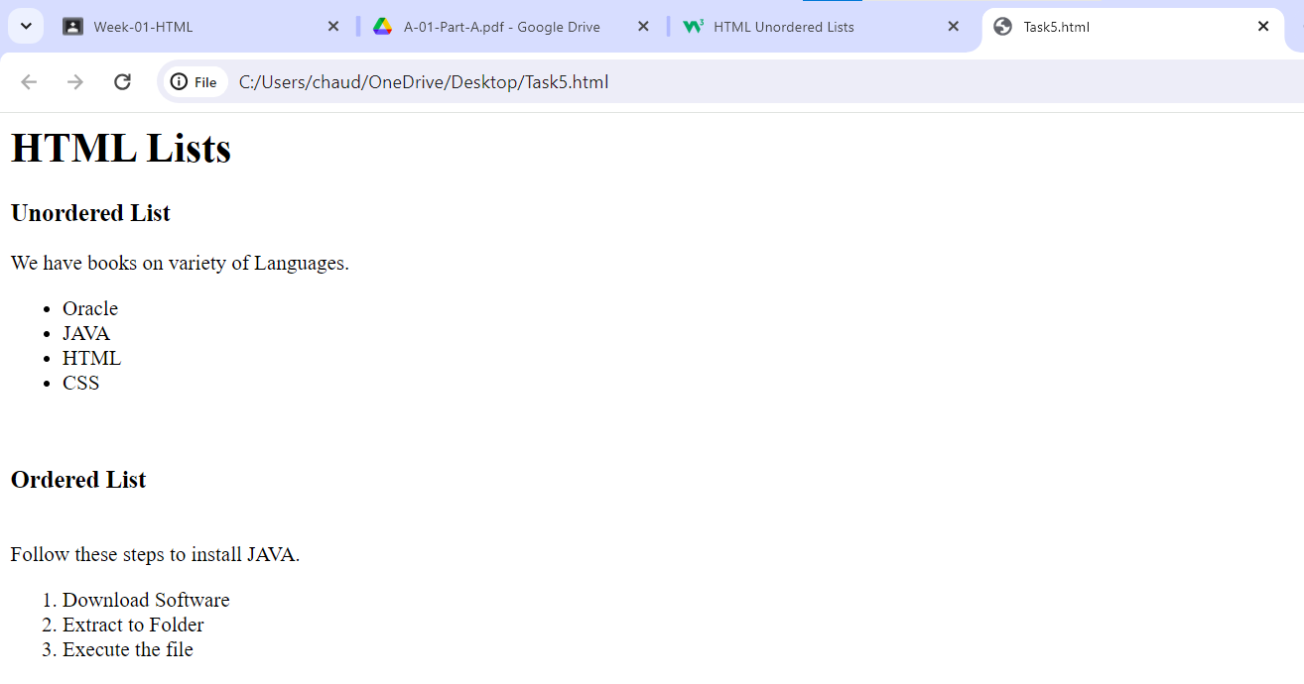

# Task6:

CODE:

<!DOCTYPE html>

<html>

<head>

<style>

table, th, td {

border: 1px solid black;

border-collapse: collapse;

}

</style>

</head>

<body>

<table width=40%>

<tr>

<th rowspan="3">APRIL</th>

</tr>

<tr>

<td>........</td>

<td>........</td>

</tr>

<tr>

<td>........</td>

<td>........</td>

</tr>

<tr>

<td>........</td>

<td>........</td>

<td>........</td>

</tr>

<tr>

<td>........</td>

<td>........</td>

<td>........</td>

</tr>

</table>

</body>

</html>

ScreenShot:

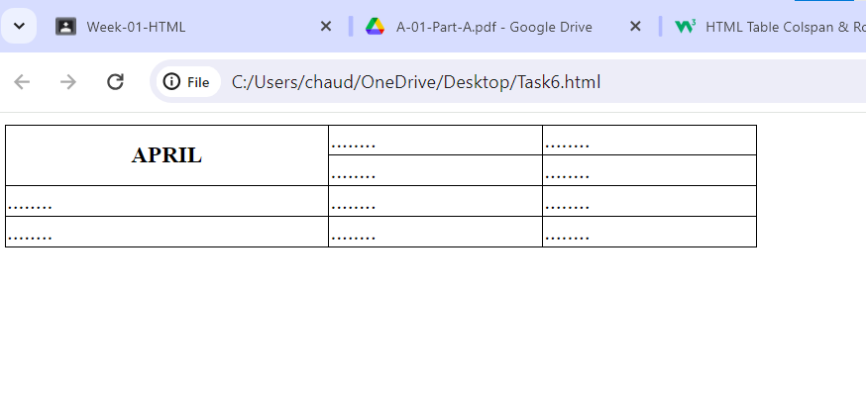

# Task7:

<!DOCTYPE html>

<html>

<head>

<style>

table, th, td {

border: 1px solid black;

border-collapse: collapse;

}

</style>

</head>

<body>

<table border="1">

<tr>

<th colspan="3">2022</th>

</tr>

<tr>

<td>.........</td>

<td>.........</td>

<td>.........</td>

</tr>

<tr>

<th colspan="2" rowspan="2">FIESTA</th>

<td>.........</td>

</tr>

<tr>

<td>.........</td>

</tr>

<tr>

<td>.........</td>

<td>.........</td>

<td>.........</td>

</tr>

</table>

</body>

</html>

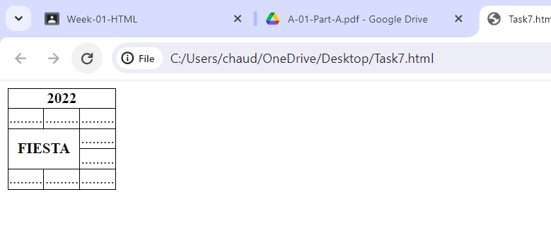

# Task8:

<!DOCTYPE html>

<html lang="en">

<head>

<title>Document</title>

</head>

<body>

<form>

<fieldset><p style="font-weight: bold; text-align:center;"> LOGIN</p></fieldset> <br>

<label>Username:</label>

<input type="text" name="Username"> <br><br>

<label>Email</label>

<input type="email" name="email"><br><br>

<label type="password" name="password">Password</label>

<input type="password" name="password"><br><br>

<label>Confirm Password</label>

<input type="password" name="password">

</form>

<input type="submit">

<input type="reset">

</body>

</html>

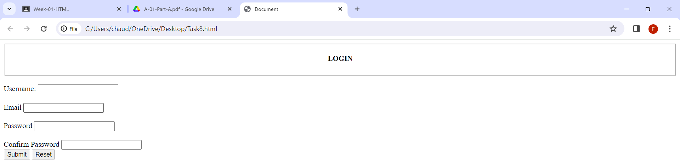

# Task9:

<!DOCTYPE html>

<html>

<head>

<title>Pete's Pizza Delivery</title>

</head>

<body>

<h1>Pete's Pizza Delivery</h1>

<h2>Online Order Form</h2>

<form>

<label for="user">*Name: </label>

<input type="text" name="user" id="user" required />

<label for="tel">*Tel: </label>

<input type="tel" name="tel" id="tel" required />

<br />

<label for="address">*Address: </label>

<input type="text" name="address" id="address" required />

<label for="email">Email: </label>

<input type="email" name="email" id="email" />

<br />

<label for="city">*Town/city: </label>

<input type="text" name="city" id="city" />

<br />

<label for="code">*Postcode: </label>

<input type="text" name="code" id="code" required />

<p>* required fields</p>

<table>

<tr>

<th>Topping</th>

<th>Size</th>

<th>Extras</th>

</tr>

<tr>

<td><input type="radio" id="margherita" name="topping" /><label for="margherita">Margherita</label></td>

<td><input type="radio" id="small" name="size" /><label for="small">Small</label></td>

<td><input type="radio" id="mushrooms" name="extra" /><label for="mushrooms">Mushrooms</label></td>

</tr>

</table>

<label for="time">Preferred delivery time: </label>

<input type="time" name="time" id="time" />

<br />

<label for="ins">Delivery instructions: </label>

<textarea name="instructions" rows="5"></textarea>

<br />

<input type="submit" value="Submit order" />

</form>

</body>

</html>

