Task1:

HTML:

<html>

<head>

<title>

Uxair

</title>

<link rel="stylesheet" href="style.css">

<style>

h1{

font-size: 36px;

}

</style>

</head>

<body style="background-color: blue">

<h1>My name is Uzair Qaiser</h1>

<p>I am a Student of CS in FAST University</p>

</body>

</html>

External CSS:  
body{

text-shadow: 2px 2px 5px green;

}

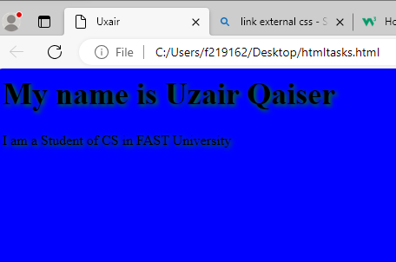

Task2:

HTML:

<html>

<head>

<title>

Uxair

</title>

<link rel="stylesheet" href="style.css">

</head>

<body>

<div class="hello">

<p class="p1">Start CSS Exercises</p>

<p>Good Luck!</p>

<div>

<button>

Start CSS Exercise >

</button>

</div>

<br>

<br>

</div>

</body>

</html>

External CSS:  
body{

color: white;

}

button{

border: none;

background-color: #04AA6D;

color: white;

padding: 10px;

border-radius: 3px;

}

.hello{

padding-left: 10px;

padding-top: 1px;

background-color: black;

margin-bottom: 50%

}

.p1{

font-size:25px

}

p{

font-size:12px

}

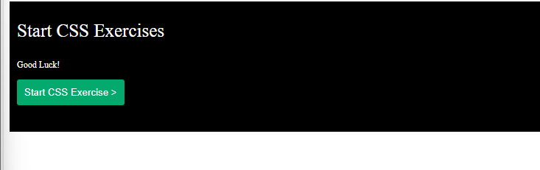

Task3:

<!DOCTYPE HTML>

<html>

<head>

<title>

CONTACT

</title>

<link rel="stylesheet" href="style.css">

</head>

<body>

<div class="header">

<h2>Contact Us</h2>

<form action="/action_page.php">

<label for="name">Your Name:</label>

<br>

<input type="text" id="name" name="Name" value="Uzair Qaiser"><br><br>

<label for="email">Your Email:</label>

<br>

<input type="email" id="email" name="email" value="uzair@gmail"><br><br>

<label for="Phone">Phone Number:</label>

<br>

<input type="tel" id="Phone" name="Phone" value="1122"><br><br>

<label for="email">Your Message:</label>

<br>

<textarea rows="4" cols="50" name="comment" form="usrform">

Enter text here...</textarea>

<button type="submit" formmethod="get">Submit</button><br>

<button type="reset">Reset</button>

</form>

</div>

</body>

</HTML>

CSS:

body{

background-color:linen

}

h1{

color:blue

}

.header{

background-color:white;

text-align:left;

margin: auto;

width: 40%;

border: 3px solid green;

padding: 10px;

}

h2{

text-align: center;

}

.button{

text-align: center;

width: 100%;

}

input{

width:90%;

margin:2%;

padding:2px;

}

button{

border-radius: 10px;

background: #73AD21;

margin-left:3%;

border-color:#73AD21;

border-bottom-color:#73AD21;

height:30px;

margin-bottom:5px;

padding:2px;

margin-left:3%;

width:94%;

color:white;

}

textarea{

width:90%;

margin:2%;

padding:2px;

}

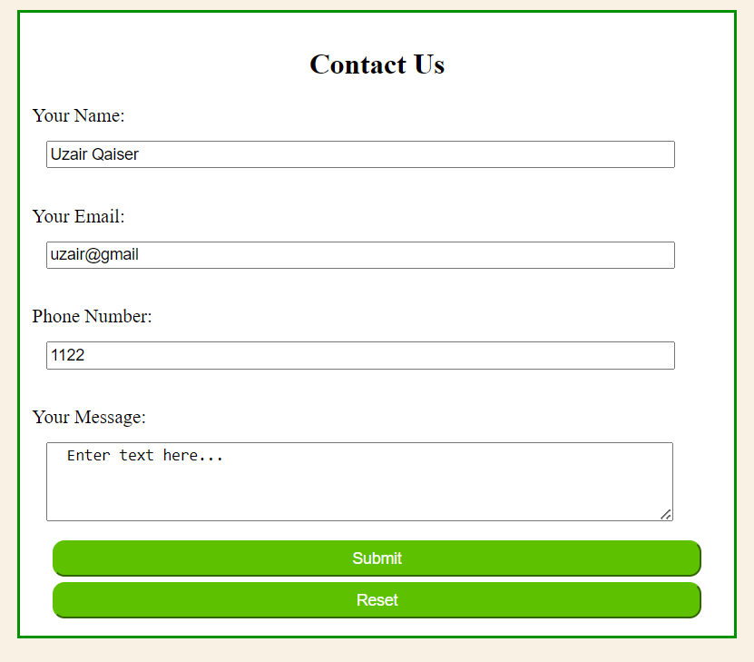

Task4:

<!DOCTYPE HTML>

<html>

<head>

<title>

CARD

</title>

<link rel="stylesheet" href="styles.css">

</head>

<body>

<div class="card">

<img src="download.jpeg" alt="Image">

<div class="container">

<h4>Cinque Terre</h4>

</div>

</div>

</body>

</HTML>

CSS:

.card{

text-align:center;

box-shadow: 0 4px 8px 0 rgba(0, 0, 0, 0.2), 0 6px 20px 0 rgba(0, 0, 0, 0.19);

width:320px;

transition: transform 1s;

margin:auto;

}

h4{

padding-bottom:10px;

}

img{

width:100%;

}

.card:hover{

transform:scale(1.1);

}

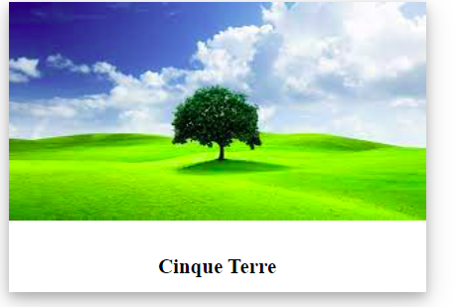

Task5:

<!DOCTYPE HTML>

<html>

<head>

<title>

CARD

</title>

<link rel="stylesheet" href="stytles2.css">

</head>

<body>

<div class="header">

<div class="inner">

My name is uzair.

</div>

</div>

<div class="card">

<h2>About me</h2>

<p>

My name is Uzair Qaiser. I am a student of computer-

science in Fast-NUCES CFD Campus.

</p>

</div>

</div>

<br>

<br>

<div class="card">

<h2><b>Personal Information:</b></h2>

<p>

<ul>

<li>Date of Birth: March 09,2003.</li>

<li>Nationality: Pakistan.</li>

<li>Address: Chiniot.</li>

<li>Email: email@gmail.com.</li>

<li>Phone: 123456789.</li>

</ul>

</p>

</div>

</div>

<br>

<br>

<div class="card">

<h2>Education:</h2>

<p>

I have done my matriculation and ICS from Chenab College Chiniot.

Currently doing my Bachelors in CS from Fast-NUCES.

<ul>

<li>Degree: BSCS.</li>

<li>Institute: Fast-NUCES.</li>

<li>Graduation Year: 2025.</li>

</ul>

</p>

</div>

</div>

<br>

<br>

<div class="card">

<h2>Work Experience:</h2>

<p>

<ul>

<li>Job Title: NILL</li>

<li>Company: NILL</li>

<li>Duration: NILL</li>

<li>Responsibilities: NILL</li>

</ul>

</p>

</div>

</div>

<br>

<br>

<div class="card">

<h2>My Projects:</h2>

<h3>Project 1:</h3>

<p>Candy Crush Game(Programming Fundamentals)<br></p>

<button><span>Show Details</span></button>

<h3>Project 2:</h3>

<p>Contact Manager(Object Oriented Programming)<br></p>

<button><span>Show Details</span></button>

</div>

</div>

<div class="footer">

<b>Contact me at email: f219162@cfd.nu.edu.pk</b>

</div>

<br>

<br>

</body>

</HTML>

CSS:

.card{

box-shadow: 0 4px 8px 0 rgba(0, 0, 0, 0.2), 0 6px 20px 0 rgba(0, 0, 0, 0.19);

width:95%;

transition: transform 1s;

margin:auto;

}

h2{

padding-left:10px;

padding-top:15px;

}

img{

width:100%;

}

.card:hover{

transform:scale(1.06);

}

.header{

font-size:50px;

height:150px;

background-color:#808080;

padding:5px;

margin:5px;

}

.inner{

text-align:center;

margin-left:20%;

}

.footer{

text-align:center;

background-color:#808080;

padding:50px;

margin:5px;

height:20px;

}

p{

padding-left:15px;

padding-bottom:15px;

}

button{

border-radius: 4px;

background-color: #000080;

color: white;

text-align: center;

padding: 10px;

width: 130px;

transition: all 0.5s;

margin-left:15px;

}

button span {

cursor: pointer;

display: inline-block;

position: relative;

transition: 0.5s;

}

button span:after {

content: '\00bb';

position: absolute;

opacity: 0;

top: 0;

right: -20px;

transition: 0.5s;

}

button:hover span {

padding-right: 25px;

}

button:hover span:after {

opacity: 1;

right: 0;

}

