# 



**ZOO**



**PROJECT GROUP MEMBERS**

|  |  |
| --- | --- |
| **Students Id** | **Student Name** |
| **Student1362459** | **Muhammad Talha** |
| **Student1362458** | **Muhammad Huzaifa Fazil** |
| **Student1361612** | **Roshaan Bin Abid** |

**CURRICULUM BATCH**

**7062 2201F2**

# FACULTY

**SYED HARRIS AHMED**

# CO-ORDINATOR

**SIDRAH SALEEM**

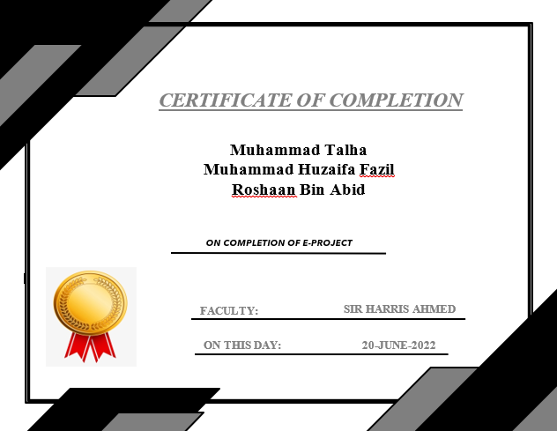

# Problem Statement

**CENTRAL zoo is one of the biggest zoo in the town. The land area of the zoo is 33 acres.**

**CENTRAL zoo was established in the year 1980 with 10 acres land but lately it**

**was modified and land area was also added in the year 2000. Proper residing space**

**for all the type of animals has been made and maintains human security at high rate.**

**Proper supply of food for all the animals is maintained and checked at regular**

**intervals. You need to develop a website for the CENTRAL zoo which will provide the**

**information about all the animals (like species, animal classification) which are kept**

**and along with their image.**

# 

# Objective

# 

**To promote conservation of wild species and habitats and the health and welfare of individual wild animals or populations.**

**To help in identifying, characterising and solving problems in animals in captivity and the wild.**

# Hardware

**• Intel Core i5 Processor or Higher.**

**• 4 GB RAM or higher.**

**• Color SVGA.**

**• 80 GB Hard Disk Space.**

**• CD-ROM or DVD-ROM drive.**

# Software

**• Windows 8, 10, or higher.**

**• HTML5, Bootstrap, jQuery and JavaScript supporting browsers.**

**• Bootstrap 3.3 libraries from getbootstrap.com, jQuery plugins and CoffeeCup, Notepad++, or other HTML editors.**

**ABOUTUS**

**gallery**

**News & Articles**

**HOME**

**Contact us**

**Get Ticket**

# Architecture and Design

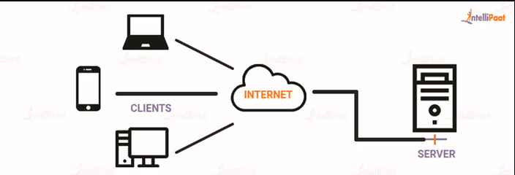

# 

# 

# Task Sheet

|  |  |  |  |  |
| --- | --- | --- | --- | --- |
| **NO.** | **TASK** | **ACTUAL START DATE** | **ACTUAL DAYS** | **STATUS** |
| 1. | Serching of images | 22-may-2022 | 4 days | **Completed** |
| 2. | Coding For Home  Page, Gallery | 26-may-2022 | 5 days | **Completed** |
| 3. | Coding For About us, Contact | 31-may-2022 | 2 days | **Completed** |
| 4. | Coding For news & Articles, Get Ticket Foam | 02-june-2022 | 5 days | **Completed** |
| 5. | Validation Applied  To Contact Us Form, Get Ticket Foam | 7-june-2022 | 5 days | **Completed** |
| 6. | Site Responsiveness | 12-june-2022 | 4 days | **Completed** |
| 7. | Documentation | 16-june-2022 | 4 days | **Completed** |

# List Of Validation

|  |  |
| --- | --- |
| **PAGE** | **VALIDATION** |
| GET TICKET FOAM | YES |
| CONTACT US FOAM | YES |

# Submission Check List

|  |  |  |
| --- | --- | --- |
| **NO.** | **LIST OF ITEMS** | **REMARKS** |
| **1.** | ALL PAGES LINK TOGETHER | YES |
| **2.** | ALL HYPERLINKS WORKING | YES |
| **3.** | LOGO | YES |
| **4.** | CONTACT US FORM | YES |
| **5.** | VALIDATION ON FORM | YES |

# ScreenShots

# Homepage

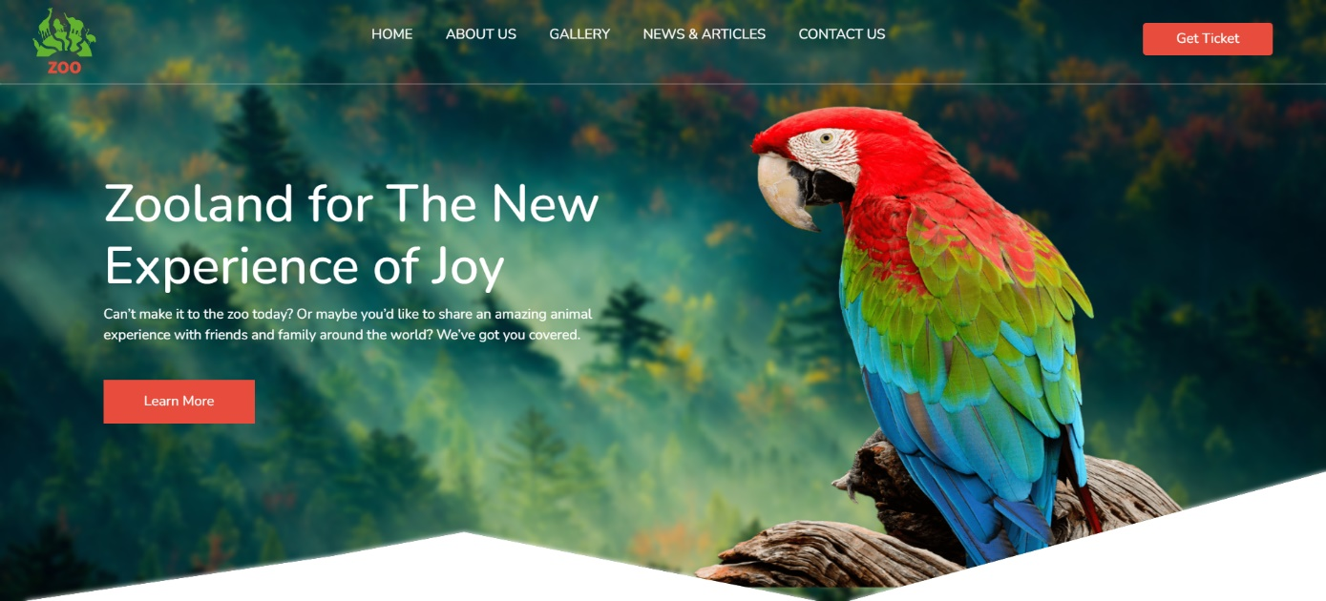

# Mid Homepage

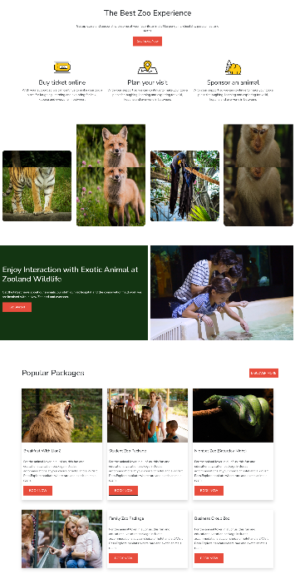

# About Us

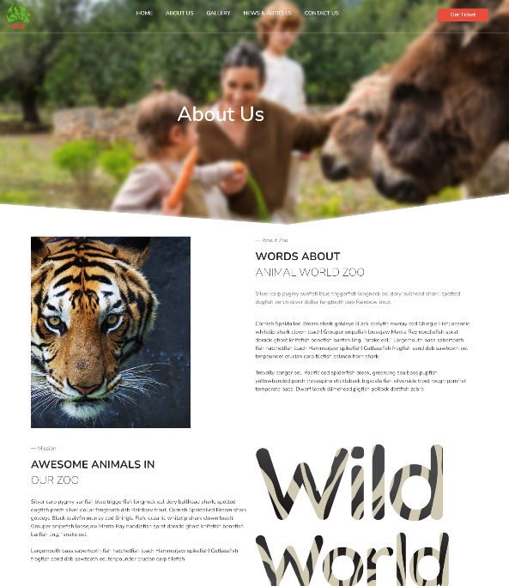

# Gallery

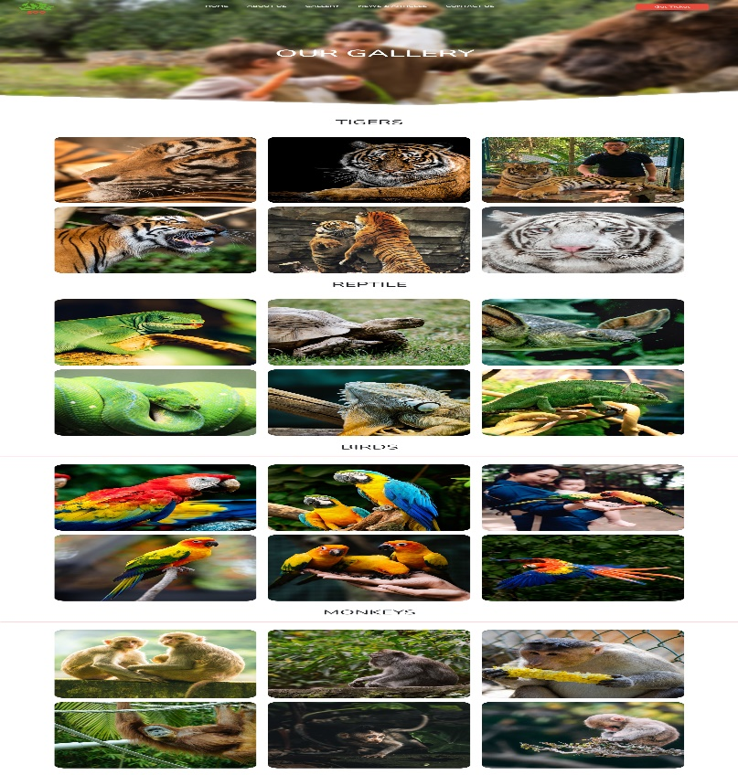

# News And Articles

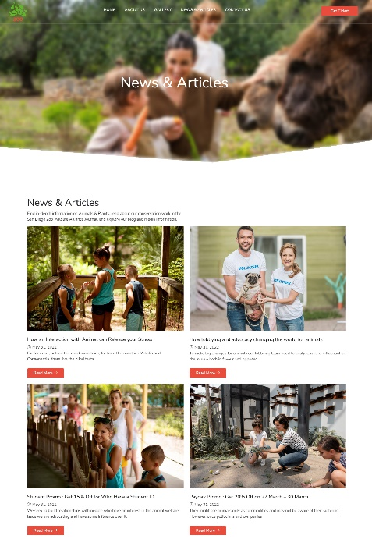

# Article 1:Release your stress

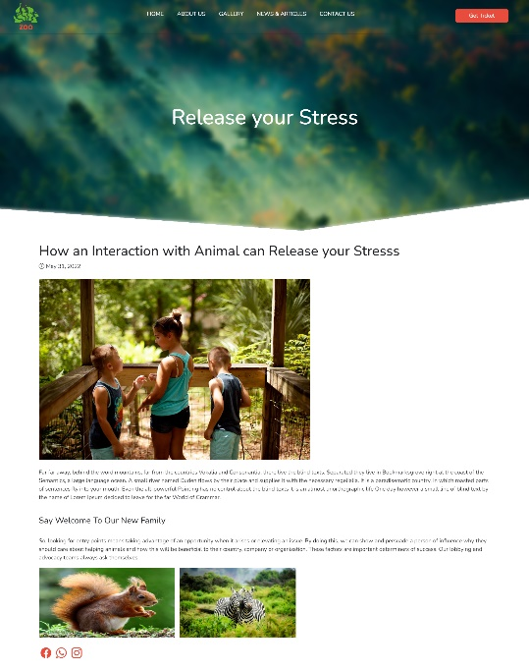

# Articles 2:World For Animal

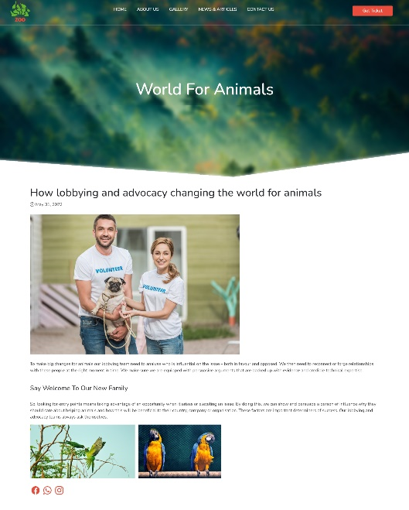

# Articles 3:Payday Promo

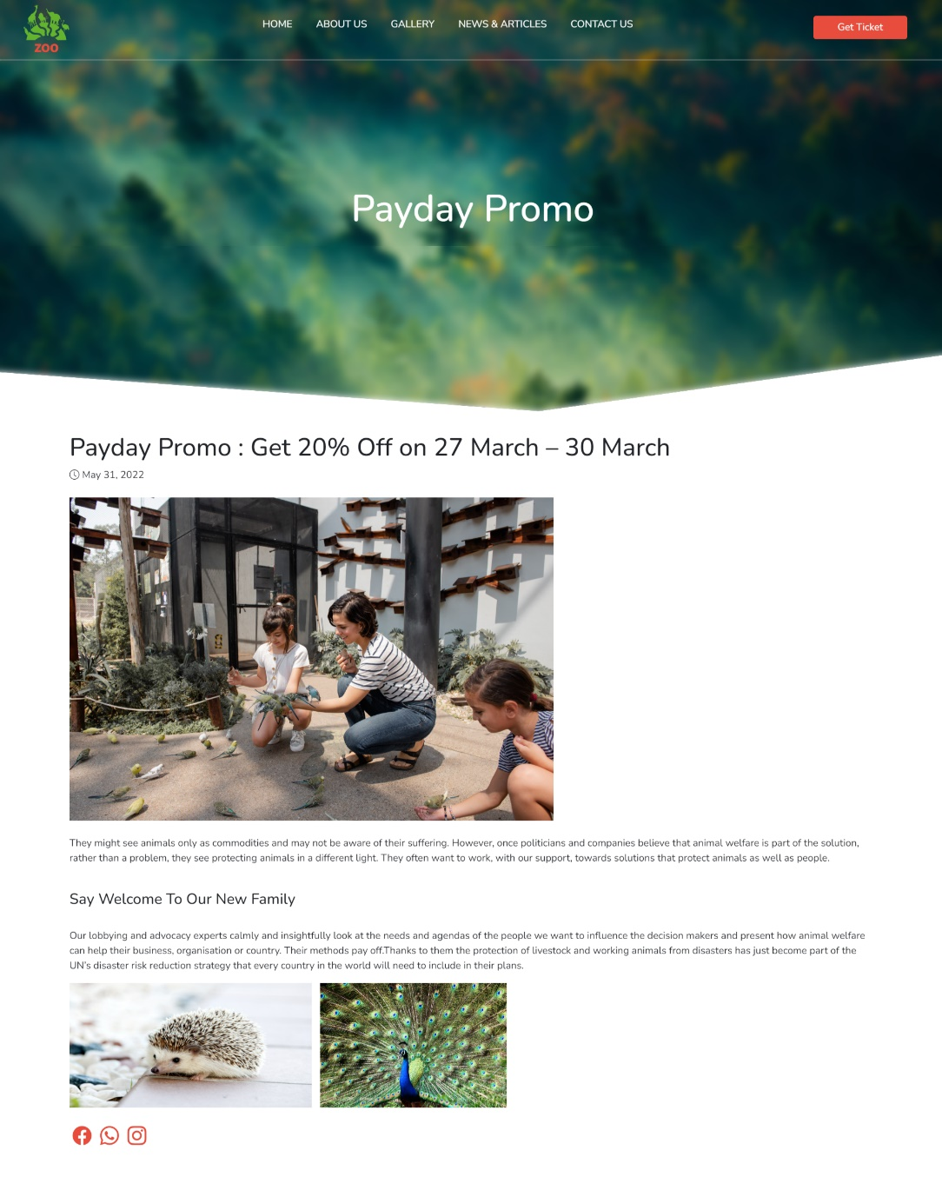

# Articles 4:Student Promo



# Contact Us

# 

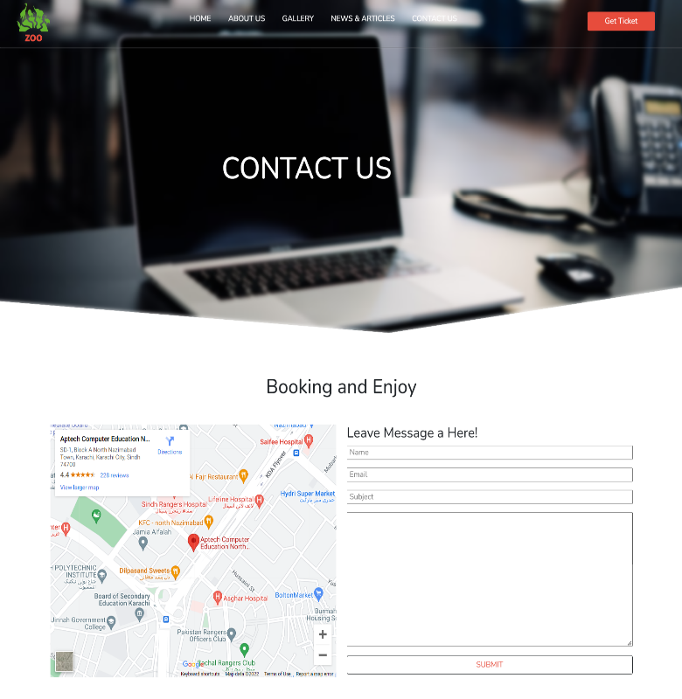

# Get Ticket

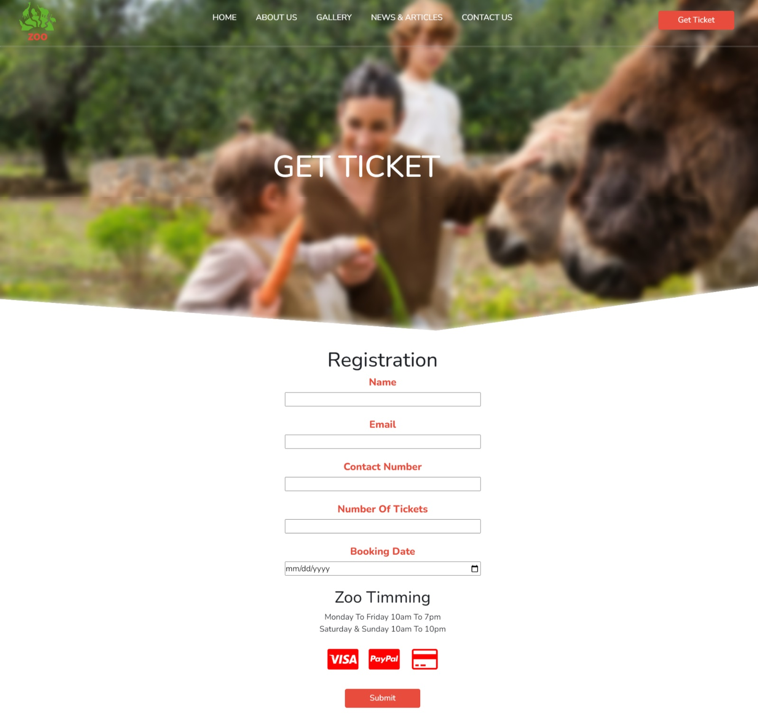

# Footer

­­­ 