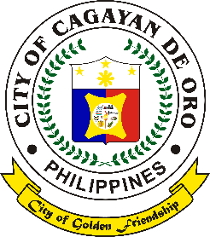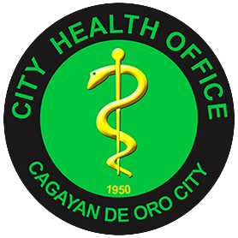Republic of the Philippines

**City Government of Cagayan de Oro**

**CITY HEALTH OFFICE**

***Laboratory and Imaging Division***

*Arch. Hayes St., Barangay 40, Cagayan de Oro City*

Laboratory Exam Report for _____________

For the Month of _____________ , Year _________