#Show film name ONLY which has screening.

SELECT DISTINCT film.name

FROM film

RIGHT JOIN screening ON film.id = screening.film_id;

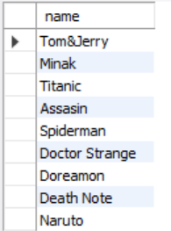

#Show Room name with all seat row and seat column of "Room 2"

SELECT room.name, seat.row, seat.number

FROM seat

JOIN room ON seat.room_id = room.id

WHERE room.name = 'Room 2';

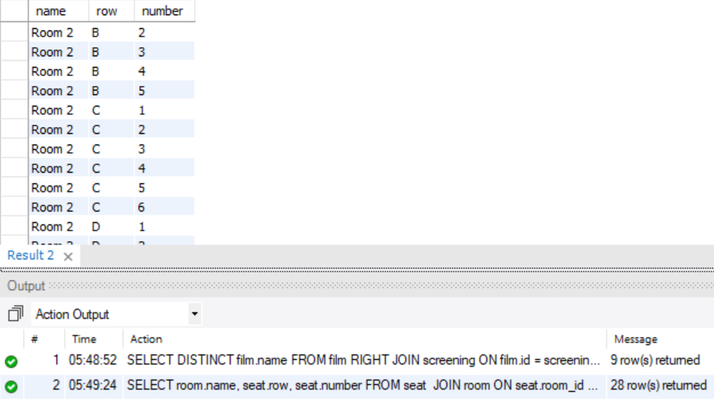

#Show all Screening Infomation including film name, room name, time of film "Tom&Jerry"

SELECT film.name, room.name, screening.start_time

FROM screening

JOIN film ON screening.film_id = film.id

JOIN room ON screening.room_id = room.id

WHERE film.name = 'Tom&Jerry';

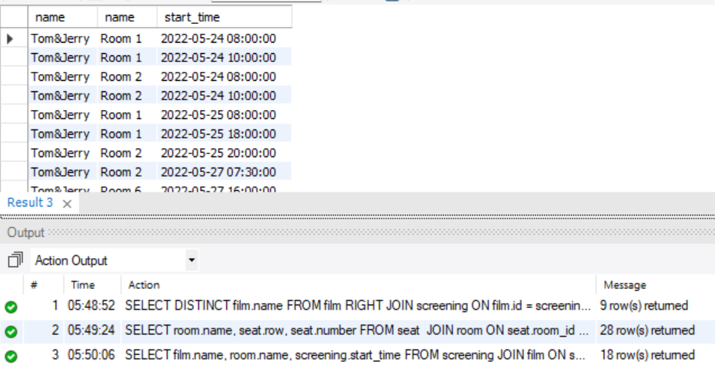

#Show what seat that customer "Dung Nguyen" booked

SELECT customer.first_name, customer.last_name, seat.row, seat.number

FROM reserved_seat

JOIN booking ON reserved_seat.booking_id = booking.id

JOIN seat ON reserved_seat.seat_id = seat.id

JOIN customer ON booking.customer_id = customer.id

WHERE customer.first_name = 'Dung' AND customer.last_name = 'Nguyen';

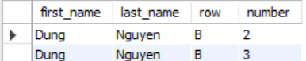

#How many film that showed in 24/5/2022

SELECT COUNT(DISTINCT film.name) AS total_film

FROM screening

JOIN film ON screening.film_id = film.id

WHERE DATE(screening.start_time) = '2022-05-24';



#What is the maximum length and minumum length of all film

SELECT

(SELECT name FROM film WHERE length_min = (SELECT MAX(length_min) FROM film)) AS longest_film,

(SELECT MAX(length_min)) AS max_length,

(SELECT name FROM film WHERE length_min = (SELECT MIN(length_min) FROM film)) AS shortest_film,

(SELECT MIN(length_min)) AS min_length

FROM film

LIMIT 1;

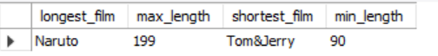

#How many seat of Room 7

SELECT COUNT(seat.id) AS total_seat

FROM room

JOIN seat ON room.id = seat.room_id

WHERE room.name = 'Room 7';

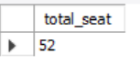

#Total seat are booked of film "Tom&Jerry"

SELECT COUNT(reserved_seat.seat_id) AS total_reserved_seats

FROM reserved_seat

JOIN booking ON reserved_seat.booking_id = booking.id

JOIN screening ON booking.screening_id = screening.id

JOIN film ON screening.film_id = film.id

WHERE film.name = 'Tom&Jerry';

