**Ministry of Education and Science of the Republic of Kazakhstan**

**Astana IT University**

Furniture Online-Store Management System

Olzhas Uikas, Aya Almatay, Dias Doktyrbek

BD-2006

Information and communication technologies: Final report Database project

**Instructor:** M.Ed. Aivar Sakhipov

**Submission date:** 23.11.2020

**Nur-Sultan, 2020**

1. Determine the purpose of your system.

-The database is intended for an online furniture store. For customers, furniture, and addressing of orders. The main function of this database is to create a favorable environment for buying furniture online. You can use it for a website or even for a mobile app. The database has 11 tables, but 3 of the 11 are intermediate tables (cashbox, del_order, warehouse). So, they have real 8 tables: client, AdressToDel, material, CompanyDel, dimension, Furniture_creator, Style_fur, furniture. One example of how this database works: so, a customer wants to buy a new sofa for their living room. And the customer lives in Kazakhstan. Now the customer sees new sofas from the site, and this is the site of our store. And he ordered one sofa for the living room. And he specified the address of the order. The order address is Kazakhstan. And we, as an" online store", say order-company address of the customer and order-company deliver this sofa by plane, because the sofa Creator is not a company from Kazakhstan. And when the order is delivered, we can change the delivery status to "True". Because the "False" is the order hasn't been delivered yet.

* What is the purpose of the database? Why is this needed? What should he do?
* This is a database for an online furniture store. The purpose of the database is to view customer and furniture information. Since the store is online, everything is done through the site. And all the information comes from the site. This helps to simplify store management as well as organize all data for future use.
* Who are users and what are they information needs?
* Administration, technical support and logisticians are users. And customers are end users. They will have access to a website where they can see all the furniture, choose a delivery method and order furniture online.
* What problems should the system solve decide?
* Reduces the risks of shortages of goods. This is due to the constant checking of goods on the store, it is possible to replenish goods from time to time. It also helps in target marketing. This means that I know the information can be advertised to the end user that he will probably buy. This is done using data stored in a database.
* What input data are available in the database?
* Information about the buyer, information about where and who delivers the goods, delivery status, the total amount of all furniture that is in stock, types of furniture: their sizes, their materials, their creators.
* What information should be kept in database?
* Do not store unnecessary information that will not be useful for improving sales or control of goods. The main data of this date base is: Names and addresses of customers, type and price of furniture and delivery details to ensure that delivery will be delivered.

2.Create ERD using Crow’s Foot notation (min.10 well-organized entities; their attributes, and types of relations);

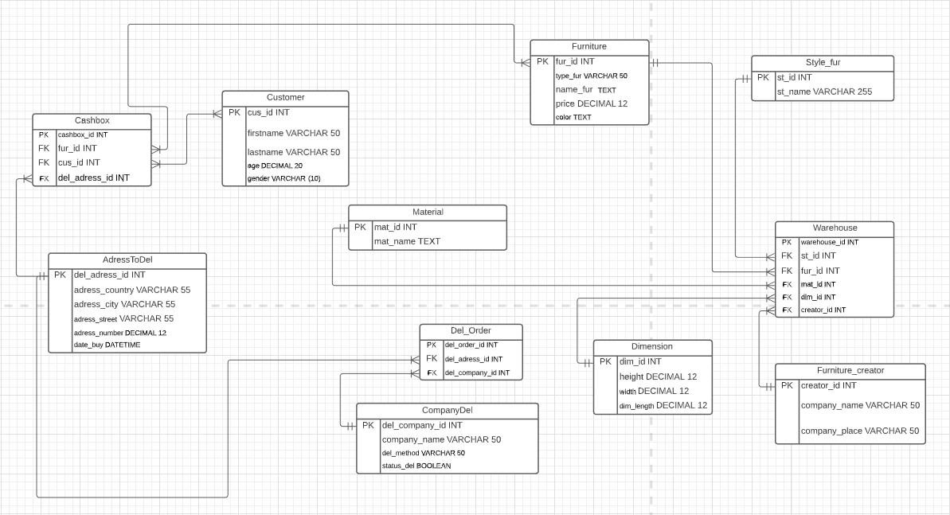

The whole relationship is shown at ERD using Crow’s Foot notation:

1. *Cashbox* and *Furniture* many to many;
2. *Cashbox* and *Customer* many to many;
3. *Cashbox* and *AdressToDel* many to one;
4. *AdressToDel* and *Del_Order* one to many;
5. *CompanyDel* and *Del_Order* one to many;
6. *Dimension* and *Warehouse* one to many;
7. *Furniture_creator* and *Warehouse* one to many;
8. *Material* and *Warehouse* one to many;
9. *Style_fur* and *Warehouse* one to many;
10. *Furniture* and *Warehouse* one to many;

*Cashbox*, *Del_Order* and *Warehouse* are an intermediate table. This means that they link tables to each other with which they relate.

These business rules are the restrictions under which the database will work stably.

1. One *Furniture* has a one *Furniture Creator*
2. One *Furniture Creator* can create one or many *Furniture*
3. Many *Customers* can buy and order many *Furniture*
4. One *Furniture* has only one *Furniture Type*
5. Many *Orders* may have one *Address*
6. Same *Materials* have one or many *Furniture*
7. One *Furniture* has one *Material*
8. On *Furniture* can be only on *Furniture Style*
9. One *Delivery Company* have one or many *Order*
10. One *Furniture* can be order only one *Customer*

3. Create database: tables with entities (tables) and constraints (PK, FK, UK, and etc.);

CREATE TABLE Material ( --1 mat_id INT NOT NULL, mat_name TEXT NOT NULL,

quality VARCHAR(50) NOT NULL,

PRIMARY KEY (mat_id)

);

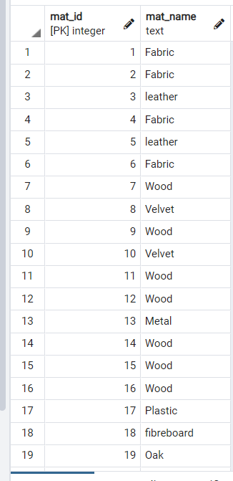

CREATE TABLE Furniture ( --2 fur_id INT NOT NULL,

type_fur VARCHAR(50) NOT NULL, name_fur VARCHAR(50) NOT NULL, price DECIMAL(12) NOT NULL,

PRIMARY KEY (fur_id)

);

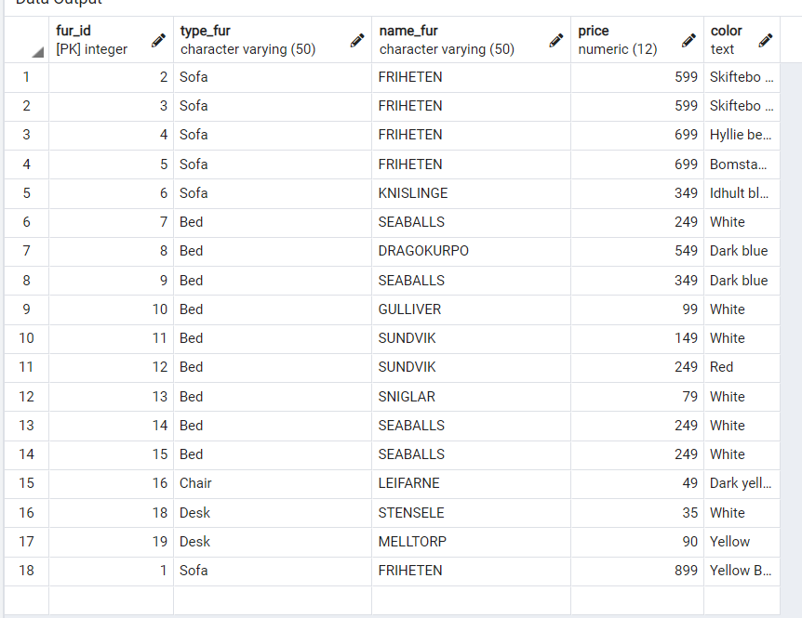

CREATE TABLE Style_fur ( --3 st_id INT NOT NULL,

st_name VARCHAR(255) NOT NULL, PRIMARY KEY (st_id)

);

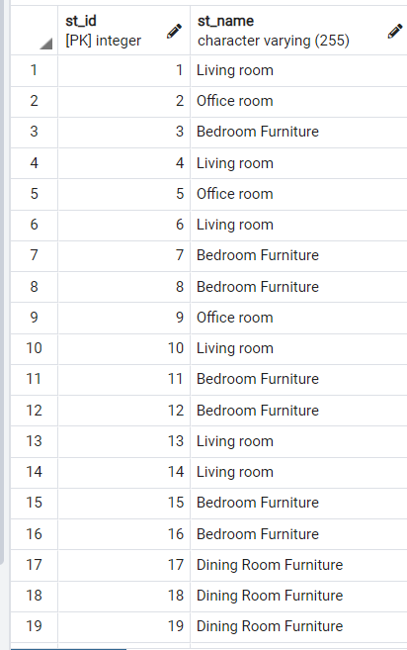

CREATE TABLE Furniture_creator ( --4 creator_id INT NOT NULL,

company_name VARCHAR(50) NOT NULL, company_place VARCHAR(50) NOT NULL, PRIMARY KEY (creator_id)

);

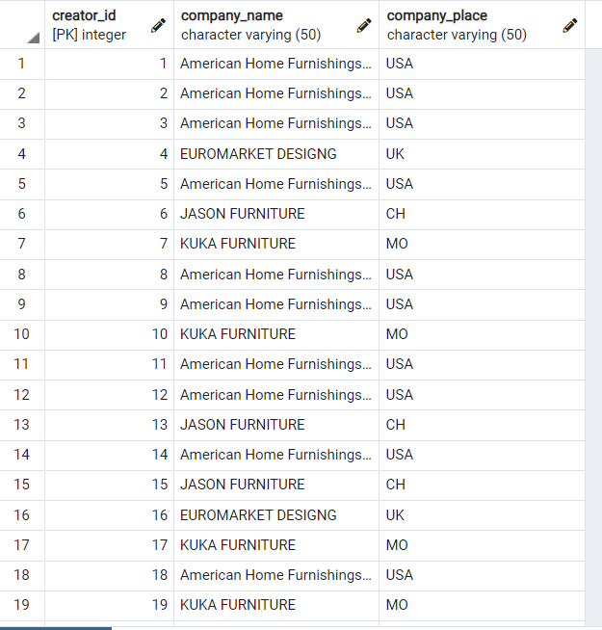

CREATE TABLE Dimension ( --5 dim_id INT NOT NULL,

height DECIMAL(12) NOT NULL, weight DECIMAL(12) NOT NULL, width DECIMAL(12) NOT NULL,

dim_length DECIMAL(12) NOT NULL, PRIMARY KEY (dim_id)

);

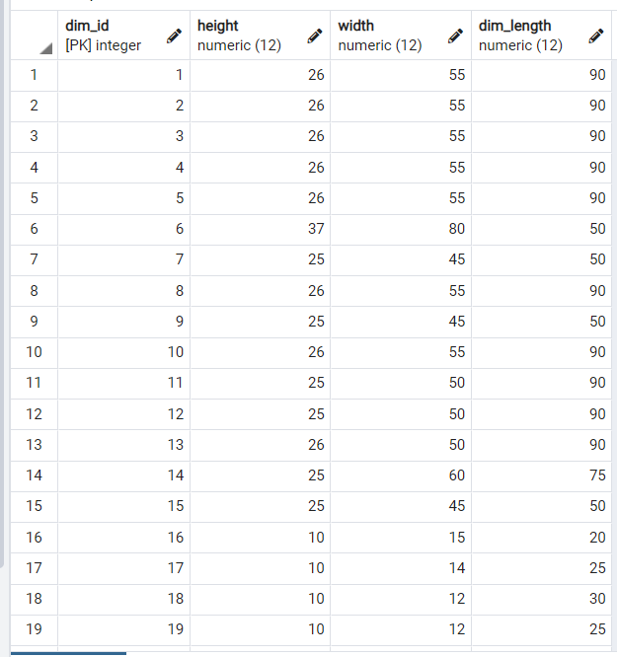

CREATE TABLE Warehouse ( --6 warehouse_id INT NOT NULL, st_id INT NOT NULL,

fur_id INT NOT NULL, mat_id INT NOT NULL, dim_id INT NOT NULL, creator_id INT NOT NULL,

PRIMARY KEY (warehouse_id),

FOREIGN KEY (st_id) REFERENCES Style_fur(st_id), FOREIGN KEY (fur_id) REFERENCES Furniture(fur_id), FOREIGN KEY (mat_id) REFERENCES Material(mat_id), FOREIGN KEY (dim_id) REFERENCES Dimension(dim_id),

FOREIGN KEY (creator_id) REFERENCES Furniture_creator(creator_id)

);

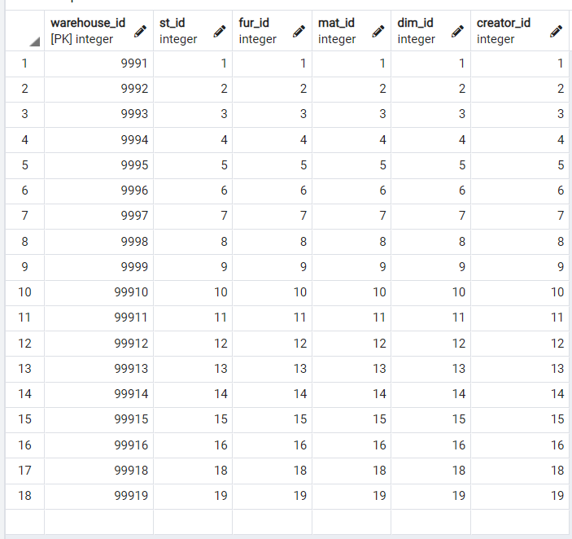

CREATE TABLE CompanyDel ( --7 del_company_id INT NOT NULL, company_name VARCHAR(50) NOT NULL, del_method VARCHAR(50) NOT NULL, PRIMARY KEY (del_company_id)

);

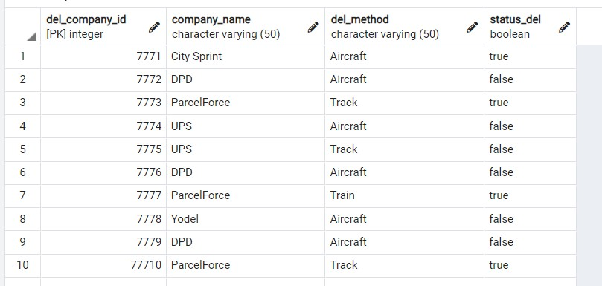

CREATE TABLE AdressToDel ( --8 del_adress_id INT NOT NULL, adress_country VARCHAR(55) NOT NULL, adress_city VARCHAR(55) NOT NULL, adress_street VARCHAR(55) NOT NULL, adress_number DECIMAL(12) NOT NULL, date_buy DATE NOT NULL,

PRIMARY KEY (del_adress_id)

);

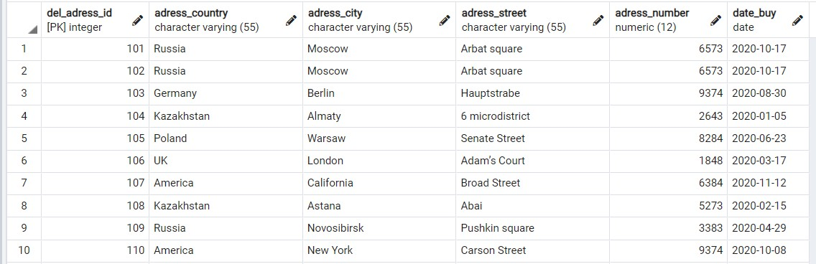

CREATE TABLE Del_Order ( --9

del_order_id INT NOT NULL, del_adress_id INT NOT NULL, del_company_id INT NOT NULL, PRIMARY KEY (del_order_id),

FOREIGN KEY (del_adress_id) REFERENCES AdressToDel(del_adress_id), FOREIGN KEY (del_company_id) REFERENCES CompanyDel(del_company_id)

);

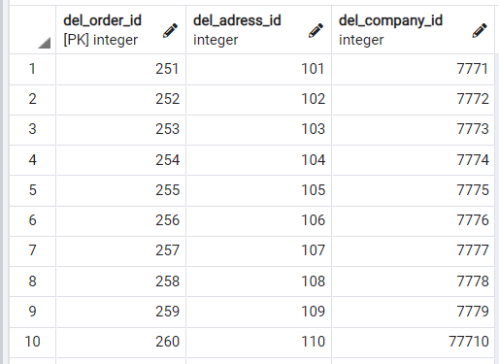

CREATE TABLE Customer ( --10

cus_id INT NOT NULL,

firstname VARCHAR(50) NOT NULL, lastname VARCHAR(50) NOT NULL, age DECIMAL(20) NOT NULL, gender VARCHAR(10) NOT NULL,

PRIMARY KEY (cus_id)

);

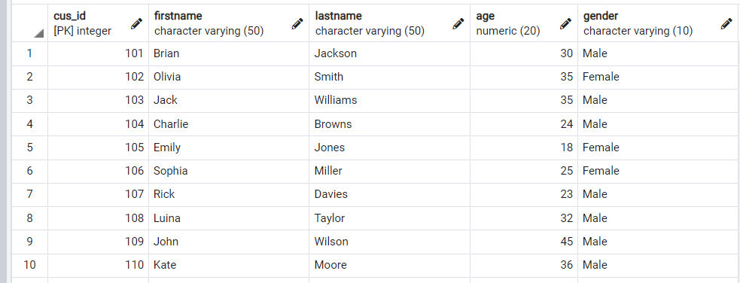

CREATE TABLE Cashbox ( --11

cashbox_id INT NOT NULL,

fur_id INT NOT NULL, cus_id INT NOT NULL,

del_adress_id INT NOT NULL, PRIMARY KEY (cashbox_id),

FOREIGN KEY (fur_id) REFERENCES Furniture(fur_id), FOREIGN KEY (cus_id) REFERENCES Customer(cus_id),

FOREIGN KEY (del_adress_id) REFERENCES AdressToDel(del_adress_id)

);

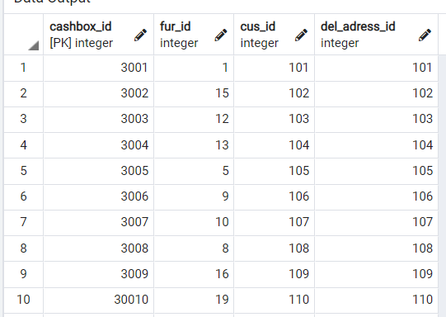

4.Write 5 different (add, drop and constraints) ALTER TABLE statements;

1. ALTER TABLE Furniture ADD color TEXT not null; ALTER TABLE CompanyDel

ADD status_del BOOLEAN NOT NULL;

1. ALTER TABLE Material DROP COLUMN quality; ALTER TABLE Dimension

DROP COLUMN weight;

1. ALTER TABLE Material

ADD PRIMARY KEY (mat_id);

1. ALTER TABLE Del_Order

ADD FOREIGN KEY (del_company_id) REFERENCES CompanyDel(del_company_id);

1. ALTER TABLE Material ADD test_column TEXT; ALTER TABLE Material

RENAME COLUMN test_column TO test_column_new;

5.Write SQL query for DML statements (insert, delete, update). Insert - for all tables at least 10 rows, Update – for each table with a condition, Delete – for each table with a condition;

INSERT INTO Furniture VALUES (1,'Sofa', 'FRIHETEN' , '699.00' , 'Hyllie dark gray') ; INSERT INTO Furniture VALUES (2,'Sofa', 'FRIHETEN' , '599.00' , 'Skiftebo blue') ; INSERT INTO Furniture VALUES (3,'Sofa', 'FRIHETEN' , '599.00' , 'Skiftebo dark gray') ; INSERT INTO Furniture VALUES (4,'Sofa', 'FRIHETEN' , '699.00' , 'Hyllie beige') ; INSERT INTO Furniture VALUES (5,'Sofa', 'FRIHETEN' , '699.00' , 'Bomstad black') ; INSERT INTO Furniture VALUES (6,'Sofa', 'KNISLINGE' , '349.00' , 'Idhult black') ; INSERT INTO Furniture VALUES (7,'Bed', 'SEABALLS' , '249.00' , 'White') ;

INSERT INTO Furniture VALUES (8,'Bed', 'DRAGOKURPO' , '549.00' , 'Dark blue') ; INSERT INTO Furniture VALUES (9,'Bed', 'SEABALLS' , '349.00' , 'Dark blue') ; INSERT INTO Furniture VALUES (10,'Bed', 'GULLIVER' , '99.00' , 'White') ; INSERT INTO Furniture VALUES (11,'Bed', 'SUNDVIK' , '149.00' , 'White') ; INSERT INTO Furniture VALUES (12,'Bed', 'SUNDVIK' , '249.00' , 'Red') ;

INSERT INTO Furniture VALUES (13,'Bed', 'SNIGLAR' , '79.00' , 'White') ; INSERT INTO Furniture VALUES (14,'Bed', 'SEABALLS' , '249.00' , 'White') ; INSERT INTO Furniture VALUES (15,'Bed', 'SEABALLS' , '249.00' , 'White') ;

INSERT INTO Furniture VALUES (16,'Chair', 'LEIFARNE' , '49.00' , 'Dark yellow') ; INSERT INTO Furniture VALUES (17,'Chair', 'INGOLF' , '59.00' , 'White') ; INSERT INTO Furniture VALUES (18,'Desk', 'STENSELE' , '35.00' , 'White' ) ; INSERT INTO Furniture VALUES (19,'Desk', 'MELLTORP' , '90.00' , 'Yellow' ) ;

INSERT INTO Style_fur VALUES (1, 'Living room') ; INSERT INTO Style_fur VALUES (2, 'Office room') ; INSERT INTO Style_fur VALUES (3, 'Bedroom Furniture') ; INSERT INTO Style_fur VALUES (4, 'Living room') ; INSERT INTO Style_fur VALUES (5, 'Office room') ; INSERT INTO Style_fur VALUES (6, 'Living room') ; INSERT INTO Style_fur VALUES (7, 'Bedroom Furniture') ; INSERT INTO Style_fur VALUES (8, 'Bedroom Furniture') ; INSERT INTO Style_fur VALUES (9, 'Office room') ; INSERT INTO Style_fur VALUES (10, 'Living room') ; INSERT INTO Style_fur VALUES (11, 'Bedroom Furniture') ; INSERT INTO Style_fur VALUES (12, 'Bedroom Furniture') ; INSERT INTO Style_fur VALUES (13, 'Living room') ; INSERT INTO Style_fur VALUES (14, 'Living room') ; INSERT INTO Style_fur VALUES (15, 'Bedroom Furniture') ; INSERT INTO Style_fur VALUES (16, 'Bedroom Furniture') ;

INSERT INTO Style_fur VALUES (17, 'Dining Room Furniture') ; INSERT INTO Style_fur VALUES (18, 'Dining Room Furniture') ; INSERT INTO Style_fur VALUES (19, 'Dining Room Furniture') ;

INSERT INTO Furniture_creator VALUES (1,'American Home Furnishings Alliance', 'USA') ; INSERT INTO Furniture_creator VALUES (2,'American Home Furnishings Alliance', 'USA') ; INSERT INTO Furniture_creator VALUES (3,'American Home Furnishings Alliance', 'USA') ; INSERT INTO Furniture_creator VALUES (4,'EUROMARKET DESIGNG', 'UK') ;

INSERT INTO Furniture_creator VALUES (5,'American Home Furnishings Alliance', 'USA') ;

INSERT INTO Furniture_creator VALUES (6,'JASON FURNITURE', 'CH') ; INSERT INTO Furniture_creator VALUES (7,'KUKA FURNITURE', 'MO') ;

INSERT INTO Furniture_creator VALUES (8,'American Home Furnishings Alliance', 'USA') ; INSERT INTO Furniture_creator VALUES (9,'American Home Furnishings Alliance', 'USA') ; INSERT INTO Furniture_creator VALUES (10,'KUKA FURNITURE', 'MO') ;

INSERT INTO Furniture_creator VALUES (11,'American Home Furnishings Alliance', 'USA') ; INSERT INTO Furniture_creator VALUES (12,'American Home Furnishings Alliance', 'USA') ; INSERT INTO Furniture_creator VALUES (13,'JASON FURNITURE', 'CH') ;

INSERT INTO Furniture_creator VALUES (14,'American Home Furnishings Alliance', 'USA') ; INSERT INTO Furniture_creator VALUES (15,'JASON FURNITURE', 'CH') ;

INSERT INTO Furniture_creator VALUES (16,'EUROMARKET DESIGNG', 'UK') ; INSERT INTO Furniture_creator VALUES (17,'KUKA FURNITURE', 'MO') ;

INSERT INTO Furniture_creator VALUES (18,'American Home Furnishings Alliance', 'USA') ; INSERT INTO Furniture_creator VALUES (19,'KUKA FURNITURE', 'MO') ;

insert into customer values (101, 'Brian', 'Jackson','30', 'Male'); insert into customer values (102, 'Olivia', 'Smith','35', 'Female'); insert into customer values (103, 'Jack', 'Williams','35', 'Male'); insert into customer values (104, 'Charlie', 'Browns','24', 'Male'); insert into customer values (105, 'Emily', 'Jones','18', 'Female'); insert into customer values (106, 'Sophia', 'Miller','25', 'Female'); insert into customer values (107, 'Rick', 'Davies','23', 'Male'); insert into customer values (108, 'Luina', 'Taylor','32', 'Male'); insert into customer values (109, 'John', 'Wilson','45', 'Male'); insert into customer values (110, 'Kate', 'Moore','36', 'Male');

INSERT INTO Material VALUES (1, 'Fabric') ; INSERT INTO Material VALUES (2, 'Fabric') ; INSERT INTO Material VALUES (3, 'leather') ; INSERT INTO Material VALUES (4, 'Fabric') ;

INSERT INTO Material VALUES (5, 'leather') ; INSERT INTO Material VALUES (6, 'Fabric') ; INSERT INTO Material VALUES (7, 'Wood') ;

INSERT INTO Material VALUES (8, 'Velvet') ; INSERT INTO Material VALUES (9, 'Wood') ;

INSERT INTO Material VALUES (10, 'Velvet') ; INSERT INTO Material VALUES (11, 'Wood') ; INSERT INTO Material VALUES (12, 'Wood') ; INSERT INTO Material VALUES (13, 'Metal') ; INSERT INTO Material VALUES (14, 'Wood') ; INSERT INTO Material VALUES (15, 'Wood') ; INSERT INTO Material VALUES (16, 'Wood') ;

INSERT INTO Material VALUES (17, 'Plastic') ; INSERT INTO Material VALUES (18, 'fibreboard') ; INSERT INTO Material VALUES (19, 'Oak') ;

INSERT INTO Dimension VALUES (1, '26','55','90') ; INSERT INTO Dimension VALUES (2, '26','55','90') ; INSERT INTO Dimension VALUES (3, '26','55','90') ; INSERT INTO Dimension VALUES (4, '26','55','90') ; INSERT INTO Dimension VALUES (5, '26','55','90') ; INSERT INTO Dimension VALUES (6, '37','80','50') ; INSERT INTO Dimension VALUES (7, '25','45','50') ; INSERT INTO Dimension VALUES (8, '26','55','90') ; INSERT INTO Dimension VALUES (9, '25','45','50') ; INSERT INTO Dimension VALUES (10, '26','55','90') ; INSERT INTO Dimension VALUES (11, '25','50','90') ; INSERT INTO Dimension VALUES (12, '25','50','90') ; INSERT INTO Dimension VALUES (13, '26','50','90') ; INSERT INTO Dimension VALUES (14, '25','60','75') ;

INSERT INTO Dimension VALUES (15, '25','45','50') ; INSERT INTO Dimension VALUES (16, '10','15','20') ; INSERT INTO Dimension VALUES (17, '10','14','25') ; INSERT INTO Dimension VALUES (18, '10','12','30') ; INSERT INTO Dimension VALUES (19, '10','12','25') ;

insert into AdressToDel(del_adress_id, adress_country, adress_city, adress_street, adress_number, date_buy)

values (101, 'Russia', 'Moscow', 'Arbat square', '6573', '17.10.2020'),

(102, 'Russia', 'Moscow', 'Arbat square', '6573', '17.10.2020'),

(103, 'Germany', 'Berlin', 'Hauptstrabe', '9374', '30.08.2020'),

(104, 'Kazakhstan', 'Almaty', '6 microdistrict', '2643', '05.01.2020'),

(105, 'Poland', 'Warsaw', 'Senate Street', '8284', '23.06.2020'),

(106, 'UK', 'London', 'Adam’s Court', '1848', '17.03.2020'),

(107, 'America', 'California', 'Broad Street', '6384', '12.11.2020'),

(108, 'Kazakhstan', 'Astana', 'Abai', '5273', '15.02.2020'),

(109, 'Russia', 'Novosibirsk', 'Pushkin square', '3383', '29.04.2020'),

(110, 'America', 'New York', 'Carson Street', '9374', '08.10.2020')

INSERT INTO Warehouse VALUES (9991,1,1,1,1,1) ; INSERT INTO Warehouse VALUES (9992,2,2,2,2,2) ; INSERT INTO Warehouse VALUES (9993,3,3,3,3,3) ; INSERT INTO Warehouse VALUES (9994,4,4,4,4,4) ; INSERT INTO Warehouse VALUES (9995,5,5,5,5,5) ; INSERT INTO Warehouse VALUES (9996,6,6,6,6,6) ; INSERT INTO Warehouse VALUES (9997,7,7,7,7,7) ; INSERT INTO Warehouse VALUES (9998,8,8,8,8,8) ; INSERT INTO Warehouse VALUES (9999,9,9,9,9,9) ; INSERT INTO Warehouse VALUES (99910,10,10,10,10,10) ; INSERT INTO Warehouse VALUES (99911,11,11,11,11,11) ;

INSERT INTO Warehouse VALUES (99912,12,12,12,12,12) ; INSERT INTO Warehouse VALUES (99913,13,13,13,13,13) ; INSERT INTO Warehouse VALUES (99914,14,14,14,14,14) ; INSERT INTO Warehouse VALUES (99915,15,15,15,15,15) ; INSERT INTO Warehouse VALUES (99916,16,16,16,16,16) ; INSERT INTO Warehouse VALUES (99917,17,17,17,17,17) ; INSERT INTO Warehouse VALUES (99918,18,18,18,18,18) ; INSERT INTO Warehouse VALUES (99919,19,19,19,19,19) ;

INSERT INTO CASHBOX VALUES (3001,1,101,101) ; INSERT INTO CASHBOX VALUES (3002,15,102,102) ; INSERT INTO CASHBOX VALUES (3003,12,103,103) ; INSERT INTO CASHBOX VALUES (3004,13,104,104) ; INSERT INTO CASHBOX VALUES (3005,5,105,105) ; INSERT INTO CASHBOX VALUES (3006,9,106,106) ; INSERT INTO CASHBOX VALUES (3007,10,107,107) ; INSERT INTO CASHBOX VALUES (3008,8,108,108) ; INSERT INTO CASHBOX VALUES (3009,16,109,109) ; INSERT INTO CASHBOX VALUES (30010,19,110,110) ;

INSERT INTO CompanyDel VALUES (7771,'City Sprint','Aircraft','True') INSERT INTO CompanyDel VALUES (7772,'DPD','Aircraft','False') ; INSERT INTO CompanyDel VALUES (7773,'ParcelForce','Track','True') ; INSERT INTO CompanyDel VALUES (7774,'UPS','Aircraft','False') ; INSERT INTO CompanyDel VALUES (7775,'UPS','Track','False') ;

INSERT INTO CompanyDel VALUES (7776,'DPD','Aircraft','False') ; INSERT INTO CompanyDel VALUES (7777,'ParcelForce','Train','True') ; INSERT INTO CompanyDel VALUES (7778,'Yodel','Aircraft','False') ; INSERT INTO CompanyDel VALUES (7779,'DPD','Aircraft','False') ; INSERT INTO CompanyDel VALUES (77710,'ParcelForce','Track','True') ;

INSERT INTO Del_Order VALUES (251,101,7771) ; INSERT INTO Del_Order VALUES (252,102,7772) ; INSERT INTO Del_Order VALUES (253,103,7773) ; INSERT INTO Del_Order VALUES (254,104,7774) ; INSERT INTO Del_Order VALUES (255,105,7775) ; INSERT INTO Del_Order VALUES (256,106,7776) ; INSERT INTO Del_Order VALUES (257,107,7777) ; INSERT INTO Del_Order VALUES (258,108,7778) ; INSERT INTO Del_Order VALUES (259,109,7779) ; INSERT INTO Del_Order VALUES (260,110,77710) ;

UPDATE Furniture

SET color = 'Yellow Blue Dragon', price = '899' WHERE fur_id = 1;

UPDATE CompanyDel SET status_del = 'False'

WHERE del_company_id = 1;

DELETE FROM WAREhouse WHERE fur_id =17 ;

DELETE FROM Furniture WHERE fur_id = 17;

6.Write at least 10 queries: using DISTINCT, conditions (,=), OR, AND, BETWEEN, IN, LIKE, LENGHT, COUNT, MAX, MIN, SUM, AVG, INNER JOIN, LEFT JOIN, RIGHT JOIN, FULL JOIN and etc. The queries should be coherent and complex.

1. SELECT * FROM Furniture WHERE price < '100';

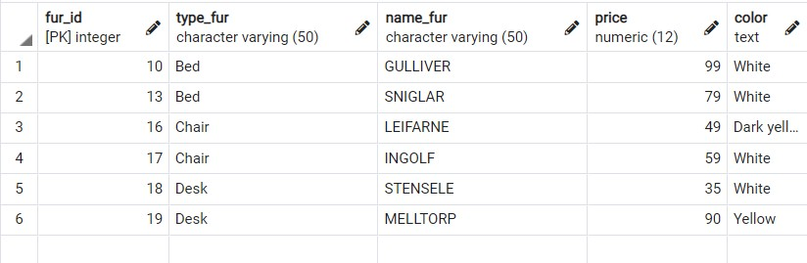

1. SELECT name_fur, price, dim_length FROM Furniture

INNER JOIN Dimension ON fur_id = dim_id WHERE price > '140' AND dim_length > '75' ;

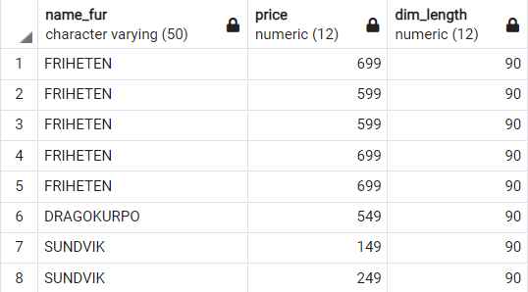

1. SELECT name_fur, price, color, dim_length, company_place FROM Furniture

INNER JOIN Dimension ON fur_id = dim_id

INNER JOIN Furniture_creator ON dim_id = creator_id WHERE company_place = 'USA' OR company_place = 'MO' AND dim_length BETWEEN '90' AND '25' ;

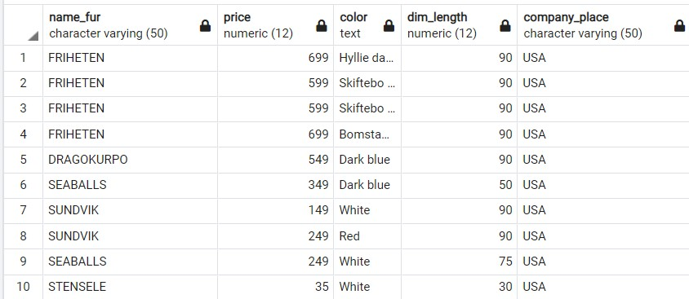

1. SELECT * FROM Furniture_creator

WHERE company_place IN ('USA', 'CH') AND creator_id <= '12'

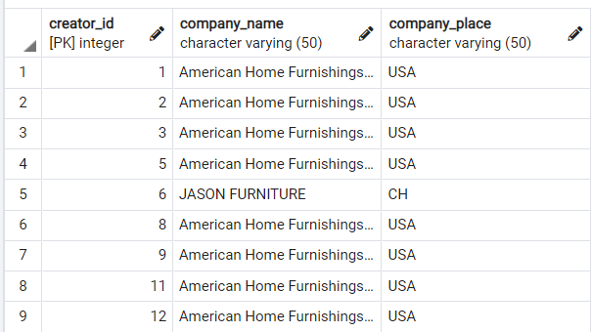

1. SELECT * FROM Furniture_creator

WHERE company_place NOT IN ('USA') OR creator_id > '5'

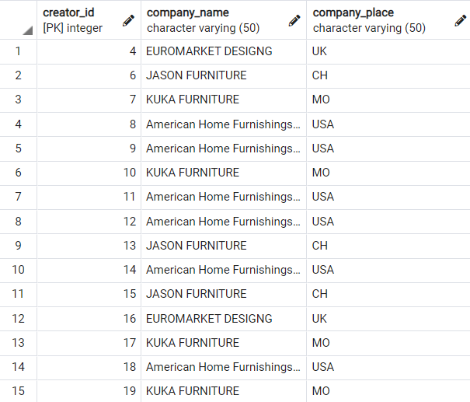

1. SELECT adress_country, adress_city, date_buy FROM AdressToDel

WHERE adress_city LIKE 'M%'; --Finds any values that start with 'M'

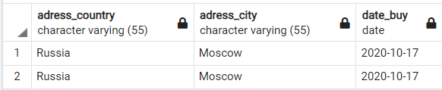

1. SELECT adress_country, adress_city, date_buy FROM AdressToDel

WHERE adress_city LIKE '%a'; --Finds any values that end with "a"

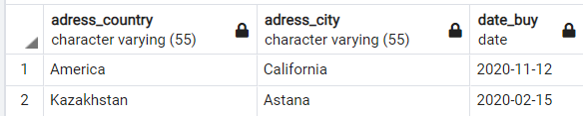

1. SELECT adress_country, adress_city, date_buy FROM AdressToDel

WHERE adress_country LIKE '%er%'; --Finds any values that have "er" in any position

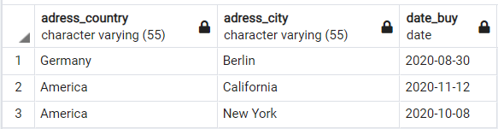

1. SELECT adress_country, adress_city, date_buy FROM AdressToDel

WHERE adress_city LIKE '_o%'; --Finds any values that have "o" in the second position

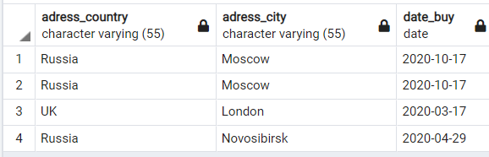

1. SELECT adress_country, adress_city, date_buy FROM AdressToDel

WHERE adress_city LIKE 'A_%'; --Finds any values that start with "A" and are at least 2 characters in length

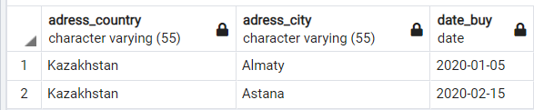

1. SELECT adress_country, adress_city, date_buy

FROM AdressToDel

WHERE adress_city LIKE 'A %'; --Finds any values that start with "A" and are at least 3 characters in length

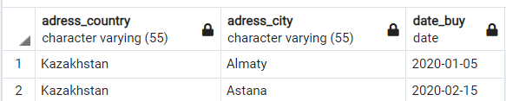

1. SELECT adress_country, adress_city, date_buy FROM AdressToDel

WHERE adress_city LIKE 'L%n'; --Finds any values that start with "L" and ends with "n"

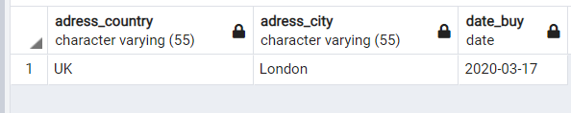

1. SELECT Length (adress_street) FROM AdressToDel WHERE adress_street = 'Abai';

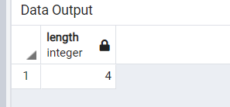

1. SELECT firstname,lastname, Customer.cus_id, name_fur ,CASHBOX.cus_id, CASHBOX.fur_id, Furniture.fur_id

FROM Furniture

FULL JOIN CASHBOX ON Furniture.fur_id = CASHBOX.fur_id RIGHT JOIN Customer ON CASHBOX.cus_id = Customer.cus_id ;

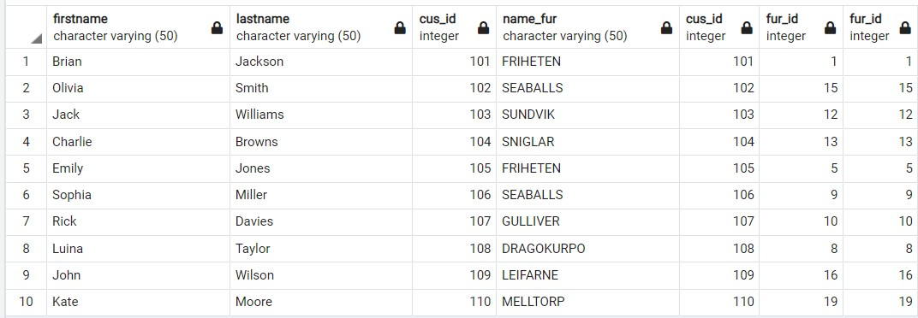

1. SELECT firstname,lastname, Customer.cus_id, name_fur ,CASHBOX.cus_id, CASHBOX.fur_id, Furniture.fur_id

FROM Furniture

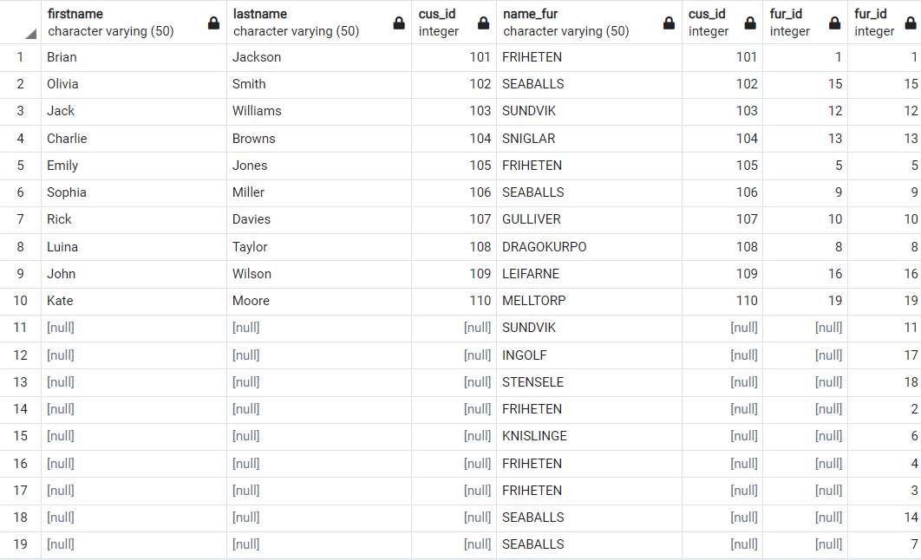FULL JOIN CASHBOX ON Furniture.fur_id = CASHBOX.fur_id Left JOIN Customer ON CASHBOX.cus_id = Customer.cus_id ;

1. SELECT firstname,lastname, Customer.cus_id, name_fur ,CASHBOX.cus_id, CASHBOX.fur_id

FROM Customer

FULL JOIN CASHBOX ON Customer.cus_id = CASHBOX.cus_id right JOIN Furniture ON CASHBOX.fur_id = Furniture.fur_id ;

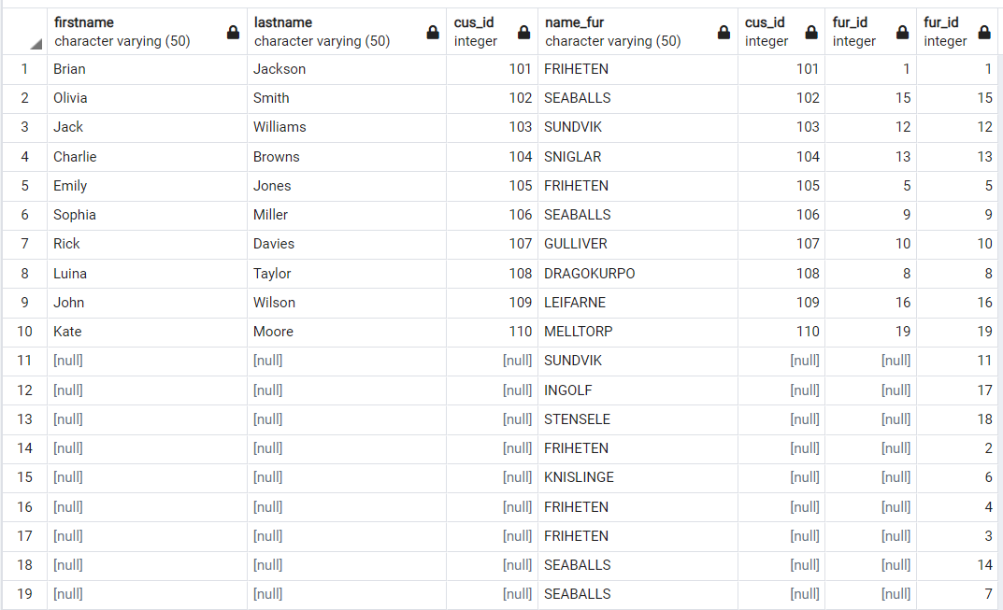

1. SELECT COUNT (firstname) FROM Customer

INNER JOIN Cashbox ON Customer.cus_id = Cashbox.cus_id RIGHT JOIN Furniture ON Cashbox.fur_id = Furniture.fur_id;

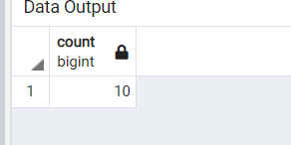

1. SELECT AVG(price) AS "Average purchase", MIN(price) AS "Minimum purchase", MAX(price) AS "Maximum purchase",

SUM(price) AS "Total money spent" FROM Customer

INNER JOIN Cashbox ON Customer.cus_id = Cashbox.cus_id Left JOIN Furniture ON Cashbox.fur_id = Furniture.fur_id ;

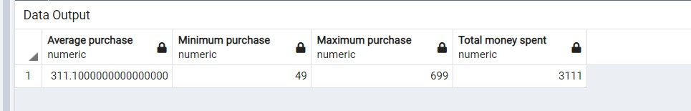

7.Write at least 5 subqueries: single-row, multiple-row and multiple-column subqueries, and etc.;

1. -- single row

SELECT firstname,lastname FROM Customer

WHERE cus_id = (SELECT cus_id FROM Customer WHERE firstname = 'Rick');

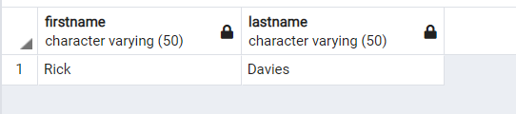

1. -- multiple row

SELECT company_name, del_method, status_del FROM CompanyDel

WHERE del_company_id IN (SELECT del_company_id FROM Del_Order WHERE del_method

= 'Aircraft');

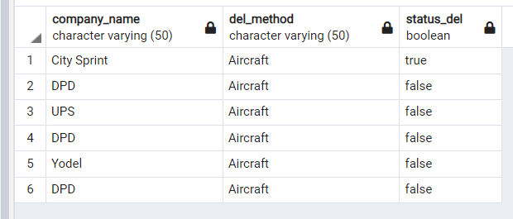

1. ---Multiple Column Subqueries

SELECT price, fur_id, color, name_fur FROM Furniture WHERE (fur_id,price) IN (SELECT fur_id,price FROM Furniture WHERE name_fur = 'FRIHETEN');

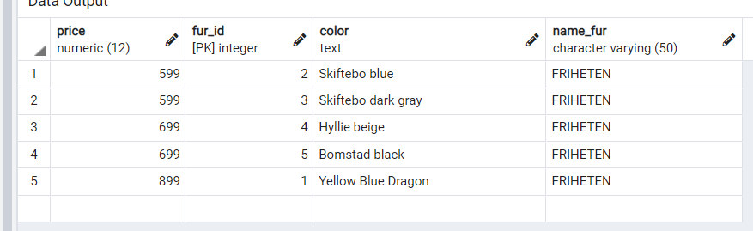

1. --Multiple Column Subqueries

SELECT date_buy, del_adress_id, adress_country, adress_number

FROM AdressToDel WHERE (del_adress_id,date_buy) IN (SELECT del_adress_id,date_buy FROM AdressToDel WHERE date_buy = '2020-10-17');

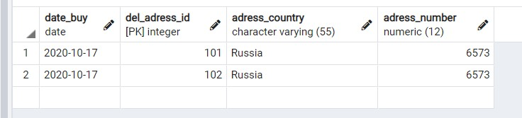

1. – Multiple Row Subqueries

SELECT width, dim_id,dim_length FROM Dimension

WHERE dim_id IN (SELECT dim_id FROM Dimension WHERE width > '14' AND width <> '50');

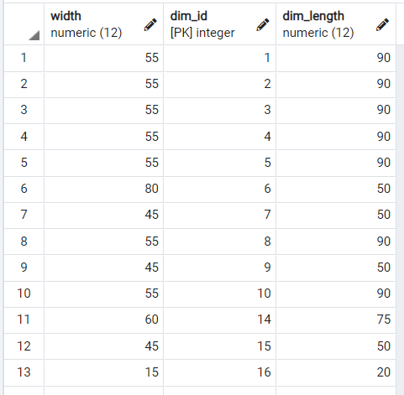

6)-- Multiple Column Subqueries

SELECT price, fur_id, color, name_fur

FROM Furniture

WHERE (fur_id,price)

IN

(SELECT fur_id,price

FROM Furniture GROUP BY fur_id

);

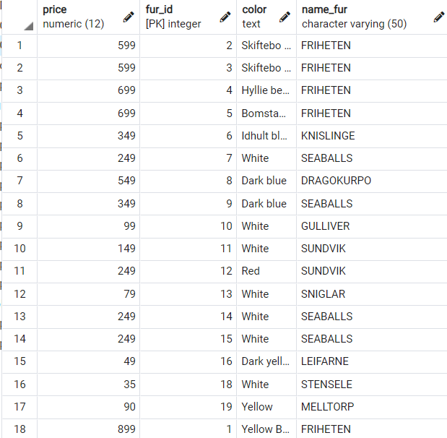

**References:**

1. <https://www.ikea.com/us/en/cat/all-sofas-39130/>

* To keep all prices real for sofas.

1. <https://www.bassettfurniture.com/blog/different-types-of-furniture.aspx>
2. https://en.wikipedia.org/wiki/List_of_furniture_types

* Studied all styles for furniture.