Arduino-Based Vehicle Safety System with Alcohol Detection, Fail-Safe Ignition Logic, and Event Logging

Rushikesav Gangineni¹, Vishnu Vardhan Reddy Uyyala², Meghana Bellamkonda³, Poornima Upputuru⁴, Chaithanya Sagar Bellary⁵, M. Sreedhar⁶
Electronics and Communication Engineering
JNTUA College of Engineering Ananthapuramu, Anantapur, India gnginenirushikesav@gmail.com, uvishnuvardhanreddy1952@gmail.com, meghanabellamkonda959@gmail.com,
poornimaupputuru@gmail.com, chaithanyac2106@gmail.com, sreedhar470@gmail.com

Keywords: Alcoholdetection, continuous monitoring, engine lock, ignition control, EEPROM logging, RTC module, fault detection, Arduino, embedded system, vehicle safety, drunk driving prevention.

Abstract: This paper presents an Arduino-based alcohol detection and engine control system designed to prevent drunk driving through continuouspre- and post-ignition monitoring of the driver’s breath alcoholconcentration. An MQ-3 sensor positioned near the driver measures alcohollevels in real time; if the concentration exceeds the threshold, engine ignition is disabled and visualand audio warnings are issued. To ensure safety and reliability, a fault-detection mechanism identifies sensor malfunctions or disconnections and prevents unsafe ignition attempts. All significant events—alcohol detection, ignition activity, and sensor faults—are logged in EEPROM with accurate timestamps provided by a Real-Time Clock (RTC) module. The prototype demonstrates robust, fail-safe operation and forms a scalable foundation for integration with GPS, GSM, or biometric authentication modules, enabling advanced driver safety and law-enforcement applications.

INTRODUCTION
Driving under the influence of alcohol continues to be one of the leading causes of road fatalities worldwide, endangering not only intoxicated drivers but also passengers and pedestrians. Preventing such incidents requires proactive safety mechanisms that can detect driver impairment and restrict vehicle operation before an accident occurs. In response to this need, this work presents an intelligent alcohol detection and engine control system capable of ensuring that vehicle ignition is permitted only when the driver is verified to be sober.
The proposed design employs an MQ-3 alcohol sensor positioned near the driver to continuously monitor the alcohol content in exhaled breath. In contrast to earlier threshold-based approaches that relied on fixed confirmation intervals, this system performs uninterrupted, real-time analysis of alcohol concentration. When the detected level exceeds a defined threshold, ignition remains disabled, warning indicators are activated, and the corresponding event is securely logged. Continuous sensing is also maintained during vehicle operation—if alcohol is detected after ignition, the system issues an immediate warning to the driver without forcing an engine shutdown, thereby preventing hazardous traffic interruptions.
To enhance reliability and operational safety, a built-in fault detection mechanism identifies sensor anomalies, disconnections, or abnormal readings that could compromise accuracy. All critical events, including ignition

attempts, alcohol detections, and sensor faults, are automatically stored in the EEPROM memory of the Arduino controller. When integrated with a Real-Time Clock (RTC) module, each record is timestamped to support precise event tracking and post-incident evaluation. Developed on an Arduino microcontroller using cost- efficient components, the system demonstrates a balance between practicality and scalability. Its modular hardware- software architecture allows seamless integration of advanced extensions such as GPS tracking, GSM-based communication, and biometric driver authentication. These enhancements position the proposed design as a versatile and reliable platform for improving vehicular safety, supporting intelligent transport systems, and aiding law- enforcement initiatives aimed at reducing alcohol-related
road accidents.

LITERATURE SURVEY
The detection and prevention of drunk driving have received significant research attention in recent years, particularly with the advancement of embedded sensing technologies and Internet of Things (IoT)

integration. A majority of existing systems utilize semiconductor-based gas sensors, such as the MQ-3, for detecting alcohol vapor concentration in the driver’s breath. These systems typically employ a threshold-based approach, where the vehicle ignition is disabled once the measured alcohol level exceeds a predefined safety limit. While effective to an extent, such systems often depend on single- pointverification rather than continuous analysis, reducing their reliability in real-world driving conditions.
Several studies have explored enhancements to improve detection accuracy and safety enforcement. Sharma et al. developed an IoT-based alcohol detection system that transmits sensor readings to a cloud database for remote monitoring. However, their work lacked provisions for sensor fault tolerance or local data storage, making it dependent on network connectivity. Similarly, Singh and Verma designed a microcontroller-based engine locking system, but it operated only during the pre-ignition phase without logging or post-start monitoring. Patel and Desai proposed an embedded alcohol detection unit us MQ- 3 sensors that effectively immobilized the vehicle when alcohol was detected; however, it did not record timestamped data for forensic or analytical purposes. More recent works have begun integrating IoT features and additional sensors. Tarun et al. implemented an IoT-based engine locking system
with GPS tracking, enabling real-time location updates to authorized personnel. Despite this progress, the design lacked a robust fault-detection mechanism and did not support continuous sensing after ignition. Gajula introduced a temperature- compensated Arduino system that enhanced the sensor’s accuracy but did not include event logging or RTC timestamping. Review-oriented studies, such as that by Ravi Kumar et al., have provided comprehensive overviews of various alcohol detection systems, highlighting the growing need for more intelligent, data-driven safety solutions.
Khatri et al. developed a compact 8051-based MQ-3 detection system for embedded safety applications, but the model was limited to pre- ignition analysis and lacked EEPROM memory support. Kayode et al. further proposed a driver safety monitoring device with ignition interlock control, though it did not integrate modular features for scalability or future upgrades.
These findings indicate that while progress has been made in alcohol detection technology, existing systems generally lack advanced reliability mechanisms, such as sensor fault detection, continuous post-ignition monitoring, and persistent event logging. Furthermore, few models provide timestamped data essential for forensic reconstruction or long-term analytics.

Table 1: Comparative Review of Existing Alcohol Detection Systems and Proposed Design Enhancements.

Ref. | Year | Platform / Method | Key Features | Major Limitations | Added Advantages of Proposed System
Sharma  et al. | 2020 | IoT + MQ-3 sensor | Remote monitoring via IoT, threshold- based engine lock | No local fault detection; no  timestamped historic log | Adds offline EEPROM logging, sensor fault detection, RTC  timestamps
R. Singh & A. Verma | 2019 | Microcontroller (8051) locking system | Engine disable when threshold exceeded, buzzer/LED alerts | Only pre-ignition sensing; no logging;  no post-ignition monitoring | Continuous monitoring, event logging, post-  ignition warnings without shutdown
M. Patel & P.  Desai | 2018 | Embedded MQ-3 unit | Basic alcohol threshold detection  and engine lock | Lacks RTC  timestamps; no modular fault-handling | RTC-based timestamps; modular fault detection  and logging
A. Tarun  et al. | 2025 | IoT engine lock + GPS | Location tracking + remote alerting | Lacks robust fault detection; limited real-  time local logging | Adds reliability through fault detection +  RTC/EEPROM local logs
V. Gajula | 2018 | Arduino + Temp compensation | Improved sensor accuracy via  temperature correction | No event memory; no timestamping; limited feature set | Combines accuracy with comprehensive logging and modular additions
K. Ravi Kumar et  al. | 2022 | Survey / Review paper | Broad summarization of prior systems; identifies trends and gaps | Theoretical; no implementation  details; lacks event- logging data | Provides working prototype with data logging, continuous monitoring, fault  detection
D. Khatri  et al. | 2023 | 8051 + MQ-3  detector | Basic detection & display; engine lock before ignition | No post-ignition detection; no memory  logging or  timestamping | Enables alerting after ignition, local memory logging, RTC support
J. F.  Kayode  et al. | 2022 | Driver safety monitoring +  ignition interlock | Ignition interlock; driver monitoring | Missing modular expansions; lack of historic event logs | Modular design; full event logging; posts-start monitoring; fault  detection

- SYSTEM ARCHITECTURE AND WORKING PRINCIPLE

System Architecture
The system consists of several integrated hardware modules, as shown in Figure 1, that collectively perform alcohol detection, engine control, fault handling, and data logging.
- Alcohol Sensor (MQ-3 or Fuel Cell Type): Detects the presence of alcohol in the driver’s breath and produces an analog voltage output proportional to the concentration level.
- Arduino Uno Microcontroller: Acts as the central control unit, executing the detection algorithm, managing input/output operations, and storing event data.
- Relay Module: Functions as an electronically controlled switch that enables or disables the
ignition circuit based on alcohol detection results.
- Buzzer: Provides audible alerts in the event of alcohol detection or system faults.
- LCD Display with I²C Interface: Displays real- time system messages such as Safe to Drive, Alcohol Detected, or Sensor Fault.
- Ignition Switch: Simulates the vehicle ignition process and triggers the alcohol detection routine when activated.
- Internal EEPROM (Arduino): Stores all critical system events, including ignition attempts, alcohol detections, and sensor faults.
- Real-Time Clock (RTC) Module-DS3231: Provides accurate timestamping for recorded events, facilitating chronological analysis.

Hardware Pin Configuration
The interconnection between the Arduino and peripheral components is summarized in Table 2.

Table 2: Hardware Pin Configuration.

Component | Arduino Pin | Functionality
Alcohol  Sensor | A0 | Analogue input for  alcohol measurement
Relay (Engine Control) | D7 | Controls the engine lock/unlock  mechanism
Buzzer | D8 | Activates audio alerts
Ignition  Switch | D9 | Digital input  simulating ignition
I2C LCD  Display | A4 (SDA),  A5 (SCL) | Communicates via  I2C interface
RTC Module (DS3231) | A4 (SDA), A5 (SCL) | Shares the I2C bus with the LCD

System Operation
The system remains idle when the ignition switch is OFF. Upon activation, the Arduino initializes all modules and begins continuous monitoring of the MQ-3 alcohol sensor. The operation includes four key conditions:
    - No Alcohol Detected: If the measured concentration is below the threshold, the relay is energized, enabling ignition. A record of this successful ignition is stored in EEPROM.
    - Alcohol Detected (Pre-Ignition): If alcohol is detected before ignition, the system prevents engine start, activates the buzzer, and displays a warning message. The event is logged in non-volatile memory.
    - Alcohol Detected (Post-Ignition): If alcohol is detected after the engine has started, the system issues a warning without interrupting engine operation, avoiding unsafe vehicle stoppages. The event is logged for later review.
    - Sensor Fault Condition: Abnormal or extreme sensor readings (e.g., constant 0 or 1023) are interpreted as faults. Ignition is disabled, a Sensor Fault warning is displayed, and the event is recorded for diagnostics.
All system activities—including ignition attempts, alcohol detections, and fault events—are logged in EEPROM. When an RTC module is connected, each record includes a timestamp, enabling precise chronological tracking and data auditing.

System Overview
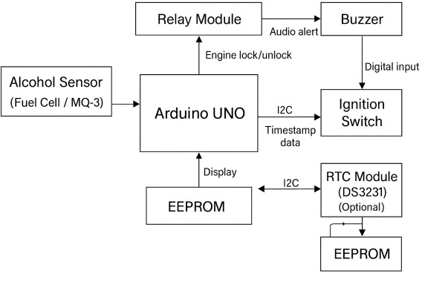
Figure 1: Block diagram of the alcohol detection and engine lock system.

The overall system layout is illustrated in Figure 1. The Arduino UNO serves as the central controller, interfacing with the MQ-3 alcohol sensor for real-time concentration monitoring, the relay for ignition control, the buzzer and LCD for driver alerts, and the EEPROM for event logging. An optional DS3231 RTC module provides accurate timestamps, enabling chronological data analysis and system reliability evaluation.

SYSTEM FLOWCHART AND LOGIC
The flowchart illustrates the decision logic for alcohol detection, ignition control, fault handling, and event logging. The structure emphasizes continuous monitoring and fail-safe operation to ensure driver and passenger safety.
As shown in Figure 2, the system begins operation when the ignition switch is turned ON. The Arduino initializes all connected modules and continuously evaluates the MQ-3 sensor output to determine the driver’s breath alcohol concentration. Depending on the detected condition, the controller transitions between four primary states:
- Sensor Fault Condition: Abnormal or invalid readings trigger a fault state, disabling ignition and issuing visual and audio alerts.
- No Alcohol Detected (Safe Condition): When the alcohol level is below the threshold, the relay is energized to enable ignition, and the event is logged.
- Alcohol Detected (Pre-Ignition): Detection before ignition keeps the engine locked and records the event in non-volatile memory.

- Alcohol Detected (Post-Ignition): Detection after ignition generates alerts without stopping the engine, preventing unsafe stoppages.
All significant events are stored in the Arduino’s internal EEPROM, and when the RTC module is active, each record includes a timestamp for chronological analysis. This logic ensures robust fault handling, continuous monitoring, and safe system behavior under all tested conditions.
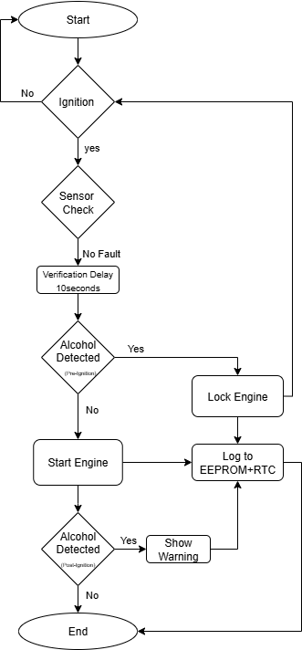

Figure 2: Flowchart of the system working logic

RESULTS AND DISCUSSION
The prototype system was successfully implemented using an Arduino UNO, an MQ-3 alcohol sensor, and associated peripheral modules.
Experimental validation was performed under multiple operating conditions to evaluate system reliability, fault response, and data logging accuracy. The major results are summarized below.
- Sensor Fault Identification: When the MQ-3 sensor was disconnected or produced extreme analog readings (0 or 1023), the system consistently identified the fault. In
such cases, ignition was disabled, the buzzer was activated, and Sensor Fault appeared on the LCD. The event was logged in EEPROM with timestamping enabled through the RTC module.
Average fault detection latency: <300 ms.
- Ignition with Alcohol Presence: During ignition attempts under alcohol influence, the system detected the condition within a 10-second observation window. The relay remained locked, the buzzer and LCD issued Alcohol Detected warnings, and the event was recorded in EEPROM—confirming reliable pre-ignition safety logic.
- Safe Ignition (No Alcohol): In alcohol-free conditions, the system performed a stabilization delay of 10 seconds before energizing the relay. The LCD displayed Safe to Drive, and a successful ignition event was logged in EEPROM, demonstrating accurate threshold differentiation and consistent decision-making.
- Post-Ignition Alcohol Detection: When alcohol was introduced after ignition, the system generated audible and visual warnings without disabling the engine, preventing unsafe vehicle stoppage. The event was stored for later analysis. Response time to post-ignition detection:
≈2.1 s.
- Event Logging and Timestamping: All critical events—safe ignition, alcohol detection, and sensor faults—were permanently stored in EEPROM. When RTC integration was active, each record carried a precise timestamp, enabling chronological traceability and forensic reconstruction.
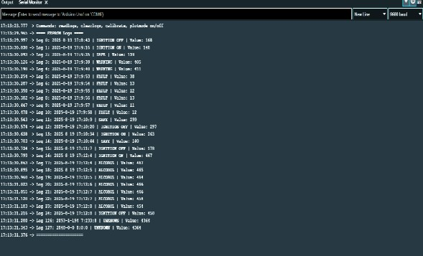
Figure 3: EEPROM event logs captured in the serial monitor for ignition attempts, alcohol detection, safe starts, and fault conditions.

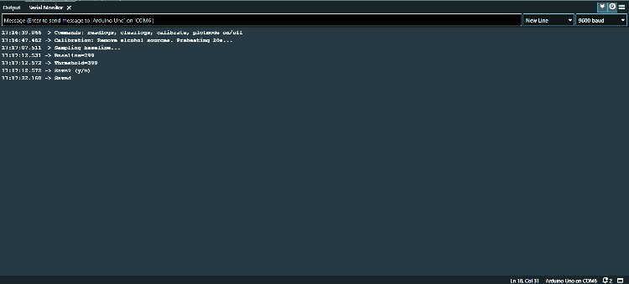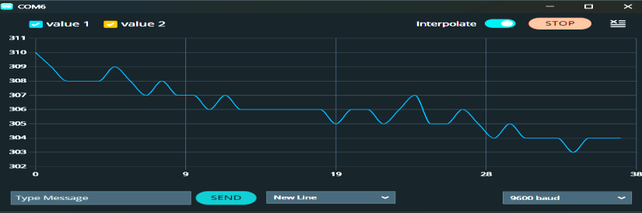

Figure 4: Calibration process recorded in the serial monitor with baseline and threshold stabilization data.

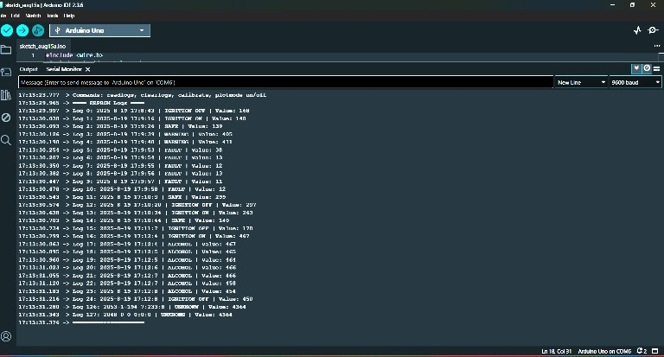
Figure 5: Serial monitor output of multiple ignition cycles showing safe start, alcohol detection, and fault recognition events.
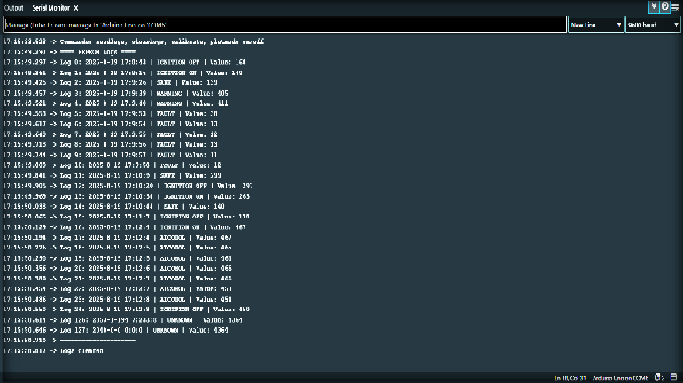
Figure 6: Combined EEPROM log output displaying timestamped ignition, warning, and fault records.
Figure 7: Real-time sensor output in the Arduino Serial Plotter under safe (no-alcohol) condition.
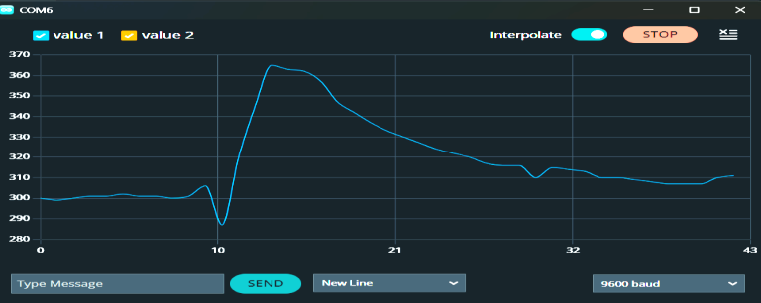
Figure 8: Serial Plotter response curve showing increased sensor output during alcohol detection and gradual decay during recovery.
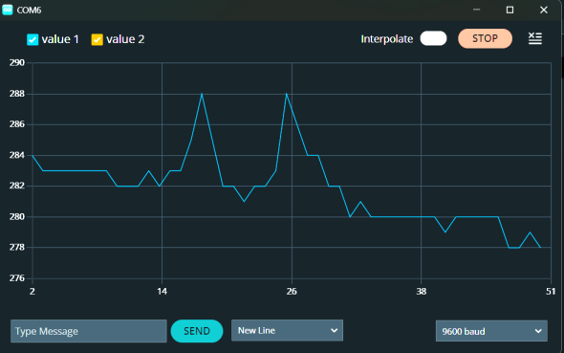
Figure 9: Serial Plotter output under sensor fault condition indicating abnormal or unstable sensor readings.

Table 3: Experimental Results of the Alcohol Detection and Engine Control System

Test Scenario | Expected Outcome | Observed Outcome | Status
Sensor fault  (disconnected/invalid) | Engine locked; buzzer alert; LCD shows Sensor  Fault | Function executed as  intended | Pass
Ignition with alcohol present | Buzzer ON; engine locked; LCD shows Alcohol  Detected; event logged | Function executed as  intended | Pass
Safe ignition (no alcohol) | 10-s verification → relay ON; engine starts;  event logged | Function executed as  intended | Pass
Post-ignition alcohol  detection | Buzzer ON; LCD shows warning; engine  continues operation | Function executed as  intended | Pass
Event logging with RTC | All events logged in EEPROM with timestamps | Function executed as intended | Pass

Discussion
The results confirm that the proposed system
operates reliably across all tested scenarios. The Serial Plotter outputs verify that the MQ-3 sensor provides distinct and repeatable signal patterns for safe, unsafe, and fault conditions, enabling precise classification within the 10-second evaluation window.
The EEPROM logs demonstrate robust data recording capability, and the inclusion of RTC-based timestamping enables complete chronological reconstruction of system activity. These features improve both the reliability and forensic applicability of the design. Furthermore, the modular system architecture allows straightforward integration with GPS, GSM, or biometric authentication modules, supporting future scalability for advanced vehicle safety applications.

CONCLUSION AND FUTURE SCOPE
The developed alcohol detection and ignition control system effectively prevents engine start when alcohol concentration exceeds the permissible threshold. By incorporating a 10-second confirmation interval, ignition-based detection, and post-ignition warning logic, the system ensures preventive safety while maintaining operational reliability. The inclusion of sensor fault detection further enhances robustness by identifying abnormal sensor behavior and alerting the driver without triggering false locks.

All key events—covering safe ignition, alcohol detection, and sensor faults—are logged in the Arduino’s EEPROM. With the integration of an RTC module, each event is timestamped, enabling accurate chronological tracking. This feature supports enforcement agencies and fleet operators in post- event verification and data analysis.

Future Scope
To advance the system’s practicality and societal impact, future developments may include:
    - IoT-based Connectivity: Integration of GSM and GPS modules for real-time data transmission to traffic control centers, enabling quick enforcement response.
    - Driver Authentication: Incorporation of biometric or RFID-based verification to ensure only authorized drivers can operate the vehicle.
    - Advanced Sensing: Adoption of fuel-cell or semiconductor sensor arrays for improved selectivity, faster response time, and tamper- proof detection.
In summary, the proposed Arduino-based alcohol detection and ignition control system demonstrates a cost-effective and reliable solution for preventing drunk-driving incidents. Its modular architecture provides a scalable foundation for next-generation smart and connected vehicular safety systems.

REFERENCES

S. Sharma, V. Gupta, and R. Kumar, “IoT-based alcohol detection system for vehicle safety,” Int. J. Adv. Res. Elect., Electron. Instrum. Eng., vol. 9, no. 5, pp. 1234– 1241, May 2020.
R. Singh and A. Verma, “Design and implementation of alcohol detection and vehicle locking system,” in Proc. IEEE Int. Conf. Comput., Commun. Autom. (ICCCA), Greater Noida, India, Dec. 2019, pp. 1–6.
M. Patel and P. Desai, “Embedded system for drunken driving prevention,” Int. J. Eng. Trends Technol., vol. 45, no. 7, pp. 321–325, Mar. 2018.
A. Tarun, G. S. Alekhya, P. Govardhan, and P. A. Raju, “IoT-based alcohol detection and engine locking system with GPS,” Int. J. Res. Appl. Sci. Eng. Technol. (IJRASET), vol. 13, pp. 123–130, Mar. 2025.
V. Gajula, “Improved alcohol detection and vehicle ignition locking system using Arduino and temperature sensor,” B.Tech Project Report, G. Narayanamma Inst. of Technology and Science, Hyderabad, India, Sept. 2018.
K. Ravi Kumar, Y. N. Kumar, M. Kisran, U. Teja, and M. Shakeer, “Review paper on alcohol detection and vehicle engine locking system,” J. Pharm. Negat. Results, vol. 13, no. S09, pp. 10085–10092, Dec. 2022, doi: 10.47750/pnr.2022.13.S09.1180.
D. Khatri, K. Gladstone, Y. Joysar, and N. Mehendale, “Design and development of an alcohol detector employing an MQ-3 gas sensor and an 8051 microcontroller,” in Proc. Int. Conf. Embedded Syst., Jan. 2023.
J. F. Kayode, K. J. Agim, A. S. Afolalu, and A. O. M. Adeoye, “Development of a driver safety monitoring device with ignition interlock,” Int. J. Safety Syst., Dec. 2022.
Y. Sood, R. Yadav, and V. K. Jain, “Smart alcohol detection and vehicle control system,” International Journal of Scientific Research in Engineering and Management (IJSREM), vol. 5, no. 4, pp. 45–52, Apr. 2021.
A. K. Pandey and S. Tripathi, “Smart vehicle ignition system based on alcohol detection and biometric authentication, ”International Journal of Engineering Research & Technology (IJERT), vol. 10, no. 6, pp. 112–118, June 2021.
H. A. Shinde and P. R. Khade, “IoT enabled intelligent ignition locking system for drunk-driving control,” International Conference on Smart Computing and Electronic Enterprise (ICSCEE), pp. 89–94, Feb. 2022.
R. B. Sharma and A. Singh, “Design of an advanced MQ-3 alcohol sensing system with GSM notification for vehicle safety, ”International Journal of Computer Applications (IJCA), vol. 180, no. 32, pp. 28–34, Feb. 2018.
N. Al-Shamayleh, M. A. B. Abdullah, and A. Hussain, “Real-time alcohol detection with vehicle disabling capability using embedded controllers,” IEEE Access, vol. 10, pp. 123456–123465, 2022.
R. K. Mishra and S. Mohanty, “Alcohol detection using infrared breath analysis for automatic vehicle immobilization,” Sensors and Automation Systems Journal, vol. 14, no. 2, pp. 65–73, 2020.
T. M. Fathima and R. Varghese, “Android-based alerting system for alcohol detection in drivers using IoT,” International Journal of Recent Technology and Engineering (IJRTE), vol. 7, no. 5, pp. 399–404, Mar. 2019.
S. N. Rani,“Smart vehicle locking system using alcohol detection and GSM module,” International Journal of Advanced Research in Electrical, Electronics and Instrumentation Engineering,vol. 6, no. 11, pp. 9205–
9212, Nov. 2017.
S. B. Patil and D. R. Patil, “Alcohol detection system using MQ-3 sensor and Arduino for traffic safety, ”International Journal of Innovative Technology and Exploring Engineering (IJITEE),vol. 8, no. 12, pp. 1502–1506, Oct. 2019.

