
COMSATS University Islamabad, Lahore Campus
Department of Computer Engineering
Final Year Project (FYP) Proposal
Project Title | IntelliSafe: Real-Time Working Site Safety Monitoring Using Edge Computer Vision
Project Supervisor | Dr. Ikram Ullah Khosa, Assistant Professor

Group Members | Name | Reg. ID | Email Address
i | Uzair | CIIT/FA23-BCE-098 | FA23-BCE-098@cuilahore.edu.pk
ii | Muhammad Ahmad | CIIT/FA23-BCE-113 | FA23-BCE-113@cuilahore.edu.pk

Comments about the Group and the Project Scope:
Group of two final-year students (BCE, FA23 batch). Scope: design, build and evaluate a real-time computer-vision system, deployed on an edge device, that detects missing personal protective equipment (helmet, high-visibility vest, safety boots) and smoke/fire on working sites, raises immediate alerts, and gives supervisors an end-of-day violation log through an application. The work spans FYP-I (Fall 2026) and FYP-II (Spring 2027).

First student’s signature  (Uzair) | Second student’s signature  (Muhammad Ahmad)
Supervisor Name: Dr. Ikram Ullah Khosa
(Checked and Signed by the Supervisor)
Department of Computer Engineering
COMSATS University Islamabad
LAHORE Campus – PAKISTAN
Table of Contents
1. Abstract 2
2. Introduction 3
2.1 Overview 3
2.2 Problem Statement 3
2.3 Objectives / Goals 3
2.4 Project Mapping on SDGs 4
2.5 Deliverables 4
3. Methodology 5
4. Timeline 6
5. References 7

1. Abstract
Industrial and construction sites expose workers to serious safety risks, most notably the non-use of required protective equipment and a delayed response to fire and smoke hazards. Monitoring large worksites manually is impractical and prone to human error. This project proposes IntelliSafe, an automated, real-time safety monitoring system that applies computer vision at the edge to close these gaps.
The system runs on an on-site edge computing device and analyses live camera feeds to verify that workers wear the required safety gear — helmets, high-visibility jackets and protective boots — while simultaneously watching the scene for smoke and fire. Any violation or hazard triggers an immediate alert so that supervisors can respond without delay, and every event is recorded so that supervisors can review the day’s activities and violations as logs in the accompanying application. Over two semesters we will build and benchmark YOLO-based detectors on public and self-collected data, deploy them on embedded hardware, and evaluate accuracy, latency and false-alarm rate. The goal is to improve workplace safety through continuous, intelligent and automated surveillance, reducing the probability of accidents and improving compliance at industrial worksites.

2. Introduction

2.1 Overview
Construction remains one of the most dangerous industries: the International Labour Organization (ILO) reports that at least 108,000 workers are killed on construction sites every year, about 30% of all fatal occupational injuries [1]. Personal protective equipment (PPE) such as helmets, high-visibility vests and safety footwear is a basic and inexpensive defence, but checking its use across a large, constantly changing site depends on supervisors walking the floor. Fire and smoke add a second hazard, for which every minute of detection delay matters.
Deep-learning object detectors now make automated verification practical. Lema et al. showed that a low-cost YOLOv5-based system with object tracking can run on a Jetson Nano and raise PPE alarms in a real industrial facility [2], and Kim and Xiong reported 92.52% mAP@0.5 for an improved YOLOv8 deployed on a Jetson Xavier NX, at 9.11 frames per second [3]. Public datasets such as SH17 (8,099 images, 17 classes) [4] and Color Helmet and Vest (CHV) [5] support training, while the D-Fire dataset (over 21,000 images) and a pruned CNN show that fire and smoke detection is feasible on low-power hardware [6]. In the work we reviewed, however, PPE verification and fire/smoke detection are treated as separate problems, and the datasets we examined label footwear only generically (SH17 has “foot” and “shoes” classes rather than safety boots). IntelliSafe brings both hazard types into one edge pipeline, with on-site alerts and a supervisor log.

2.2 Problem Statement
Working sites need continuous verification that (i) every worker wears the required PPE and (ii) no fire or smoke goes unnoticed. Today this depends on manual supervision, which does not scale to large sites, varies between shifts, and reacts only after a violation has been seen. Cloud-based video analytics could help, but streaming continuous video needs reliable bandwidth, raises worker-privacy concerns and adds latency [2].
The problem addressed by this project is therefore: how can PPE compliance and fire/smoke hazards be detected reliably and in real time on low-cost, on-site hardware, and be reported to supervisors immediately and traceably?

2.3 Objectives / Goals
- Detect PPE non-compliance — a missing helmet, high-visibility vest or safety boots — for each worker in live video.
- Detect smoke and fire early from the same camera feeds.
- Run inference entirely on an edge device so that the system works on-site without a continuous cloud connection.
- Raise an immediate on-site alert and notify the supervisor once a violation or hazard is confirmed, using temporal confirmation to limit false alarms.
- Log every event (time, camera, type, snapshot) and give supervisors an application to review the day’s activities and violations.
- Evaluate the system against measurable targets. Proposed targets, to be refined after baseline benchmarking: at least 85% mAP@0.5 for helmet and vest, at least 15 frames per second per camera stream on the edge device, and alert latency under 2 seconds.

2.4 Project Mapping on SDGs
The project addresses four UN Sustainable Development Goals [7]; the inclusion levels below are our proposal for the supervisor’s review.
SDG | Inclusion level | How the project contributes
SDG 8: Decent Work and Economic Growth | Major | Directly supports Target 8.8 (safe and secure working environments): automated PPE verification reduces exposure to preventable injuries.
SDG 3: Good Health and Well-being | Average | Lowers injury and fire-related harm to workers on site.
SDG 9: Industry, Innovation and Infrastructure | Average | Applies low-cost edge AI to modernise safety monitoring in industrial and construction settings.
SDG 11: Sustainable Cities and Communities | Partial | Early fire and smoke warning on construction sites contributes to safer urban development.

2.5 Deliverables
At the end of the FYP we intend to deliver:
- Trained and validated detection models for PPE (person, helmet, high-visibility vest, safety boots) and for fire/smoke, with documented per-class performance.
- A curated, annotated dataset combining public sources and our own site-like images, with licence terms recorded.
- An edge prototype: camera plus embedded device running the real-time pipeline with a local buzzer/LED alarm.
- An alerting and logging module with a local event database and violation snapshots.
- A supervisor application showing live alerts and end-of-day logs, with filtering and exportable reports.
- Documentation: FYP-I and FYP-II reports, user manual, demonstration video and source code repository.

3. Methodology
The proposed methodology follows the pipeline in Fig. 1: camera frames are processed on an edge device, confirmed violations trigger an on-site alert, and all events are stored and presented to supervisors in an application.
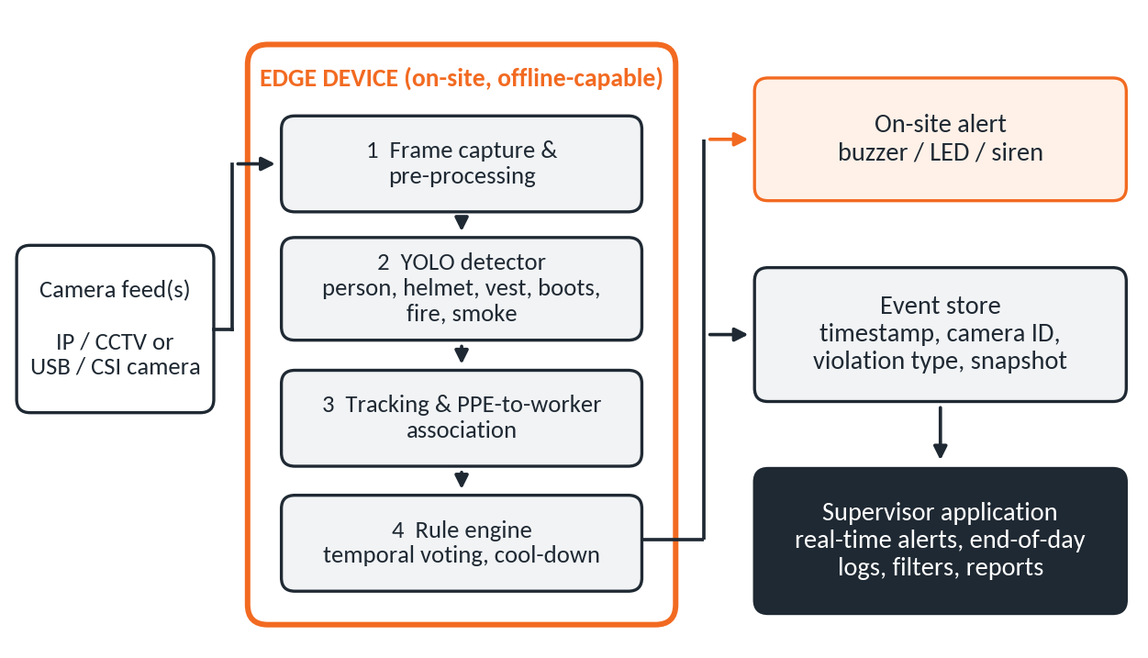
Fig. 1. Proposed IntelliSafe system architecture.
- Data preparation. Build a six-class dataset (person, helmet, high-visibility vest, safety boots, fire, smoke) from public sources (SH17 [4], CHV [5], D-Fire [6]) plus images we collect and annotate in site-like conditions, deliberately including hard negatives such as orange clothing, welding arcs, steam and dust. Data are split by scene, not by frame, to avoid leakage, and dataset licences are checked (SH17 is non-commercial).
- Model development. Train and compare lightweight one-stage detectors [8] from the Ultralytics YOLO family (YOLO11 and YOLO26 nano/small variants [9]) with transfer learning from COCO weights, scored by per-class precision, recall, mAP@0.5 and mAP@0.5:0.95. Because safety boots are small and often occluded, direct detection will be compared with a two-stage approach (foot-region detector plus crop classifier).
- Edge deployment. Export the chosen model to an optimised runtime (e.g., TensorRT or ONNX Runtime) and run it on a Jetson-class embedded board with a live camera, comparing it with a CPU-only baseline. Capture and inference are pipelined for real-time throughput.
- Decision logic and alerting. Detected PPE items are associated with tracked workers, e.g., by the share of a PPE box overlapping a person box as in [2]. A violation is confirmed only if it persists over several consecutive frames: tracking proved necessary for reliable alarms in [2], and temporal analysis cut false positives by 60% in [6]. Confirmed events trigger a local buzzer/LED and a supervisor notification, with a cool-down to avoid alert flooding.
- Logging and supervisor application. Each event is stored locally (timestamp, camera ID, violation type, confidence, snapshot) and shown in an application with live alerts and end-of-day logs. Video is processed on the device and only event snapshots are kept, limiting privacy exposure.
- Evaluation. Test on held-out scenes and recorded site-like video, measuring per-class mAP, on-device frames per second and latency, false alarms per hour, missed violations and alert delivery time, with and without temporal confirmation.
Tentative stack: Python, PyTorch/Ultralytics, OpenCV, TensorRT or ONNX Runtime, SQLite and a web dashboard. Final hardware and software choices will be confirmed with the supervisor.

4. Timeline
Fig. 2 shows the tentative plan for both semesters, based on the university calendar (classes begin 7 Sep 2026 and 8 Feb 2027; FYP submission is due 28 Dec 2026 and 28 May 2027). A weekly progress meeting with the supervisor is proposed; day and time are to be agreed.
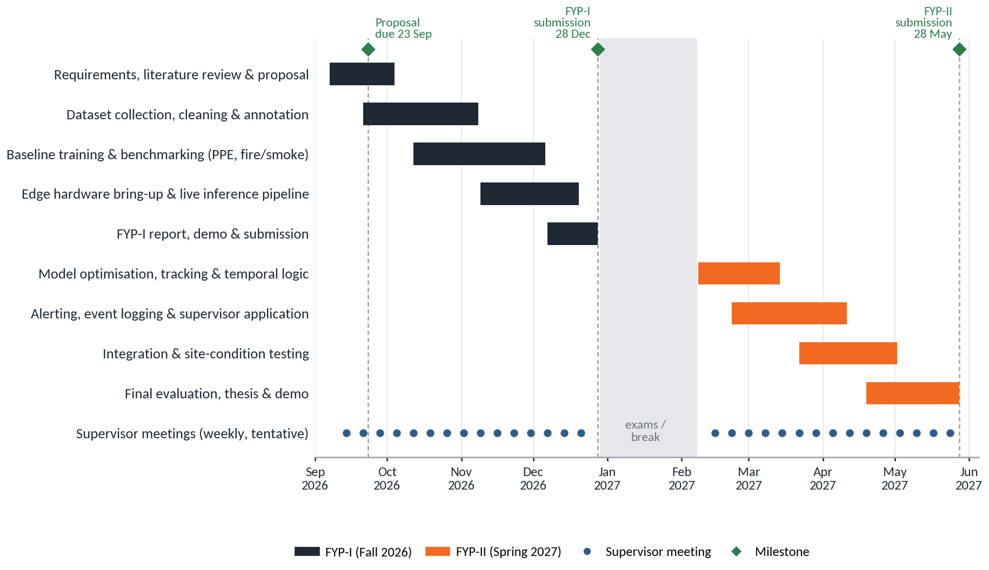
Fig. 2. Gantt chart of project activities and tentative supervisor meetings.

Objectives to achieve during the year
FYP-I — Fall 2026 (7 Sep – 28 Dec) | FYP-II — Spring 2027 (8 Feb – 28 May)
- Define the safety rules to check (required PPE, fire/smoke hazards).  - Build the six-class annotated dataset from public and self-collected images.  - Train and benchmark baseline detectors; shortlist models.  - Run the first live camera-to-alert pipeline on the edge device.  - Submit the FYP-I report and demonstration. | - Optimise the chosen model for real-time speed on the device.  - Add tracking and temporal confirmation to limit false alarms.  - Implement alerting, event logging and the supervisor application.  - Integrate and test under site-like conditions against the targets.  - Submit the final report, thesis and demonstration.

5. References
[1] International Labour Organization, “Construction: a hazardous work.” [Online]. Available: https://www.ilo.org/resource/construction-hazardous-work (accessed Sep. 20, 2026).
[2] D. G. Lema, R. Usamentiaga, and D. F. García, “Low-cost system for real-time verification of personal protective equipment in industrial facilities using edge computing devices,” J. Real-Time Image Process., vol. 20, no. 6, Art. no. 111, Dec. 2023, doi: 10.1007/s11554-023-01368-7.
[3] D. Kim and S. Xiong, “Enhancing worker safety: Real-time automated detection of personal protective equipment to prevent falls from heights at construction sites using improved YOLOv8 and edge devices,” J. Constr. Eng. Manage., vol. 151, no. 1, Art. no. 04024187, Jan. 2025, doi: 10.1061/JCEMD4.COENG-14985.
[4] H. M. Ahmad and A. Rahimi, “SH17: A dataset for human safety and personal protective equipment detection in manufacturing industry,” J. Saf. Sci. Resil., 2024, doi: 10.1016/j.jnlssr.2024.09.002.
[5] Z. Wang, Y. Wu, L. Yang, A. Thirunavukarasu, C. Evison, and Y. Zhao, “Fast personal protective equipment detection for real construction sites using deep learning approaches,” Sensors, vol. 21, no. 10, Art. no. 3478, 2021.
[6] P. V. A. B. de Venâncio, A. C. Lisboa, and A. V. Barbosa, “An automatic fire detection system based on deep convolutional neural networks for low-power, resource-constrained devices,” Neural Comput. Appl., vol. 34, no. 18, pp. 15349–15368, 2022, doi: 10.1007/s00521-022-07467-z.
[7] United Nations General Assembly, “Transforming our world: The 2030 Agenda for Sustainable Development,” Resolution A/RES/70/1, 2015. [Online]. Available: https://sdgs.un.org/2030agenda
[8] J. Redmon, S. Divvala, R. Girshick, and A. Farhadi, “You only look once: Unified, real-time object detection,” in Proc. IEEE Conf. Comput. Vis. Pattern Recognit. (CVPR), 2016, pp. 779–788.
[9] Ultralytics, “Models supported by Ultralytics (YOLO11, YOLO26).” [Online]. Available: https://docs.ultralytics.com/models (accessed Sep. 20, 2026).

