PDF ANALYSIS USING DL:

Title:
In progress

Summary:

This report presents the major findings of the demographic and health survey pdhs conducted from December 1990 to May 1991 on a nationwide basis. It is the first in a series of reports with the objective of improving the population welfare programme and healt h services in pakistan. The country is situated in the northwestern part of the south asian subcontinent obtained independence from the british on August 14, 1947. The majority of the population is Muslim, with a negligible minority of Christians.

Major Keyword:
population,,report,presents,major,findings,demographic,health,survey,pdhs

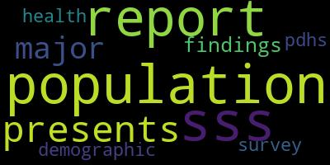

WORD CLOUD
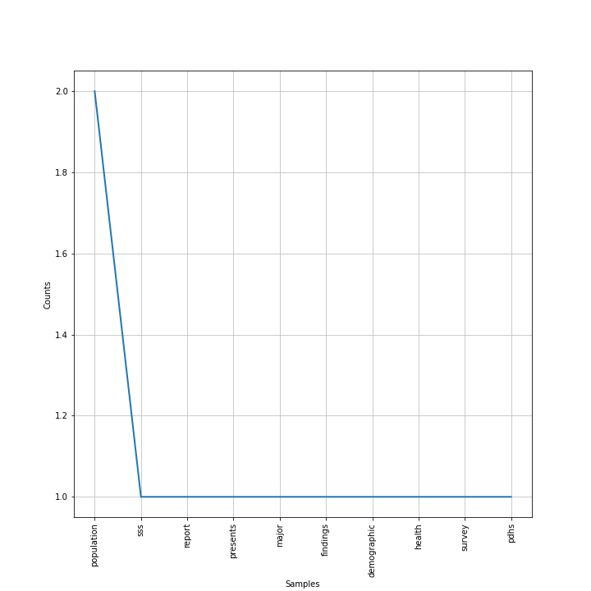

WORD FREQ

