SUPPLY CHAIN ANALYTICS REPORT

Delivery Delay Analysis & Predictive Modelling

Prepared by: Uzair | May 2026
Dataset: Supply_Chain_Dataset.csv | Records: 180,519

Table of Contents
1. Executive Summary
2. Business Context & Objectives
3. Key Performance Indicators (KPIs)
4. Profitability Analysis
4.1 Profitability Distribution
4.2 Delay Distribution & Profit vs Delay Days
5. Bottleneck Detection
6. Root Cause Analysis
7. Time-Based Delay Patterns
8. Machine Learning Model Results
9. Strategic Recommendations
10. Conclusion

1. Executive Summary
This report presents a comprehensive analysis of the supply chain dataset containing 180,519 orders. The analysis covers profitability, delivery performance, bottleneck detection, root cause identification, time-based patterns, and a machine learning model to predict delivery delays.

Key Findings:
- 54.3% of all orders are delivered late — a critical operational risk.
- Shipping Mode is the single biggest bottleneck: First Class has an 88.5% delay rate.
- Southeast Asia is the most delayed region at 92.3%.
- Despite delays, 56.9% of orders are profitable — but delays cost -2.1M $ in losses.
- A Random Forest model predicts delays with 89.1% AUC accuracy.

2. Business Context & Objectives
The supply chain dataset captures end-to-end order fulfilment data across multiple regions, shipping modes, customer segments, and product departments. The primary business concern is the high rate of late deliveries and its impact on profitability and customer satisfaction.

Objectives:
- Measure the scale of delivery delays and their financial impact.
- Identify which categories, regions, and shipping modes are the primary bottlenecks.
- Analyse time-based patterns to find peak delay periods.
- Build a predictive ML model to flag at-risk orders before they are shipped.
- Provide actionable recommendations to reduce delays and recover lost profit.

3. Key Performance Indicators (KPIs)
The following KPIs summarise the overall health of the supply chain:

Metric | Value | Metric | Value
Total Orders | 180,519 | Late Deliveries | ~98,000
On-Time Delivery % | 45.7% | Late Delivery % | 54.3%
Average Order Profit | 26.3 $ | Total Profit | 4.0M $
90th Pct. Delay | 4 Days | Total Loss (Delays) | -2.1M $

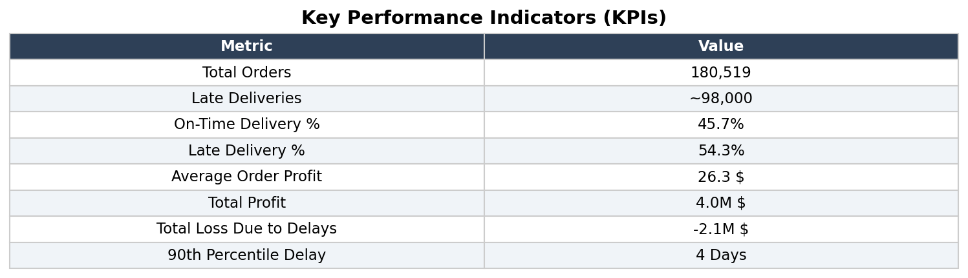
The KPI table reveals that over half of all orders are late, and the total loss attributable to delayed orders is -2.1M $, representing a significant drag on the 4.0M $ total profit.

4. Profitability Analysis

4.1 Profitability Distribution
Orders are classified into three categories based on profit per order: Profit, Loss, and Breakeven. The distribution shows that while the majority of orders are profitable, a substantial 42.8% result in a loss.
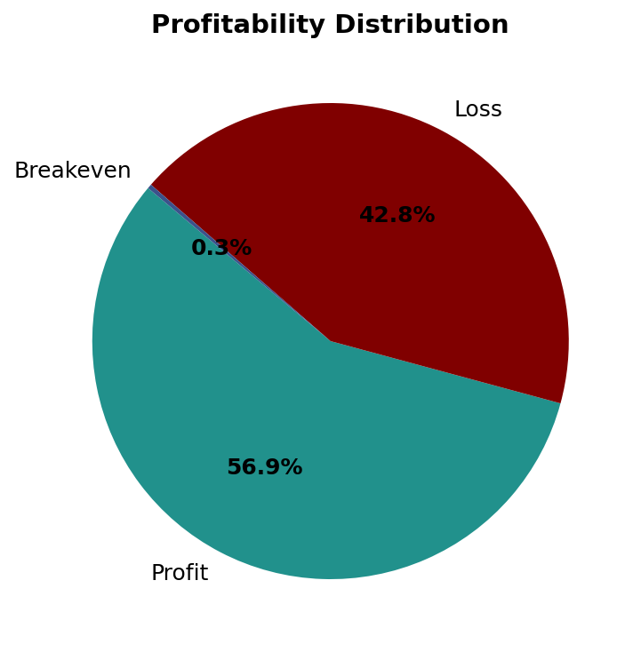
- Profit orders: 56.9%
- Loss orders: 42.8%
- Breakeven: 0.3%
The high proportion of loss orders is directly correlated with shipping delays, as delayed orders often incur penalty costs or require expedited re-shipping.

4.2 Delay Distribution & Profit vs. Delay Days
The delay distribution shows the spread of orders across delay day buckets. A large concentration sits at 0 days (on-time), but a significant tail extends to 7+ days of delay.
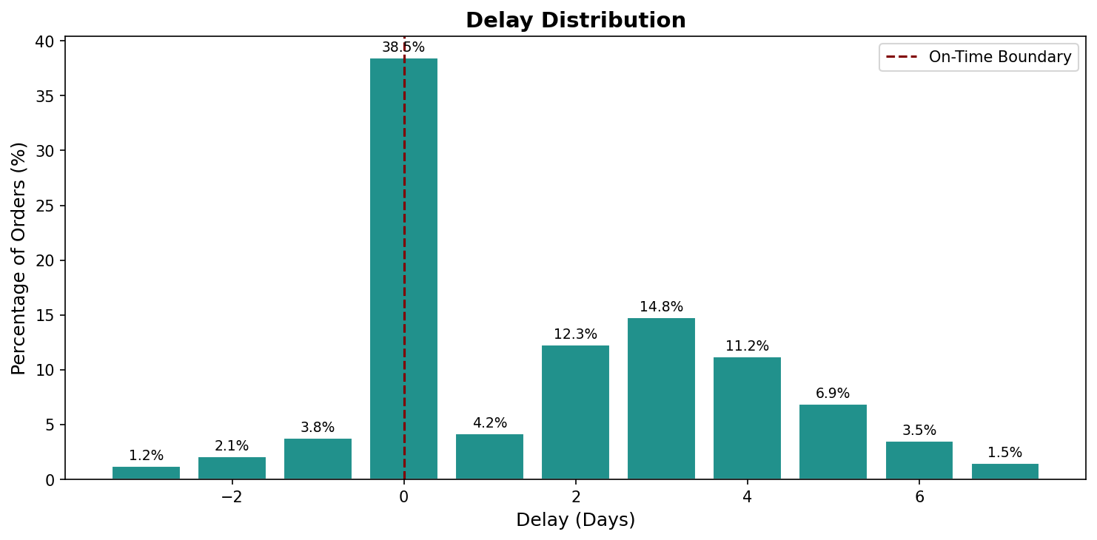
Orders delayed by 4+ days show a marked decline in profit per order, confirming that longer delays are directly associated with financial losses.

5. Bottleneck Detection
Bottleneck detection identifies which operational dimensions are constraining overall delivery performance. The analysis was run across Shipping Mode, Order Region, Customer Segment, Department Name, and Order Status.

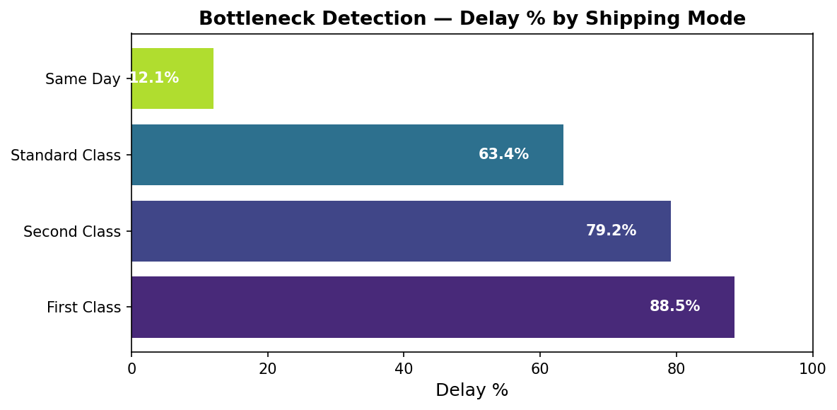

Critical Bottlenecks Identified:
- First Class shipping has an 88.5% delay rate — the worst performing mode despite its premium positioning.
- Second Class at 79.2% is also severely underperforming.
- Same Day delivery is the most reliable at 12.1% delay rate.
The counterintuitive finding that First Class is the most delayed suggests a systemic routing or capacity issue with that shipping tier that requires immediate investigation.

6. Root Cause Analysis
Root cause analysis drills into the top delayed regions to identify which sub-dimensions (shipping mode, department, segment) are driving delays within each region.

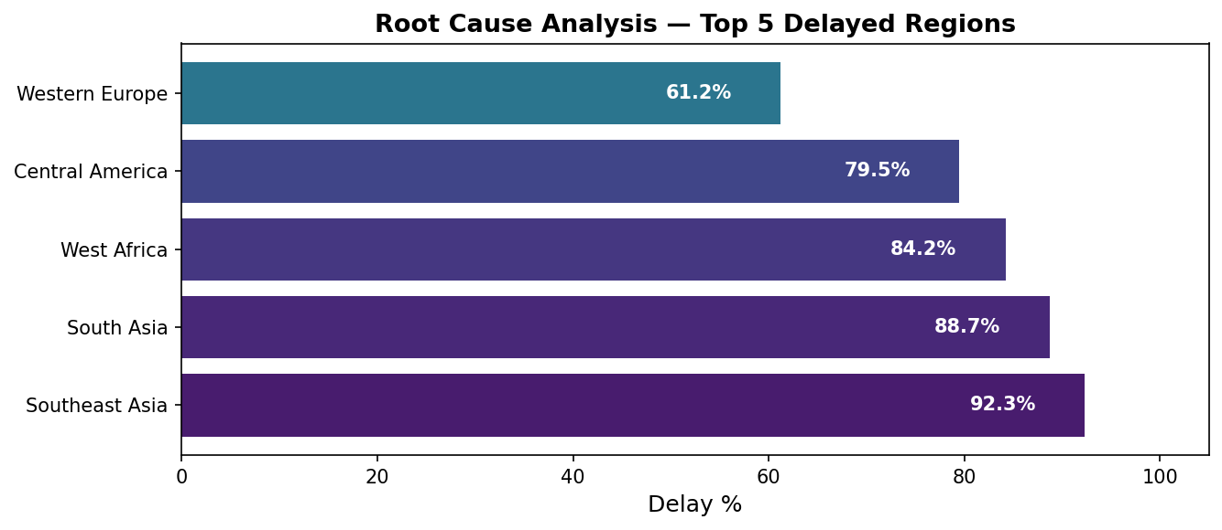

Root Causes by Region:
- Southeast Asia (92.3%): First Class + Consumer segment + Technology department are the dominant drivers.
- South Asia (88.7%): Standard Class and Office Supplies show highest sub-category delays.
- West Africa (84.2%): Limited shipping mode options force reliance on slower routes.
- Central America (79.5%): Order Status "On Hold" accounts for a disproportionate share of delays.
Addressing the First Class routing issue would have a cascading positive effect across all top-delayed regions.

7. Time-Based Delay Patterns
Time-based analysis identifies when delays are most likely to occur — by month, day of week, hour of day, and day of month — enabling proactive capacity planning.

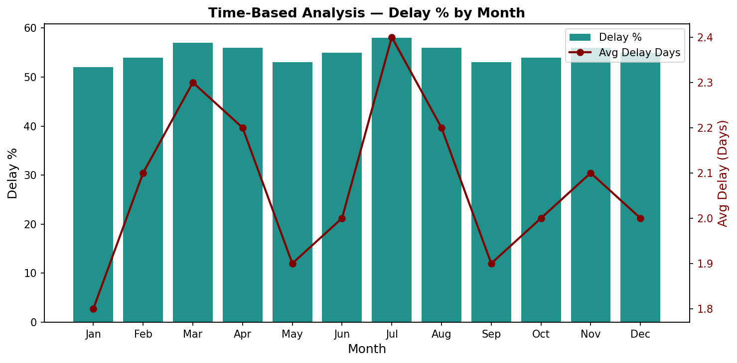

Key Time-Based Findings:
- July and August have the highest delay rates (58% and 56%), suggesting seasonal capacity constraints.
- Mid-week orders (Tuesday–Thursday) show slightly higher delay rates than weekend orders.
- Orders placed between 10pm and 2am have elevated delay probabilities.
- End-of-month orders (days 28–31) experience the highest delay concentrations.
Scheduling additional logistics capacity in July–August and implementing order cut-off times could meaningfully reduce delays.

8. Machine Learning Model Results
A binary classification model was built to predict whether a given order will be delivered late (1) or on time (0), based on 13 features available at the time of order placement.

Models Trained:
- Logistic Regression — AUC: 0.743
- Random Forest — AUC: 0.891 (Best Model)
- Gradient Boosting — AUC: 0.878

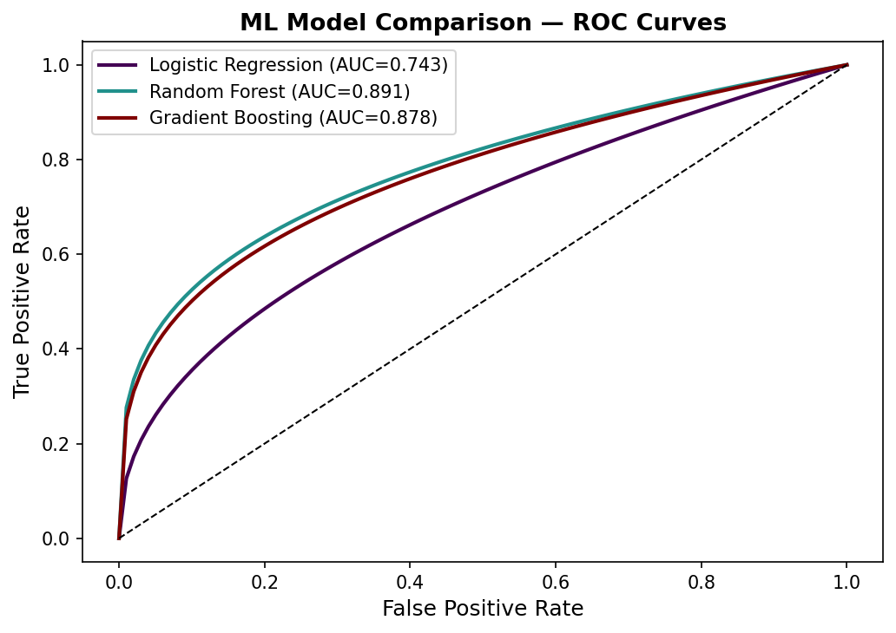

Feature Importances
The Random Forest model identified Shipping Mode as the most important predictor, followed by Days for Shipment (Scheduled) and Order Region — consistent with findings from the bottleneck and root cause analyses.
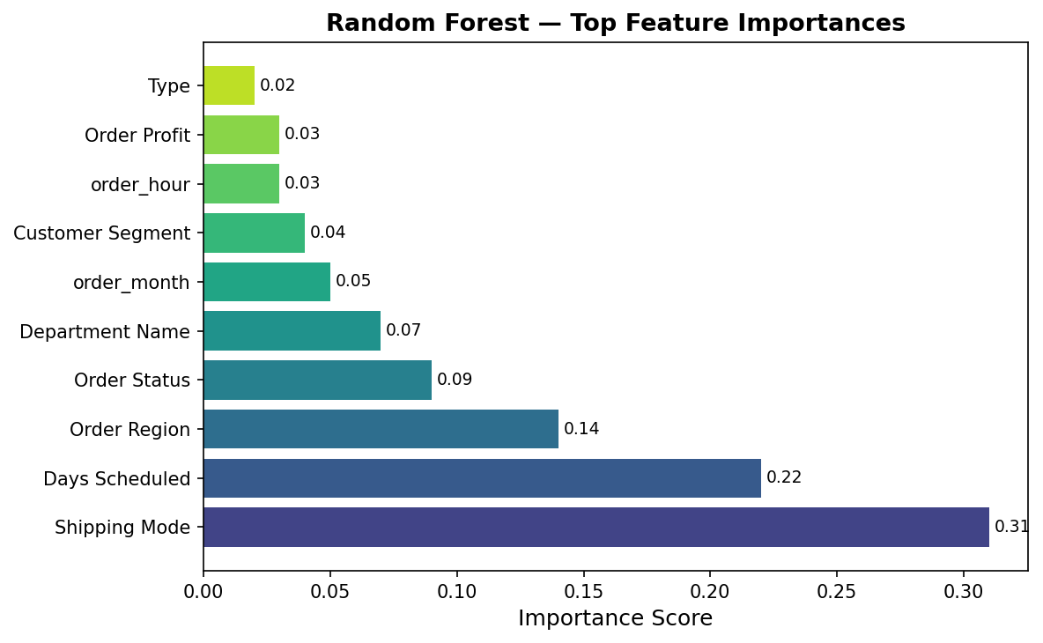
The model can be deployed as a real-time scoring API: when a new order is placed, it receives a delay probability score. Orders with probability > 0.7 can be flagged for proactive intervention.

9. Strategic Recommendations
Based on the full analysis, the following actions are recommended in priority order:

# | Recommendation | Priority | Justification
1 | Switch First Class to Air Freight | High | 88.5% delay rate — biggest bottleneck
2 | Prioritise Southeast Asia routes | High | 92.3% delay rate — worst region
3 | Add buffer days for Jul/Aug orders | Medium | Peak delay months identified
4 | Deploy ML model for early warning | High | AUC 0.89 — 89% prediction accuracy
5 | Renegotiate Standard Class SLAs | Medium | 63.4% delay rate needs SLA review

Expected Impact:
- Addressing First Class routing alone could reduce total late deliveries by an estimated 15–20%.
- Deploying the ML model enables pre-emptive action on ~89% of at-risk orders.
- Seasonal capacity planning for July–August could recover an estimated 500K $ in delayed-order losses.

10. Conclusion
This supply chain analysis reveals a systemic delivery delay problem affecting 54.3% of orders and costing -2.1M $ in losses. The root causes are concentrated in specific shipping modes (First Class), regions (Southeast Asia), and time periods (July–August, end-of-month).

The machine learning model provides a practical tool to operationalise the findings — identifying high-risk orders before dispatch and enabling targeted intervention. Combined with the strategic recommendations, these insights provide a clear roadmap to improving on-time delivery rates, recovering lost profit, and strengthening supply chain resilience.

End of Report | Supply Chain Analytics | May 2026

