NexPlay Website Documentation
React and Vite fandom discovery platform
Project guide, feature overview and user instructions
NexPlay is a responsive fan platform that brings anime, gaming, movies, television, K-Pop, comics and manga into one visual experience. This document explains the project structure, available features, user flows and local setup steps for demonstration and evaluation.

Project Overview
The application is built as a single-page React interface powered by Vite. It combines local curated content with public catalog services and uses browser storage for lightweight personal features. The design supports dark and light themes, responsive layouts, themed cards and an accessible sidebar navigation system.
Area | Implementation
Frontend | React with Vite
Styling | Responsive CSS with dark and light themes
Content | Seven fandom categories, local assets and API-backed catalogs
Storage | Browser localStorage for theme, bookmarks, notes, cart and stock
Commerce | Temporary demo cart only; no checkout or payment collection

Feature Set
- Seven fandom categories: Anime, Gaming, Movies, TV Shows, K-Pop, Comics and Manga
- Global search with filtering and sorting across content cards
- Articles and news, trailers, videos, audio and image galleries
- Character profiles, events and upcoming releases
- Merchandise cards with quantity controls, stock limits and demo order confirmation
- Bookmarks and personal notes saved in the browser
- Pre-scripted Nex Guide chatbot for recommendations and navigation
- Real-time clock, visitor counter, breadcrumbs and animated interface details
- Responsive presentation for desktop, tablet and mobile screens
- About Us, Privacy Policy and Contact pages accessible from the sidebar

Visual Tour
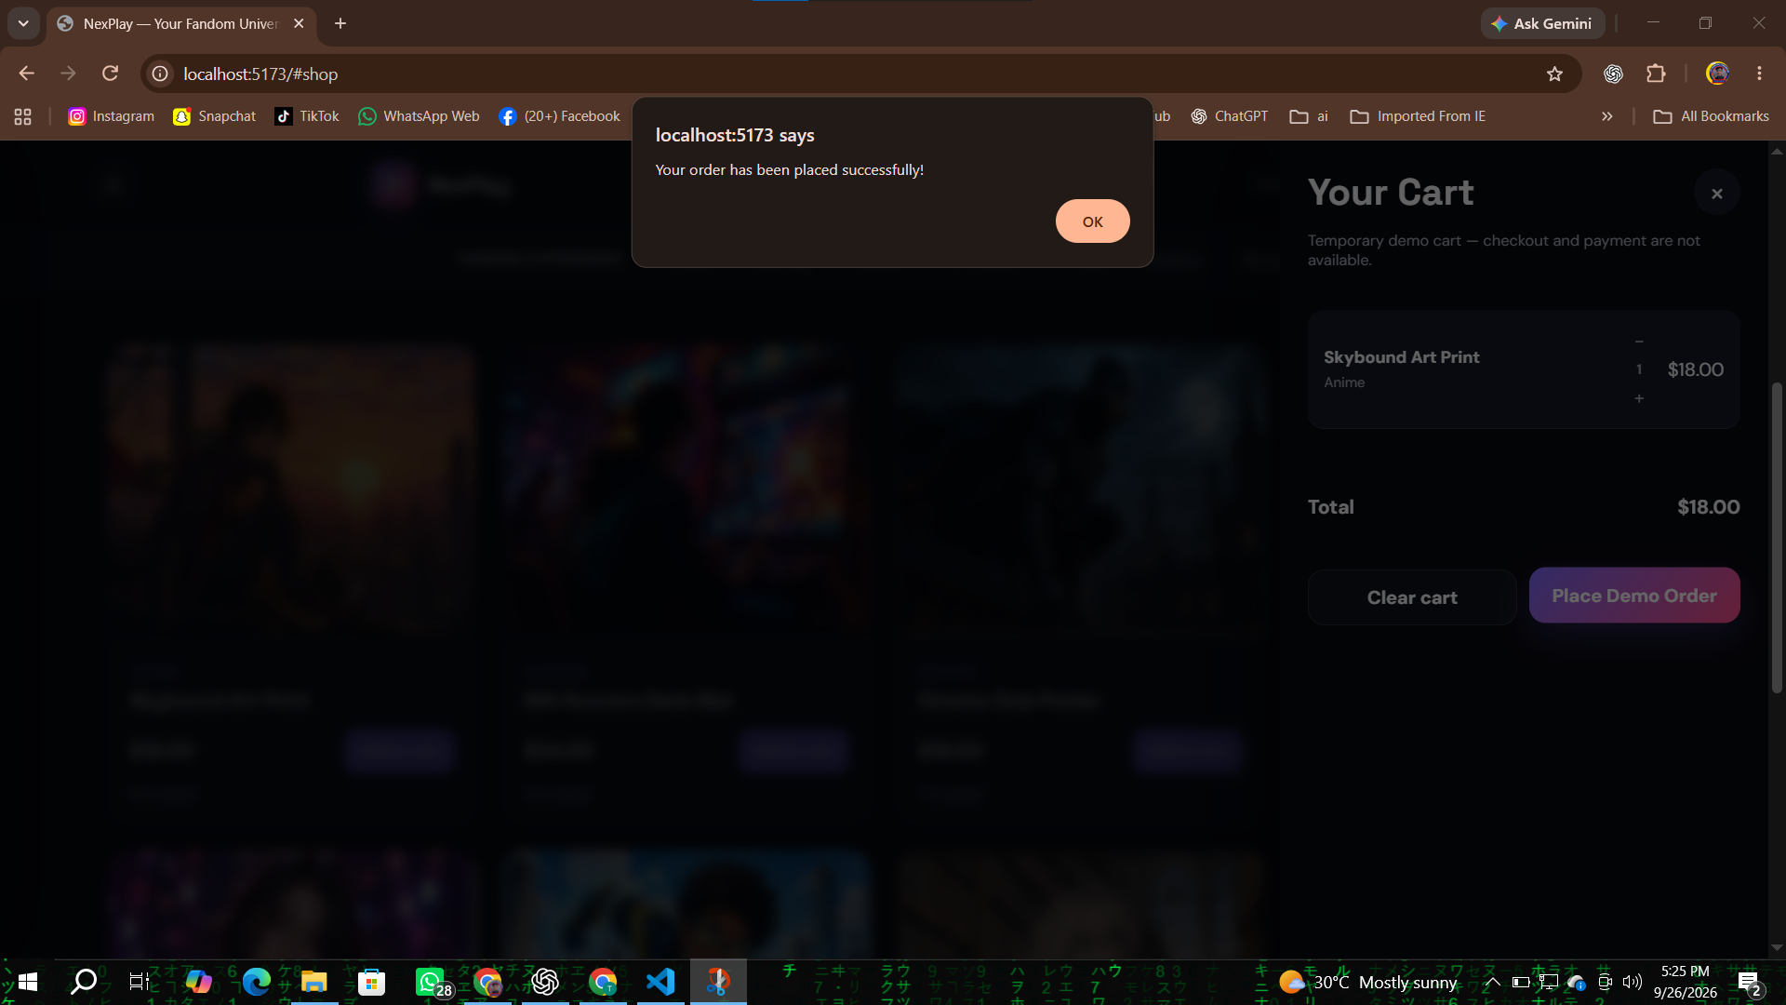
Figure 1. The themed merchandise cart and custom order feedback flow.

Navigation and User Experience
The main header keeps the primary actions visible: Home, Discover and About Us. The menu button opens the full sidebar, where every feature page and all fandom categories are available. The category bar beneath the header provides one-click access to the seven content worlds.

Main navigation
- Home: featured hero, highlights and current content
- Discover: searchable content cards and filters
- Articles and News: editorial-style stories
- Trailers, Video and Audio: media browsing and playback
- Image Galleries: visual category collections
- Character Profiles: featured characters
- Events and Releases: upcoming fandom moments
- Merchandise: product cards, cart and stock-aware demo ordering
- Bookmarks and Notes: saved personal collection
- About Us, Contact and Privacy Policy: project information and support pages

Media and detail views
Selecting a card opens a detail panel with the title, category, artwork, rating, year, description and personal note area. Media cards can show a playable preview or embedded trailer where a public source is available. The viewer controls allow play, pause, progress seeking and volume control when the selected media provides a playable source.

Merchandise and demo order flow
The merchandise area is intentionally a demonstration cart rather than a real store. Each product has a visible stock count. Add, remove and quantity controls respect that stock. Selecting Place Demo Order decreases the stored stock, clears the cart and shows a NexPlay-themed confirmation message. No address, payment or checkout information is collected.

Chatbot and personal tools
Nex Guide is a pre-scripted assistant that responds to common questions about categories, media, bookmarks and the merchandise area. Bookmarks and personal notes are kept in local browser storage, so the saved collection remains available on the same browser without a server account.

Technical Structure
File or folder | Purpose | Required
src/App.jsx | Main React application, routing, state and reusable UI | Yes
src/styles.css | Theme, layout, responsive rules and component styling | Yes
src/data.json | Categories, curated cards and media metadata | Yes
src/main.jsx | React entry point and stylesheet import | Yes
public/assets | Category artwork, game posters and local video assets | Yes
index.html | Vite HTML entry document | Yes
package.json and package-lock.json | Scripts and dependency manifest | Yes
vite.config.js | Vite React configuration and API proxy settings | Yes
START_NEXPLAY.bat | Optional Windows shortcut for starting the dev server | Optional
.gitignore | Excludes generated dependencies, builds, logs and system files | Recommended

How to Run the Project
Open PowerShell in the project folder:
C:\Users\ANAS LAPTOP\Documents\NexPlay_166166_React
npm.cmd install
npm.cmd run dev
Vite will display a local address such as http://localhost:5173. Open that address in Chrome. The optional START_NEXPLAY.bat file can also start the same workflow with a double-click.

Testing Checklist
- Open the home page and verify the intro screen enters the main interface
- Switch between dark and light themes
- Open a category and use search, filtering and sorting
- Open a card, play available media and add a personal note
- Bookmark a card and confirm it appears in Bookmarks and Notes
- Add merchandise, test quantity controls and confirm stock limits
- Place a demo order and verify the themed confirmation message
- Submit the Contact form and verify its themed success message
- Resize the browser to confirm desktop, tablet and mobile layouts

Limitations and Notes
Public APIs can change availability, rate limits or response formats. When an external media source is unavailable, the interface keeps the card and artwork visible and uses the available local or fallback presentation. The merchandise, visitor counter and notes are demonstrations stored only in the current browser.

Live Website Screenshots by Feature
These screenshots were captured directly from the running NexPlay website in Chrome. Each image is placed beside the feature heading it documents.

Home and Hero Experience
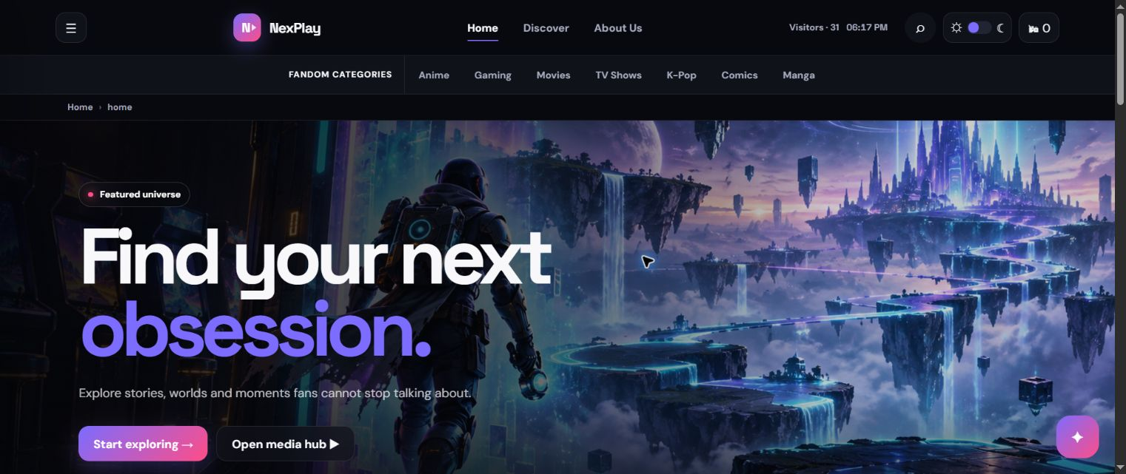
Live Chrome capture: Home and Hero Experience.

Discover and Search Content
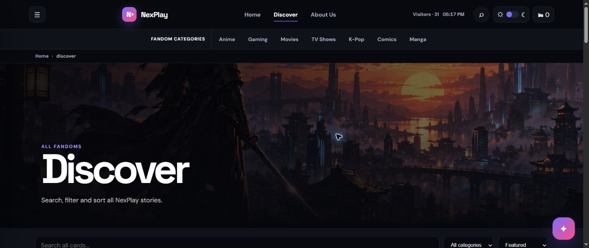
Live Chrome capture: Discover and Search Content.

Trailers Video and Audio
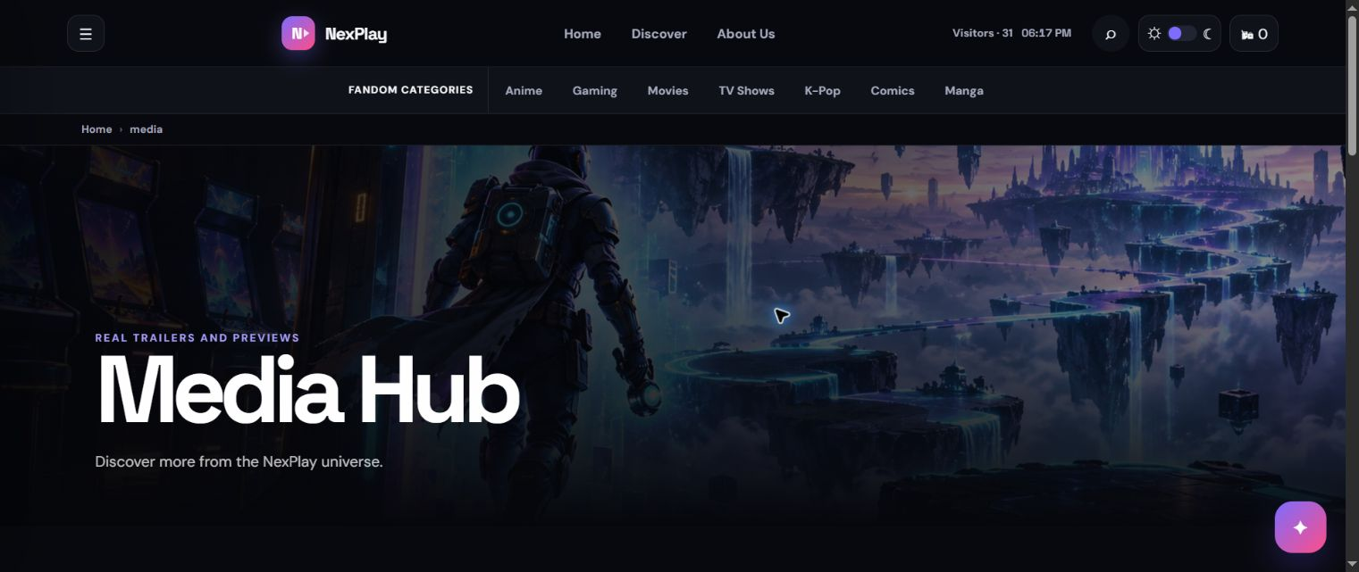
Live Chrome capture: Trailers Video and Audio.

Merchandise and Stock Cart
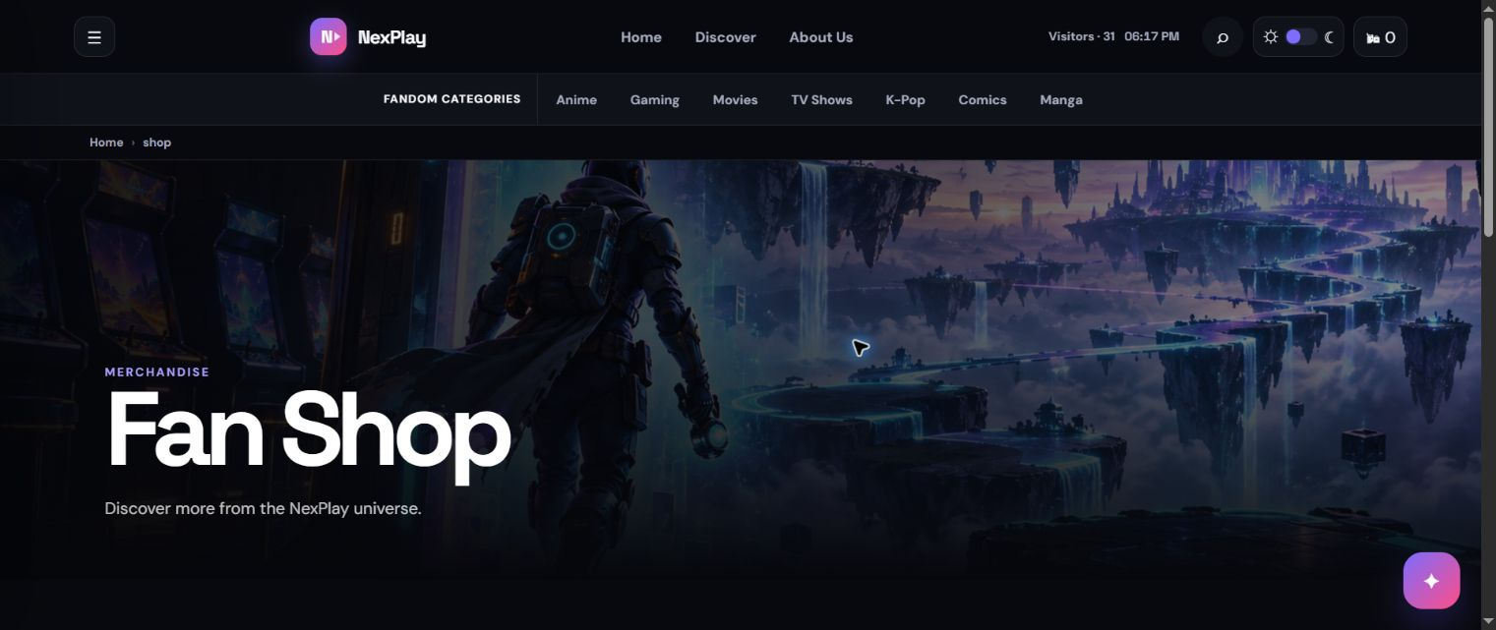
Live Chrome capture: Merchandise and Stock Cart.

Contact Page
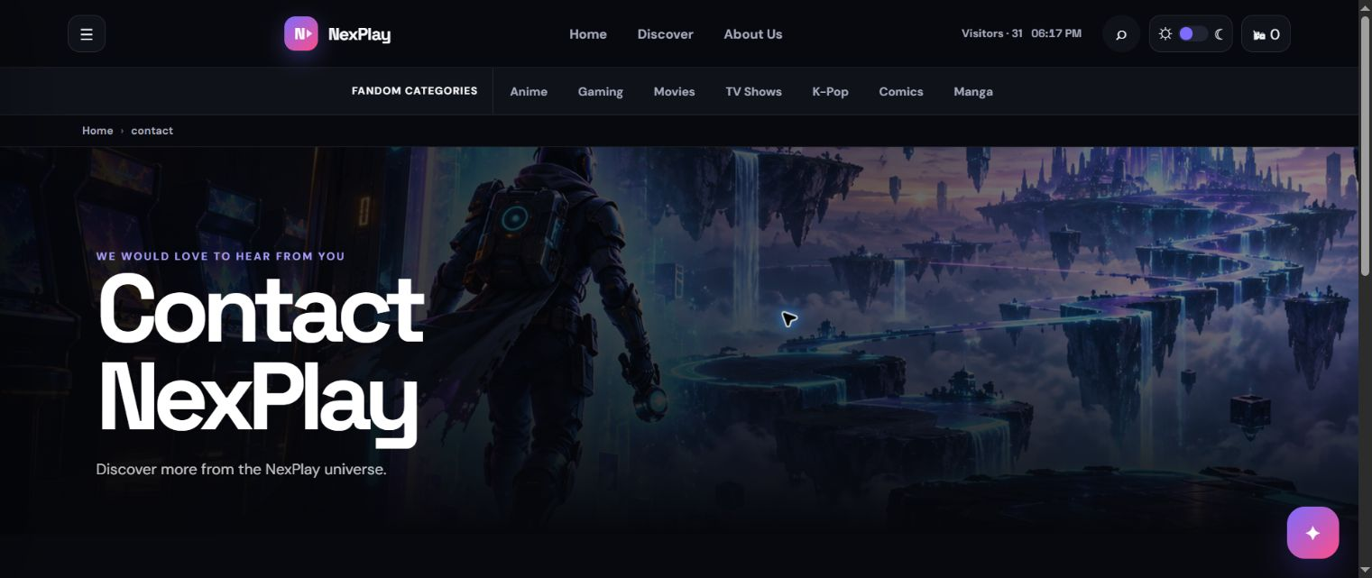
Live Chrome capture: Contact Page.

Fandom Category View Anime
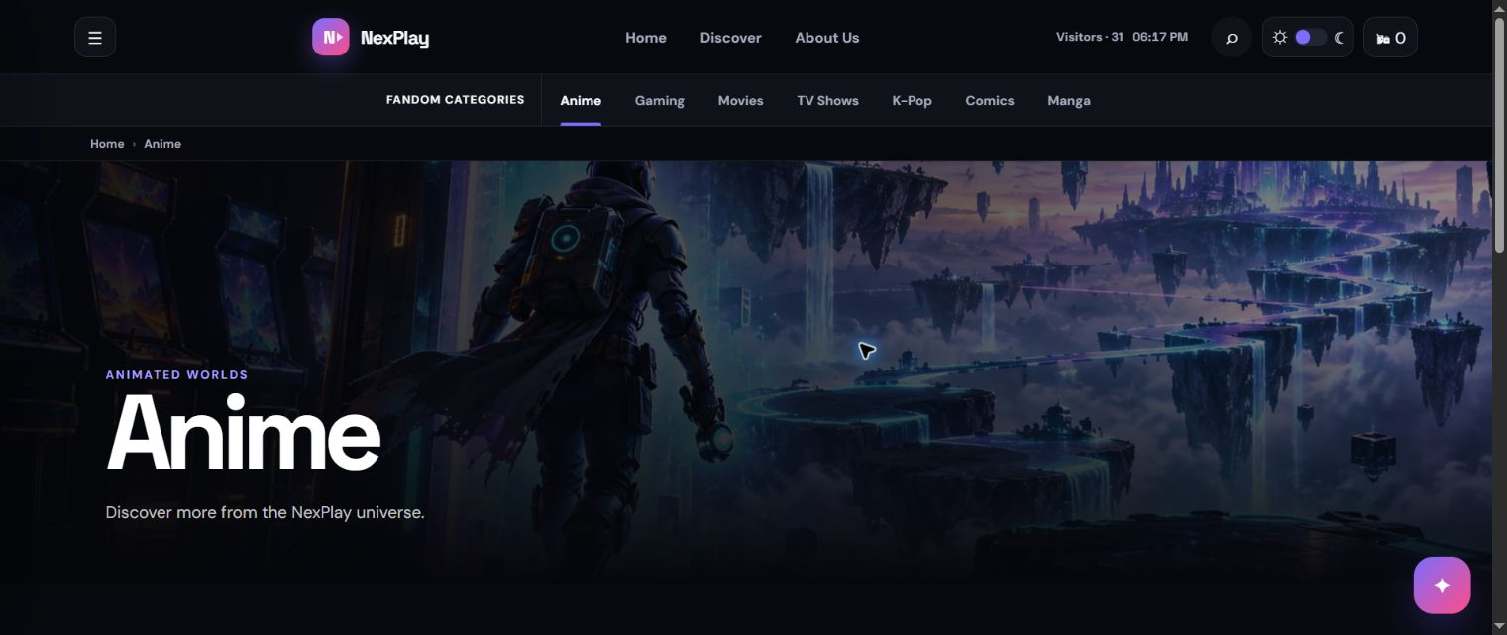
Live Chrome capture: Fandom Category View Anime.

