

E- Project Report

**Online Floral Delivery Website**

**(Batch: NK_2202F1)**

*Project Instructor*

**Sir Muneeb Ullah Khan**

Submitted by:

**Muhammad Abrar Student1355396**

**Muhammad Hanzala Adam Student1364769**

**Syed Hamza Ali Student1362691**

**Syed Ismail Shah Bukhari** **Student1339749**

1

**Declaration**

*I hear by declare that the following documented project report titled “Online floral Delivery ” is an authentic work done by us.*

*The project was undertaken as a park of the course curriculum of E-Project, Aptech NK. This has not been submitted to any other examination body earlier.*

2

*CERTIFICATE*

**This is to certify that**

**Muhammad Abrar Student1355396**

**Muhammad Hanzala Adam Student1364769**

**Syed Hamza Ali Student1362691**

**Syed Ismail Shah Bukhari Student1339749**

Has Successfully Designed & Developed:

*Online Floral Delivery*

*Muhammad Abrar*

*Muhammad Hanzala Adam*

*Syed Hamza Ali*

*Syed Ismail Shah Bukhari*

Date of issue:

**15-7-2023**

**3**

**Preface**

In this report firstly we explained the description of our project, in this a user simply go to the website and easily can view his desired products and its description, whatever he/she wants to find about flower,view cart,florist etc. information on our website.

The overall experience of this project was wonderful for the team. The members got to learn many things and have developed their problem-solving skills. The features that were promised in the beginning of the project were achieved and fulfilled and got each and every goal of this project.

External of this project is satisfied from the team and his work and that is project team achievement. It is hope that this website will fulfill the purpose it is designed for.

4

Acknowledgment

First of all, we thank Almighty Allah who gives us the strength and ability to think, work and deliver what we are assigned to do.

We earnestly hope that this project will provide all the necessarily information required for the user to fulfill their inspiration. However, suggestions for improvement of the project will be thankful received & acknowledge.

5

**SYNOPSIS**

**Online Floral Delivery**

From the time when **Online Floral Delivery Pvt. Ltd.** started its operations in 1983 in Pakistan with a small business idea that initiated its journey from 5 destinations by delivering letters and documents, is now transformed into a leading Logistics, Courier & Warehousing service provider across Pakistan, with over 700+ Express Centers, handling over 90 million packages a year, 1500+ Service Locations across Pakistan with 4000+ Vehicles fleet & over 2200 Destinations Worldwide, serving Proprietors Entrepreneurs, Small Medium Business Enterprises SME, Students, Individuals, Travelers, FMCGs, Transnational Companies, Large Business Corporations (Textile, Leather, & other sectors), Government Sectors, Non-Government Organizations & Foreign Missions to fulfill their Courier, logistics & Supply Chain needs.

6

**Contents**

**Chapter Introduction 09**

* Goals and objectives 09
* System Statement of scope 09
* Theoretical background 09
* 10

**Chapter Problem Statement 11**

2.1 Requirement Specification 11

2.2 Hardware / Software Requirements 12

**Chapter System Estimates & Actual Outcome 13**

* Estimation Techniques applied 13
* System Estimate & actual outcome 14
* Estimation of Time for the Project 14
* Actual Time for the Project 14
* Actual Results 15
* System resources 15
* System Resources Used 15
* **Chapter Conclusion 16**

Conclusion\summary 16

4.2 List of Validation 16

**J. APPENDICES**

* Project Schedule
* Snap Shots of Project

**K. REFERENCES**

**CHAPTER 01**

**INTRODUCTION**

* **Introduction**

***Online Floral Delivery is the best website for online in pakistan***, you can find a wide variety offlower bouquets and baskets on our website to **send flowers online** all over pakistan and Internationally. Online floral delivery offersservice to go along with a flower bouquet. **Online Flowers Delivery** was never as easy as it has become now and we want to make it more and more accessible for the general public. It may not be a basic necessity but it sure is the best way to express one’s feelings and gratitude. the best florist for**online floral delivery**, so pick some flowers today . Our perfect chain of florists will make the delivery super-fast and efficient, maintaining the quality of the flowers and your feelings as well. That’s how **online floral delivery** ought to be, that’s how feelings should be expressed, that’s how one must love. [*Online floral delivery, send flowers, cake, gifts online by pakistan florist*](https://www.phoolwala.com/), we offers flowers baskets arrangements of various designs along with sweets, cakes, chocolates, soft toys, and other gifts items on Birthday, Anniversary, Love N Romance, Get-Well Soon and on other important occasions worldwide.

**Goals and objectives**

* Creating Impact & Delivering Value Through Excellence Drive and Innovation for our Stakeholders.
* **System statement of scope**

Sustainable business begins with sustainable supply chains. As the pioneer of green logistics, we have an unmatched portfolio of green logistics solutions. Together with our customers worldwide, we’re minimizing emissions without compromising operations. Find out what we have to offer, why we’re committed to sustainability, and how our industry is helping deliver a sustainable future.

**Theoretical Background**

We choose windows 10 because there is the biggest market share of windows 10 nowadays and is increasing day by day as various platforms are working for it.

* **Technology & Tools/hardware components**

**1.4.1 Asp.Net**

In 2002, Microsoft released Asp.NET Framework, a development platform for creating Windows apps. Today ASP.NET Framework is at version 4.8 and remains fully supported by Microsoft. In 2014, Microsoft introduced .NET Core as a cross-platform, open-source successor to Asp.NET Framework.

SQL server is **a database management system**.  
  
It may be anything from a simple shopping list to a picture gallery or the vast amounts of information in a corporate network. To add, access, and process data stored in a computer database, you need a database management system such as SQL Server.

**1.4.3**

**CHAPTER 02**

**PROBLEM STATEMENT**

* **Problem Statement**

**Online Floral Delivery is supposed to be effective and utilize the resources in an optimum manner to ensure timely service with least cost**. **Every aspect of the operation from pickup/receipt must be logged properly.**

**Requirement Specification:**

The Web site is to be created based on the following requirements.

**Hardware/ Software Requirements**

**Hardware**

* A minimum computer system that will help you access all the tools in the courses is a Pentium 166 or better.
* 128 Megabytes of RAM or better

**Software**

* Microsoft SQL Server
* Visual Studio 2022
* ASP . Net
* Window 10

**CHAPTER 03**

**SYSTEM ESTIMATES & ACTUAL OUTCOME**

* **System Estimates and Actual Outcome**

Sometimes the software estimation becomes a huge below by mean of system decomposition and system resizing. System estimation and actual outcome shows your scope efforts, engineering efforts and deploy effort.

To estimate time and resources for project is a challenging task. At the initial it was such a difficult task to estimate its resources and time.

Based on the project scope, the estimation of time is discussed below

* **Estimation techniques applied and results.**

There are many estimation techniques for project estimation, but we considered very common and effective cost estimation by mean of exact time management. We considered the scope of estimation technique because project resources and uses may tolerate by mean of requirement**.**

* **System Estimates and Actual Outcome**
* **Estimation of time for the software**

|  |  |
| --- | --- |
| **Estimation Of time** | **Days** |
| Researching and information collecting period | 2 days |
| Analyzing other software and tools | 1 day |
| Formation of website | 27 days |
| Duration of Report | 25 days (simultaneously with project) |
| **Total time** | 30 days |

* **Actual time for the software**

|  |  |
| --- | --- |
| **Actual time** | **Days** |
| Researching and information collecting period | 1 and 1/2 days |
| Analyzing other software and tools | 1/2 day |
| Formation of website | 28 days |
| Duration of Report | 23 days (simultaneously with project) |
| **Total time** | 30 days |

* **Actual Results and Deviation from Estimates**

Actual time estimation is varied because project member was 3.

* **System Resources**

System is divided into two major parts, on the bases of which cost estimations were performed.

* Software
* Hardware

**System Resources Used**

* Microsoft SQL Server
* Visual Studio 2022
* ASP . Net

**CONCLUSION**

* **Conclusion / Summary**

The overall experience of this project was wonder full for the team. The members got to learn many things in fact faced many problems but, in the end, fixed them out. The features that were promised in the beginning of the project were achieved and got each goal of this project.

External of this project is satisfied from our teamwork and that is project`s team achievement. It is hoped that this application will fulfill the purpose, it is designed for.

**List of Validation**

|  |  |
| --- | --- |
| Option | Validation |
| Suitable logo on main page | Yes |
| Proper menu | Yes |
| All services details provided | Yes |
| Various pages have details about events | Yes |
| Contact us page | Yes |
| Events are properly categorized | Yes |

**Snap Shots of website:**

**“Section 1: Admin & Customer Home Page”**

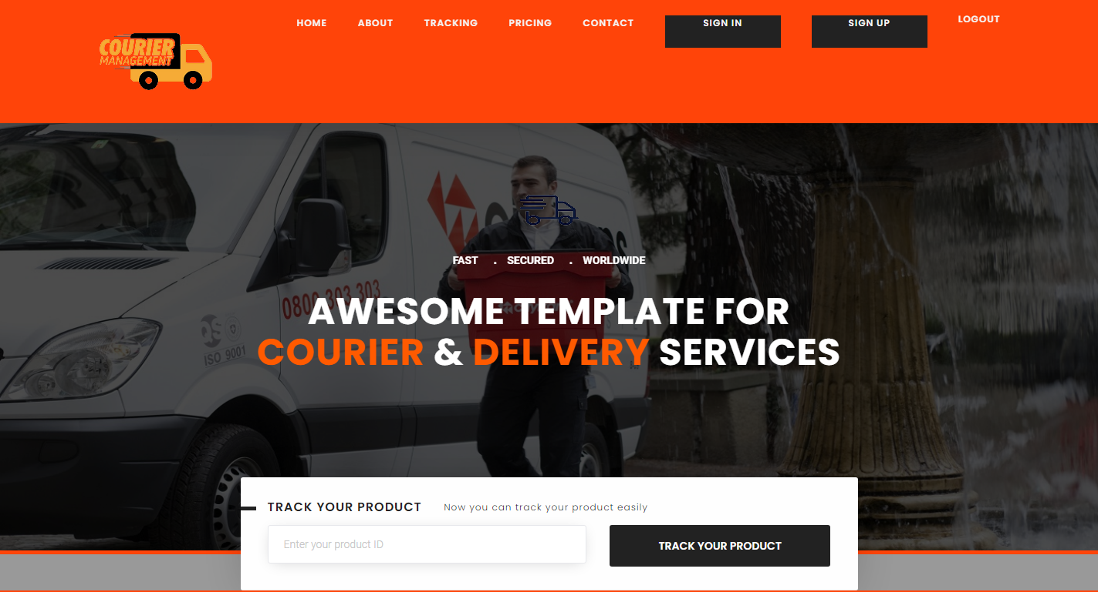

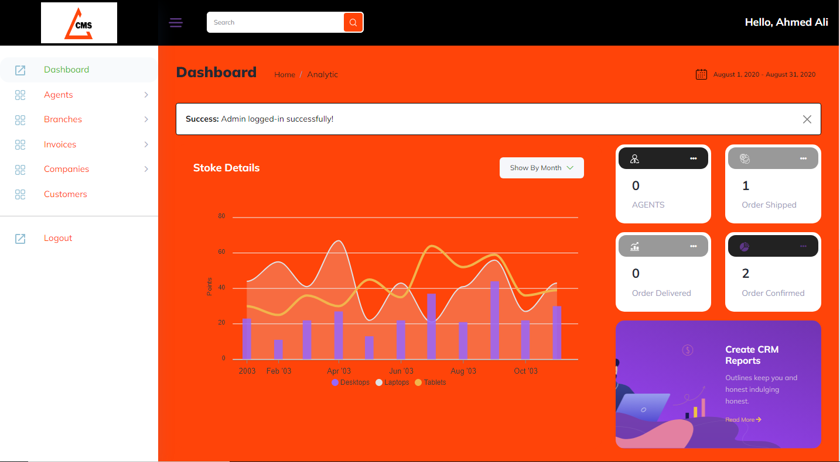

**“Section 2: About”**

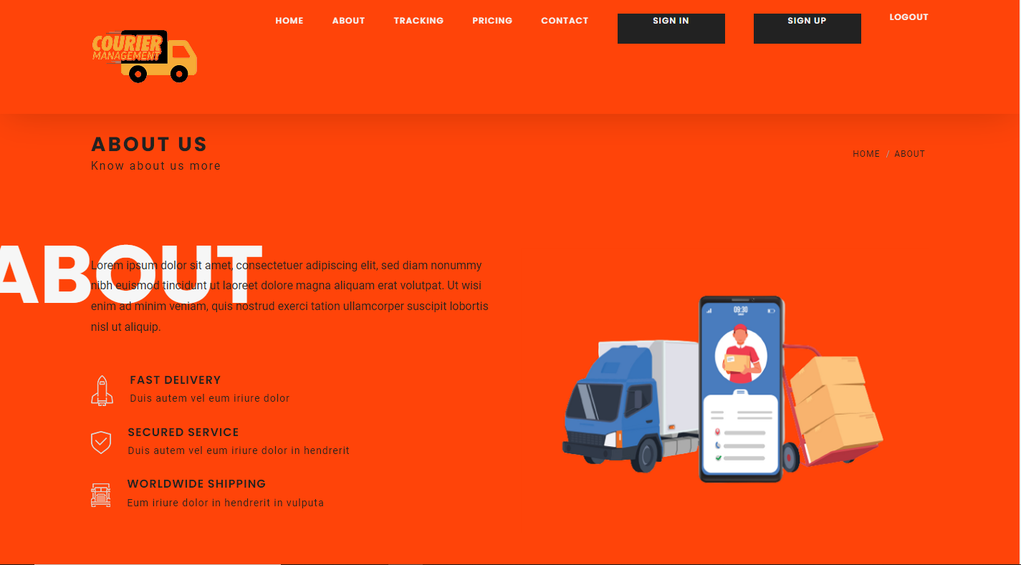

**Section 3: Pricing & Plans”**

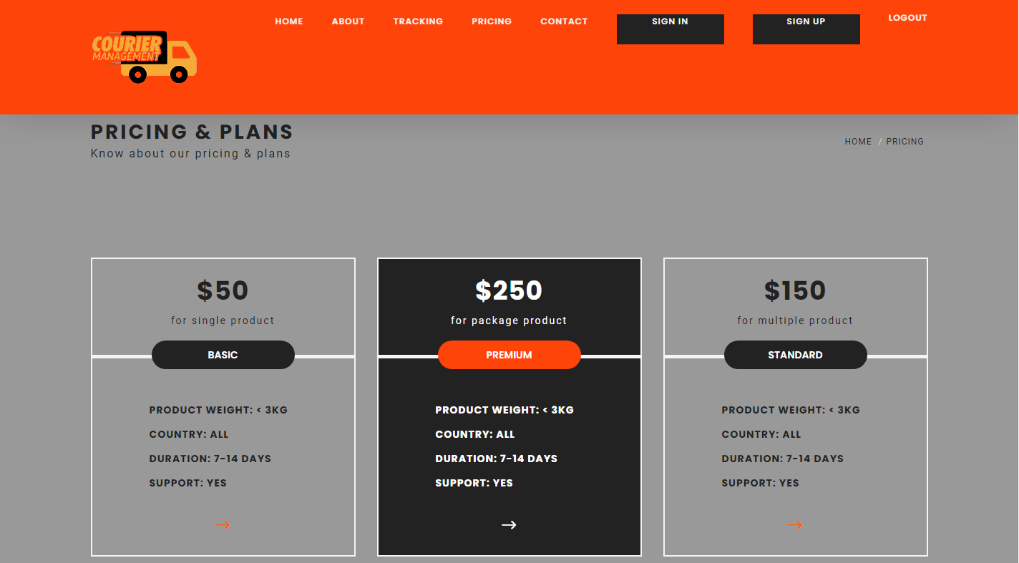

**“Section 5: “Sign in/up”**

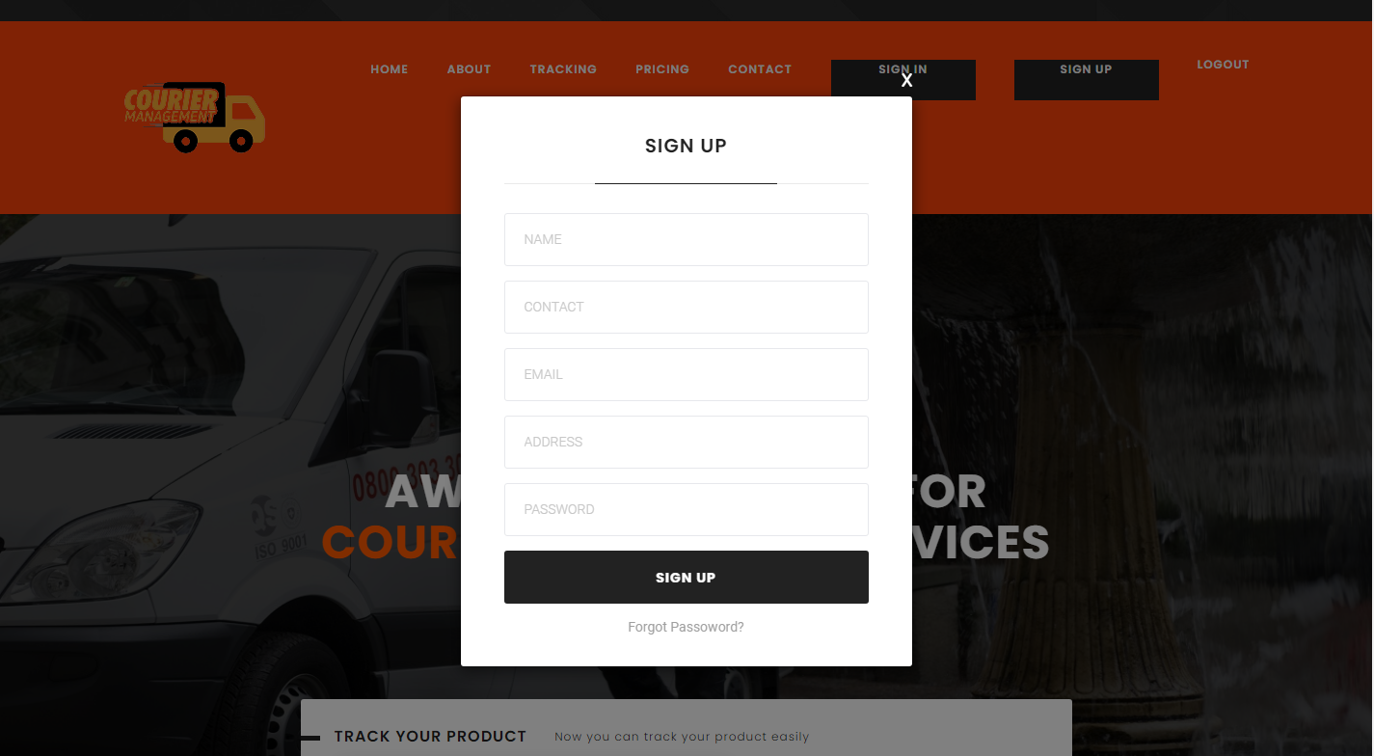

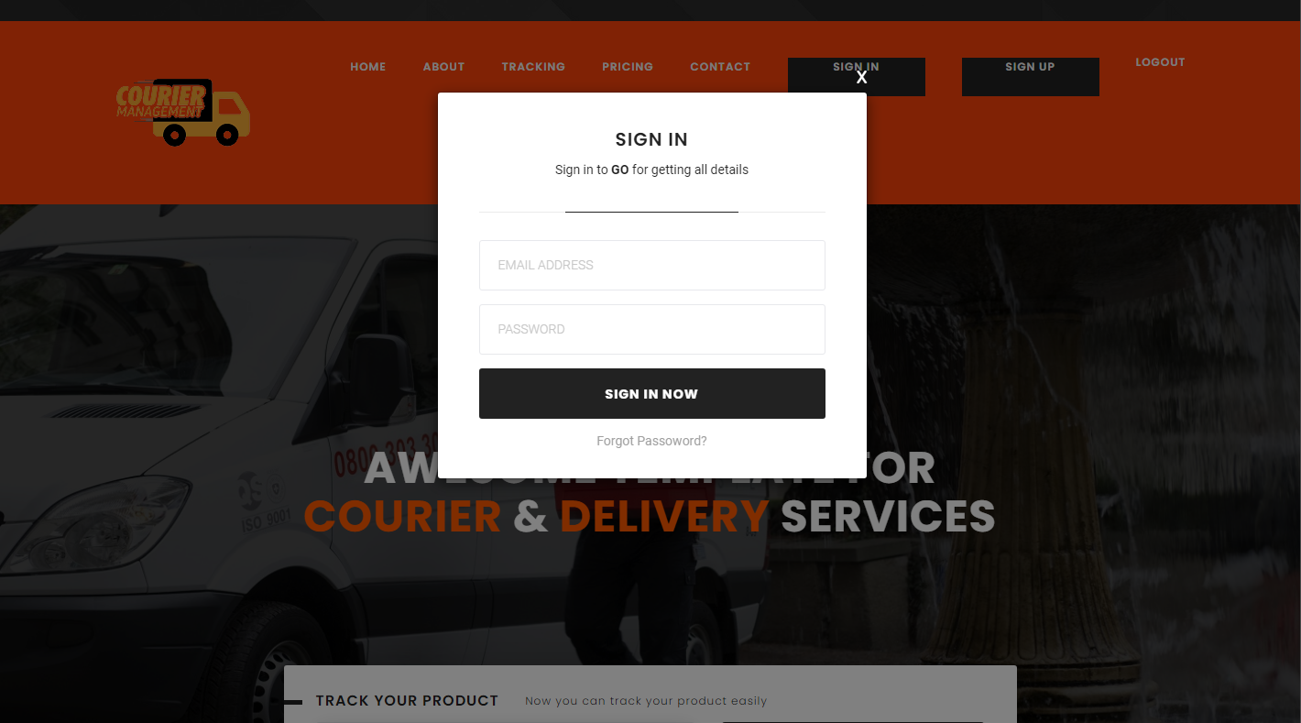

**“Section 5: “Contact Us”**

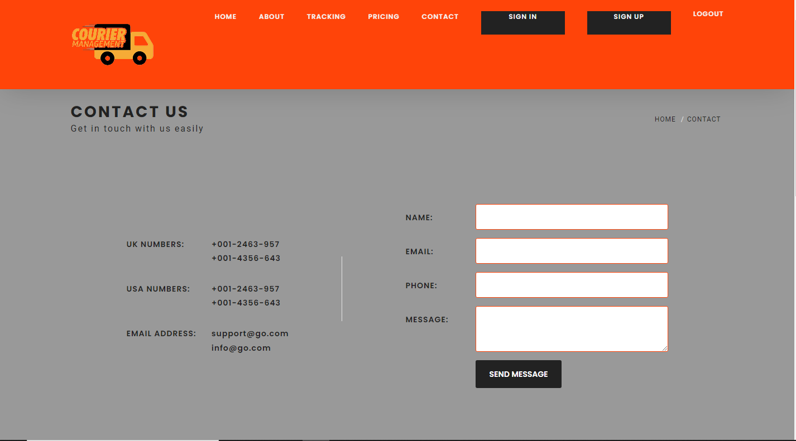

**“*End*”**