|  |  |
| --- | --- |
| Student Name | Uzair Hussain |
| Roll Number | 21SW085 |
| Section # | 3rd or III |
| Lab # | 4th |
| Topic # | De Normalization |

**Task:**

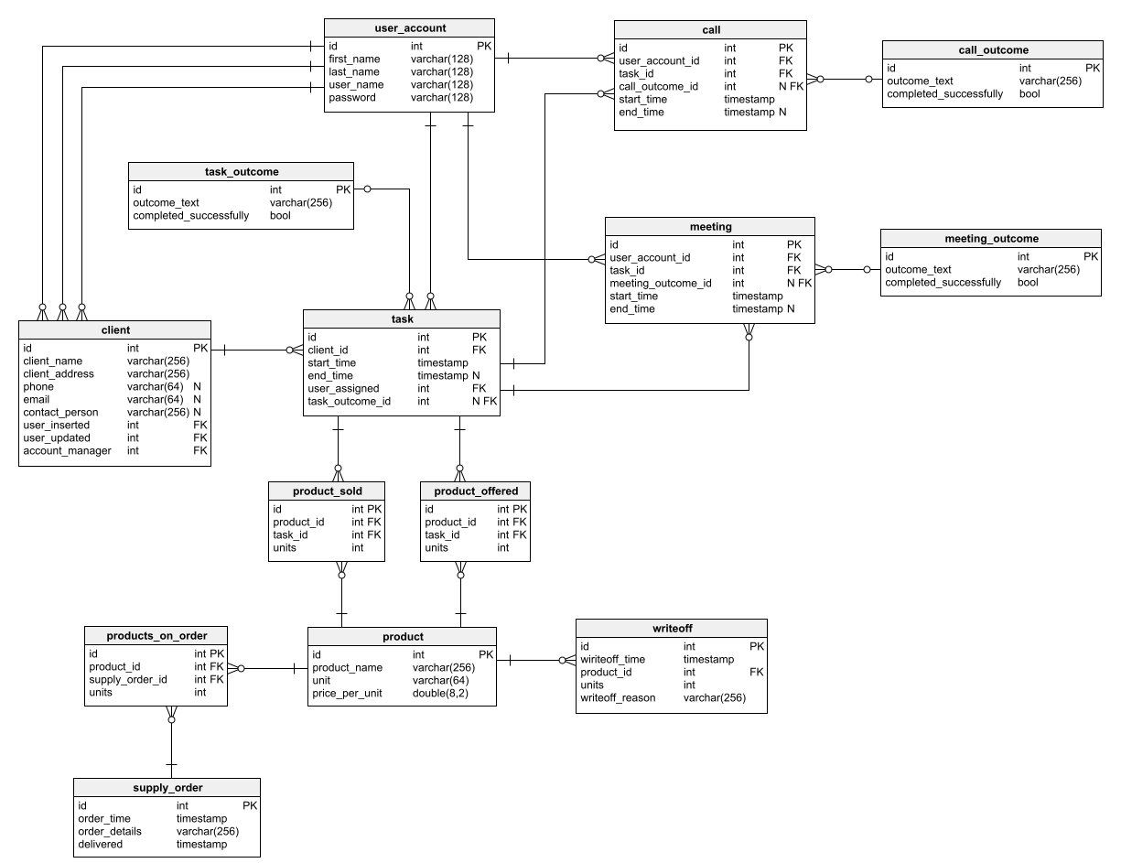

**Solutions:**

**deNormalized Table**

|  |  |  |  |  |  |  |  |  |  |
| --- | --- | --- | --- | --- | --- | --- | --- | --- | --- |
| id | firstName | lastName | userName | pass | userAccID | callOutcomeID | startTime | endTime | outcomeText |
|  |  |  |  |  |  |  |  |  |  |

**Above table is continue….**

|  |  |  |  |  |  |  |  |  |  |  |
| --- | --- | --- | --- | --- | --- | --- | --- | --- | --- | --- |
| completed  Successfully | | clientName | clientAddress | phone | email | contactPerson | UserInserted | userUpdated | accountManager | userAssigned |
|  |  | |  |  |  |  |  |  |  |  |

**Continue…**

|  |  |  |  |  |  |  |  |
| --- | --- | --- | --- | --- | --- | --- | --- |
| taskOutID | meetOutID | Prod.ID | Units | supplyOrderId | pricePerUnit | writeOffTime | WriteOffReason |
|  |  |  |  |  |  |  |  |

**Continue…**

|  |  |  |
| --- | --- | --- |
| orderTime | orderDetails | delivered |
|  |  |  |