|  |  |
| --- | --- |
| Student Name | Uzair Hussain |
| Roll Number | 21SW085 |
| Section # | 3rd or III |
| Lab # | 7th |
| Topic # | Group Functions |

**Task:**

1. Write a query to display the employee name, department number, dept name and dept location for all the employees.
2. Create a unique listing of all jobs that are in dept 30. Include the location of department in the output.
3. Write a query to display the employee name, emp sal, department name, dept location of all employees who earn a commission.
4. Write a query that lists empno, ename, mgr id and dname from emp and dept table.
5. Write a query that returns all the employees, their related information and dept name and even those department where no employee is working.
6. Write a query to find the grade of employees based on their high and low salaries

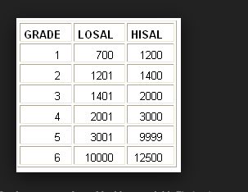

**Solutions:**

1. SELECT e.ename, e.deptno, d.dname, d.loc

FROM emp e

INNER JOIN dept d

ON e.deptno = d.deptno;

1. SELECT DISTINCT j.job, d.loc

FROM emp e

INNER JOIN dept d

ON e.deptno = d.deptno

INNER JOIN emp j

ON e.job = j.job

WHERE e.deptno = 30;

1. SELECT e.ename, e.sal, d.dname, d.loc

FROM emp e

INNER JOIN dept d

ON e.deptno = d.deptno

WHERE e.comm IS NOT NULL;

1. SELECT e.empno, e.ename, e.mgr, d.dname

FROM emp e

INNER JOIN dept d

ON e.deptno = d.deptno;

1. SELECT e.*, d.dname, d.loc

FROM emp e

RIGHT JOIN dept d

ON e.deptno = d.deptno;

1. SELECT e.ename,

CASE

WHEN e.sal >= g.hisal THEN g.grade

WHEN e.sal <= g.losal THEN g.grade - 1

ELSE g.grade - 0.5

END AS grade

FROM emp e

INNER JOIN salgrade g

ON e.sal BETWEEN g.losal AND g.hisal;