**MEHRAN UNIVERSITY OF ENGINEERING AND TECHNOLOGY, JAMSHORO**

**CEP ASSINGMENT**

**( 21SW – III )**

**DATABASE SYSTEMS**

**BY**

**UZAIR HUSSAIN SHAIKH 21SW085-III**

**SUBMITTED TO:**

**MA’AM RABEEA JAFFERI**

**Tasks**

An aviation company requires a database to store details about an airline’s fleet, flights, and seat bookings. The entities for the required database can be identified via the requirements below:

- The airline has one or more airplanes.

- An airplane has a model number, a unique registration number, and the capacity to take one or more passengers.

- An airplane flight has a unique flight number, a departure airport, a destination airport, a departure date and time, and an arrival date and time.

- Each flight is carried out by a single airplane.

- A passenger has given names, a surname, and a unique email address.

- A passenger can book a seat on a flight.

You are required to create a logical entity relationship diagram (ERD) fulfilling the above requirements followed by the physical database implementation in any RDBMS of your choice.

Perform the following actions on the created database.

1. Use meaningful names and datatypes during the database design.

2. Design and execute queries to create the tables. Assign keys and create the relationships between the tables.

3. Populate the database with at least 20 records including a record with your details as the passenger. Create sequences wherever necessary.

4. Retrieve the booking details for all passengers flying on 24-03-2023 and delete the booking details for the date 20-03-2023. (Hint: a booking table must be created in the database).

5. Create a view on the flights table displaying only the flight number, source, and destination of the flight. Update the view such that the flight on 24-03-2023 departs from Dubai and arrives in Pakistan.

Note:- Submit the report with query output screenshots against each question along with the database file

**EER DIAGRAM:**

**Creating Data Base and Tables acc to EER:**

create database aviations;

* CREATE TABLE IF NOT EXISTS `aviations`.`airlines` (

`airline_id` INT NOT NULL,

PRIMARY KEY (`airline_id`));

airlinesENGINE = InnoDB

* CREATE TABLE IF NOT EXISTS `aviations`.`flights` (

`flight_no` INT NOT NULL,

`departure_airport` VARCHAR(45) NULL,

`destination_airport` VARCHAR(45) NULL,

`departure_time` DATETIME NULL,

`arival_time` DATETIME NULL,

`airplane_id` INT NOT NULL,

PRIMARY KEY (`flight_no`, `airplane_id`),

INDEX `airplane_id_idx` (`airplane_id` ASC) VISIBLE,

CONSTRAINT `airplane_id`

FOREIGN KEY (`airplane_id`)

REFERENCES `aviations`.`airplane` (`airline`)

ON DELETE NO ACTION

ON UPDATE NO ACTION)

ENGINE = InnoDB

* CREATE TABLE IF NOT EXISTS `aviations`.`booking` (

`passenger_email` VARCHAR(45) NOT NULL,

`flight_no` INT NOT NULL,

PRIMARY KEY (`passenger_email`, `flight_no`),

INDEX `flight_no_idx` (`flight_no` ASC) VISIBLE,

CONSTRAINT `email`

FOREIGN KEY (`passenger_email`)

REFERENCES `aviations`.`passengers` (`email`)

ON DELETE NO ACTION

ON UPDATE NO ACTION,

CONSTRAINT `flight_no`

FOREIGN KEY (`flight_no`)

REFERENCES `aviations`.`flights` (`flight_no`)

ON DELETE NO ACTION

ON UPDATE NO ACTION)

ENGINE = InnoDB

* CREATE TABLE IF NOT EXISTS `aviations`.`passengers` (

`email` VARCHAR(50) NOT NULL,

`first_name` VARCHAR(45) NULL,

`last_name` VARCHAR(45) NULL,

`surname` VARCHAR(45) NULL,

PRIMARY KEY (`email`))

ENGINE = InnoDB

**Outputs:**

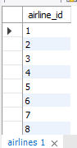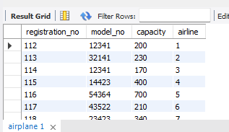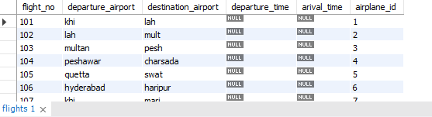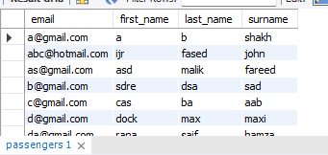

**Question 4:**

* Delete FROM booking

WHERE flight_no IN

( select flight_no

from flights

where departure_time

like '%2023-03-20%');

**Question 5:**

* CREATE OR Replace VIEW FlightDetails AS

SELECT flight_no "FlightNumber", departure_airport 'Source', destination_airport "Destination"

FROM aviations.flights;

**The End!**