|  |  |
| --- | --- |
| Student Name | Uzair Hussain |
| Roll Number | 21SW085 |
| Section # | 3rd or III |
| Lab # | 1st |

**Task#01**

Implement the following classes:

1. Employee class

* Employee.java

1. MenuBuilder class

* MenuBuilder.java

**Code 01:**

|  |
| --- |
| //primitive variables  public class Task1_Employee_Class {      public static void main(String[] args) {          // Create a variable called age of type int and assign it the value 29.          int age = 29;          // Print the age variable to the console.          System.out.println(age);          // Create a variable called isAManager of type boolean and assign it the value          // true.          boolean isAManager = true;          // Print the isAManager variable to the console.          System.out.println(isAManager);          // Create a variable called yearsOfService of type double and assign it the          // value 2.5.          double yearsOfService = 2.5;          // Print the yearsOfService variable to the console.          System.out.println(yearsOfService);          // Create a variable called baseSalary of type int and assign it the value 3000.          int baseSalary = 3000;          // Create a variable called overtimePayment of type int and assign it the value          // 40.          int overtimePayment = 40;          // Create a variable called totalPayment of type int and assign it to the value          // of baseSalary added to overtimePayment.          int totalPayment = baseSalary + overtimePayment;          // Print the totalPayment variable to the console.          System.out.println(totalPayment);          // Create three variables all of type double on a single line.          // They should be called firstBonus, secondBonus and thirdBonus and they should          // be assigned the values 10.00, 22.00 and 35.00.          double firstBonus = 10.00, secondBonus = 22.00, thirdBonus = 35.00;          // Print out the sum of the variables called firstBonus, secondBonus and          // thirdBonus.          double sum = firstBonus + secondBonus + thirdBonus;          System.out.println("Sum: " + sum);      }  } |

**Output 01:**

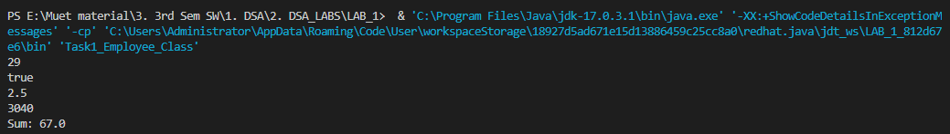

**Code 02:**

import java.util.ArrayList;

// package Tasks_Reference_Type;

public class Task1_Menu_Builder {

    public static void main(String[] args) {

        // Create a variable called menuTitle of type String and assign it the value "My

        // Dream Menu:".

        String menuTitle = "My Dream Menu:";

        // Print the menuTitle variable to the console.

        System.out.println(menuTitle);

        // Create a variable called menu of type ArrayList.

        ArrayList<String> menu = new ArrayList<>();

        // Create a variable called starter of type string and pass in the name of

        // your favourite starter.

        String starter = "Soup";

        // Add the starter variable to the ArrayList called menu.

        menu.add(starter);

        // Create a variable called mainCourse of type string and pass in the name of

        // your favourite main course.

        String mainCourse = "Biryani";

        // Add the mainCourse variable to the ArrayList called menu.

        menu.add(mainCourse);

        // Create a variable called dessert of type string and pass in the name of

        // your favourite dessert.

        String desert = "Ice Cream";

        // Add the dessert variable to the ArrayList called menu.

        menu.add(desert);

        // Print the menu variable to the console.

        for (String string : menu) {

            System.out.println(string);

        }

    }

}

**Output 02:**

**Task 02:**

Write a java program which will take age and display the theatre ticket cost

* For adult(age>13) ticket is $10
* for the child(age <13) ticket cost is $5
* there is a special discount for senior citizens(age>65) and ticket is $7 for them

**Code:**

import java.util.*;

public class Task2_Ticket_by_Age {

    public static void main(String[] args) {

        Scanner in = new Scanner(System.in);

        System.out.println("Enter age: ");

        int age = in.nextInt();

        if (age < 13) {

            System.out.println("Ticket is of $5");

        } else if (age >= 13 && age < 65) {

            System.out.println("Ticket is of $10");

        } else if (age >= 65) {

            System.out.println("Ticket is of $7");

        } else {

            System.out.println("Please enter valid age");

        }

    }

}

**Output :**

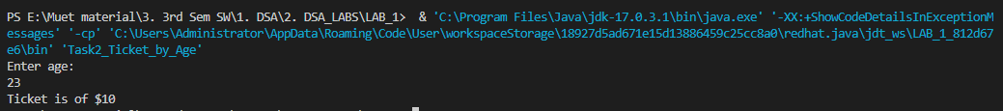

**Task 03:**

**Code:**

import java.util.*;

public class Task3_Mcqs {

    public static void main(String[] args) {

        Scanner in = new Scanner(System.in);

        System.out.println("Q: Who is the founder of Pakistan: ");

        String option1 = "Quiad-e-Azam";

        String option2 = "Allama Iqbal";

        String option3 = "Anonymous";

        System.out.println("1. " + option1);

        System.out.println("2. " + option2);

        System.out.println("3. " + option3);

        System.out.println("Enter choice (1,2,3): ");

        int choice = in.nextInt();

        if (choice == 1) {

            System.out.println("Correct Answer");

        } else if (choice == 2) {

            System.out.println("Answer is wrong");

        } else if (choice == 3) {

            System.out.println("Answer is wrong");

        } else {

            System.out.println("Invalid choice");

        }

    }

}

**Output :**

**Task 04:**

**Code:**

import java.util.*;

public class Task4_Employee_Salary {

    public static void main(String[] args) {

        Scanner in = new Scanner(System.in);

        System.out.print("Enter number of hours of employee per week: ");

        int hrs = in.nextInt();

        System.out.print("\nEnter money the employee makes per hour: ");

        int money = in.nextInt();

        System.out.print("\nEnter vacation days: ");

        int vacation = in.nextInt();

        vacation *= 8;

        int weeklySalary = hrs * money;

        System.out.println("Weekly Salary is : " + weeklySalary);

        System.out.println("Gross Yearly Salary is: " + ((weeklySalary * 52.143) - (vacation * money)));

    }

}

**Output:**

**The End!**