|  |  |
| --- | --- |
| Student Name | Uzair Hussain |
| Roll Number | 21SW085 |
| Section # | 3rd or III |
| Lab # | 10th – Recursion |

**Task#01**

**Code:**

class Task1_Factorial{

    public int factorial(int i){

        if(i==0){

            return 1;

        }

        else{

            return i*factorial(i-1);

        }

    }

}

**Output 1:**

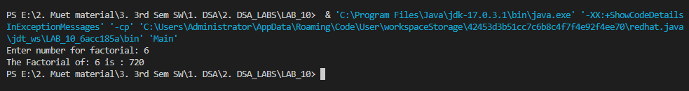

**Task 2:**

**Code:**

class Task2_NNumbers {

    public static void printNumbers(int n) {

      if (n == 0) {

        return;

      } else {

        printNumbers(n - 1);

        System.out.print(n+" ");

      }

    }

}

**Output:**

**Task 3:**

**Code:**

class Task3_Fabonacci {

    public static int fibonacci(int n) {

        if (n <= 1) {

          return n;

        } else {

          return fibonacci(n - 1) + fibonacci(n - 2);

        }

    }

}

**Output:**

**Task 4:**

**Code:**

public class Task4_Binary_Search_Recurrsion {

    public static int binarySearch(int[] array, int target, int low, int high) {

      if (low > high) {

        return -1;

      }

      int mid = (low + high) / 2;

      if (array[mid] == target) {

        return mid;

      } else if (array[mid] < target) {

        return binarySearch(array, target, mid + 1, high);

      } else {

        return binarySearch(array, target, low, mid - 1);

      }

    }

  }

**Output:**



**Main Class:**

import java.util.Scanner;

public class Main {

    public static void main(String[] args) {

        // Task1_Factorial a=new Task1_Factorial();

        // Scanner sc=new Scanner(System.in);

        // System.out.print("Enter number for factorial: ");

        // int n=sc.nextInt();

        // System.out.println("The Factorial of: "+n+" is : "+(a.factorial(n)));

        // Task2_NNumbers b=new Task2_NNumbers();

        // Scanner sc=new Scanner(System.in);

        // System.out.print("Enter limit numbers for printing: ");

        // int n=sc.nextInt();

        // b.printNumbers(n);

        // Task3_Fabonacci c=new Task3_Fabonacci();

        // Scanner sc=new Scanner(System.in);

        // System.out.print("Enter limit numbers for fabonacci: ");

        // int z=sc.nextInt();

        // for (int i = 0; i < z; i++) {

        //     System.out.print(c.fibonacci(i) + " ");

        // }

        Task4_Binary_Search_Recurrsion d=new Task4_Binary_Search_Recurrsion();

        int[] array = {1, 2, 3, 4, 5, 6, 7, 8, 9};

        Scanner sc=new Scanner(System.in);

        System.out.print("Enter number to search: ");

        int target=sc.nextInt();

        int result = d.binarySearch(array, target, 0, array.length - 1);

        if (result == -1) {

            System.out.println("Element not found in the array");

        }

        else {

            System.out.println("Element found at index: " + result);

        }

    }

}

**GitHub Repository for all Lab Tasks: (from lab 1 to continue)**

[**https://github.com/UzairHussain193/DSA_LABS_21SW**](https://github.com/UzairHussain193/DSA_LABS_21SW)

**The End!**