|  |  |
| --- | --- |
| Student Name | Uzair Hussain |
| Roll Number | 21SW085 |
| Section # | 3rd or III |
| Lab # | Open Ended |

**Task#01: Find the shortest path using Dijkstra’s Algorithm**

**Output:**

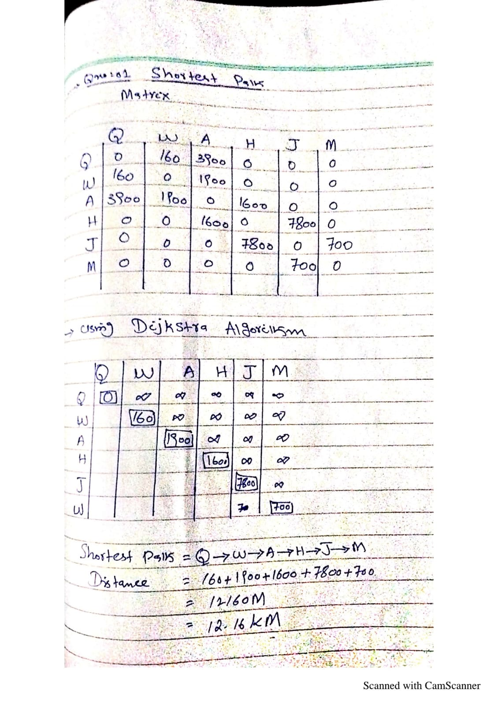

**Task#02: Design graph of the above scenario and state which type of the graph it is?**

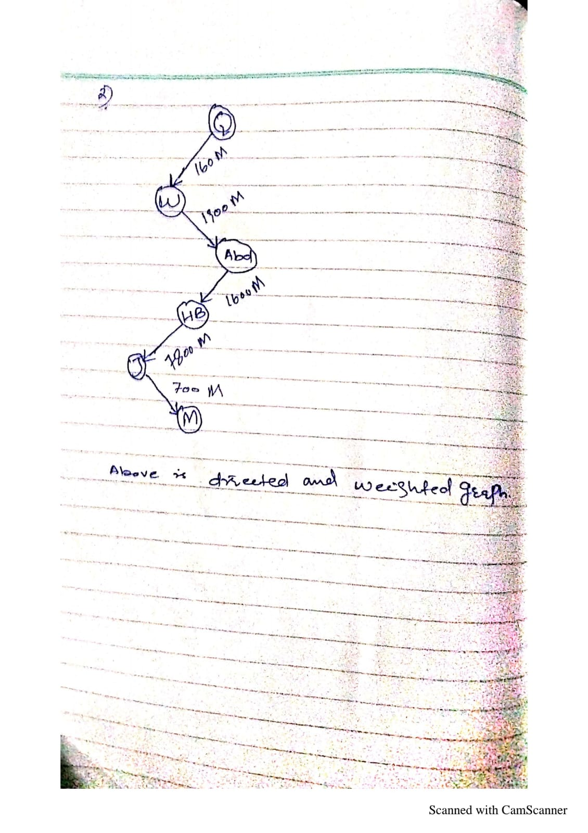

**Task#03: Represent the graph ( designed in task 2 ) in two possible ways discussed in class/ lab.**

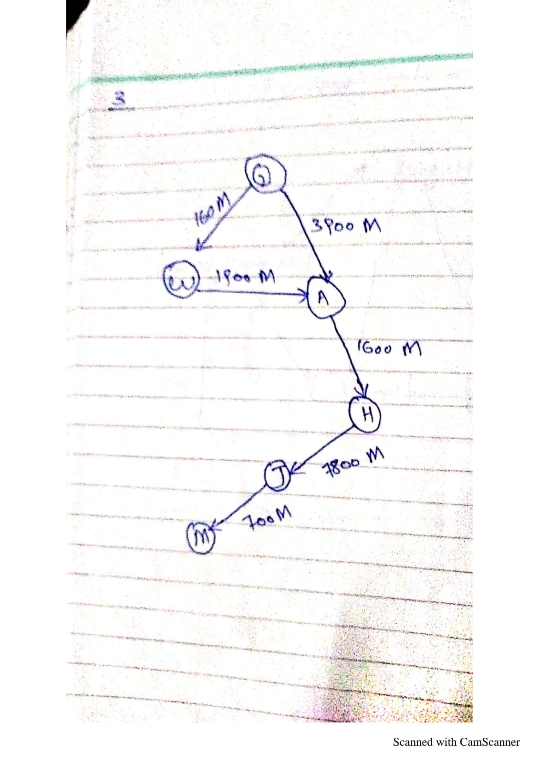

**Task 04: Using a suitable data structure, implement the above discussed example in java.**

**Code:**

public class Open_Ended_Graph {

    int size;

    String[] vertices;

    boolean[][] a;

    public Open_Ended_Graph(String[]args){

        size=args.length;

        vertices=new String[size];

        System.arraycopy(args,0,vertices,0,size);

        a=new boolean[size][size];

    }

    public void add(String v,String w){

        int i=index(v),j=index(w);

        a[i][j]=a[j][i]=true;

    }

    private int index(String v){

        for(int i=0;i<size;i++)

            if(vertices[i].equals(v))return i;

        return size;

    }

    public String toString() {

        if(size==0)return "{}";

        StringBuilder s=new StringBuilder("{ "+vertex(0));

        for(int i=1;i<size;i++)s.append(", ").append(vertex(i));

        return s+" }";

    }

    private String vertex(int i){

        StringBuilder s=new StringBuilder(vertices[i]+" : ");

        for(int j=0;j<size;j++)if(a[i][j])s.append(vertices[j]);

        return s+"";

    }

    public static void main(String[] args) {

        String[] s={"Qasimabad","Wadhuwah Rd","Abdullah Mall Rd","Hyderabad Bypass","Jamshoro","MUET Main Gate"};

        Open_Ended_Graph g=new Open_Ended_Graph(s);

        g.add("Qasimabad","Wadhuwah Rd");

        g.add("Qasimabad","Abdullah Mall Rd");

        g.add("Wadhuwah Rd","Abdullah Mall Rd");

        g.add("Abdullah Mall Rd","Hyderabad Bypass");

        g.add("Hyderabad Bypass","Jamshoro");

        g.add("Jamshoro","MUET Main Gate");

        System.out.println(g);

    }

}

**Output:**

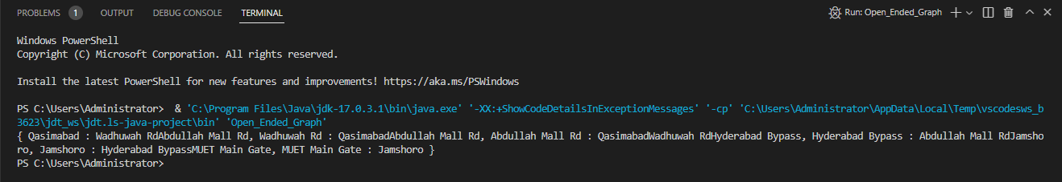

**Task 05: Write down your day to day real life application of graph.**

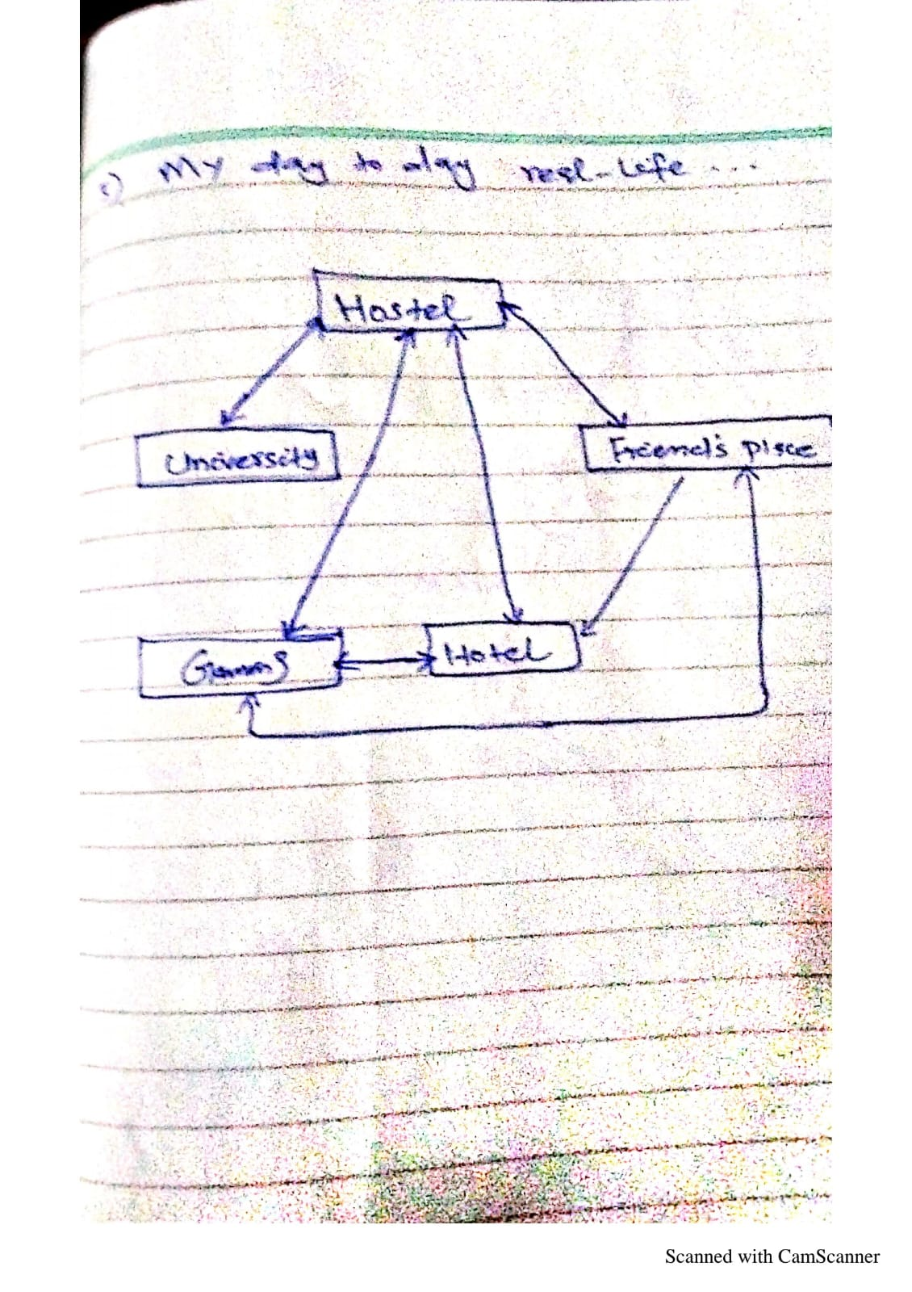

**GitHub Repository for all Lab Tasks: (from lab 1 to continue)**

[**https://github.com/UzairHussain193/DSA_LABS_21SW**](https://github.com/UzairHussain193/DSA_LABS_21SW)