|  |  |
| --- | --- |
| Student Name | Uzair Hussain |
| Roll Number | 21SW085 |
| Section # | 3rd or III |
| Lab # | 9th – Stack using Array and LinkedList |

**Task#01**

**Code:**

import java.util.NoSuchElementException;

class ArrayStack<T> {

    private T[] stack;

    private int peek;       // peek is the index number

    private int capacity;

    public ArrayStack(int capacity) {

        this.capacity = capacity;

        stack = (T[]) new Object[capacity];     // we can not create an array of generic class so we type casted here

        peek = -1;

    }

    public void push(T data) {

        if (peek == capacity - 1) {

            throw new IllegalStateException("Stack is full");

        }

        stack[++peek] = data;

        peek++;

    }

    public T pop() {

        if (isEmpty()) {

            throw new NoSuchElementException("Stack is empty");

        }

        return stack[peek--];

    }

    public T peek() {

        if (isEmpty()) {

            throw new NoSuchElementException("Stack is empty");

        }

        return stack[peek];

    }

    public boolean isEmpty() {

        return peek == -1;

    }

    public int search(T data) {

        for (int i = peek; i >= 0; i--) {

            if (stack[i].equals(data)) {

                return peek - i + 1;

            }

        }

        return -1;

    }

}

**Output 1:**

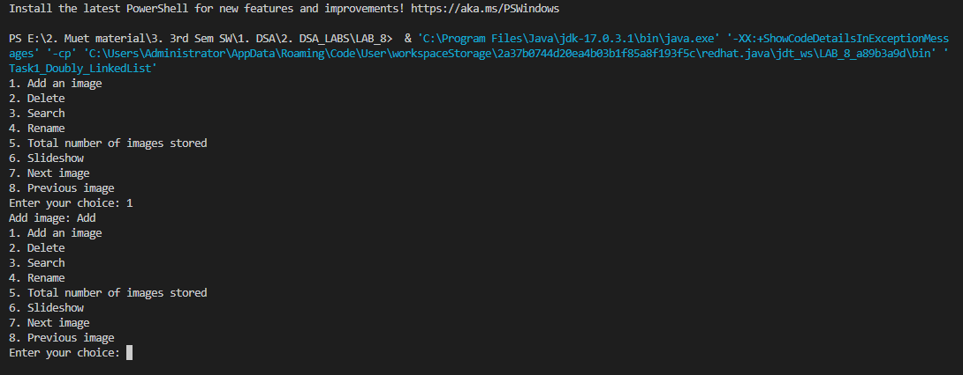

**Github Repository for all Lab Tasks: (from lab 1 to continue)**

[**https://github.com/UzairHussain193/DSA_LABS_21SW**](https://github.com/UzairHussain193/DSA_LABS_21SW)

**The End!**