**First Day :**

We will work on UI layout and Structure of your site

**2nd Day :**

Database Design

and Structure

**3rd Day :**

Queryies creation

**4th Day :**  
 Pages Design

**5 th Day :**

Compiling Pages

**6 th Day :**

Compiling Quries , Database and Pagee with Authentication

**7th Day :**

Testing Features

#### 

Admin

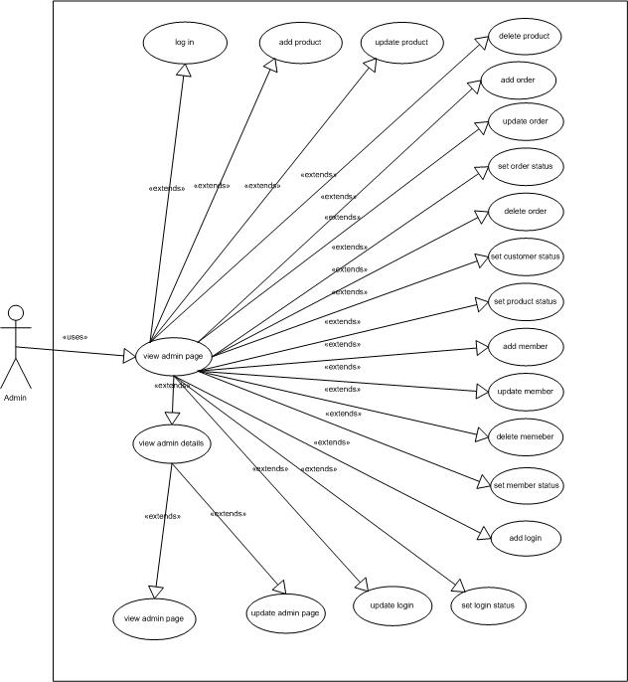

Figure 16: Use Case of set Oreder Status

Admin

Change Password

Login