FROSTMIND — Model 4 (Mixed-Load Setpoint) and Model 5 (Co-Shipment Compatibility)
Project: FROSTMIND cold-chain AIoT monitoring system · Document: technical submission for the two models requested by the professor · Date: 27 September 2026
Contents
1. Executive summary 3
2. The problem and why it matters for FROSTMIND 4
3. Data: collection and cleaning 5
3.1 Why new data was needed 5
3.2 Sources 5
3.3 Cleaning pipeline 5
3.4 The cleaned catalog 7
3.5 Keeping Model 3 and Model 4 consistent (Q10) 7
3.6 Real temperature fluctuation (σ) 7
4. Shared design: one code path for training and serving 9
5. Model 5: co-shipment compatibility 10
5.1 Labels (ground truth) 10
5.2 Features 10
5.3 How it was trained and evaluated 10
5.4 Results 11
5.5 What the model learned, and where it errs 12
5.6 From pairs to compartments (grouping) 13
6. Policy layer: rules that ML must never override 14
7. Model 4: ideal temperature for a mixed load 15
7.1 The physics teacher 15
7.2 Why also train an ML model? 15
7.3 Training data (simulated loads, real ingredients) 16
7.4 Features and the extrapolation fix 16
7.5 Results on unseen products 16
7.6 External validation and sensitivity 18
7.7 Worked examples (default σ = 0.31 °C) 19
8. Where the models are used in FROSTMIND 20
8.1 End-to-end flow (a real run) 20
8.2 Backend endpoints 20
8.3 Phone app 21
8.4 Admin panel 23
8.5 Tests 25
9. Limitations and honest caveats 26
10. How to reproduce 27
11. References 28

1. Executive summary
The professor asked for two models:
- Model 4, ideal temperature for a mix of different products. A reefer truck has only one setpoint. When it carries several products, what should that setpoint be?
- Model 5, which products can be shipped together. Given any two products, can they share a compartment? Given a whole order, how should it be split into compartments?
Both are built, trained, evaluated, and live in FROSTMIND:
- the backend endpoint POST /planner/plan;
- the driver's phone app (multi-product setup step and an AI panel on the live dashboard);
- the admin panel's Load Planner and AI Models pages;
- 72 passing backend tests.
The table below gives the headline numbers. Every number was measured on products the model never saw during training.
 | What it is | Trained on | Headline result (unseen products) | Best simple rule, for comparison
Model 5 | Random-forest classifier over 13 physical pair features | 5,671 produce pairs labelled by USDA expert compatibility groups (McGregor 1989, Agricultural Handbook 668) | ROC-AUC 0.930 ± 0.034, accuracy 86.7%, F1 0.822, MCC 0.717 (mean ± std over 30 product-disjoint splits) | "optimal temps within 2 °C": AUC 0.839, MCC 0.663
Model 4 | Gradient-boosting regressor (the "student") distilled from a physics-informed robust optimizer (the "teacher") | 16,000 simulated mixed loads of real catalog products, with real reefer temperature fluctuation from the Kaggle cold-chain milk logs | MAE 0.16 °C, R² 0.999, 93.6% within ±0.5 °C of the optimum | "midpoint of the shared range": MAE 1.32 °C, 48.1% within ±0.5 °C

To build these we collected and cleaned new data: 155 products from 4 public sources plus cited regulations. Every cleaning step is logged with row counts (Section 3).
Honesty notes, stated up front (details in Section 9):
• Model 5's labels are real expert labels, but only for produce. Dairy, meat and pharma pairs are handled by cited regulations plus a physics check, not by the ML.
• Model 4's training loads are simulated and labelled by our own physics model. The ML student learns to reproduce that physics quickly and safely. It is externally checked against USDA's published group temperatures, and it agrees for the cold groups but not for some warm ones. We report that honestly.

2. The problem and why it matters for FROSTMIND
Before this work, FROSTMIND assumed one product category per shipment. It had six categories (vaccines, milk, produce, meat, frozen food, seafood), each with one reference temperature (scripts/model3_shelf_life.py). Real trucks carry mixed loads, which raises two practical questions:
- Some products must not travel together.
  - Ethylene: apples and bananas emit ethylene gas, which ripens, yellows or spoils ethylene-sensitive items such as lettuce and kiwifruit.
  - Temperature: tropical fruit gets chilling injury at the 0 °C that lettuce needs.
  - Regulation: medicines must be segregated from food (WHO / EU Good Distribution Practice), and raw meat must be kept apart from ready-to-eat food (FDA Food Code 3-302.11).
- Products that can travel together still need one shared setpoint. Too cold and chilling-sensitive items are injured or freeze. Too warm and everything spoils faster; spoilage roughly doubles to triples for every 10 °C (Q10). The best temperature depends on the mix, on how much of each product there is, and on how much the truck's temperature wobbles.
FROSTMIND already measures the truck's temperature (ESP32 + DHT22), tracks shelf-life consumption (Model 3, Arrhenius), and can set the air-conditioner setpoint per category over BLE. Models 4 and 5 add the missing planning step: decide what goes in which compartment, and at what temperature, before the truck leaves.

3. Data: collection and cleaning

3.1 Why new data was needed
None of FROSTMIND's existing datasets (NAB machine temperature, Kaggle milk, Kaggle shipment, IoT room temperature) contain any product storage properties or compatibility information. So we built a product catalog from public, citable sources.
- scripts/fetch_product_data.py downloads each source page and saves it unchanged as a raw snapshot in data/product_catalog/raw/.
- Each snapshot's URL, HTTP status, size and SHA-256 hash are recorded in raw/SOURCES.json.
- The cleaning script only ever reads these snapshots, so the pipeline is reproducible even if a website changes.

3.2 Sources
# | Source | Rows | What we took from it
S1 | Engineering ToolBox, Fruits and Vegetables – Optimal Storage Conditions (engineeringtoolbox.com/fruits-vegetables-storage-conditions-d_710.html) | 125 | Storage temperature range (°F), chill point, freezing point, humidity, ethylene production and ethylene sensitivity, storage life
S2 | USDA Agriculture Handbook 66 (Hardenburg, Watada & Wang), as reproduced in UMaine Extension Bulletin 4135 (extension.umaine.edu/publications/4135e/) | 85 storage + 18 chilling rows | Independent cross-check of S1, gap filling, and HB66's "lowest safe temperature" chilling-injury table
S3 | *McGregor, B.M. 1989, Tropical Products Transport Handbook, USDA Agricultural Handbook 668*, as reproduced by FAO (fao.org/4/ae075e/ae075e16.htm) | 7 groups, 159 listed members | The expert mixed-load compatibility groups, plus explicit "not with …" exceptions. These are Model 5's labels and Model 4's external check. They are never used as features.
S4 | Virginia Tech Extension pub. 348-960, Food Storage Guidelines for Consumers (pubs.ext.vt.edu/348/348-960/348-960.html) | 29 rows used | Refrigerated and frozen storage times for dairy, eggs, meat, poultry, seafood and frozen foods
S5 | raw/non_produce_manual.csv, 35 rows, each with its citation | 35 | Temperature bands from FDA Food Code 2022 (≤ 5 °C cold holding for TCS foods; ≤ 7 °C shell eggs), the CDC Vaccine Storage & Handling Toolkit (2–8 °C; −50 to −15 °C; −90 to −60 °C) and USP ⟨659⟩ (controlled room temperature). These agencies' websites refuse scripted downloads (HTTP 403), and each value is a single regulatory number, so they were entered by hand with the source on every row.
S6 | Kaggle cold-chain milk (already in the project, data/kaggle_cold_chain_milk/) | 92 real sessions | The real temperature fluctuation σ of a refrigerated transport (Section 3.6)

3.3 Cleaning pipeline
scripts/build_product_catalog.py performs the steps below. Each step's counts are written to data/product_catalog/cleaning_report.json.
Step | What was wrong in the raw data | What we did | Rows affected
1. Extract | HTML table with a stray header row (%) | Stdlib html.parser table extractor; kept rows with all 11 columns | 127 → 125
2. Synonyms and typos | Beans. Lima (full stop for comma), Green Beans vs Beans, green or snap, Green Peas vs Peas, green, Onions meaning dry onions | Synonym map to one canonical name | 4
3. Typo in a Yes/No column | Ne instead of No (Kiwi, unripe) | Corrected | 1
4. Parse and convert units | Temperatures as °F text ranges (30 - 40, 55–70, 32), humidity as 90-95, ethylene as words, storage life as 1-12 months | Parsed ranges to (min, max), converted °F to °C, mapped ethylene words to ordinals (0–4 production, 0–2 sensitivity), converted storage life to days using the geometric midpoint (ranges span an order of magnitude) | 125 (62 missing freezing points, 33 missing ethylene, 50 missing storage life)
5. Duplicates | The same product listed twice with different, partly conflicting cells (Cauliflower, Escarole, Peas, Quinces, Tangerines, …) | Merged: the row that agrees with USDA HB66 wins; otherwise the most complete row. Gaps are filled from the other row, and every conflict is logged. | 125 → 119, 15 conflicts
6. Cross-check with HB66 | — | Matched 82 products to HB66: midpoint temperature MAE 0.26 °C (90% identical), freezing points identical. The two big disagreements, potatoes (8.6 vs 3.9 °C) and watermelon (16.9 vs 12.8 °C), are listed in the report. | 82 matched, 14 gaps filled
7. HB66-only rows | Green onions missing from S1 | Added | +1
8. Chilling sensitivity | S1 "chill point" is sparse | Threshold taken from HB66's lowest-safe-temperature table (preferred) or the S1 chill point. Chilling-sensitive if the threshold ≥ 2 °C or t_min ≥ 7 °C. | 18 from HB66; 38 products flagged
9. Sibling imputation | e.g. Carrots, mature has no ethylene data but Carrots, bunched does | Filled from rows of the same commodity; source recorded in imputed_fields | 14 ethylene, 10 freezing point, 4 storage life
10. Category imputation | Remaining gaps | Fruit/vegetable median (mode for ethylene classes); flagged in imputed_fields | 15 ethylene, 39 freezing point, 33 storage life
11. McGregor labels | McGregor's names differ from S1's (berries (except cranberries), leafy greens, sweetpotatoes) | Hand-written mapping, printed in full in the report. Group sets are kept, because 26 crops appear in more than one group. | 107 produce products labelled; 56 exotic McGregor crops have no catalog entry
12. Non-produce rows | — | S5 temperature bands plus S4 storage times (text such as 3-5 days or 1-2 months converted to days) | 35 rows; 29 shelf lives from VT
13. Validation | — | Checks that t_min ≤ t_opt ≤ t_max, the freezing point is below the storage range, RH is within 0–100, shelf life is plausible, and ids are unique | 155 rows, 0 problems

Leakage rule. No feature is ever filled from the McGregor groups, because those groups are the label. A unit test enforces this: it shuffles the labels and checks that every feature stays identical (backend/tests/test_products.py).

3.4 The cleaned catalog
data/product_catalog/product_catalog_clean.csv has 155 products: 46 fruits, 74 vegetables, 8 dairy, 1 eggs, 6 meat, 2 poultry, 6 seafood, 6 frozen and 6 pharmaceutical. It has 24 columns, including:
- temperature range and optimum, humidity range, freezing point;
- chilling sensitivity and threshold, shelf life, Q10;
- ethylene production and sensitivity;
- safety class and regulatory hard limits;
- the McGregor label set, source URL, and an imputed_fields audit column (105 rows have at least one imputed value, and each says where it came from).
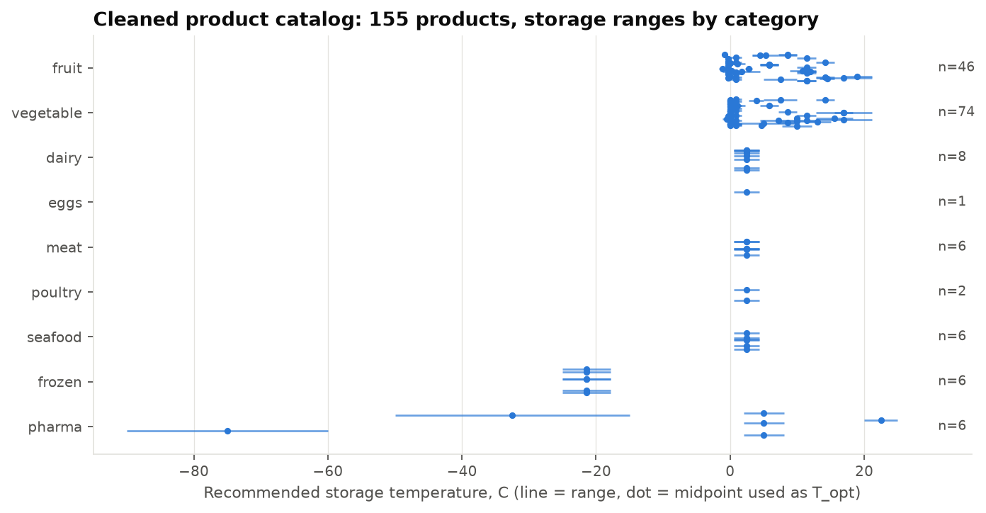
Figure 1 – Every product's recommended storage range by category (line = range, dot = midpoint used as the optimum).

3.5 Keeping Model 3 and Model 4 consistent (Q10)
Model 4 needs to know how fast each product spoils as temperature rises. FROSTMIND's Model 3 already defines an Arrhenius activation energy Ea for each of its six categories. We convert that to a Q10 so the two models agree:
Q10 = exp( 10 · Ea / (R · T1 · T2) ), where T1 = T_ref and T2 = T_ref + 10 K.
For example, milk (Ea = 65 kJ/mol at 4 °C) gives Q10 = 2.67. All produce uses the fresh_produce_generic value (Q10 = 2.31). Section 7.6 shows the setpoint is insensitive to ±20% changes in this number.

3.6 Real temperature fluctuation (σ)
A reefer never holds its setpoint exactly. scripts/estimate_reefer_fluctuation.py measures σ on the real Kaggle milk-transport sessions:
- Normal operation (in-spec readings of 72 sessions): median σ = 0.31 °C (p90 0.65 °C).
- Sessions with excursions (63 sessions): median σ = 0.56 °C (p90 1.12 °C).
The sensors report in 0.5 °C steps, so σ is floored at 0.2 °C. FROSTMIND's own database (5,932 readings) holds bench tests at about 29 °C, not reefer data, so it only supplies the sensor noise floor (0.11 °C).
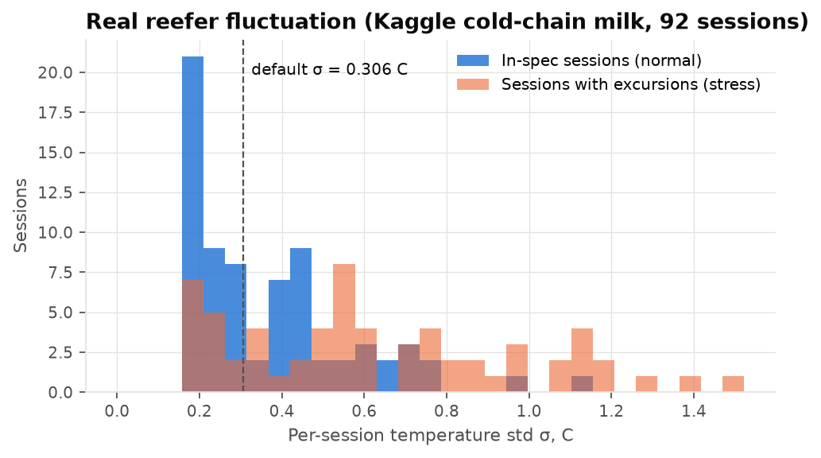
Figure 2 – Real reefer fluctuation measured on the Kaggle cold-chain milk sessions; the median, 0.31 °C, is the planner's default.

4. Shared design: one code path for training and serving
All features, physics and grouping live in `scripts/common/products.py`. The training scripts import it, and the live backend imports the same file (backend/app/load_planner.py, the same way app/ml.py already imports Model 3). What the models were trained on is therefore exactly what they are scored on in production, with no train/serve skew.
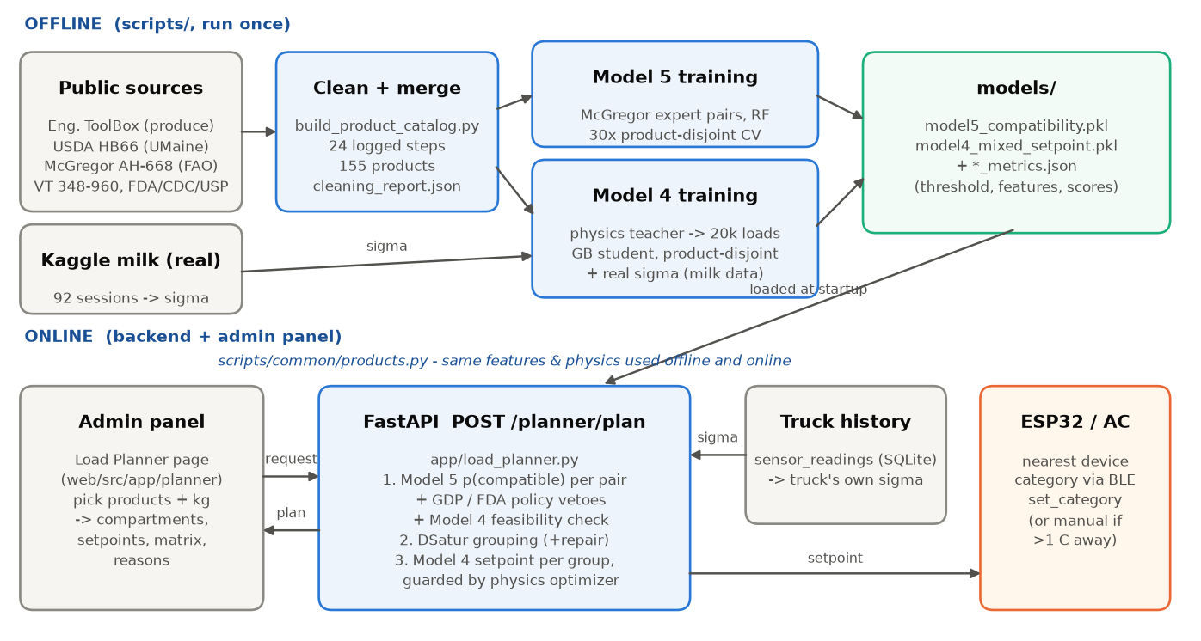
System architecture: where Models 4 and 5 sit in FROSTMIND

5. Model 5: co-shipment compatibility

5.1 Labels (ground truth)
McGregor (USDA AH-668) sorts about 85 crops into 7 groups, each with a temperature, a humidity, and an ethylene role. Examples:
- G1, 0–2 °C / 90–95% RH: many ethylene producers (apples, pears, grapes, berries, …);
- G2, 0–2 °C / 95–100% RH: ethylene-sensitive leafy vegetables;
- G6, 13–15 °C: tropical fruit.
For two catalog products that McGregor grouped, the pair is compatible (1) if their group sets overlap. McGregor's explicit exceptions ("figs not with apples", "green onions not with figs, grapes, mushrooms, rhubarb or corn", "sweet potatoes and watermelon separate from pears and tomatoes") override this to incompatible (0).
This gives 107 products and 5,671 labelled pairs, 40.4% compatible. We deliberately did not invent labels for dairy, meat or pharma pairs using our own rules. A model trained on rule-generated labels would just learn the rules back, and its accuracy would be meaningless.

5.2 Features
There are 13 symmetric features per pair, computed by pair_feature_frame(). A symmetry test checks that (A, B) and (B, A) give identical values.
Feature | Meaning
temp_overlap_c | Width of the overlap of the two recommended temperature ranges (negative means a gap)
topt_diff_c, topt_mean_c | Difference and mean of the two optimal temperatures
rh_overlap, rh_mid_diff | Humidity-range overlap and difference of the humidity midpoints
ethylene_risk | max(production_A × sensitivity_B, production_B × sensitivity_A)
ethylene_prod_max, ethylene_sens_max | Strongest producer and most sensitive product in the pair
chill_risk_c | How far one product's optimum sits below the other's chilling limit
freeze_risk_c | How far one product's low end sits below the other's freezing point
n_chilling_sensitive | 0, 1 or 2
log_shelf_life_ratio | Mismatch in storage life
same_category | Both fruit, or both vegetable

5.3 How it was trained and evaluated
Every product appears in about 100 pairs. A random split of pairs would let the model see each test product during training and simply remember it. We avoid that with a product-disjoint protocol:
- Split the products 70/30, stratified by McGregor group.
- Train on pairs where both products are in the training set (2,701 pairs).
- Test on pairs where both products are in the test set (528 pairs). This is a strict cold start: the model has never seen either product.
- Choose the decision threshold with Youden's J on out-of-fold predictions from a 5-fold product-level cross-validation inside the training products. The test set is never touched.
- Repeat the whole procedure for 30 random product splits and report the mean ± standard deviation.
Three algorithms were compared, all with class_weight="balanced" (the hyperparameters are stored in the metrics file):
- logistic regression, with standardisation and median imputation;
- random forest: 300 trees, min_samples_leaf 3;
- histogram gradient boosting: learning rate 0.05, 300 iterations, max depth 4.
They were benchmarked against two rules an expert might write by hand. The winner, random forest (chosen by mean MCC), was refit on all 5,671 pairs. Its final threshold, from product-level cross-validation, is 0.463.

5.4 Results
Model (unseen products, 30 splits) | ROC-AUC | PR-AUC | Accuracy | Balanced acc. | Precision | Recall | F1 | MCC
Random forest (selected) | 0.930 ± 0.034 | 0.917 | 0.867 | 0.855 | 0.843 | 0.805 | 0.822 | 0.717 ± 0.063
Gradient boosting | 0.928 ± 0.034 | 0.907 | 0.862 | 0.851 | 0.838 | 0.803 | 0.817 | 0.709 ± 0.065
Logistic regression | 0.915 ± 0.032 | 0.890 | 0.836 | 0.828 | 0.792 | 0.795 | 0.787 | 0.660 ± 0.070
Rule: optimal temps within 2 °C | 0.839 | 0.694 | 0.830 | 0.839 | 0.737 | 0.876 | 0.798 | 0.663 ± 0.068
Rule: ranges overlap and no ethylene clash | 0.808 | 0.690 | 0.825 | 0.808 | 0.796 | 0.736 | 0.763 | 0.627 ± 0.083

- When one product of a pair is unseen, the random forest reaches ROC-AUC 0.963, accuracy 90.5% and MCC 0.803.
- Pooled over all 30 splits, its confusion matrix is: 8,734 true "separate", 4,994 true "compatible", 926 false "compatible", 1,186 false "separate".
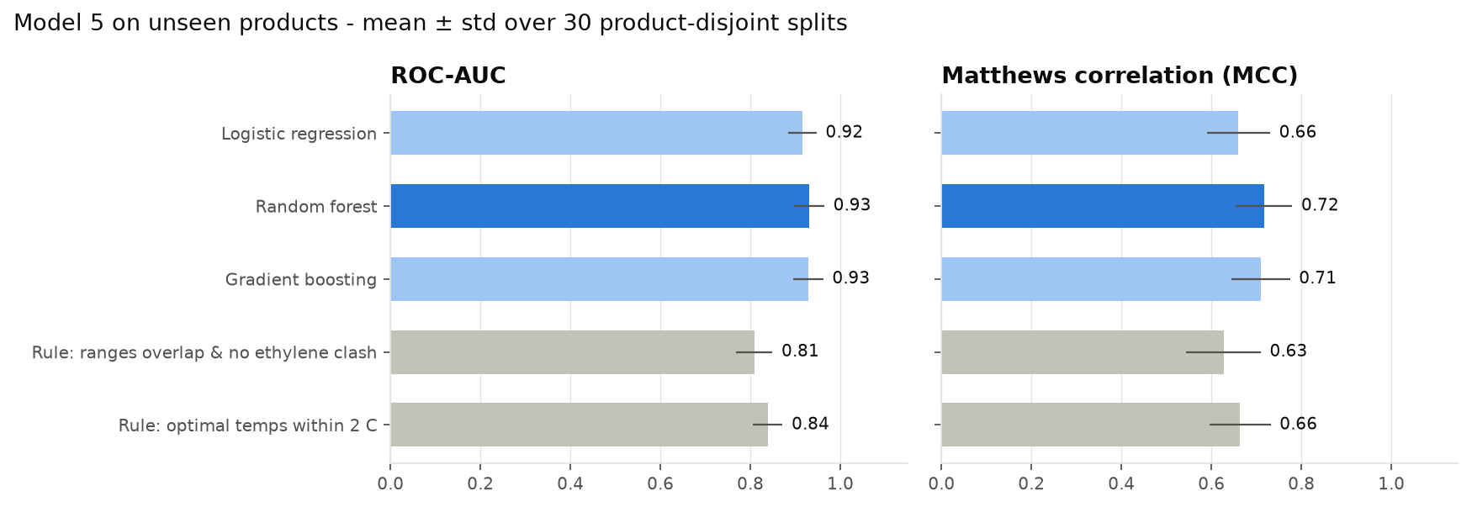
Figure 3 – Model 5 against two hand-written rules on unseen products (mean ± std over 30 splits).
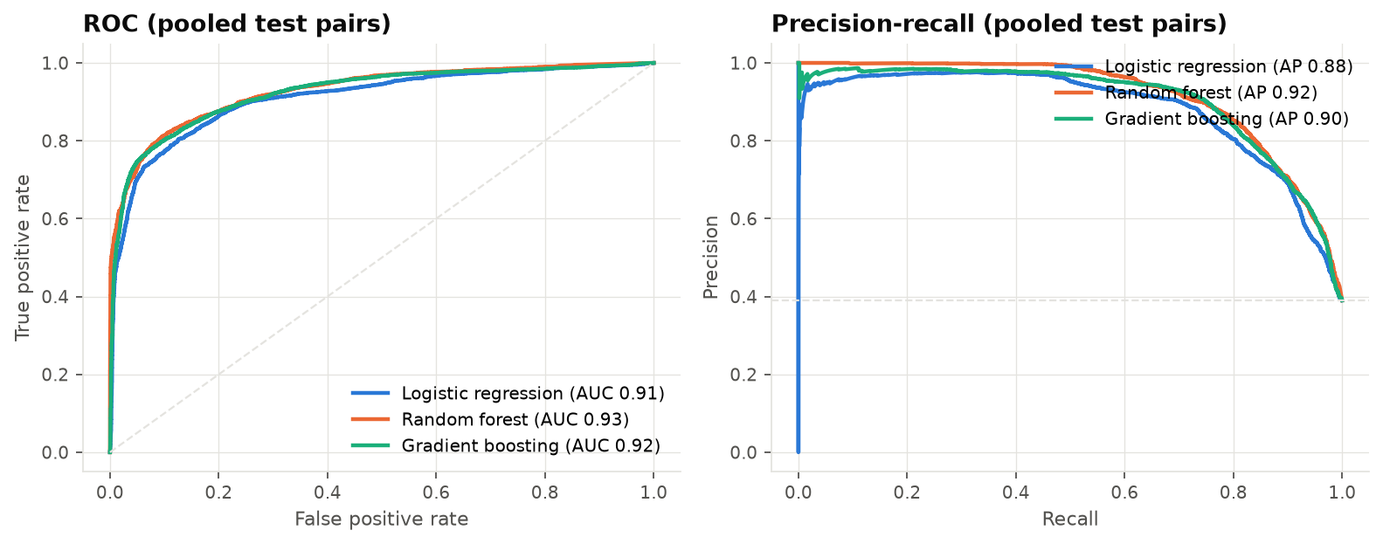
Figure 4 – ROC and precision-recall curves, pooled over the 30 test sets.
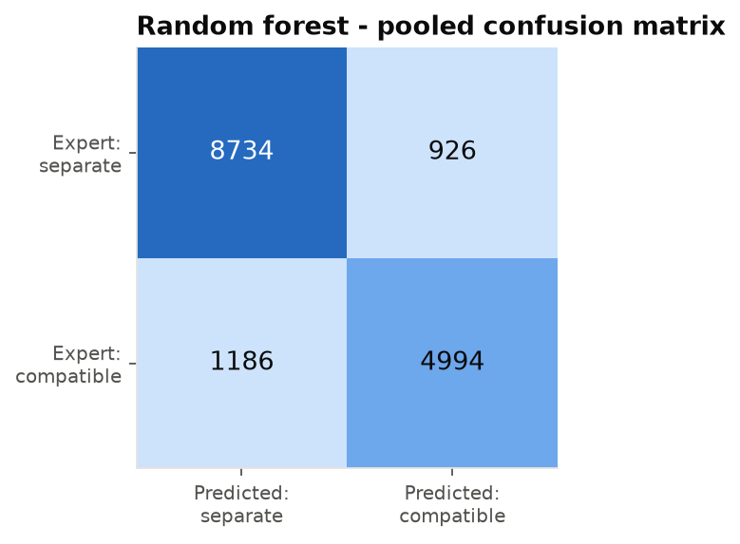
Figure 5 – Pooled confusion matrix of the selected random forest.
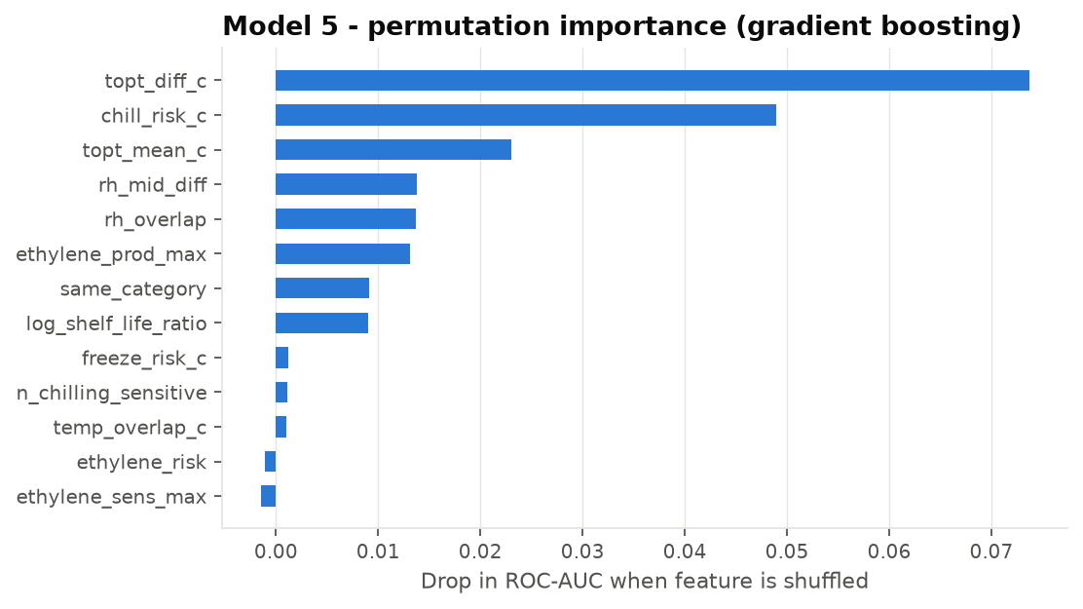
Figure 6 – Permutation importance (drop in ROC-AUC when a feature is shuffled).

5.5 What the model learned, and where it errs
- Optimal-temperature difference and chilling risk dominate. That matches how McGregor built the groups, which are mainly temperature classes.
- Ethylene adds little on its own. McGregor's two big 0–2 °C groups (producers in G1, sensitive leafy vegetables in G2) share many crops, such as berries, grapes, cherries and radishes, so ethylene is not a clean separator in the labels. The planner still explains ethylene clashes to the user (Section 8), and the raw physics check still applies.
- ML beats the best rule by about 9 AUC points and 0.05 MCC. The rule "optimal temps within 2 °C" has high recall but lower precision, because it pairs products that sit near each other in temperature but differ in humidity or chilling behaviour.
- What it's for: the model's real use is products McGregor never grouped. For example, it pairs basil with sweet peppers, cucumbers and eggplant (the 7–10 °C crops), and southern peas with lima beans. These predictions are stored in models/model5_compatibility_metrics.json.

5.6 From pairs to compartments (grouping)
- The backend builds an incompatibility graph: an edge joins any pair that is vetoed, infeasible, or below the threshold.
- It colours the graph with the DSatur algorithm (Brélaz 1979). Each colour is a set of mutually compatible products, which becomes one compartment or truck.
- If a group turns out to have no common legal setpoint once σ margins stack up, its most distant pair is split and the graph is recoloured.

6. Policy layer: rules that ML must never override
Two regulatory rules are applied on top of Model 5 as hard vetoes, and every response says which one fired:
- Medicines never share a compartment with food. Source: WHO TRS 961 Annex 9 and EU GDP Guidelines 2013/C 343/01.
- Raw animal foods are kept apart from produce and ready-to-eat food. Source: FDA Food Code 3-302.11.
Frozen and chilled products are separated automatically, because no single setpoint is feasible for both (Model 4's feasibility check). These rules were never used as training labels (Section 5.1).

7. Model 4: ideal temperature for a mixed load

7.1 The physics teacher
For product i at actual temperature X, the expected loss per day, as a fraction of its shelf life, is:
ℓᵢ(X) = Q10ᵢ^((X − T_opt,i)/10) / SLᵢ + κᵢ · (Lᵢ − X)₊² + κ_f · (T_f,i − δ − X)₊
The three terms are:
- Spoilage: Arrhenius/Q10 decay relative to the rated shelf life SL.
- Lower wall at t_min: chilling injury. Its stiffness κ is 0.05 for chilling-sensitive products and 0.01 otherwise.
- Freezing damage: κ_f = 1 per °C below the freezing point minus a 0.5 °C supercooling allowance δ.
Pharmaceuticals use a symmetric band penalty instead, κ_p[(t_min − X)₊² + (X − t_max)₊²]. That puts 2–8 °C vaccines at exactly 5.0 °C, as the CDC toolkit recommends.
Robustness to the truck's wobble. The actual temperature is X = μ + ε with ε ~ N(0, σ²). All three expectations have closed forms (a lognormal factor for the Q10 term, normal partial moments for the walls), so the optimum is computed exactly, not by Monte Carlo. The load objective weights each product by its mass share:
J(μ) = Σᵢ wᵢ · E[ℓᵢ(μ + ε)]
Legal limits are chance constraints: the setpoint must stay 2σ inside every hard limit, so about 97.7% of readings stay legal on each side. The limits are:
- pharma band;
- FDA ≤ 5 °C for dairy, meat and seafood; ≤ 7 °C for shell eggs;
- ≤ −17.8 °C for frozen food;
- above the freezing point for fresh products.
The teacher minimises J on a 0.05 °C grid inside that safe interval. It returns:
- the setpoint;
- a near-optimal band (within 10% of the minimum);
- each product's expected loss per day.
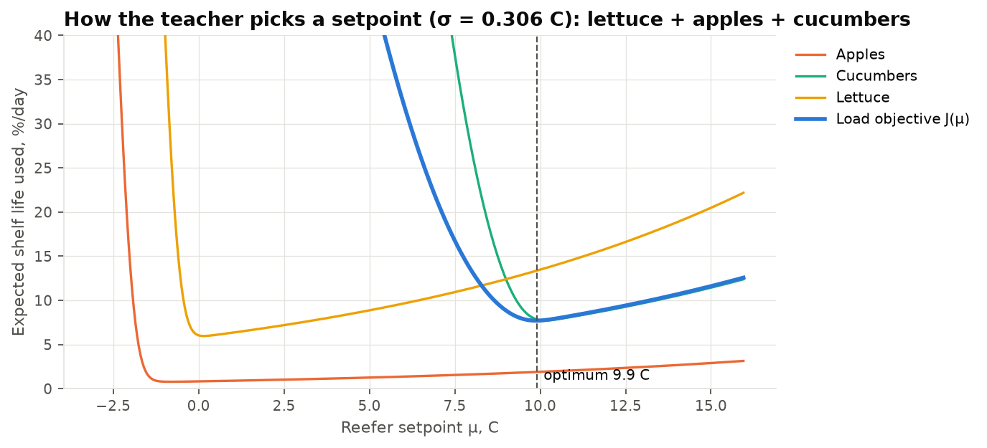
Figure 7 – How the teacher picks a setpoint for a deliberately incompatible load (lettuce + apples + cucumbers). Cucumber's chilling wall forces 9.9 °C, which costs lettuce about 13%/day. That is exactly why Model 5 separates such products first.

7.2 Why also train an ML model?
The teacher is exact, but it needs every product's full kinetic parameters. The ML student maps a compact 24-number summary of the load straight to the setpoint. It is:
- compact and fast: a single 1.3 MB tree ensemble, a candidate to run on the phone bridge or at the edge;
- the component that learns from reality later: once FROSTMIND logs delivery-quality outcomes, the student is fine-tuned on them. This is the same "learned correction layer" already planned for Model 3.
In production the two work together as guarded ML. The student's answer is clipped into the safe interval and served only if it agrees with the teacher to within 0.5 °C. Otherwise the teacher's answer is served, and the response says so.

7.3 Training data (simulated loads, real ingredients)
- Loads: 20,000 feasible mixed loads, each 1–8 products, with quantity shares drawn from a Dirichlet distribution.
- σ: drawn from the real milk σ distribution (75% normal sessions, 25% excursion sessions).
- Sampling mix: 40% from the same McGregor group, 30% from the same temperature regime (optima within 3 °C), 30% random.
- Excluded: loads violating the policy rules.
- Labels: the teacher's optimum for each load.
- Split: the products were split 108/47 first. The 16,000 training loads use only training products, and the 4,000 test loads use only test products.
- Stored in data/product_catalog/mixed_load_scenarios_{train,test}.csv.gz.

7.4 Features and the extrapolation fix
The student uses 25 permutation-invariant load features (LOAD_FEATURE_COLS). One of them, the weighted-mean optimum, serves as the anchor described below, which leaves 24 model inputs. They include:
- the safe interval;
- the warmest t_min and coldest t_max;
- the weighted mean and spread of the optima;
- the highest chilling wall and freezing point;
- the fractions of chilling-sensitive, pharma and frozen products;
- the mean Q10 and shelf life;
- σ.
The first version predicted absolute temperatures and failed badly on ultra-cold mRNA vaccines (−75 °C) and room-temperature medicines (22.5 °C). Both happened to fall only in the test split, and tree models cannot extrapolate beyond the targets they were trained on. The fix is to make the student shift-invariant:
- every temperature feature is expressed relative to the load's weighted-mean optimum;
- the target becomes "setpoint minus that anchor".
This cut test MAE from 0.41 °C to 0.16 °C and the number of large errors (> 3 °C) from 82 to 2. A unit test checks the invariance.

7.5 Results on unseen products
Model (4,000 test loads, unseen products) | MAE (°C) | RMSE (°C) | R² | Within ±0.5 °C | Within ±1 °C | Mean regret (%/day)
Gradient boosting (selected student) | 0.159 | 0.316 | 0.999 | 93.6% | 97.9% | 0.283
Random forest | 0.162 | 0.336 | 0.999 | 93.5% | 97.9% | 0.108
Baseline: midpoint of shared range | 1.323 | 2.321 | 0.955 | 48.1% | 65.4% | 7.157
Baseline: weighted mean of optima | 1.415 | 2.433 | 0.950 | 44.5% | 62.9% | 5.298
Baseline: warmest product's optimum | 1.359 | 1.865 | 0.971 | 31.6% | 50.8% | 0.727

Regret is the extra shelf life lost per day by using the prediction instead of the true optimum. The student cuts the error of every rule by about 8×. The random forest has slightly lower mean regret; gradient boosting was chosen by MAE, as decided before the run. Either is a defensible choice.
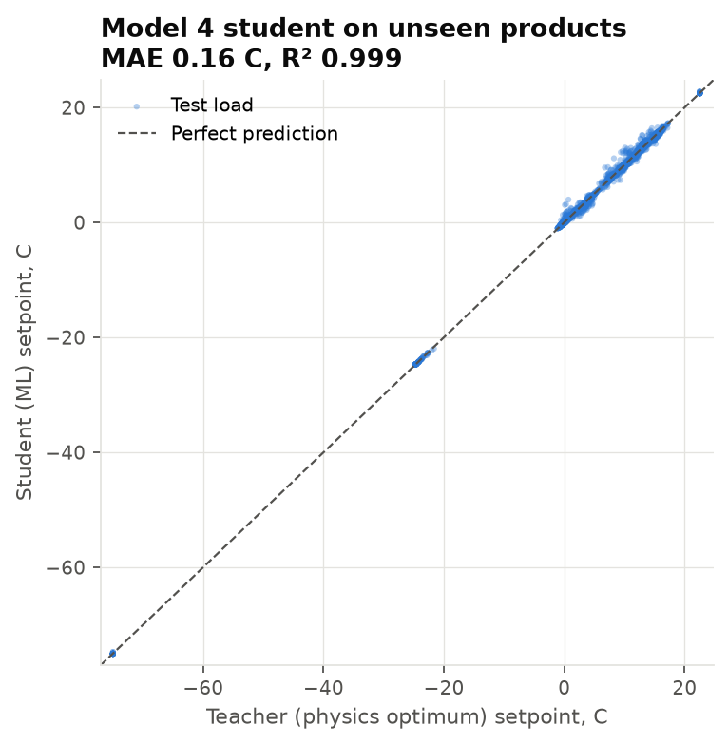
Figure 8 – Student vs teacher on unseen products.
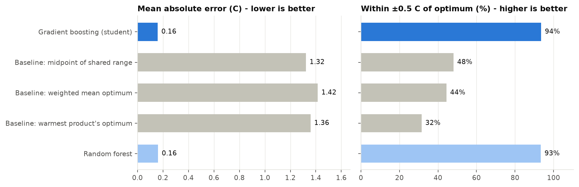
Figure 9 – Student against three hand-written baselines.

7.6 External validation and sensitivity
Against McGregor's published group temperatures, which were never used in Model 4, we took each group plus 100 random 2–5-member subsets at the default σ:
McGregor group (published temp.) | Teacher inside range | Within ±0.5 °C | Median setpoint | Members whose own HB66/S1 range even overlaps the group's
G1 (0–2 °C) | 6.9% | 42.6% | −0.2 °C | 82%
G2 (0–2 °C) | 35.6% | 91.1% | −0.05 °C | 97%
G3 (0–2 °C) | 100% | 100% | 0.35 °C | 100%
G4 (4.5 °C) | 32.7% | 33.7% | 10.9 °C | 83% (lemons: 11–13 °C in S1)
G5 (10 °C) | 44.6% | 44.6% | 7.6 °C | 75% (snap and lima beans: 3–7 °C)
G6 (13–15 °C) | 16.8% | 46.5% | 13.2 °C | 65%
G7 (18–21 °C) | 0% | 0% | 13.1 °C | 75% (sweet potato: 13–16 °C)

How to read the table:
- Cold groups agree. For G1–G3 the teacher agrees within ±0.5 °C in most cases. It tends to sit just below 0 °C because HB66 recommends −1 to 0 °C for pears, grapes and cherries.
- Warm groups disagree, and the right-hand column explains why. The per-product tables we used (HB66 via UMaine, Engineering ToolBox) themselves recommend different temperatures from McGregor's 1989 groups for several warm-group crops. The disagreement is between the sources, not a modelling error, and we report it rather than tune it away.
- The student matches the teacher closely on this check.
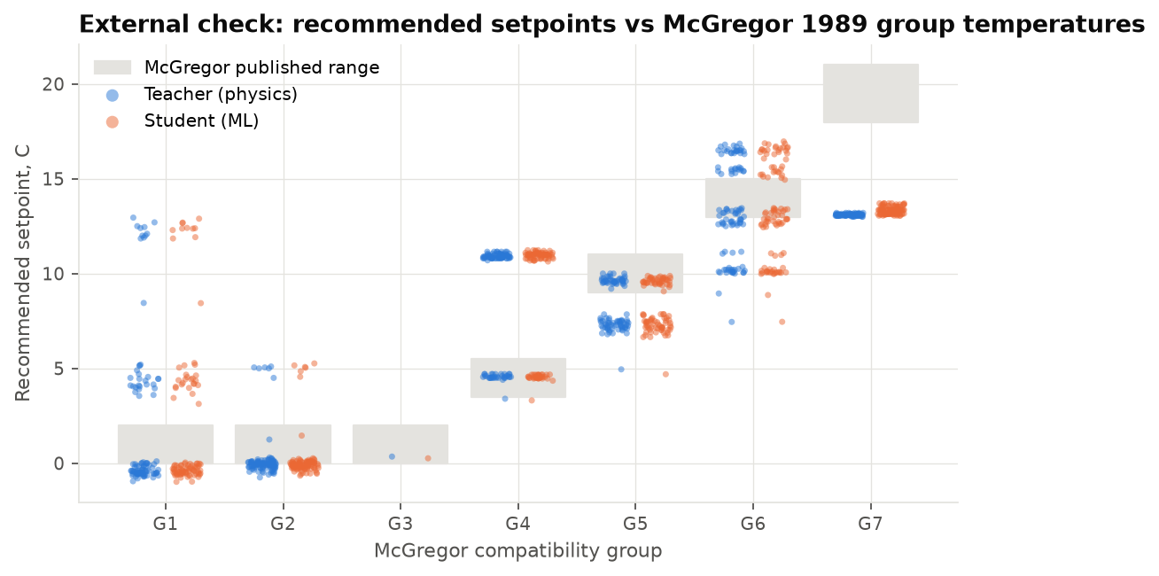
Figure 10 – External check: recommended setpoints vs McGregor 1989 group temperatures (grey bands).
Other checks:
- Single products: the teacher's optimum lies within 0.5 °C of the product's own published range for 89.9% of the 149 non-pharma products.
- Sensitivity, over 300 test loads (mean absolute shift of the optimum):
  - κ_f from 1.0 to 0.3 or 3.0: 0.03–0.04 °C;
  - κ_chill from 0.05 to 0.02 or 0.1: 0.09–0.15 °C;
  - produce Q10 ± 20%: 0.06–0.09 °C;
  - supercooling allowance 0 or 1 °C: 0.07–0.15 °C.
So the recommendations are robust to the uncertain constants.

7.7 Worked examples (default σ = 0.31 °C)
Load | Teacher | Student | Near-optimal band | Expected loss (%/day)
Apples + pears + grapes | −0.70 °C | −0.50 °C | −1.15 to 0.65 | 1.7
Lettuce + broccoli + spinach | 0.05 °C | 0.04 °C | −0.05 to 1.30 | 7.7
Bananas + mangos + avocados (ripe) | 13.25 °C | 13.07 °C | 12.55 to 14.55 | 6.9
Cucumbers + sweet peppers + eggplant | 9.85 °C | 9.67 °C | 9.05 to 11.15 | 9.3
Milk + yogurt + hard cheese | 0.40 °C | 0.39 °C | −0.25 to 1.60 | 4.9
Raw chicken + raw beef | −0.75 °C | −0.76 °C | −0.85 to 0.85 | 37.8 (1–2 day shelf life)
Vaccines + insulin | 5.00 °C | 4.95 °C | 2.65 to 7.35 | 0.0
Frozen vegetables + ice cream | −24.60 °C | −24.59 °C | −25.05 to −22.60 | 0.3

8. Where the models are used in FROSTMIND
Models 4 and 5 are part of the normal workflow, not a side tool:
- The driver's phone app plans the load with them.
- The backend refuses unsafe mixes and stores the recommended setpoint on the shipment.
- Every later reading is checked against that setpoint.
- Shelf life is tracked per product.
- The AI explanations reach both the phone and the admin panel.

8.1 End-to-end flow (a real run)
Step | Where | What the AI does
1 | Phone app, setup step 3, "What are you shipping?" | The driver adds products and kilograms (search or presets). Check load (AI) calls the Load Planner.
2 | POST /planner/plan | Model 5 scores every pair (with reasons), DSatur groups compatible products into compartments, and Model 4 gives each compartment's setpoint.
3 | Phone app | Shows the compartments, setpoints and why items were separated. The driver taps Create shipment for the compartment this truck carries.
4 | POST /shipments with products | The server checks the mix again: an incompatible mix gets a 422 listing its groups and clashes. It stores the products, Model 4's setpoint, the near-optimal band and the method. The phone sends the nearest device preset to the ESP over BLE set_category.
5 | POST /ingest, every batch | Model 3 shelf life is computed per product, and the most perishable product drives the shipment-level number and its alerts. A reading more than 3 °C from Model 4's setpoint is flagged. Each new incident gets a local LLM explanation, newest first.
6 | Phone dashboard, GET /shipments/{id}/live (device-key auth) | The AI panel shows the recommended setpoint against the actual temperature, shelf life per product, the latest alerts with the LLM's assessment and "Do:" action, and which models are live.
7 | Admin panel | Shipment page: "Mixed load · AI plan" panel. Alerts page: AI analysis. AI Models page: live status and scores of every component, plus a one-click LLM test.

Verified on the running system (end-to-end script, local Ollama model gemma-4-E4B-it):
- The planner split apples, pears, lettuce and bananas into 3 compartments.
- An apples + bananas shipment was rejected (422) with reasons.
- An apples + pears shipment was created at −0.9 °C (method: AI).
- Warm readings were flagged against the setpoint, with per-product shelf life live.
- The AI explanation arrived 7 s after the alert: "…an excursion to 8.5C, substantially above the required −0.9C for fresh produce… potentially accelerated by the reported 'door open'… Do: immediately inspect the cargo area…"

8.2 Backend endpoints
backend/app/load_planner.py loads both .pkl files at startup. If one is missing, it falls back to physics and rules; it never crashes.
Endpoint | Auth | Purpose
GET /products | public | The 155-product catalog
POST /planner/plan | public (pure calculation; the phone has no admin login) | Compartments, setpoints and pairwise compatibility with reasons
POST /shipments with products | open, like the rest of the setup wizard | Mixed-load shipment. Model 5 check (422 if the mix is unsafe), Model 4 setpoint stored
GET /shipments/{id}/live | X-Device-Key of that truck's ESP | Phone AI feed: shipment, per-product shelf life, setpoint, latest alerts with LLM text, AI status
GET /ai/status | public | Every AI component: status, measured scores (from models/*_metrics.json), where used, live usage counts
POST /ai/llm/test | admin JWT | Real round trip to the local LLM: reply, model and latency
GET /health | public | Adds model4_status, model5_status and llm_status

LLM robustness:
- The backend asks Ollama which models are installed. It uses the configured model if present, otherwise the smallest installed instruction model.
- Any failure falls back to "no explanation" and never blocks.
- Only the newest alert of each type in a batch is explained, so a backlog doesn't queue minutes of LLM work.
Example POST /planner/plan response (abridged, live run):
sigma_c 0.306 (default, real milk-transport data) model4_active true model5_active true
Compartment 1 lettuce 0.13 C method=ml -> ESP preset seafood_fresh_chilled (0 C)
Compartment 2 bananas_ripe 13.51 C method=ml -> no ESP preset near 13.5 C, set the reefer manually
Compartment 3 apples+pears -0.90 C method=ml -> ESP preset seafood_fresh_chilled (0 C)
bananas + lettuce p=0.00 keep apart "Ethylene: Bananas, ripe produces ethylene (medium) and Lettuce is sensitive."
apples + bananas p=0.02 keep apart "Temperature: Apples is stored at -1.1-4.4 C but Bananas, ripe needs 13.3-15.6 C (no overlap)."

8.3 Phone app
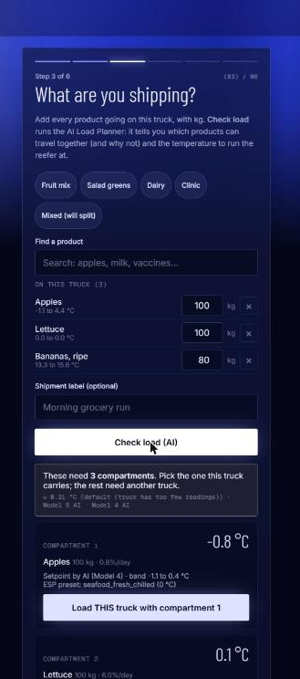
Figure 11 – Phone app, setup step 3: products added, AI load check splits them into compartments with setpoints.
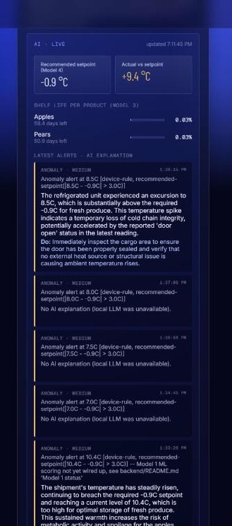
Figure 12 – Phone dashboard AI panel: Model 4 setpoint vs actual, per-product shelf life (Model 3), and the latest alert with the local LLM's assessment and recommended action.

8.4 Admin panel
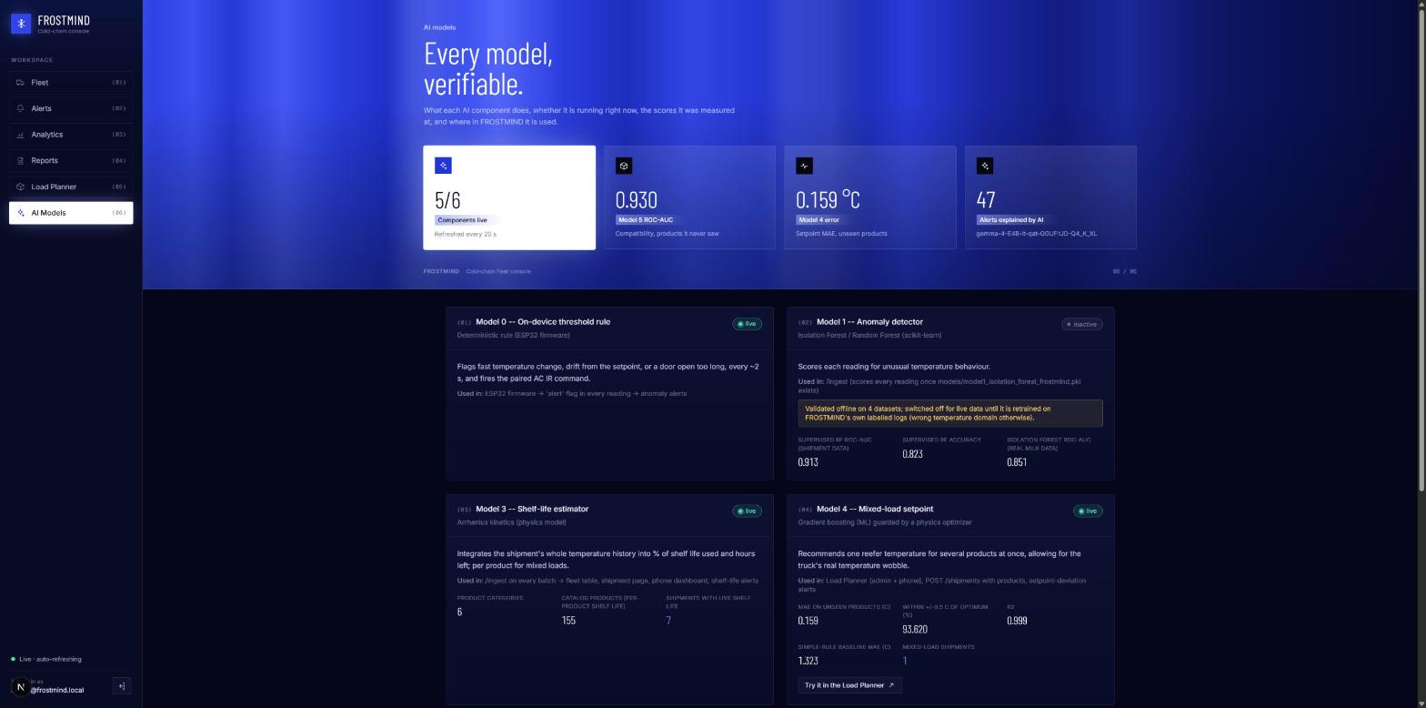
Figure 13 – AI Models page: every component's live status, measured scores, where it is used and live usage; the LLM card has a one-click test.
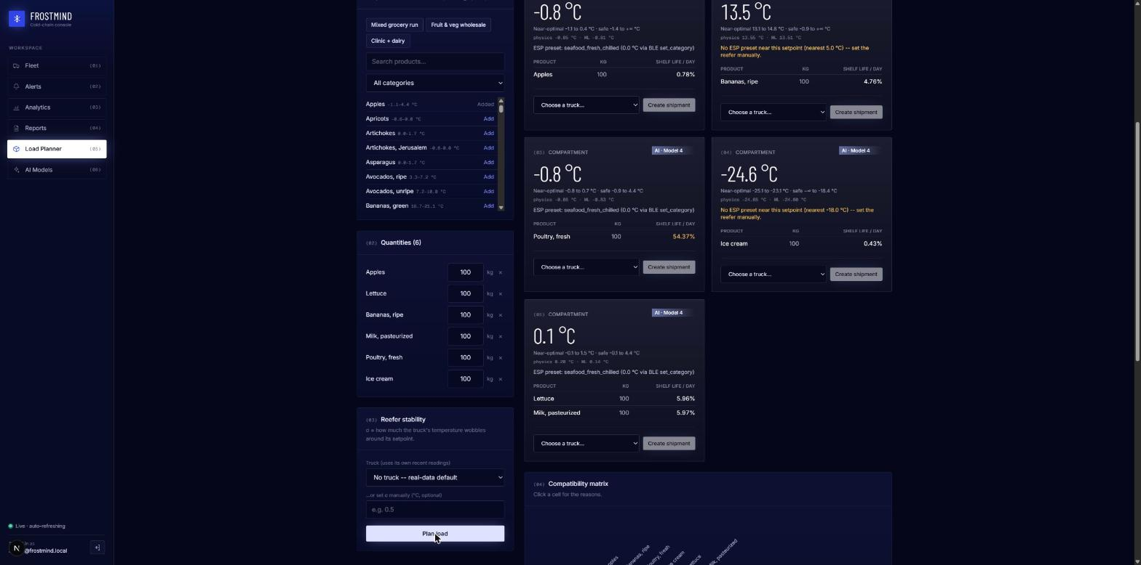
Figure 14 – Load Planner (admin): compartments with setpoints and a "Create shipment" control per compartment.
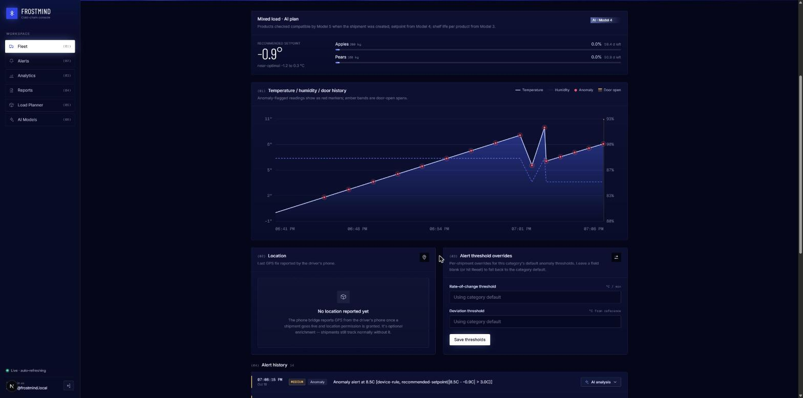
Figure 15 – Shipment page for a mixed load: Model 4 setpoint and Model 3 shelf life per product, above the live temperature chart with flagged readings.
The full data flow is the architecture diagram in Section 4 (docs/figures/model4_5/architecture.png).

8.5 Tests
72 backend tests pass: 34 original tests plus 38 new ones.
- test_products.py:
  - physics sanity targets;
  - FDA chance constraint;
  - Q10 taken from Model 3;
  - pair-feature symmetry;
  - label-leakage guard;
  - DSatur;
  - shift-invariance of the student model.
- test_planner.py:
  - grouping;
  - vetoes;
  - safe ranges;
  - device-preset warning;
  - σ fallback;
  - no-.pkl fallback.
- test_mixed_load.py:
  - a compatible mix becomes one shipment, and an incompatible mix gets a 422 with reasons;
  - per-product shelf life and setpoint-drift alerts via /ingest;
  - /live requires the truck's own device key;
  - classic single-category shipments still work;
  - /ai/status lists every component;
  - the LLM test needs admin and reports failure honestly.
The web app passes ESLint, TypeScript checking and next build. The phone app's JavaScript passes node --check.

9. Limitations and honest caveats
- Model 4's labels come from our physics model, not from measured delivery quality. The student reproduces the teacher; it cannot be better than the teacher's assumptions (κ values, Q10, the chance-constraint level). The sensitivity analysis shows the setpoints are robust to these, and the external McGregor check shows where published sources disagree.
- Model 5's ML only covers produce, because that is where expert labels exist. Pairs involving dairy, meat, seafood, frozen or pharma get a probability marked extrapolated, but the decision for them rests on the cited regulations and the physics feasibility check.
- Source conflicts are real. HB66 and McGregor disagree for several warm crops (potatoes, lemons, beans, sweet potato). We keep both and report the conflict instead of choosing silently.
- Some values are imputed (39 freezing points, 33 shelf lives, 15 ethylene classes). All are flagged in imputed_fields. The non-produce freezing points are category-level assumptions.
- σ comes from milk transport, not from FROSTMIND's own trucks. The planner switches to a truck's own σ once it has at least 30 readings.
- The device supports only six category setpoints. The planner warns when a recommendation cannot be applied by the ESP32; arbitrary setpoints would need a firmware change.
- The LLM runs locally (Ollama), so an explanation takes about 5–20 s and only the newest alert of each incident is explained; if Ollama is not running, alerts simply have no explanation (the AI Models page shows this).
- Not certified. This is a university prototype. Pharmaceutical shipments must follow the product's labelled storage conditions.

10. How to reproduce
.venv\Scripts\python.exe scripts\fetch_product_data.py
.venv\Scripts\python.exe scripts\build_product_catalog.py
.venv\Scripts\python.exe scripts\estimate_reefer_fluctuation.py
.venv\Scripts\python.exe scripts\train_model5_compatibility.py
.venv\Scripts\python.exe scripts\train_model4_mixed_setpoint.py
cd backend ; ..\.venv\Scripts\python.exe -m pytest ; cd ..
.venv\Scripts\python.exe start_frostmind.py # backend + phone app + admin panel, any machine/network

start_frostmind.py prints the addresses to open:
- Phone: https://<this-machine's-IP>:5500 (accept the certificate once at :8000/health and at :5500).
- Admin panel: http://localhost:3000, or http://<IP>:3000 from another device.
No IP address is hard-coded anywhere.
scripts/train_all.py runs the whole pipeline together with the earlier models. All random seeds are fixed at 42, and a full rerun reproduced every number in this document.
Files delivered:
- Data: data/product_catalog/ (raw snapshots, cleaned catalog, cleaning report, σ, training pairs and loads).
- Code:
  - scripts/common/products.py;
  - scripts/fetch_product_data.py;
  - scripts/build_product_catalog.py;
  - scripts/estimate_reefer_fluctuation.py;
  - scripts/train_model5_compatibility.py;
  - scripts/train_model4_mixed_setpoint.py;
  - backend/app/load_planner.py;
  - backend/app/routers/planner.py;
  - backend/app/routers/ai.py;
  - phone-bridge/js/wizard.js (step 3) and phone-bridge/js/dashboard.js (AI panel);
  - web/src/app/planner/page.tsx;
  - web/src/app/ai/page.tsx;
  - start_frostmind.py.
- Models: models/model5_compatibility.pkl and models/model4_mixed_setpoint.pkl, each with a _metrics.json file.
- Figures: docs/figures/model4_5/.

11. References
- Hardenburg, R.E., Watada, A.E., Wang, C.Y. (1986). The Commercial Storage of Fruits, Vegetables, and Florist and Nursery Stocks. USDA-ARS Agriculture Handbook 66 (as reproduced in University of Maine Cooperative Extension Bulletin 4135).
- McGregor, B.M. (1989). Tropical Products Transport Handbook. USDA Office of Transportation, Agricultural Handbook 668 (as reproduced in FAO, Small-Scale Postharvest Handling Practices, ch. 7).
- The Engineering ToolBox (2004). Fruits and Vegetables – Optimal Storage Conditions.
- Virginia Cooperative Extension (2019). Food Storage Guidelines for Consumers, pub. 348-960.
- U.S. FDA (2022). Food Code, §3-501.16 (cold holding), §3-202.11 (shell eggs), §3-302.11 (separation of raw animal foods).
- U.S. CDC. Vaccine Storage and Handling Toolkit.
- United States Pharmacopeia. General Chapter ⟨659⟩ Packaging and Storage Requirements.
- WHO Technical Report Series 961, Annex 9, Model guidance for the storage and transport of time- and temperature-sensitive pharmaceutical products; EU Guidelines on Good Distribution Practice of medicinal products for human use (2013/C 343/01).
- Brélaz, D. (1979). New methods to color the vertices of a graph. Communications of the ACM 22(4).
- Kaggle. Data Sets Cold Chain Milk (92 real transport sessions), already used by FROSTMIND Model 1.

