Ranking, Not Predicting: An Equal-Weight Ensemble for 21-Day Stock Selection on the NSE
Uzair Manjre ¹*, Pal Gandhi ², Malav Thakor ³ and Shlok Barot ⁴
Affiliation: ¹⁻⁴ Department of Computer Science and Engineering, School of Engineering and Technology, Navrachana University, Vadodara, Gujarat, India; uzair.s.manjre@nuv.ac.in, pal.v.gandhi@nuv.ac.in, malav.a.thakor@nuv.ac.in, shlok.m.barot@nuv.ac.in
* Correspondence: uzair.s.manjre@nuv.ac.in

Abstract
Background: Predicting whether an individual stock will rise or fall is close to a coin toss. On 209 NSE-listed stocks over August 2020 to October 2026, a LightGBM model called the direction of 21-day excess returns correctly only 52.3% of the time. This paper asks whether reframing the task as cross-sectional ranking (selecting each day the 20 stocks most likely to outperform over the next 21 sessions) yields a measurable and honest edge.
Methods: We engineer 33 stock-level features, compare ten model variants and evaluate them with an embargoed, expanding-window walk-forward protocol whose test period (March 2025 to September 2026) was never used for training or tuning. The final model is an equal-weight blend of four weak, partly independent signals: 12-1 month momentum, a LightGBM rank regression, a LightGBM median forecast and per-stock history.
Results: The blend's top 20 beat the average stock on 65.0% of test days, against 59.9% for momentum alone and 49–51% for blends with fitted weights. On the 48% of days with above-median member agreement, the top 20 beat the NIFTY 50 on 73.8% of days, against 67.9% otherwise. LightGBM's 10th–90th percentile bands covered 80–83% of outcomes against a nominal 80%. Optuna tuning overfit (validation IC 0.059, test IC 0.009), and a Temporal Fusion Transformer, LambdaRank and filing sentiment added no reliable signal.
Conclusions: Ranking with an equal-weight ensemble gives a modest, consistent edge where direction forecasting fails. With only about 18 independent test months, the evidence supports a ranking edge, not a proven trading strategy.
Keywords: Stock Selection; Cross-Sectional Ranking; Ensemble Learning; LightGBM; Walk-Forward Validation; Quantile Regression; Momentum; NSE India

1. Introduction

1.1 Motivation
Machine learning for stock prediction is popular and often over-claimed. Many studies report high accuracy from deep networks trained on price series, usually measured as error on the price level [1, 2]. Such figures flatter models, because tomorrow's price is close to today's, and shuffled splits or test-set tuning inflate them further. Asked a decision-relevant question (will this stock beat the market?) under a strict time-ordered test, accuracy falls towards 50%. This project met exactly that limit: a LightGBM model with 37 inputs called the direction of 21-day excess returns correctly 52.3% of the time. Rather than chase a higher number through leakage, we changed the question.

1.2 Problem Statement and Research Questions
At the close of each trading day t, using only information available at t, rank 209 NSE stocks by their expected 21-session log return in excess of the NIFTY 50, and hold the top 20. We ask four questions:
- RQ1: Can machine learning predict the direction of individual excess returns meaningfully better than 50%?
- RQ2: Does cross-sectional ranking, with several weak models combined, beat the best single signal (12-1 month momentum)?
- RQ3: Can the system identify in advance the days on which its picks are more reliable?
- RQ4: Do a Temporal Fusion Transformer, learning-to-rank, hyperparameter tuning and filing sentiment add reliable value?

1.3 Contributions
- An end-to-end system for Indian equities: scrapers, a PostgreSQL store, a feature pipeline, ten model variants, a Streamlit dashboard and scheduled live tracking.
- A leakage-resistant protocol: embargoed walk-forward windows, IC t-statistics on non-overlapping periods, block-bootstrap intervals and an acceptance gate fixed before testing.
- Evidence of the forecast-combination puzzle in Indian stock selection, and an agreement-based confidence flag defined before it was measured.
- Documented negative results for tuning, deep learning, learning-to-rank and sentiment.
Section 2 reviews the literature, Sections 3–5 describe the data, methods and protocol, Section 6 reports and analyses the results, and Sections 7–9 cover live tracking, limitations and conclusions.

2. Literature Survey
Five decades of research agree on three points: individual returns are hard to forecast, a few cross-sectional patterns such as momentum persist, and most published gains shrink under honest out-of-sample testing. Figure 1 maps the studies reviewed in this section by theme and period.
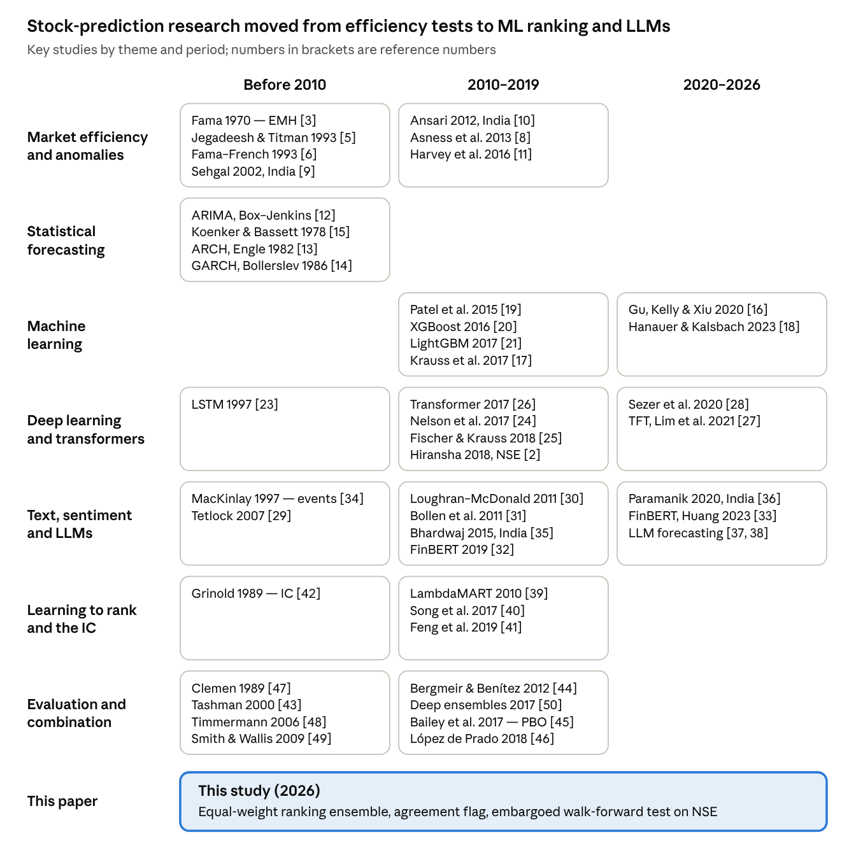
Figure 1 • Research map of the studies reviewed, by theme (rows) and period (columns); bracketed numbers are reference numbers.
Figure 1 shows two shifts. After 2010, econometric forecasting of single series gave way to machine learning on large panels of stocks, and since 2019 text models have moved from word lists to transformers and large language models. Indian evidence appears in most strands but is concentrated in momentum tests and price-level forecasting, which leaves cross-sectional ranking of NSE stocks largely unexplored.

2.1 Market Efficiency and Anomalies
The efficient-market hypothesis holds that prices reflect available information [3], yet Lo and MacKinlay rejected the random walk for weekly US returns, mainly because of small stocks [4]. Jegadeesh and Titman found that buying 3–12-month winners and selling losers earned significant profits [5]. Fama and French captured common return variation with market, size and value factors [6], Carhart's added momentum factor explained most apparent persistence in mutual-fund performance [7], and Asness et al. found value and momentum premia in eight markets and asset classes [8]. In India, Sehgal and Balakrishnan reported significant short-term momentum payoffs [9], and Ansari and Khan found momentum profits over 1995–2006 that neither the CAPM nor the three-factor model explains [10]. Harvey et al. argue that after hundreds of factor tests, a new factor needs a t-statistic above 3 [11]. Momentum is therefore the natural benchmark for a stock-ranking model.

2.2 Statistical Forecasting
ARIMA models capture autocorrelation in a single series [12], while ARCH [13] and GARCH [14] model time-varying volatility; they forecast risk far better than direction. Quantile regression estimates conditional quantiles by minimising an asymmetric absolute loss [15] and underlies the forecast bands used in this study.

2.3 Machine Learning
Gu et al. showed on US equities that trees and neural networks beat linear models by capturing nonlinear interactions, with momentum, liquidity and volatility the strongest predictors [16]. Krauss et al. found that an equal-weight ensemble of deep networks, boosted trees and random forests earned over 0.45% a day before costs on S&P 500 constituents from 1992 to 2015, although profits declined over time [17]. Hanauer and Kalsbach confirmed the advantage of nonlinear models out of sample in emerging markets, after costs [18]. For India, Patel et al. compared ANN, SVM, random forest and naive Bayes models on two stocks and the Nifty and Sensex indices, and showed that trend-encoded inputs improve direction accuracy [19]. XGBoost [20] and LightGBM [21] made boosting practical on large panels, and Optuna automated hyperparameter search [22].

2.4 Deep Learning and Transformers
Long short-term memory (LSTM) networks [23] dominate deep-learning work on prices. Nelson et al. reached up to 55.9% accuracy in predicting upward moves [24], and Fischer and Krauss found that LSTMs beat random forests and logistic regression on S&P 500 stocks, although the excess returns vanished after 2010 [25]. On NSE data, Selvin et al. compared LSTM, RNN and CNN models [1], and Hiransha et al. found CNNs best for NSE and NYSE closing prices [2]; both forecast price levels. The transformer replaced recurrence with attention [26], and the Temporal Fusion Transformer (TFT) added variable selection and interpretable attention for multi-horizon forecasting [27]. A review of 2005–2019 studies found that deep models often beat classical machine learning [28], but evaluation by price error rather than out-of-sample ranking after costs remains common.

2.5 Text, Sentiment and Events
Tetlock showed that pessimistic media content predicts falling prices followed by reversion [29]. Loughran and McDonald found that about three-quarters of the words in a general negative-word list are not negative in finance [30]. Bollen et al. linked Twitter mood dimensions to better Dow Jones predictions [31], and FinBERT adapted BERT to financial sentiment [32, 33]. Event studies measure price reactions around announcements [34]. Indian work includes sentiment-based Sensex and Nifty forecasting [35] and evidence that negative news drives volatility more than positive news [36]. Most recently, GPT-4 sentiment scores on headlines published after the model's training cutoff predicted subsequent price drift [37], and large-language-model embeddings of news in 16 markets beat technical signals [38].

2.6 Learning to Rank and the Information Coefficient
Learning-to-rank methods optimise the order of items rather than their values; LambdaMART won the 2010 Yahoo! Learning to Rank Challenge [39]. Song et al. built long–short portfolios with ListNet and RankNet that beat the S&P 500 on a risk-adjusted basis [40], and Feng et al. trained deep models directly for stock ranking using firm relations [41]. Grinold's fundamental law, IR ≈ IC × √breadth, explains why ranking suits stock selection [42]: a small information coefficient (IC), applied to many stocks every day, can still produce a useful information ratio (IR).

2.7 Validation, Overfitting and Forecast Combination
Tashman favoured rolling-origin evaluation over a single holdout [43], and Bergmeir and Benítez studied blocked cross-validation for time series [44]. Bailey et al. showed that a holdout cannot reveal how far a backtest is overfit and proposed estimating the probability of backtest overfitting [45]; López de Prado recommends purging and embargoing overlapping labels [46]. Forecast-combination research finds that simple averages often match or beat estimated optimal weights [47, 48], a puzzle Smith and Wallis attribute to the error in estimating the weights [49]. Disagreement among ensemble members also measures predictive uncertainty [50], which motivates our confidence flag.

2.8 Comparison and Research Gap
Table 1 compares representative studies with this one.
Table 1 • Comparison of Representative Studies
Study | Market and data | Method | Key finding
Jegadeesh & Titman [5] | US stocks | Winner-minus-loser portfolios | 3–12-month winners beat losers
Ansari & Khan [10] | Indian stocks, 1995–2006 | Momentum portfolios; factor tests | Momentum profits unexplained by risk factors
Patel et al. [19] | Two stocks, Nifty, Sensex, 2003–2012 | ANN, SVM, RF, naive Bayes | Trend-encoded inputs raise direction accuracy
Krauss et al. [17] | S&P 500, 1992–2015 | DNN, boosted trees, RF, ensemble | Ensemble earns over 0.45% a day before costs
Song et al. [40] | Stocks with news, 2006–2014 | ListNet, RankNet | Ranked portfolios beat the S&P 500
Fischer & Krauss [25] | S&P 500, 1992–2015 | LSTM vs RF, DNN, logit | LSTM best; edge gone after 2010
Hiransha et al. [2] | NSE and NYSE closes | MLP, RNN, LSTM, CNN | CNN lowest price error
Gu et al. [16] | US equities | Linear, trees, neural nets | Nonlinear models win
Hanauer & Kalsbach [18] | Emerging markets | Linear vs nonlinear ML | ML wins after costs
Lopez-Lira & Tang [37] | Post-cutoff headlines | GPT-4 sentiment | Scores predict later drift
This study | 209 NSE stocks, 2020–2026 | Equal-weight ranking blend, agreement flag | Top 20 beat average stock on 65% of days
Five gaps remain. Indian studies mostly forecast index or price levels instead of ranking a broad NSE universe by excess return; few use embargoed walk-forward tests with non-overlapping t-statistics and a pre-set acceptance gate; the forecast-combination puzzle is rarely tested in Indian stock selection; ensemble disagreement is rarely used as a day-level confidence flag; and negative results are seldom reported. This study addresses all five.

3. Data and Problem Formulation
The study uses daily data on 209 large- and mid-cap NSE stocks from August 2020 to October 2026 (Table 2).
Table 2 • Datasets Used in This Study
Dataset | Source | Coverage | Size
Daily prices and volume (OHLCV, adjusted close) | Yahoo Finance via yfinance | 209 stocks, 31 Aug 2020 – 30 Oct 2026 | 310,540 stock-days; 1,526 sessions
NIFTY 50 index | Yahoo Finance | Same period | 1 daily series
Corporate announcements | NSE filings (metadata and summaries) | 208 stocks, Sep 2020 – Oct 2026 | 169,343 filings
Filing-PDF sentiment | FinBERT and VADER scores | Stocks with filings | Non-zero on 14% of stock-days
Sector labels | Yahoo Finance profiles | All stocks | 11 sectors
Financial Services is the largest sector (25% of stock-days). Raw data are stored in PostgreSQL and joined by a feature builder into one 70-column Parquet table.

3.1 Cleaning
Free price data contain errors that create fake returns. A repair script deletes single-day prints that jump more than 50% and then revert, removes zero-volume placeholder rows on holidays, and back-adjusts unadjusted corporate actions such as demergers. Any remaining one-day move above 20% is reviewed manually.

3.2 Prediction Target
For stock i, day t and horizon h sessions, the target is the log return in excess of the NIFTY 50:

where P is the adjusted close and I the NIFTY 50 level. Excess return removes the market's common movement, so a model must say something about individual stocks. The main horizon is h = 21 sessions (about one month); over the sample its mean is +0.80%, its standard deviation 9.1%, and 51.8% of its values are positive.

3.3 Look-Ahead and Survivorship Bias
Every feature for day t uses data available at its close. Filing sentiment is delayed by one session because filing timestamps are unreliable, and an embargo separates training targets from test windows (Section 5). The universe consists of stocks listed today, so firms delisted during 2020–2026 are missing. This survivorship bias flatters momentum and the universe's return against the index.

4. Methodology
The final system scores every stock each evening with four simple, partly independent models, converts each score to a within-day rank, averages the ranks and holds the top 20.

4.1 System Architecture
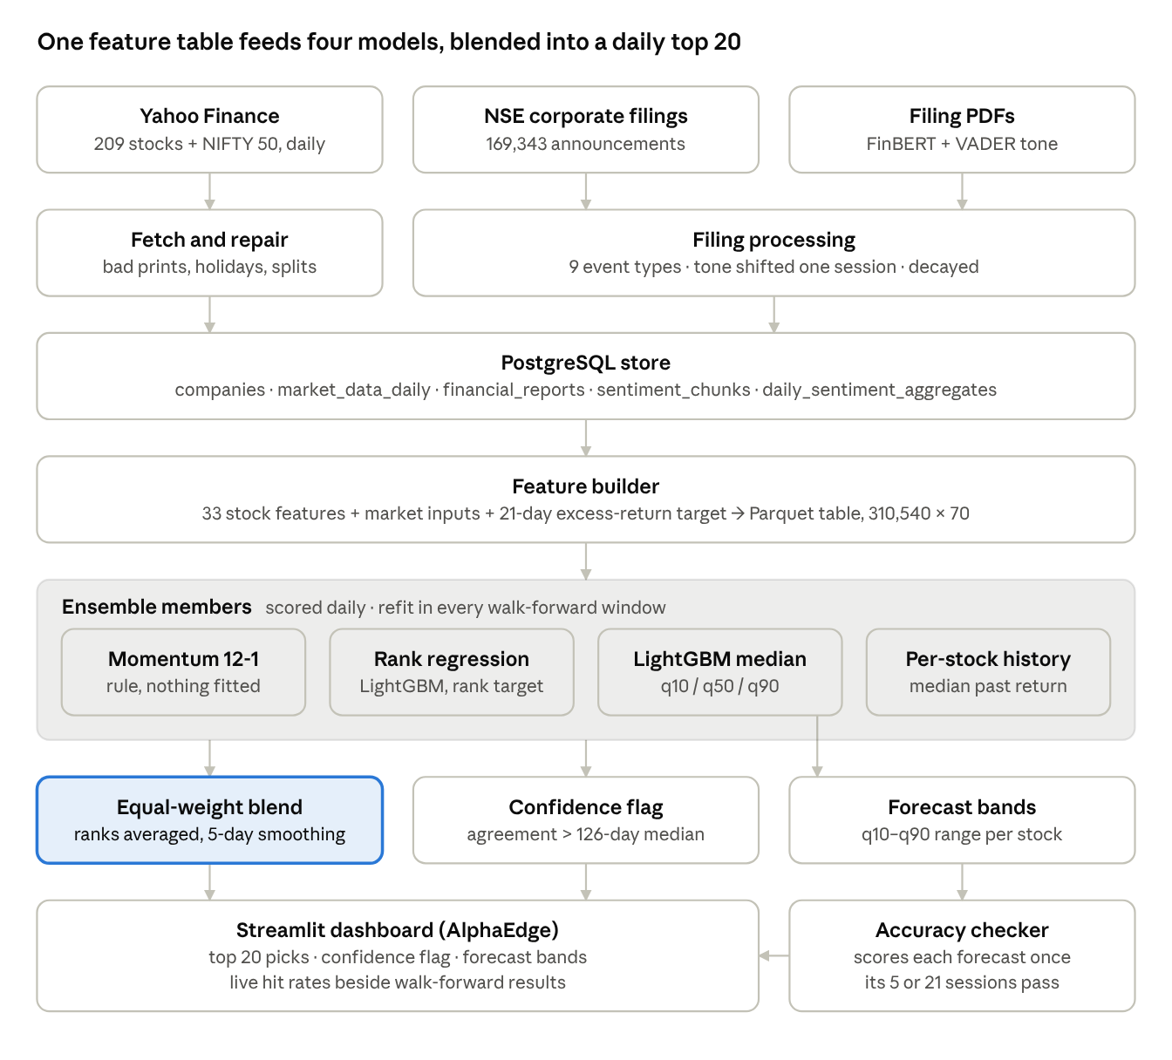
Figure 2 • System architecture of the AlphaEdge pipeline, run each weekday at 18:30 IST.
Figure 2 shows seven layers. Data flow one way, from sources through repair and storage to a single feature table, so every model sees identical, time-aligned inputs. The four ensemble members are scored from that table, and their outputs feed the blend, the confidence flag and the forecast bands. The accuracy checker closes the loop by scoring each forecast once its horizon has passed, and the walk-forward harness reuses the same table offline.

4.2 Feature Engineering
We compute 33 stock-level features in six groups on split- and dividend-adjusted prices (Table 3).
Table 3 • Stock-Level Features
Group | Features | No.
Returns and momentum | Log returns over 1, 3, 5, 10, 21 and 126 days; 10-day momentum; 12-1 month momentum | 8
Trend and oscillators | RSI-14; stochastic RSI; MACD line, signal and histogram; price vs 50-day mean; price vs 52-week high; RSI divergence | 8
Volatility and risk | 20- and 60-day volatility; ATR-14; Bollinger width; volatility regime; 60-day beta | 6
Volume and liquidity | Volume spike; normalised OBV; normalised PVT; Amihud illiquidity; size proxy | 5
Sector context | Sector-relative return; sector volatility | 2
Filing sentiment | Decayed net, bullish and bearish tone; 7-day filing count | 4
12-1 month momentum skips the most recent month to avoid short-term reversal:

Filing sentiment decays with a half-life of 1.5 sessions for the most liquid fifth of stocks, 6 sessions for the least liquid fifth and 4 otherwise. The quantile model also receives market inputs, raw price and volume, and eight categorical fields (37 inputs in all). The ranking models instead use each feature's within-day percentile rank and exclude the ticker and price levels, so they cannot memorise a stock's average return.

4.3 Models
Table 4 lists the ten model variants compared.
Table 4 • Models Compared
Model | Type | What it learns or computes | In final blend
Predict zero | Baseline | Zero excess return | No
Per-stock history | Baseline | Each stock's historical median excess return | Yes
Momentum 12-1 | Rule | Rank by 12-1 month momentum | Yes
Reversal 1-month | Rule | Rank by minus the last 21-day return | No
Factor composite | Rule | Mean rank of momentum, low volatility, nearness to 52-week high | No
LightGBM quantile | Boosted trees | 10th, 50th and 90th percentiles of excess return | Yes (median)
Rank regression | Boosted trees | Within-day percentile rank of future return | Yes
LambdaRank | Learning to rank | Within-day order (NDCG@20) | No
Temporal Fusion Transformer | Attention network | 5-day excess return from a 21-day window | No
CatBoost | Boosted trees | Rank target (tuning only) | No
The LightGBM [21] quantile models minimise the pinball loss for quantile τ:
They use 63 leaves, a learning rate of 0.05 and early stopping, and their outputs are sorted so that q10 ≤ q50 ≤ q90. The rank regression is deliberately coarse (31 leaves, at least 200 rows per leaf). The TFT [27] was sized for a 6 GB GPU (hidden size 32, two attention heads).

4.4 The Ensemble
Each member's score is converted to a within-day percentile rank (a missing score is set to 0.5), the ranks are averaged with equal weights, and the average is smoothed over each stock's last five sessions to reduce turnover:

The 20 stocks with the highest S are the picks. We also tested IC-weighted and ridge-stacked blends, fitted only on earlier windows.

4.5 The Confidence Flag
Agreement is the mean Spearman correlation over the six pairs of member rankings:

A day is high-confidence when Aₜ exceeds the median of the previous 126 days (at least 21 required). The rule was fixed before its effect on hit rates was measured, in the spirit of using ensemble disagreement as an uncertainty signal [50].

5. Experimental Setup

5.1 Walk-Forward Validation
Random k-fold cross-validation leaks future information because neighbouring days share most of a 21-day target window [44, 46]. We therefore use six expanding walk-forward windows (Figure 3). Each has a training block from 31 August 2020, an embargo of h sessions, a 42-session early-stopping slice, a second embargo and a 63-session test block, and every model is refit in every window.
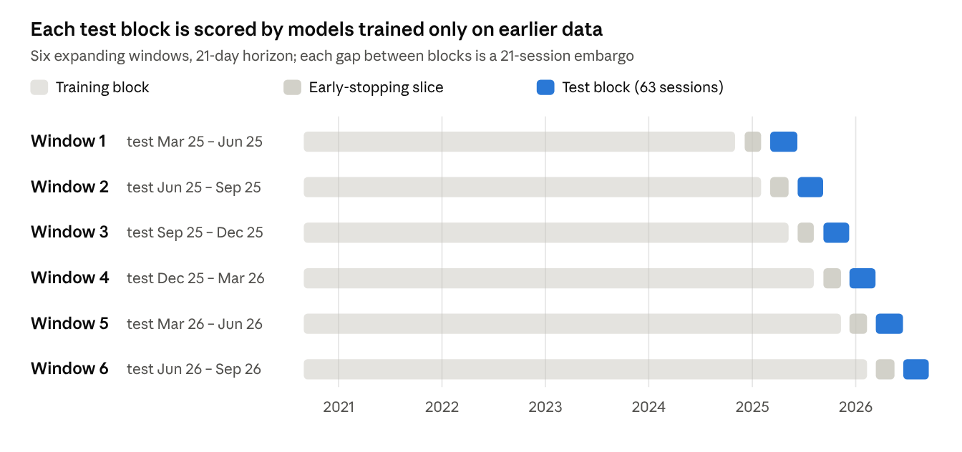
Figure 3 • Walk-forward scheme for the 21-day horizon, drawn to scale (source: results/horizon_21d/windows.csv).
Figure 3 makes two properties visible. The test blocks tile 5 March 2025 to 16 September 2026 without overlap, giving 377 test days and about 18 independent 21-day periods, while training sets grow from 207,924 to 273,548 stock-days. The gaps around each early-stopping slice are the embargoes that stop any training target from overlapping a later block.

5.2 Tuning Protocol and Pre-Set Gate
Optuna [22] (tree-structured Parzen estimator, median pruning, 100 trials) tuned the rank regression on 126-session folds ending h sessions before the test, maximising mean fold IC minus half its spread. Run 1 used four folds (January 2023 to February 2025) plus a small CatBoost grid. Run 2 used five folds from July 2022, a full-spread penalty and the average of the ten best settings, and fixed a gate before any test scoring: a tuned model joins the blend only if its fold score beats the untuned rank regression's.

5.3 Evaluation Metrics
Table 5 defines the metrics.
Table 5 • Evaluation Metrics
Metric | Definition
Direction accuracy | Share of stock-days on which the median forecast and the outcome have the same sign
MAE; pinball loss | Absolute error of the median; mean pinball loss over q10, q50 and q90
q10–q90 coverage | Share of outcomes inside the forecast band (nominal 80%)
Rank IC | Daily Spearman correlation between scores and realised excess returns
IC t-statistic | Mean IC over its standard error, using one day every h sessions
Hit rate vs NIFTY | Share of days on which the top 20's mean excess return is positive
Hit rate vs average | Share of days on which the top 20 beat the universe's mean return
Backtest | Top 20 bought every h sessions, equal weight, 0.18% round-trip cost
The IC and the hit rate are defined as

where T is the set of test days and Top20(t) the picks on day t. Neighbouring days share most of their window, so hit-rate intervals use a moving-block bootstrap with 21-session blocks and 5,000 resamples, reported at the 90% level.

5.4 Implementation
The system uses Python 3.10, pandas 2.3, LightGBM 4.6, CatBoost, Optuna 4.9, PyTorch 2.5 with PyTorch Forecasting 1.7, Hugging Face Transformers, PostgreSQL and Streamlit 1.58. Deep models were trained on an NVIDIA GTX 1660 SUPER (6 GB).

6. Results and Analysis
All results are from the walk-forward test unless stated otherwise. The equal-weighted universe beat the NIFTY 50 on 63.0% of test days, so beating the index is a low bar; the hit rate against the average stock, where chance is 50%, is the cleaner measure of skill.

6.1 RQ1: Direction Is Close to a Coin Toss
Table 6 • Forecast Quality on the Walk-Forward Test
Horizon | Model | MAE | Pinball loss | q10–q90 coverage | Direction accuracy
5 days | LightGBM quantile | 2.71% | 0.00887 | 83.1% | 49.9%
5 days | Per-stock history | 2.71% | 0.00900 | 85.5% | 51.5%
5 days | Predict zero | 2.70% | 0.00899 | — | —
10 days | LightGBM quantile | 3.89% | 0.01267 | 81.8% | 50.9%
10 days | Per-stock history | 3.90% | 0.01284 | 85.2% | 52.0%
10 days | Predict zero | 3.89% | 0.01282 | — | —
21 days | LightGBM quantile | 5.73% | 0.01854 | 80.4% | 52.3%
21 days | Per-stock history | 5.83% | 0.01899 | 84.9% | 51.6%
21 days | Predict zero | 5.76% | 0.01887 | — | —
Table 6 shows that LightGBM's direction accuracy was 49.9–52.3% and that its error matched predicting zero at every horizon. The model learned risk rather than direction: its pinball loss was 1–2% lower than the baselines', and its bands covered 80–83% of outcomes against a nominal 80%, while the historical bands over-covered (85%). RQ1 is answered in the negative.

6.2 RQ2: Momentum Is the Strongest Single Signal
Among single models, 12-1 month momentum had the highest 21-day rank IC (0.052) and the only t-statistic above 2 (Figure 4).
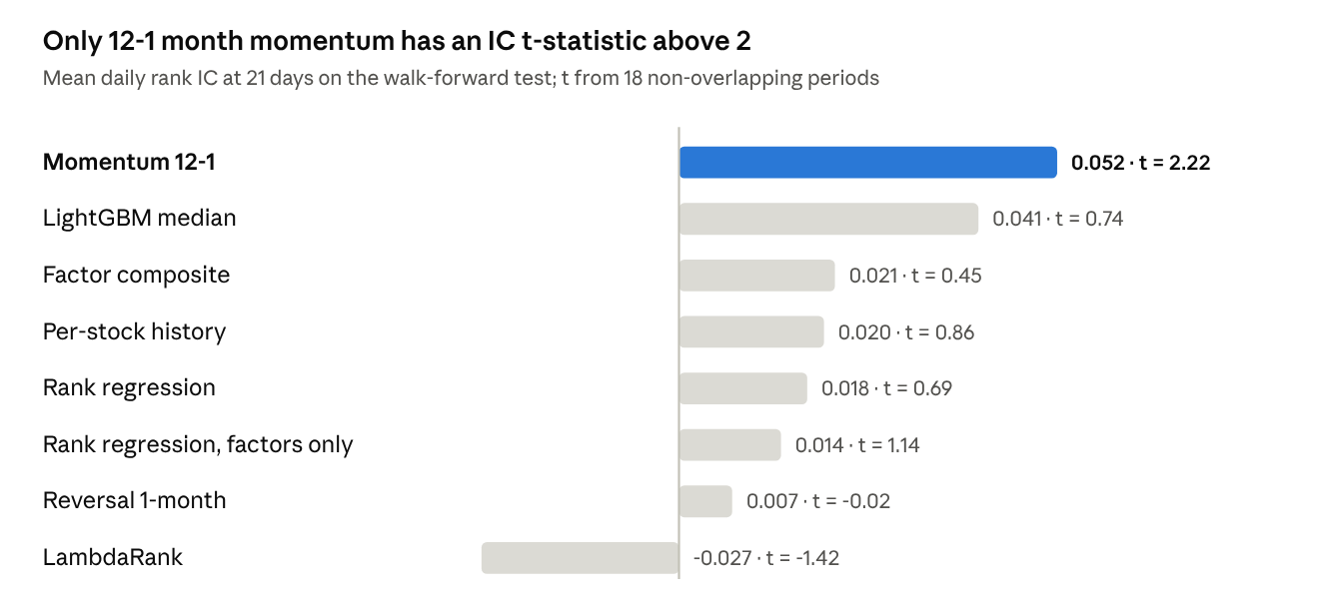
Figure 4 • Mean 21-day rank IC by model on the walk-forward test, with t-statistics (source: results/horizon_21d/metrics_summary.csv).
Figure 4 separates the signals into three tiers. Momentum stands alone with a reliable IC; LightGBM's IC of 0.041 is the second largest but unstable (t = 0.74); and the other learned rankers sit near 0.02 or below, with LambdaRank negative (−0.027). An IC of 0.05 looks small, but by the fundamental law a small IC applied to about 200 stocks every day can be valuable [42]. At the 5-day horizon, with 76 independent periods, per-stock history (t = 2.20) and momentum (t = 1.86) again led.

6.3 RQ2: An Equal-Weight Blend Beats Each Member
The smoothed four-member blend picked a top 20 that beat the average stock on 65.0% of test days, against 59.9% for momentum alone (Figure 5).
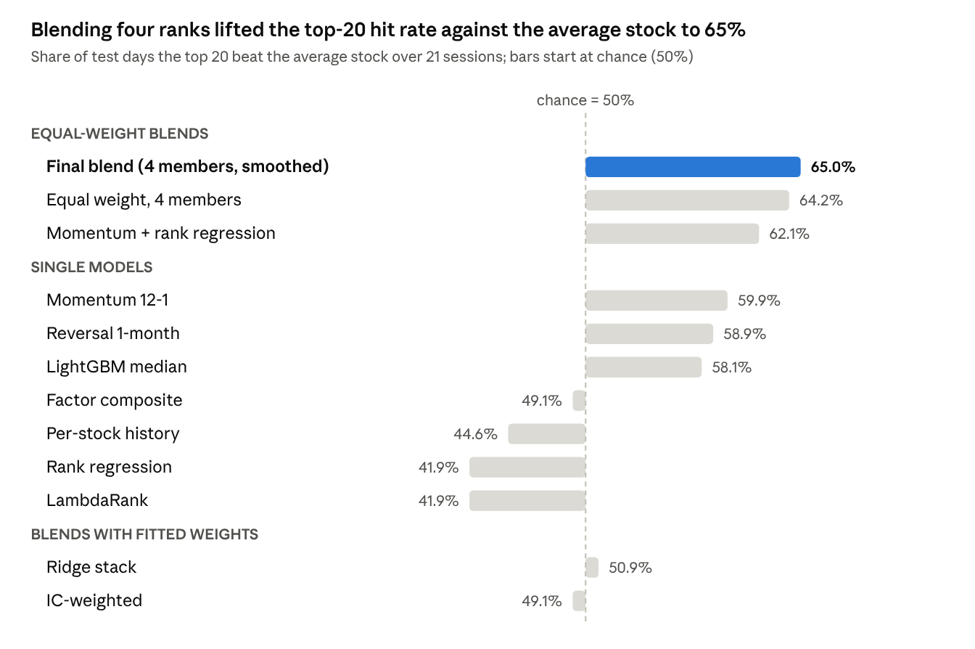
Figure 5 • Share of the 377 test days on which each model's top 20 beat the average stock; bars start at the 50% chance line (source: ensemble_summary.csv).
Figure 5 shows a clear ordering: equal-weight blends lead, single models follow, and blends with fitted weights fall to chance. The mechanism is diversification. Momentum's daily IC is negatively correlated with those of rank regression (−0.24), LightGBM (−0.15) and per-stock history (−0.27), so the members tend to fail on different days. Rank regression alone beat the average stock on only 41.9% of days, yet adding it to momentum raised the hit rate. Fitted weights chased recent winners: the IC-weighted scheme put 90% of its weight on rank regression just before that model's weak spell. This is the forecast-combination puzzle [48, 49].
Table 7 • Ranking Quality at the 21-Day Horizon
Model | Mean IC | IC t-stat | Days with IC > 0 | Top 20 beat NIFTY
Final blend (equal weight, smoothed) | 0.057 | 1.85 | 72.7% | 68.4%
Equal weight, not smoothed | 0.059 | 1.90 | 72.1% | 67.9%
Momentum + rank regression | 0.049 | 2.05 | 66.3% | 68.4%
Momentum 12-1 | 0.052 | 2.22 | 66.0% | 66.3%
LightGBM median | 0.041 | 0.74 | 65.8% | 67.4%
IC-weighted blend (fitted) | 0.025 | 0.81 | 58.9% | 58.4%
Ridge stack (fitted) | 0.026 | 0.84 | 59.2% | 58.6%
Reference: average stock | — | — | — | 63.0%
Table 7 adds the stability view. The blend's IC was positive on 72.7% of days, the steadiest of any model, although its t-statistic (1.85) falls short of 2 with only 18 independent periods. The gain is clearer at 5 days, where equal weighting raised the IC t-statistic from 1.86 (momentum) to 3.02–3.07, against 2.10–2.27 for fitted weights.

6.4 RQ3: Model Agreement Flags the Better Days
On the 48% of days flagged high-confidence, the top 20 beat the NIFTY 50 on 73.8% of days, against 67.9% on the other days (Figure 6).
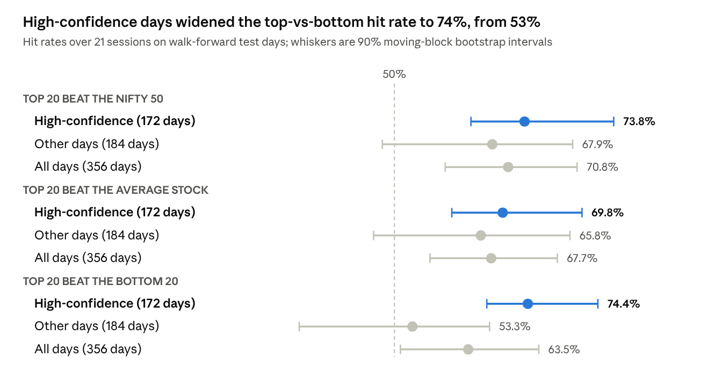
Figure 6 • Hit rates with 90% block-bootstrap intervals on high-confidence, other and all days (source: results/confidence_study/summary.csv).
Figure 6 shows that the flag's largest effect is on the spread between the best and worst picks: the top 20 beat the bottom 20 on 74.4% of high-confidence days but on only 53.3% of the others, and their average 21-day excess return was +2.09% against +0.84%. Every high-confidence interval lies above 60%, while the other-day intervals extend below 50%. The intervals still overlap, because each group contains only about eight independent months, so the flag is promising rather than proven.

6.5 Portfolio Backtest
Table 8 • Backtest of 21-Day Rebalanced Top-20 Portfolios after Costs, March 2025 – September 2026
Strategy | Total return | Annual return | Sharpe ratio | Max drawdown | Turnover
NIFTY 50 | +5.0% | +3.3% | 0.28 | −10.8% | —
Equal weight, all 209 stocks | +25.3% | +16.3% | 0.99 | −9.3% | —
LightGBM top 20 | +27.3% | +17.4% | 0.84 | −10.3% | 76%
Final blend top 20 | +33.7% | +21.4% | 0.99 | −11.2% | 48%
Momentum 12-1 top 20 | +34.6% | +21.9% | 1.32 | −6.0% | 32%
Table 8 shows that every portfolio beat the NIFTY 50, largely because the equal-weighted universe did (+25.3% against +5.0%), helped by survivorship and a strong period for mid-caps. Against that basket the blend added about 8 percentage points. Momentum alone earned a similar return with a higher Sharpe ratio, a shallower drawdown and lower turnover, so the blend's advantage lies in the consistency of its ranking rather than in returns.

6.6 RQ4: Hyperparameter Tuning Overfit
The Optuna-tuned ranker had the best validation IC (0.059) of any model and one of the worst test ICs (0.009) (Figure 7).
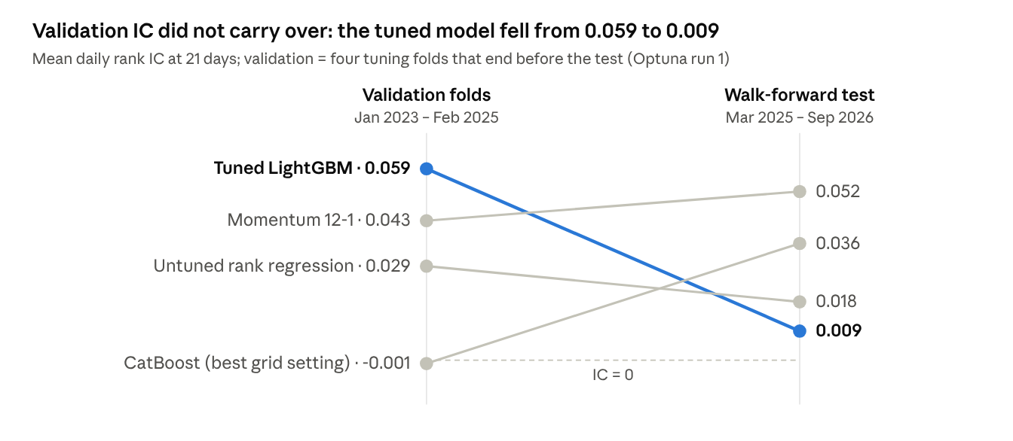
Figure 7 • Mean 21-day rank IC on the tuning folds and on the walk-forward test (source: results/tuning_21d).
Figure 7 shows the validation ranking almost reversed on the test: the tuned model fell furthest, CatBoost rose from about zero to 0.036, and only momentum held its level. Every model had a negative IC from August 2024 to January 2025, so a search that rewards the other folds fits noise, the backtest-overfitting problem described by Bailey et al. [45]. CatBoost's top 20 beat the NIFTY on 72.9% of test days, but it failed the pre-set gate and was excluded; admitting it after seeing the test would turn the test into another tuning fold. Run 2 produced no candidate that beat the untuned ranker on the folds (0.035 and 0.007 against 0.038), so the test was not scored again.

6.7 RQ4: Deep Learning and Sentiment Added No Reliable Signal
The registered TFT reached a validation loss of 0.0208, no better than a naive baseline. Adam's coupled weight decay had shrunk its variable-selection weights to about 10⁻⁴¹, making every input's weight uniform, and retraining without weight decay overfit. For filings, we mapped the 127,315 NSE announcements with usable price windows to nine event types and measured abnormal returns against the average stock (Figure 8).
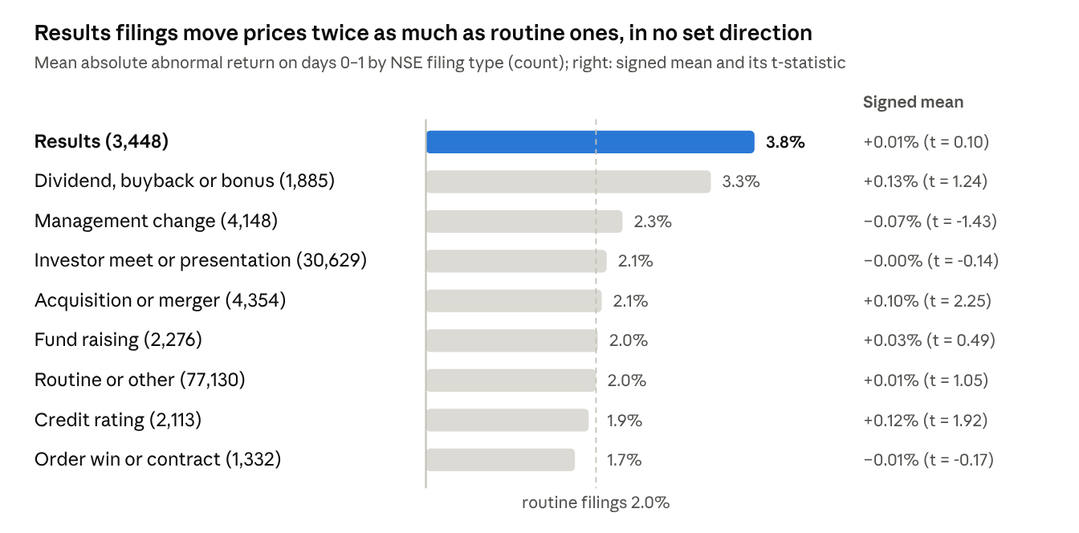
Figure 8 • Size and direction of two-day abnormal returns by NSE filing type, 127,315 filings (source: results/event_study).
Figure 8 shows that results announcements move prices most, about 3.8% over days 0–1 against 2.0% for routine filings, but every signed mean lies within ±0.13%, so the size of a reaction does not reveal its direction. No type shows significant drift after day 1. Tone does not help either: a FinancialBERT model scored 97% of 92,165 unique summaries as neutral, and clearly positive and negative summaries moved prices by +0.22% and −0.52% on days 0–1 (Welch t = 2.87) but not on days 2–5 (t = 0.3). The market absorbs filings within a day, too fast for a strategy that trades at the next close.

6.8 Stability over Time
The edge is uneven. Across the six test windows, the blend's hit rate against the average stock ranged from 38% (September to December 2025) to 94% (December 2025 to March 2026). Momentum has no fitted parameters, so it can be scored from September 2021 (Figure 9).
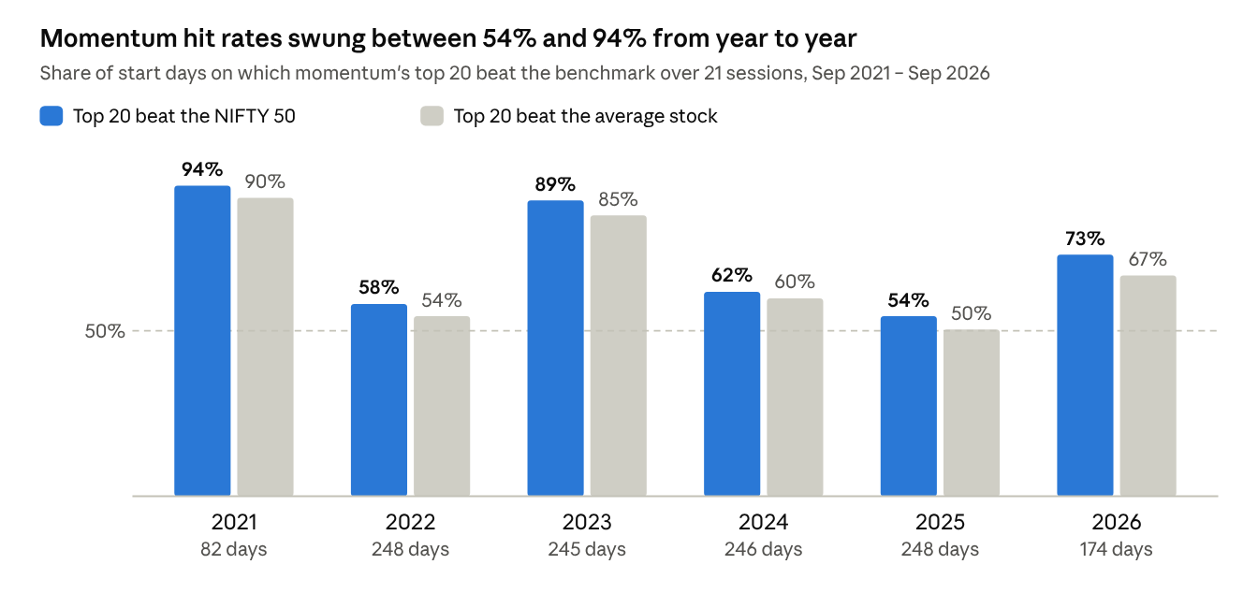
Figure 9 • Momentum's 21-day hit rate by calendar year, September 2021 to September 2026 (source: results/hit_rate_history).
Figure 9 shows momentum's 21-day hit rate against the NIFTY swinging between 54% (2025) and 94% (2021) by year, with weak years (2022, 2024, 2025) alternating with strong ones. Over 2021–2026 its hit rate also rose with the horizon, from 59% at 5 days to 64% at 10, 69% at 21 and 71% at 126 days. A longer window gives the signal time to outweigh noise, which supports the choice of a 21-day horizon.

7. Live Forward Tracking
The model was frozen on 17 October 2026, trained on data to 17 June 2026; both boosted members stopped after eight rounds, another sign of a thin signal. Each weekday at 18:30 IST a scheduled job fetches and repairs prices, rebuilds features, scores every stock, sets the confidence flag and scores matured forecasts. Table 9 lists the sessions scored by 30 October 2026.
Table 9 • Live Sessions Scored
Session | Member agreement | Threshold | Flag
30 Oct 2026 | 0.285 | 0.180 | High confidence
27 Oct 2026 | 0.290 | 0.178 | High confidence
26 Oct 2026 | 0.278 | 0.177 | High confidence
16 Oct 2026 | 0.291 | 0.177 | High confidence
All four sessions were high-confidence, with agreement near the top of its walk-forward range (median 0.163, maximum 0.300). The first matured check, the five-day outcome of the 16 October picks, trailed the NIFTY by 0.47% (momentum: −0.37%); one five-day result says nothing about a 21-day model, whose first outcome matures in mid-November 2026. Runs on the other weekdays did not complete because the host PC was off or the job was interrupted. The 1,041 older TFT forecasts scored so far show 54.2% direction accuracy but only 65.6% band coverage, consistent with the transformer's poor calibration.

8. Discussion and Limitations

8.1 Interpretation
The question mattered more than the model. Asked "up or down?", every model sat near 50%; asked "which stocks will do better than the others?", simple signals produced a measurable edge, and combining them made it steadier. The most complex components lost to an equal-weight average of four simple scores, consistent with a market that is close to efficient for individual price moves but still rewards well-known patterns such as momentum [5, 8, 10]. The confidence flag is the most practical output: acting only on flagged days halves the opportunities but improves the hit rate and the top-to-bottom spread.

8.2 Threats to Validity
- Few independent periods. About 18 test months give a single hit rate a standard error near 11 points; the 90% interval for the all-days rate against the NIFTY is 59–83%, and no IC t-statistic passes the t > 3 hurdle proposed for new factors [11].
- Survivorship bias. Missing delisted stocks inflate the universe's return and momentum's strength.
- A favourable benchmark. The average stock beat the NIFTY on 63% of test days.
- Regime dependence. Window hit rates ranged from 38% to 94%.
- Test reuse. The blend was chosen with knowledge of the test; the gate stopped further reuse, but only the live record is fully clean.
- Costs. Impact costs, taxes and execution delays are not modelled.
This is an academic study, not investment advice: a 65% hit rate still means losing to the average stock about one month in three.

9. Conclusion and Future Work
On 209 NSE stocks, machine learning could not predict the direction of individual excess returns, but a simple ensemble ranked stocks well enough that its top 20 beat the average stock on 65% of test days (Table 10).
Table 10 • Answers to the Research Questions
Question | Answer | Key evidence
RQ1: Direction | No | Accuracy 49.9–52.3%; error equal to predicting zero
RQ2: Ranking and blending | Yes, modestly | 65.0% vs 59.9% against the average stock; 5-day IC t-stat 3.07 vs 1.86
RQ3: Confidence | Probably | 73.8% vs 67.9% against the NIFTY; top beat bottom 74% vs 53%
RQ4: Complex components | No | Tuned IC fell from 0.059 to 0.009; TFT collapsed; LambdaRank negative; tone fades in a day
Three lessons follow: reframe prediction as ranking when only relative performance matters; prefer equal-weight combinations of diverse weak signals when independent periods are few; and protect the test set with embargoes and gates fixed in advance. Future work should (1) extend the history before 2020 with point-in-time index membership to remove survivorship bias, (2) track the frozen model live for at least 12 months, (3) move the daily job to a cloud scheduler, (4) add value, quality and earnings-revision factors, and (5) apply large language models to full results documents under the same gate.

Acknowledgments
The authors are grateful to the faculty and fellow students whose feedback in review sessions improved this paper. Claude (Anthropic) assisted with drafting, figure preparation and formatting during manuscript preparation. All analyses, results and text were reviewed and validated by the authors, and the AI tools did not generate the study's data or findings.
Funding: The authors received no financial support for the research, authorship or publication of this work.
Author contributions: Conceptualization, U.M.; methodology, U.M.; software, U.M. and P.G.; validation, U.M. and S.B.; formal analysis, U.M.; investigation, U.M., P.G. and M.T.; resources, S.B.; data curation, M.T. and S.B.; writing—original draft preparation, U.M.; writing—review and editing, U.M., P.G., M.T. and S.B.; visualization, U.M. and P.G.; supervision, U.M.; project administration, U.M. All authors have read and agreed to the final version of the manuscript.
Conflict of interest: The authors declare that there are no conflicts of interest regarding the publication of this paper.
Data availability statement: Daily prices were obtained from Yahoo Finance and corporate announcements from the National Stock Exchange of India, both publicly accessible. The processed feature table, model outputs and code are held in the authors' repository (github.com/UzairManjre/stock_predict) and are available from the corresponding author on reasonable request.

References
- Selvin S, Vinayakumar R, Gopalakrishnan EA, Menon VK, Soman KP. Stock price prediction using LSTM, RNN and CNN-sliding window model. In: Proc Int Conf Adv Comput Commun Inform (ICACCI). 2017. p. 1643–47. doi:10.1109/ICACCI.2017.8126078
- Hiransha M, Gopalakrishnan EA, Menon VK, Soman KP. NSE stock market prediction using deep-learning models. Procedia Comput Sci. 2018;132:1351–62. doi:10.1016/j.procs.2018.05.050
- Fama EF. Efficient capital markets: A review of theory and empirical work. J Finance. 1970;25(2):383–417. doi:10.2307/2325486
- Lo AW, MacKinlay AC. Stock market prices do not follow random walks: Evidence from a simple specification test. Rev Financ Stud. 1988;1(1):41–66. doi:10.1093/rfs/1.1.41
- Jegadeesh N, Titman S. Returns to buying winners and selling losers: Implications for stock market efficiency. J Finance. 1993;48(1):65–91. doi:10.1111/j.1540-6261.1993.tb04702.x
- Fama EF, French KR. Common risk factors in the returns on stocks and bonds. J Financ Econ. 1993;33(1):3–56. doi:10.1016/0304-405X(93)90023-5
- Carhart MM. On persistence in mutual fund performance. J Finance. 1997;52(1):57–82. doi:10.1111/j.1540-6261.1997.tb03808.x
- Asness CS, Moskowitz TJ, Pedersen LH. Value and momentum everywhere. J Finance. 2013;68(3):929–85. doi:10.1111/jofi.12021
- Sehgal S, Balakrishnan I. Contrarian and momentum strategies in the Indian capital market. Vikalpa. 2002;27(1):13–20. doi:10.1177/0256090920020103
- Ansari VA, Khan S. Momentum anomaly: Evidence from India. Manag Finance. 2012;38(2):206–23. doi:10.1108/03074351211193730
- Harvey CR, Liu Y, Zhu H. …and the cross-section of expected returns. Rev Financ Stud. 2016;29(1):5–68. doi:10.1093/rfs/hhv059
- Box GEP, Jenkins GM, Reinsel GC, Ljung GM. Time series analysis: Forecasting and control. 5th ed. Hoboken (NJ): Wiley; 2015.
- Engle RF. Autoregressive conditional heteroscedasticity with estimates of the variance of United Kingdom inflation. Econometrica. 1982;50(4):987–1007. doi:10.2307/1912773
- Bollerslev T. Generalized autoregressive conditional heteroskedasticity. J Econom. 1986;31(3):307–27. doi:10.1016/0304-4076(86)90063-1
- Koenker R, Bassett G Jr. Regression quantiles. Econometrica. 1978;46(1):33–50. doi:10.2307/1913643
- Gu S, Kelly B, Xiu D. Empirical asset pricing via machine learning. Rev Financ Stud. 2020;33(5):2223–73. doi:10.1093/rfs/hhaa009
- Krauss C, Do XA, Huck N. Deep neural networks, gradient-boosted trees, random forests: Statistical arbitrage on the S&P 500. Eur J Oper Res. 2017;259(2):689–702. doi:10.1016/j.ejor.2016.10.031
- Hanauer MX, Kalsbach T. Machine learning and the cross-section of emerging market stock returns. Emerg Mark Rev. 2023;55:101022. doi:10.1016/j.ememar.2023.101022
- Patel J, Shah S, Thakkar P, Kotecha K. Predicting stock and stock price index movement using trend deterministic data preparation and machine learning techniques. Expert Syst Appl. 2015;42(1):259–68. doi:10.1016/j.eswa.2014.07.040
- Chen T, Guestrin C. XGBoost: A scalable tree boosting system. In: Proc 22nd ACM SIGKDD Int Conf Knowl Discov Data Min. 2016. p. 785–94. doi:10.1145/2939672.2939785
- Ke G, Meng Q, Finley T, Wang T, Chen W, Ma W, Ye Q, Liu TY. LightGBM: A highly efficient gradient boosting decision tree. In: Adv Neural Inf Process Syst 30 (NIPS 2017). 2017. Available from: papers.nips.cc
- Akiba T, Sano S, Yanase T, Ohta T, Koyama M. Optuna: A next-generation hyperparameter optimization framework. In: Proc 25th ACM SIGKDD Int Conf Knowl Discov Data Min. 2019. p. 2623–31. doi:10.1145/3292500.3330701
- Hochreiter S, Schmidhuber J. Long short-term memory. Neural Comput. 1997;9(8):1735–80. doi:10.1162/neco.1997.9.8.1735
- Nelson DMQ, Pereira ACM, de Oliveira RA. Stock market's price movement prediction with LSTM neural networks. In: Proc Int Jt Conf Neural Netw (IJCNN). 2017. p. 1419–26. doi:10.1109/IJCNN.2017.7966019
- Fischer T, Krauss C. Deep learning with long short-term memory networks for financial market predictions. Eur J Oper Res. 2018;270(2):654–69. doi:10.1016/j.ejor.2017.11.054
- Vaswani A, Shazeer N, Parmar N, Uszkoreit J, Jones L, Gomez AN, Kaiser Ł, Polosukhin I. Attention is all you need. In: Adv Neural Inf Process Syst 30 (NIPS 2017). 2017. Available from: papers.nips.cc
- Lim B, Arık SÖ, Loeff N, Pfister T. Temporal fusion transformers for interpretable multi-horizon time series forecasting. Int J Forecast. 2021;37(4):1748–64. doi:10.1016/j.ijforecast.2021.03.012
- Sezer OB, Gudelek MU, Ozbayoglu AM. Financial time series forecasting with deep learning: A systematic literature review: 2005–2019. Appl Soft Comput. 2020;90:106181. doi:10.1016/j.asoc.2020.106181
- Tetlock PC. Giving content to investor sentiment: The role of media in the stock market. J Finance. 2007;62(3):1139–68. doi:10.1111/j.1540-6261.2007.01232.x
- Loughran T, McDonald B. When is a liability not a liability? Textual analysis, dictionaries, and 10-Ks. J Finance. 2011;66(1):35–65. doi:10.1111/j.1540-6261.2010.01625.x
- Bollen J, Mao H, Zeng X. Twitter mood predicts the stock market. J Comput Sci. 2011;2(1):1–8. doi:10.1016/j.jocs.2010.12.007
- Araci D. FinBERT: Financial sentiment analysis with pre-trained language models. arXiv:1908.10063 [Preprint]. 2019. doi:10.48550/arXiv.1908.10063
- Huang AH, Wang H, Yang Y. FinBERT: A large language model for extracting information from financial text. Contemp Account Res. 2023;40(2):806–41. doi:10.1111/1911-3846.12832
- MacKinlay AC. Event studies in economics and finance. J Econ Lit. 1997;35(1):13–39. Available from: ideas.repec.org
- Bhardwaj A, Narayan Y, Vanraj, Pawan, Dutta M. Sentiment analysis for Indian stock market prediction using Sensex and Nifty. Procedia Comput Sci. 2015;70:85–91. doi:10.1016/j.procs.2015.10.043
- Paramanik RN, Singhal V. Sentiment analysis of Indian stock market volatility. Procedia Comput Sci. 2020;176:330–38. doi:10.1016/j.procs.2020.08.035
- Lopez-Lira A, Tang Y. Can ChatGPT forecast stock price movements? Return predictability and large language models. J Financ Econ. 2026;184:104335. doi:10.1016/j.jfineco.2026.104335
- Chen Y, Kelly B, Xiu D. Expected returns and large language models [Working paper]. SSRN 4416687. 2026. Available from: papers.ssrn.com
- Burges CJC. From RankNet to LambdaRank to LambdaMART: An overview. Technical Report MSR-TR-2010-82. Redmond (WA): Microsoft Research; 2010.
- Song Q, Liu A, Yang SY. Stock portfolio selection using learning-to-rank algorithms with news sentiment. Neurocomputing. 2017;264:20–28. doi:10.1016/j.neucom.2017.02.097
- Feng F, He X, Wang X, Luo C, Liu Y, Chua TS. Temporal relational ranking for stock prediction. ACM Trans Inf Syst. 2019;37(2):1–30. doi:10.1145/3309547
- Grinold RC. The fundamental law of active management. J Portf Manag. 1989;15(3):30–37. doi:10.3905/jpm.1989.409211
- Tashman LJ. Out-of-sample tests of forecasting accuracy: An analysis and review. Int J Forecast. 2000;16(4):437–50. doi:10.1016/S0169-2070(00)00065-0
- Bergmeir C, Benítez JM. On the use of cross-validation for time series predictor evaluation. Inf Sci. 2012;191:192–213. doi:10.1016/j.ins.2011.12.028
- Bailey DH, Borwein JM, López de Prado M, Zhu QJ. The probability of backtest overfitting. J Comput Finance. 2017;20(4):39–69. doi:10.21314/JCF.2016.322
- López de Prado M. Advances in financial machine learning. Hoboken (NJ): Wiley; 2018.
- Clemen RT. Combining forecasts: A review and annotated bibliography. Int J Forecast. 1989;5(4):559–83. doi:10.1016/0169-2070(89)90012-5
- Timmermann A. Forecast combinations. In: Elliott G, Granger CWJ, Timmermann A, editors. Handbook of economic forecasting. Vol. 1. Amsterdam: Elsevier; 2006. p. 135–96. doi:10.1016/S1574-0706(05)01004-9
- Smith J, Wallis KF. A simple explanation of the forecast combination puzzle. Oxf Bull Econ Stat. 2009;71(3):331–55. doi:10.1111/j.1468-0084.2008.00541.x
- Lakshminarayanan B, Pritzel A, Blundell C. Simple and scalable predictive uncertainty estimation using deep ensembles. In: Adv Neural Inf Process Syst 30 (NIPS 2017). 2017. Available from: papers.nips.cc

