DESIGN DOCUMENT
Alpine Ascents
An Educational Mountaineering Website
____________________________________________________________
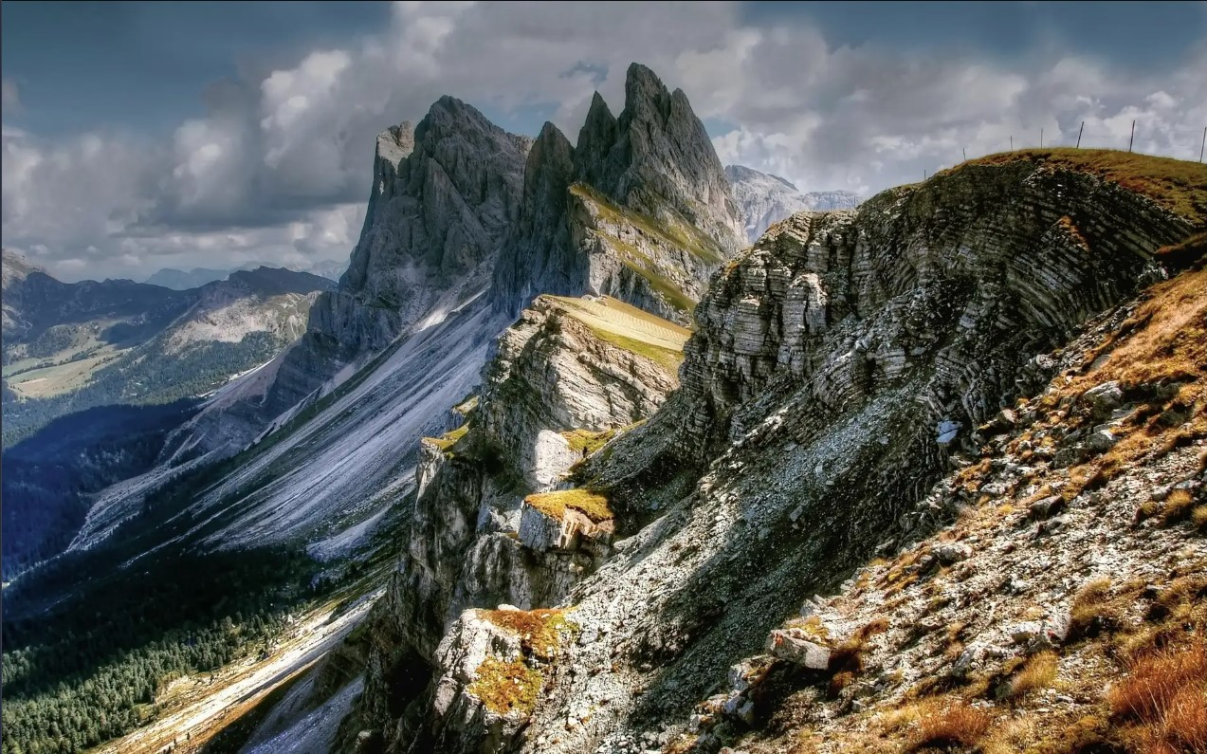
Faculty: Miss Summaiya Aslam | Batch: 2605 C1 | Group: B

Serial No. | Enrollment Number | Student Name
1 | Student1730807 | Uzair Naufil
2 | Student1731035 | Muhammad Ahmed
3 | Student1731033 | Riyan Ahmed
4 | Student1731034 | Syed Khizar Muhammad

AGGREGATED SITEMAP

The sitemap below shows the single-page structure of Alpine Ascents: the Hero section, the 11 content sections in scroll order, the Footer, the fixed Section Index Navigation (11 links), and the external services (Esri map tiles, Nominatim reverse geocoding, and browser Geolocation API).
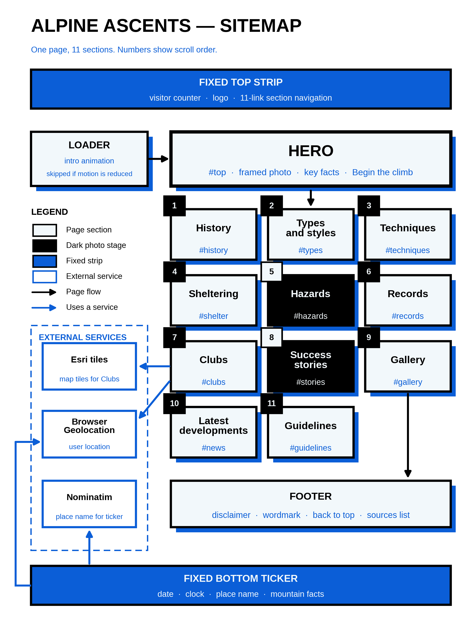
Sitemap diagram

TASK SHEET REVIEW 2: BUILD TASKS

Project Title: Alpine Ascents
Date of Preparation: [TBD]
No | Task | Start Date | Days | Team-mate | Status
1 | [TBD] | [TBD] | [TBD] | [TBD] | [TBD]
2 | [TBD] | [TBD] | [TBD] | [TBD] | [TBD]
3 | [TBD] | [TBD] | [TBD] | [TBD] | [TBD]
4 | [TBD] | [TBD] | [TBD] | [TBD] | [TBD]
5 | [TBD] | [TBD] | [TBD] | [TBD] | [TBD]

Placeholder: contents to be confirmed with faculty.

TASK SHEET REVIEW 3: CHECKING TASKS

Project Title: Alpine Ascents
Date of Preparation: [TBD]
No | Task | Start Date | Days | Team-mate | Status
1 | [TBD] | [TBD] | [TBD] | [TBD] | [TBD]
2 | [TBD] | [TBD] | [TBD] | [TBD] | [TBD]
3 | [TBD] | [TBD] | [TBD] | [TBD] | [TBD]
4 | [TBD] | [TBD] | [TBD] | [TBD] | [TBD]
5 | [TBD] | [TBD] | [TBD] | [TBD] | [TBD]

Placeholder: contents to be confirmed with faculty.

