USER GUIDE
Alpine Ascents
An Educational Mountaineering Website
____________________________________________________________
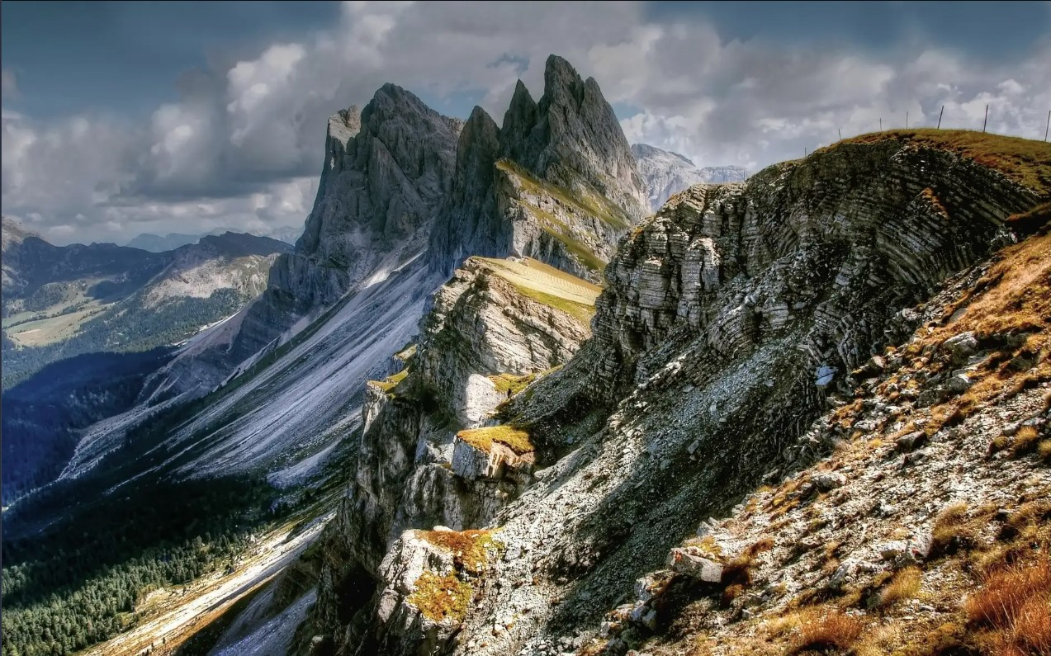
Faculty: Miss Summaiya Aslam | Batch: 2605 C1 | Group: B

Serial No. | Enrollment Number | Student Name
1 | Student1730807 | Uzair Naufil
2 | Student1731035 | Muhammad Ahmed
3 | Student1731033 | Riyan Ahmed
4 | Student1731034 | Syed Khizar Muhammad

ABOUT THIS GUIDE

Alpine Ascents is a single-page educational mountaineering website. It covers history, types, techniques, shelter, hazards, records, clubs, success stories, a gallery, latest developments and guidelines — all on one continuous page with scroll-driven storytelling.
Live site: https://alpineascents1.netlify.app/
This guide walks through each section of the site with a screenshot and a description of what the visitor can do there.
FOLDER STRUCTURE

Alpine Ascents
├── index.html
├── css
│ └── style.css
├── js
│ └── script.js
├── assets
│ └── images
│ ├── clubs — club map pins and region photos
│ ├── gallery — 10 gallery mosaic photos
│ ├── guidelines — (empty; section uses no photos)
│ ├── hazards — 4 hazard photos (avalanche, crevasse, storm, altitude)
│ ├── hero — hero background image
│ ├── history — 5 history era photos
│ ├── news — 3 news article photos
│ ├── records — (empty; section uses no photos)
│ ├── shelter — 4 shelter type photos
│ ├── stories — 3 success story photos
│ ├── techniques — 4 technique photos
│ └── types — 4 climbing type photos
└── docs

index.html — Structure and mounting points for the single-page site
css/style.css — All design: layout, typography, colours, animations
js/script.js — All content (DATA object), rendering and interactivity
assets/images/ — Images, one folder per section (12 folders)
docs/ — Project documentation

SECTION WALKTHROUGH

Hero
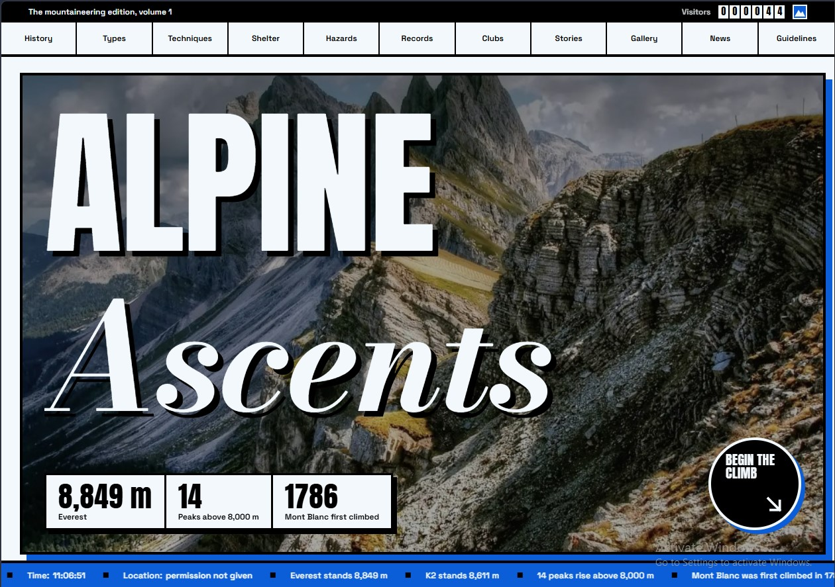
The landing section: a framed mountain photo with the title 'Alpine Ascents', key facts (Everest 8,849 m, 14 eight-thousanders, Mont Blanc 1786) and a 'Begin the climb' call-to-action.
History
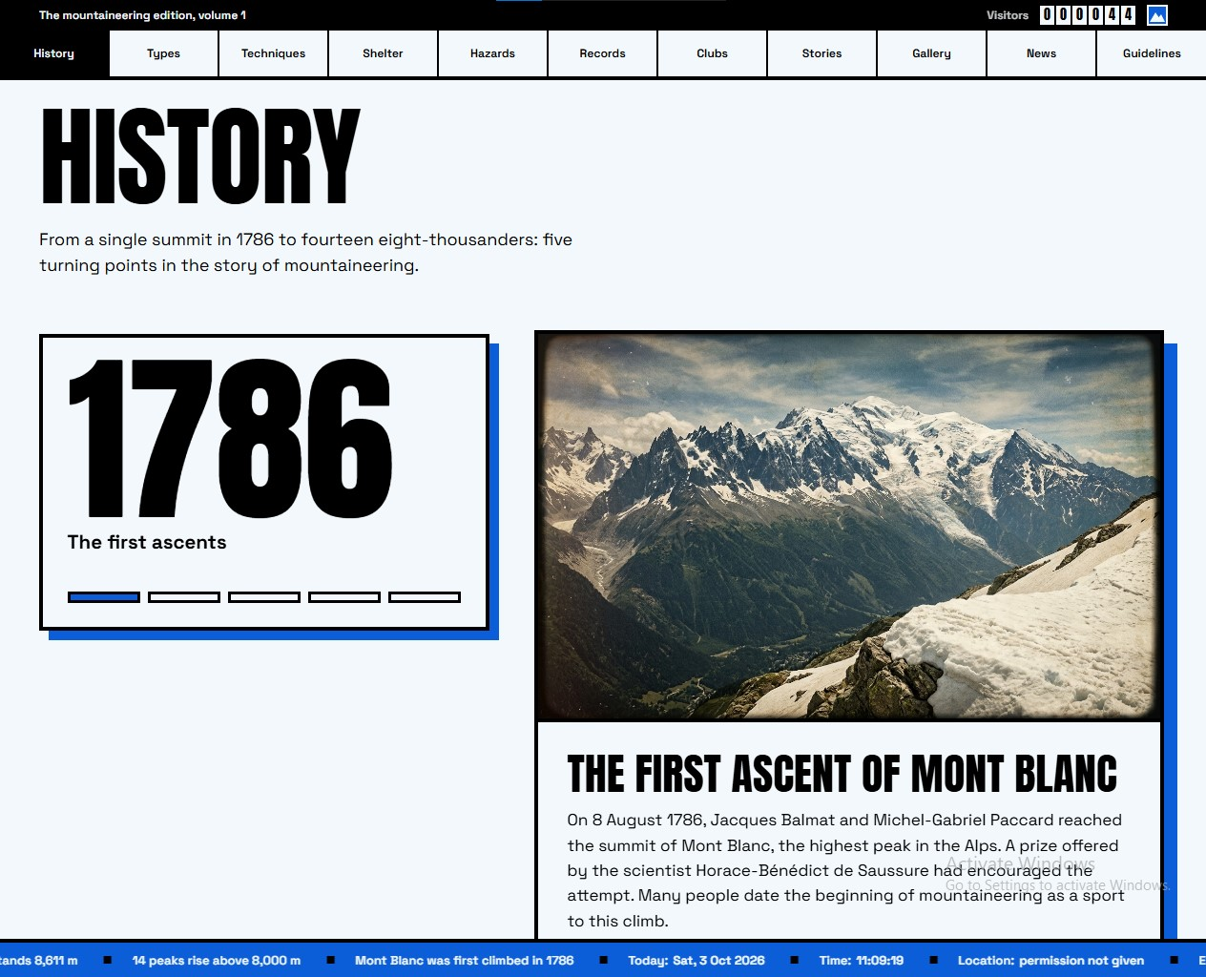
Five turning points in mountaineering history from 1786 to today. A sticky year counter animates as you scroll through each era.
Types and Styles
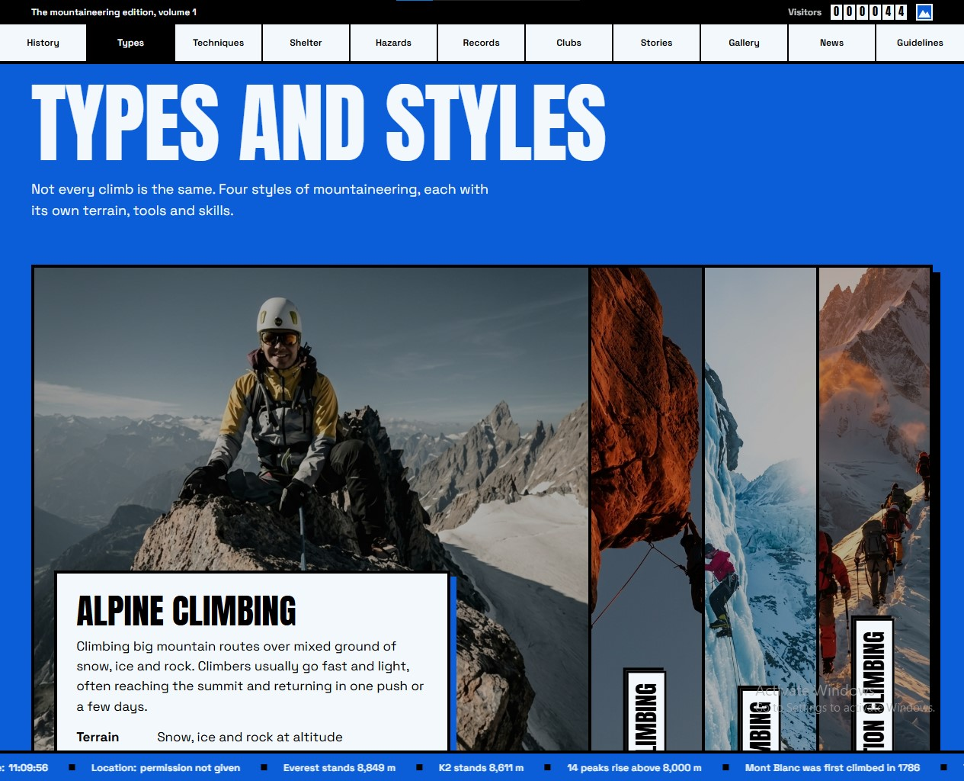
Four styles of mountaineering — Alpine, Rock, Ice and Expedition — shown as expanding panels. Hover or tap to reveal terrain, gear and example routes.
Techniques
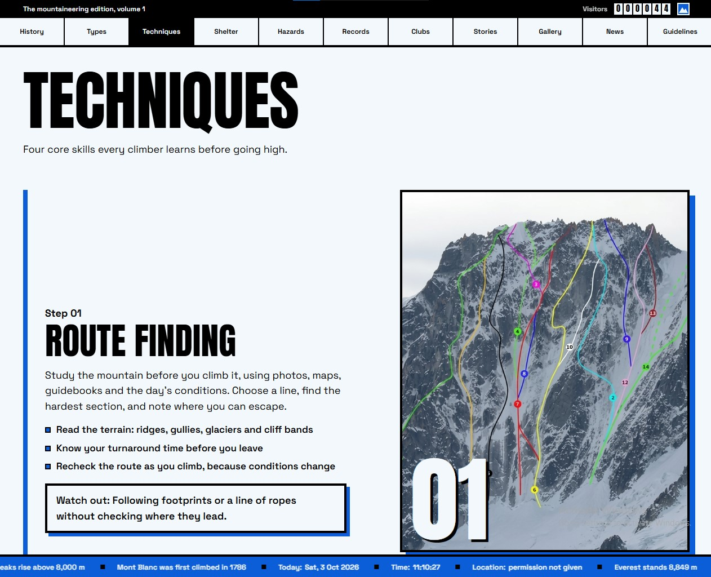
Four core skills: Route finding, Anchoring, Belaying and Rappelling. Each has key points and a 'Watch out' warning, with a crossfading photo and step counter.
Sheltering
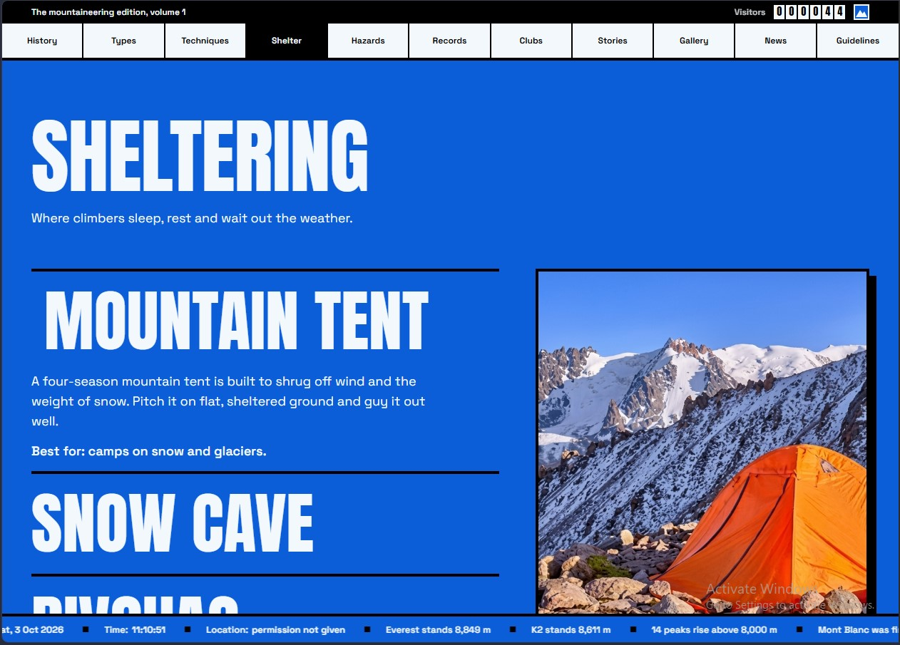
Four shelter types — Mountain tent, Snow cave, Bivouac and Mountain hut. Select one to expand its description and see the photo.
Hazards
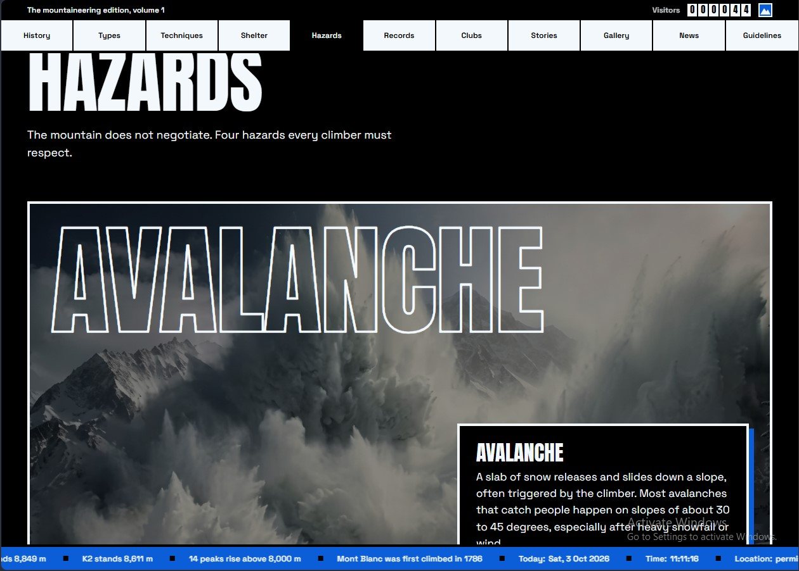
Four hazards — Avalanche, Crevasse, Snow storm and High altitude — on a dark full-bleed stage. Scroll to change the hazard; each has three 'do' items.
Records
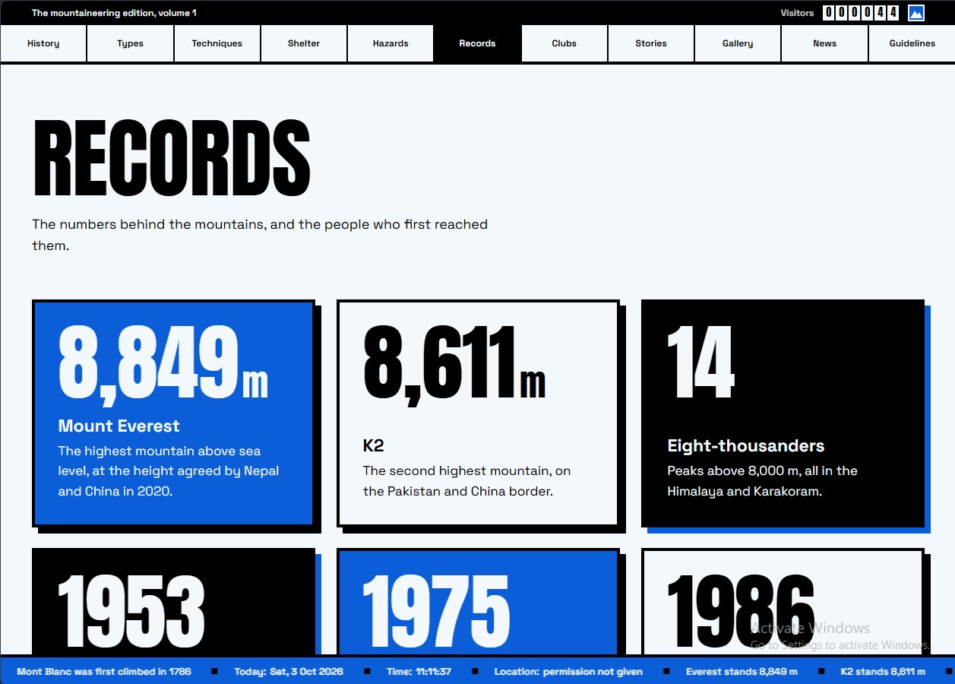
Six count-up stat tiles: Everest 8,849 m, K2 8,611 m, 14 eight-thousanders, and the firsts by Hillary & Tenzing (1953), Tabei (1975) and Messner (1986).
Clubs
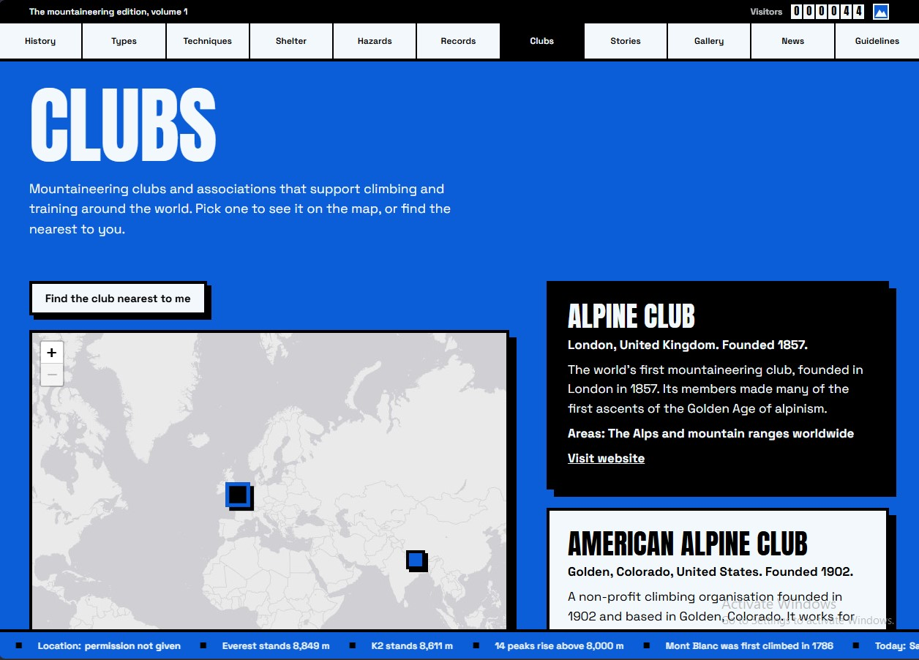
Four mountaineering clubs on an interactive Leaflet map. Click a card to fly to it, or use 'Find the club nearest to me' with geolocation.
Success Stories
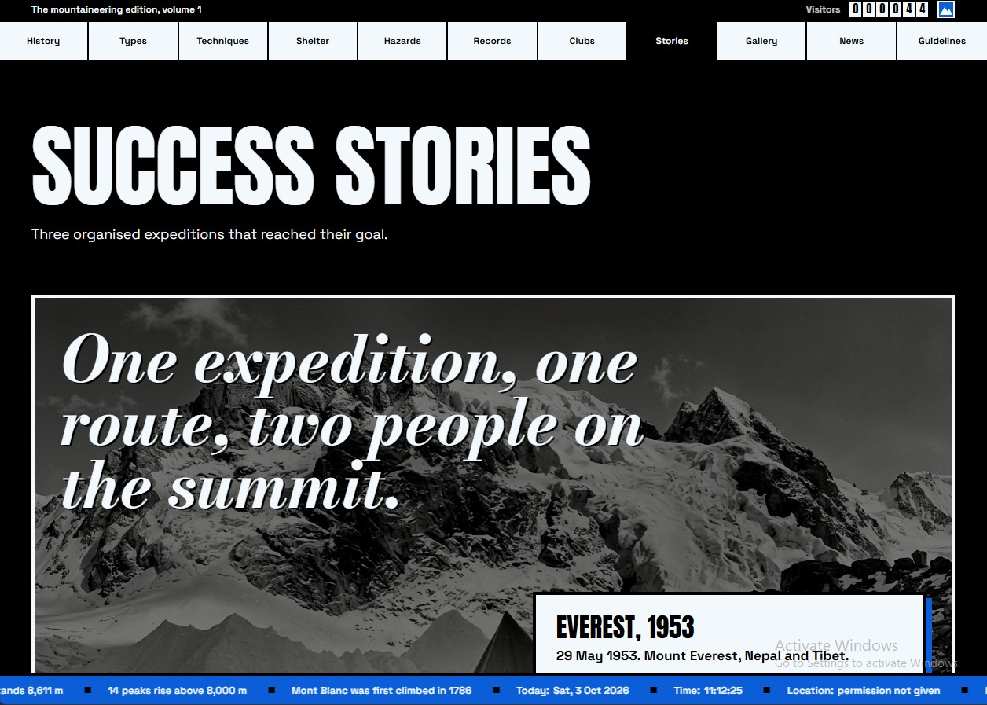
Three real expeditions — Everest 1953, Everest 1975 and K2 winter 2021 — with pull quotes and links to read more.
Latest Developments
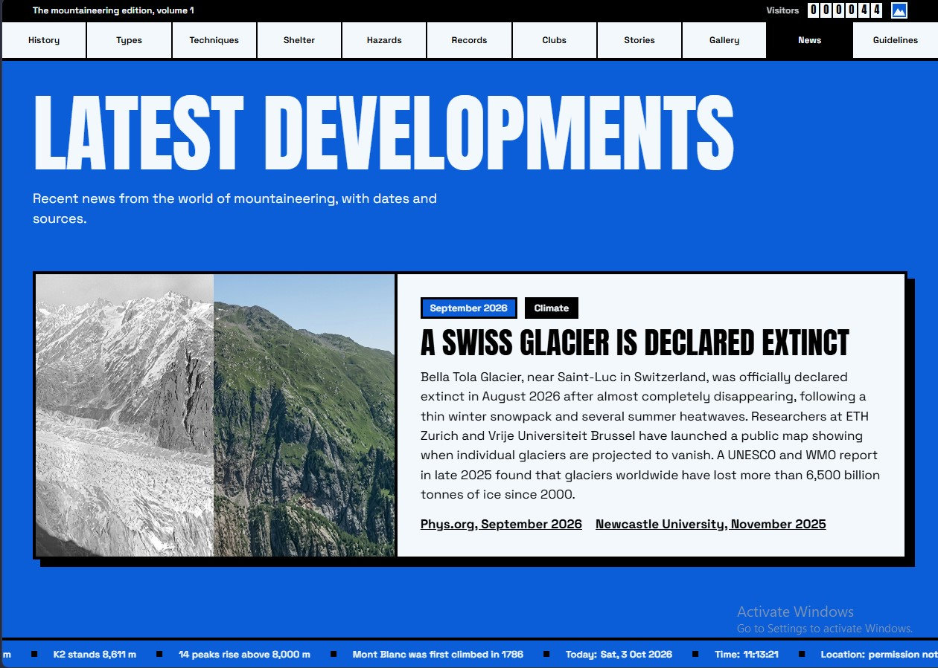
Three news cards with date tags, category tags and source links — covering glacier extinction, Everest safety technology and record permit numbers.
Gallery
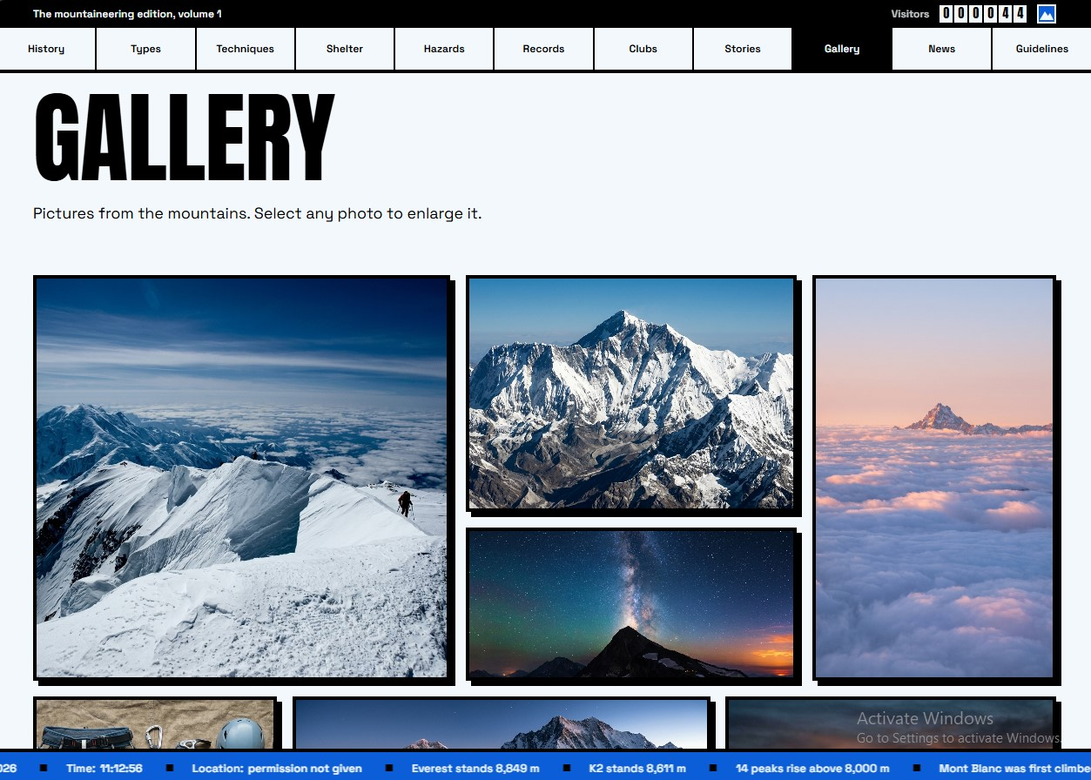
A mosaic of ten mountain photos. Click any photo to open it in a keyboard-accessible lightbox with prev/next navigation.
Guidelines
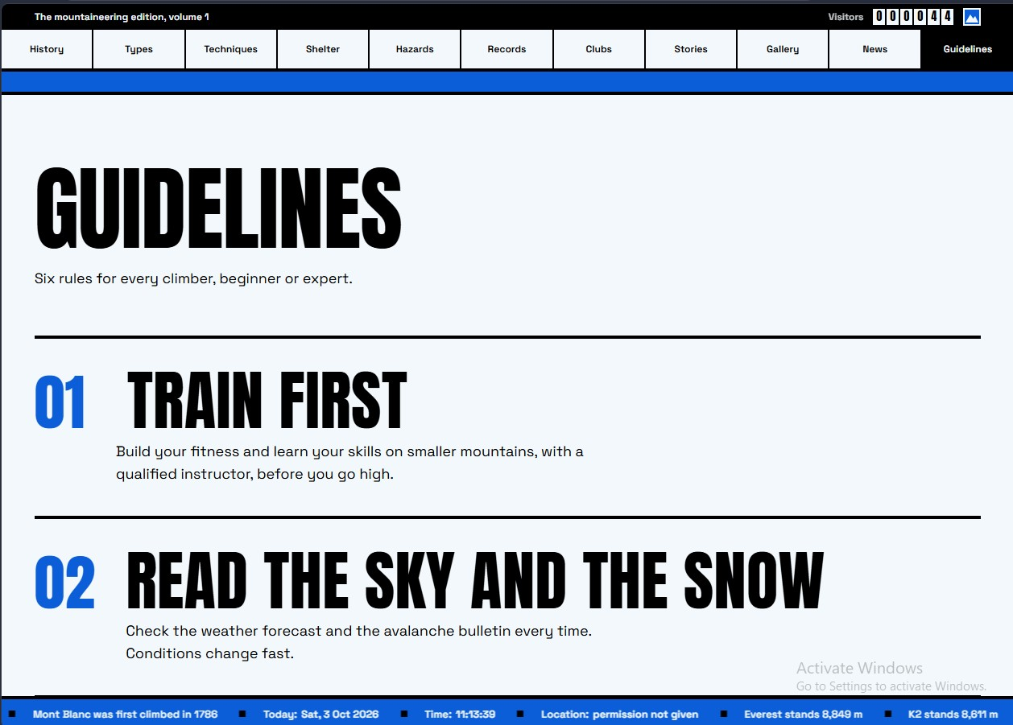
Six rules for every climber, displayed as large numbered statements: Train first, Read the sky and the snow, Tell someone your plan, and more.
Footer
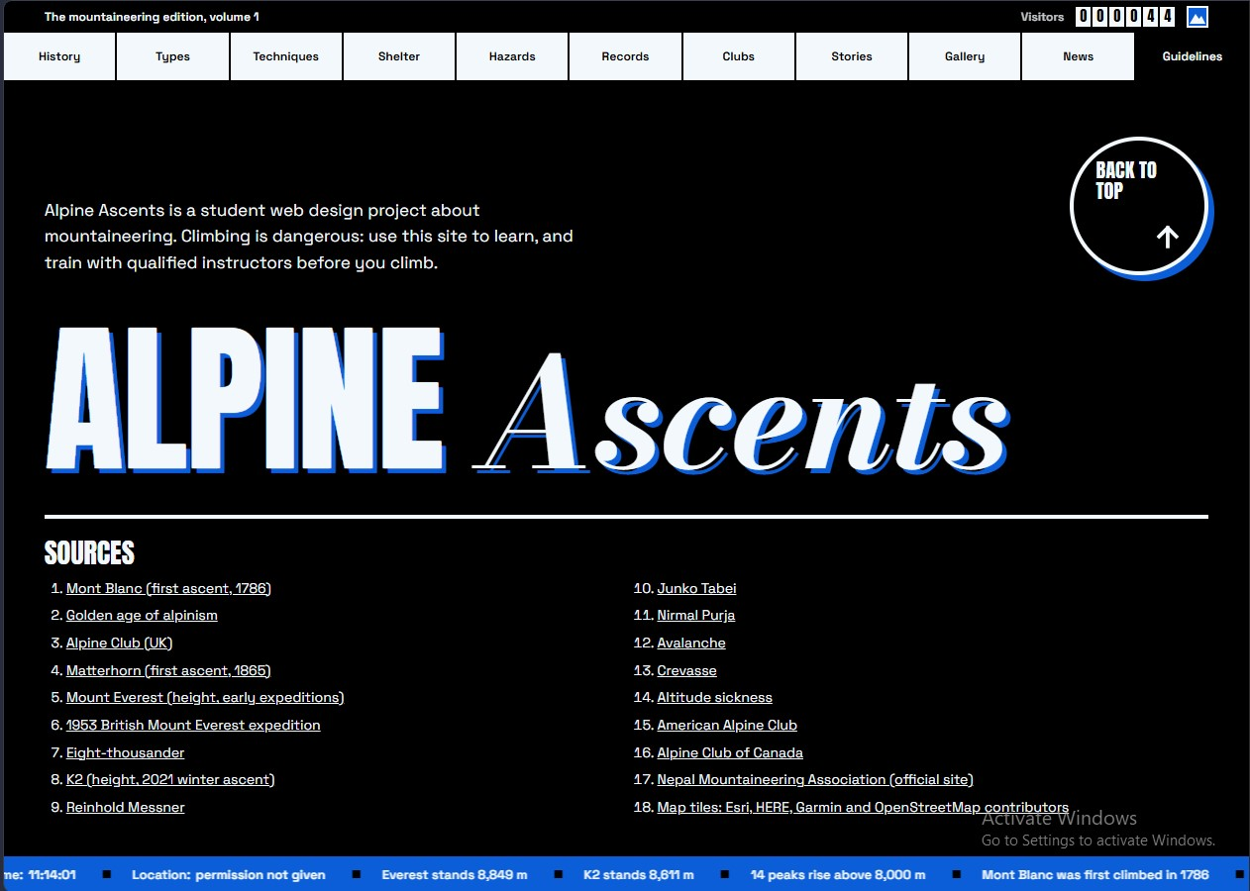
The ending section: a student disclaimer, a 'Back to top' button, the Alpine Ascents wordmark and a two-column list of 18 sources.

