SymSync
A Privacy-Preserving Mobile sEMG Biofeedback System
for Bilateral Upper-Trapezius Symmetry Awareness
Semester Project Report

Human Machine Interaction Module
Master of Science High Integrity Systems
Summer Semester 2026
Frankfurt University of Applied Sciences

Project Team
Uzair Zia Qureshi (1542053) — Team Lead
Zeeshan Bashir · Rakhimjob Berdiev · Md Rakibul Hassan · Muhammad Ahmed

Submission: July 2026
github.com/UzairZQ/SymSync

Abstract
SymSync is an Android-first mobile research prototype that translates bilateral surface electromyography (sEMG) from the upper trapezius into real-time, lay-oriented feedback. The system was developed through a human-centred process informed by two focus groups. Participants consistently preferred an anatomical, colour-coded representation over raw waveforms and abstract numerical displays, while also requesting actionable notifications, exercise guidance, accessibility options, and local data processing. The implemented Flutter application connects to a biosignalsplux acquisition device through the PLUX Android API, receives two synchronized 16-bit channels at 1000 Hz, applies a first-order 20–400 Hz band-limiting stage, calculates a 100 ms RMS envelope, removes a resting baseline in the power domain, and derives a signed bilateral symmetry index. The index controls an anatomical heatmap and a centred balance indicator; it is explicitly presented as relative activation imbalance rather than body angle or a clinical diagnosis. The application additionally supports anonymous participant identifiers, scenario tagging, participant-isolated history, local sustained-imbalance notifications, a colour-vision-accessible palette, educational exercise videos, a glossary, a sensor-placement guide, and irreversible research-data reset controls. Static analysis reports no issues and the current automated suite contains 21 passing tests covering signal processing, accessibility palettes, research context, history separation, aggregation, and deletion. The report documents the implemented system, its research rationale, and a planned SUS/TAM-based evaluation. It deliberately does not claim clinical validity: hardware validation, normalization against a physiological reference, and participant testing remain necessary before health-related inference.
Keywords
surface electromyography; biofeedback; bilateral symmetry; human–computer interaction; mobile health; accessibility; privacy-preserving research prototype

Table of Contents
All entries and page numbers are clickable Word links.
Abstract 1
Table of Contents 1
List of Figures 1
List of Tables 1
Glossary and Abbreviations 1
1 Introduction 1
1.1 Motivation and problem statement 1
1.2 Aim, objectives, and research questions 1
1.3 Scope and contributions 1
2 Background and Related Work 1
2.1 Surface electromyography and biofeedback 1
2.2 Electrode placement and signal interpretation 1
2.3 Usability and technology acceptance 1
3 Human-Centred Research and Requirements 1
3.1 Focus-group evidence 1
3.2 Requirements traceability 1
4 System Architecture and Implementation 1
4.1 Architecture overview 1
4.2 Hardware integration 1
4.3 Participant and scenario workflow 1
5 Signal Processing and Derived Metrics 1
5.1 Implemented processing pipeline 1
5.2 Symmetry index and display mapping 1
5.3 Scientific interpretation boundaries 1
6 Interaction Design and Accessibility 1
6.1 Anatomical heatmap 1
6.2 Balance monitor 1
6.3 Summary, guidance, and accessibility 1
7 Data Management, Privacy, and Research Controls 1
8 Evaluation Methodology 1
8.1 Study design 1
8.2 Procedure and measures 1
8.3 Analysis plan 1
9 Verification and Current Results 1
10 Discussion 1
11 Limitations and Future Work 1
12 Conclusion 1
References 1
Appendix A Electrode Placement Protocol 1
Appendix B Evaluation Instruments 1
Appendix C Research Session Checklist 1

List of Figures
Figure 1. Refined interface concepts evaluated in Focus Group 2. 1
Figure 2. Scenario-based view preferences reported in Focus Group 2. 1
Figure 3. SymSync software architecture and data flow. 1
Figure 4. Implemented real-time sEMG processing pipeline. 1
Figure 5. Illustrative anatomical heatmap generated from the implemented mapping. 1

List of Tables
Table 1. Project context and deliverable. 1
Table 2. Requirements traceability from user research to implementation. 1
Table 3. Principal software components. 1
Table 4. Implemented signal-processing parameters. 1
Table 5. Research-data separation and deletion controls. 1
Table 6. Planned evaluation measures and interpretation. 1
Table 7. Verification evidence for the current prototype. 1
Table 8. Known limitations and mitigation strategy. 1

Glossary and Abbreviations
Glossary of principal terms and abbreviations.
Term | Definition
ADC | Analogue-to-digital converter; the device output arrives as digital sample counts.
BLoC/Cubit | Flutter state-management pattern used to coordinate connection, recording, and UI state.
EMG / sEMG | Electromyography / surface electromyography, used to measure electrical muscle activity non-invasively.
RMS | Root mean square; a short-window measure of signal magnitude used as the activation envelope.
SI | Signed symmetry index. Negative values indicate higher left activity; positive values indicate higher right activity.
SUS | System Usability Scale, a ten-item post-use usability questionnaire.
TAM | Technology Acceptance Model, used here to assess perceived usefulness and perceived ease of use.
Relative activation | Within-session activity normalized against the highest corrected activity observed on that side.
Average deviation | The absolute magnitude of the mean signed symmetry index for the selected history period.
Best balance | The session with the smallest absolute bilateral symmetry difference.
Primary imbalance | The side that is, on average, more active in the selected period; it is descriptive, not diagnostic.

1 Introduction

1.1 Motivation and problem statement
Surface electromyography provides a non-invasive view of muscle activation, but conventional sEMG tools often present waveforms, amplitudes, and technical units that are difficult for non-specialists to interpret. HCI research has shown that real-time EMG biofeedback can support bodily insight when the feedback is connected to an understandable physical task rather than exposed as raw signal data [1]. SymSync addresses this translation problem for bilateral upper-trapezius activity: it converts two synchronized channels into an anatomical heatmap, a directional balance representation, and concise guidance.
The project is motivated by awareness rather than diagnosis. A visible left–right difference can prompt a participant to inspect posture, movement, sensor placement, or cable artefact, but the prototype cannot determine injury, weakness, pathology, or causal risk. This boundary is essential because sEMG amplitude depends on electrode position, skin preparation, anatomy, normalization, motion, and acquisition hardware [2]–[6].

1.2 Aim, objectives, and research questions
The aim is to design and implement a research-ready mobile interface that presents bilateral upper-trapezius sEMG as comprehensible, privacy-preserving, and accessible movement feedback.
- Implement a reliable end-to-end path from biosignalsplux acquisition to live Flutter visualisation.
- Transform raw ADC samples into a documented RMS-based relative activation measure.
- Represent bilateral difference without falsely presenting the result as a measured body angle.
- Trace interface decisions to evidence from the two focus groups.
- Support anonymous participant and scenario management for structured HCI evaluation.
- Prepare a repeatable evaluation protocol using SUS, TAM, observation, and task completion measures.
The report is organised around three research questions:
- RQ1: How can bilateral upper-trapezius sEMG be transformed into real-time feedback that lay participants can interpret?
- RQ2: Which interaction and accessibility mechanisms best reflect the focus-group requirements for actionable symmetry awareness?
- RQ3: How can the prototype support participant-isolated, privacy-preserving research sessions without a cloud backend?

1.3 Scope and contributions
The contribution is an integrated HMI research prototype rather than a medical device. It includes the mobile application, Android hardware bridge, signal-processing logic, visual feedback, participant workflow, local notifications, accessibility mode, local history, educational content, and evaluation instruments. The project currently targets one bilateral muscle group—the upper trapezius—to preserve methodological focus. Deltoid, latissimus, and biceps options are intentionally not implemented.
Table 1. Project context and deliverable.
Item | Current project definition
Application | Flutter mobile application with Android hardware integration and simulated non-Android fallback.
Target signal | Two-channel upper-trapezius surface EMG at a requested sample rate of 1000 Hz.
Primary users | Lay research participants supported by a researcher during prototype evaluation.
Data model | Anonymous participant codes, scenario tags, and local session summaries.
Primary output | Relative bilateral activation, signed symmetry index, heatmap, balance indicator, history, and guidance.
Non-goal | Clinical diagnosis, rehabilitation prescription, or validated measurement of posture angle.

2 Background and Related Work

2.1 Surface electromyography and biofeedback
Karolus et al. demonstrated FitBack, an EMG biofeedback system used during biceps curls, and reported that participants could use the feedback to improve exercise form and develop bodily insight [1]. SymSync adopts the same broad interaction premise—physiological sensing should produce an interpretable feedback loop—but applies it to bilateral upper-back awareness, multiple everyday scenarios, and a privacy-preserving mobile research workflow.
The surface EMG signal is stochastic and sensitive to movement artefact. A 20 Hz high-pass corner is a common compromise for attenuating low-frequency movement artefact, while useful surface EMG content commonly extends into several hundred hertz [5]. SymSync therefore applies a lightweight real-time approximation that is computationally suitable for a mobile prototype. It is documented as an approximation rather than described as a laboratory-grade Butterworth implementation.

2.2 Electrode placement and signal interpretation
SENIAM recommendations place upper-trapezius electrodes at 50% of the line between the acromion and the C7 spinous process, oriented along that line [2]. Electrode position materially changes the recorded amplitude [3], and standardisation is especially important when comparing the left and right sides [4]. SymSync therefore includes an onboarding diagram and an in-app placement guide, while the research protocol requires mirrored placement, consistent cable routing, skin preparation, and a relaxed baseline.
Absolute amplitude should not be interpreted as a direct percentage of physiological maximum without a validated normalization procedure. Reviews of upper-trapezius EMG normalization show substantial methodological variability [6]. Accordingly, SymSync labels its output “relative activation” and normalizes each side to the peak corrected activity observed within the current session. This supports visual comparison but does not produce %MVC.

2.3 Usability and technology acceptance
The System Usability Scale provides a technology-independent ten-item measure of perceived usability [7]. The Technology Acceptance Model separates perceived usefulness from perceived ease of use [8]. Both constructs are relevant because SymSync may be easy to operate yet still fail to provide meaningful bodily insight, or may appear useful while imposing unacceptable sensor burden. The evaluation therefore combines SUS with TAM-derived items and observation. Cheah et al. provide a mobile-health example of adapting these instruments, while also warning that adapted scales require reliability checks rather than automatic acceptance [9].

3 Human-Centred Research and Requirements

3.1 Focus-group evidence
The project was shaped by two five-participant focus groups. Focus Group 1 explored five concepts and established a preference for actionable, concrete feedback. Raw waveforms, microvolt values, and abstract percentage displays were rejected for lay use. Focus Group 2 evaluated the refined Balance Monitor, Anatomical View, and Activation Summary. Participants near-unanimously preferred the Anatomical View across office, exercise, and everyday scenarios, while the summary was valued for progress tracking.
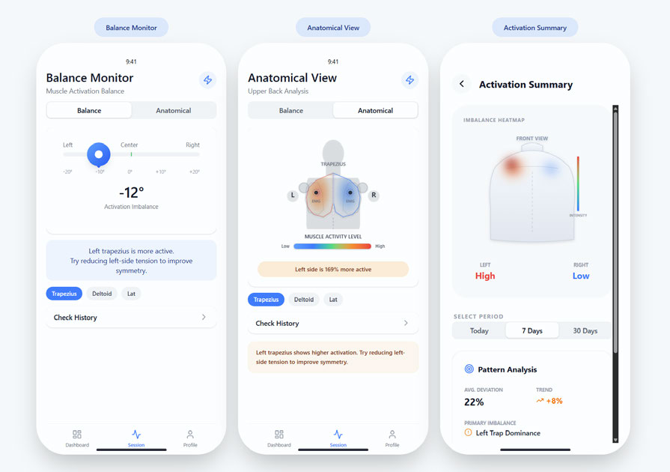
Figure 1. Refined interface concepts evaluated in Focus Group 2.
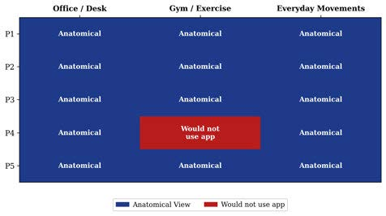
Figure 2. Scenario-based view preferences reported in Focus Group 2.
Focus Group 2 added requirements that became central to the final implementation: muscle-specific feedback, video-supported exercise guidance, colour-blind alternatives, local processing, less prominent view switching, and notifications that trigger only after sustained imbalance. The participants also framed the application as a temporary awareness-building tool rather than a permanent clinical monitor.

3.2 Requirements traceability
Table 2. Requirements traceability from user research to implementation.
Requirement | Research evidence | Implemented response
Actionable feedback | Raw data was difficult to interpret. | Plain-language dominance labels and corrective text.
Anatomical context | Anatomical View preferred across scenarios. | Posterior upper-body silhouette is the default live view.
View choice | A hidden switch was preferred over prominent switching. | Anatomical and Balance views remain available within the Session screen.
Muscle specificity | Participants wanted to know which muscle was shown. | Trapezius is explicitly named; unsupported muscles are marked “Coming soon”.
Notification timing | Avoid alerts for brief intentional asymmetry. | Threshold, sustained duration, scenario minimum, and cooldown are configurable.
Accessibility | Colour should not be the sole encoding. | Persistent colour-blind palette, text labels, semantics, and marker pattern.
Exercise guidance | Participants requested videos for corrective exercises. | Three externally opened educational video cards in Activation Summary.
Privacy | Local EMG processing was preferred. | No account or cloud backend; anonymous participant codes and local storage.
Research reset | Dummy data must not contaminate participant sessions. | Separate deletion of session history and complete participant/research reset.

4 System Architecture and Implementation

4.1 Architecture overview
SymSync uses a layered Flutter architecture. An abstract EmgHardware interface isolates the application from the acquisition implementation. Android uses PluxEmgHardware and a native Kotlin bridge; other platforms use SimulatedEmgHardware for UI development. A single SessionBloc coordinates connection state, acquisition, calibration, recording, processing, notifications, participant context, persistence, and presentation state. SharedPreferences stores compact JSON session summaries and research preferences.
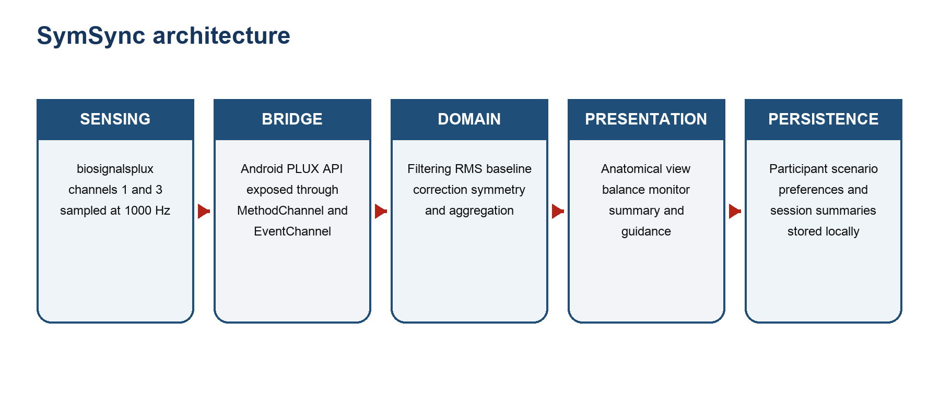
Figure 3. SymSync software architecture and data flow.
Table 3. Principal software components.
Component | Responsibility
EmgHardware | Abstract connection, streaming, acquisition, stop, and disconnect contract.
PluxBridge.kt | Creates PLUX BTH communication, requests channels, receives frames, and forwards them through an EventChannel.
SignalProcessor | Baseline correction, symmetry calculation, balance-position mapping, and guidance labels.
SignalFilterState | Stateful first-order high-pass and low-pass filters plus moving RMS.
SessionBloc | Coordinates timers, frame processing, recording, summaries, participant isolation, and notifications.
ResearchContextStore | Persists participant codes, active participant, scenario, and notification preferences.
SessionHistoryStore | Persists up to 500 local session summaries.
Presentation layer | Dashboard, Session, Anatomical View, Balance Monitor, Activation Summary, Profile, glossary, and placement guide.

4.2 Hardware integration
The Dart service uses a MethodChannel for connect, start, stop, and disconnect commands and an EventChannel for streaming frames. The native bridge requests PLUX Communication.BTH, constructs 16-bit sources for channels 1 and 3, starts acquisition at 1000 Hz, and forwards the first two analogue values as ch1 and ch3. The report intentionally avoids claiming a specific lower-level profile such as BLE GATT or SPP because the application delegates that transport detail to the supplied PLUX API.
The device MAC address is currently configured in the application shell. This is acceptable for a controlled research prototype with one known device but should be replaced by device discovery and explicit pairing in a deployable product.

4.3 Participant and scenario workflow
After onboarding, the first research launch creates an anonymous sequential code such as P001 and requires selection of Office/Desk, Gym/Exercise, or Everyday/Stairs. Every persisted session stores both participantId and scenarioId. The active-history getter filters all summaries by the selected participant, preventing measurements from different participants from appearing in the same dashboard or summary. Participant switching and deletion are blocked during an active recording.
Research identity model
Participant codes are pseudonymous local identifiers, not anonymous in an absolute legal sense. The research team must maintain any separate consent or re-identification key outside the app and according to the approved study procedure.

5 Signal Processing and Derived Metrics

5.1 Implemented processing pipeline
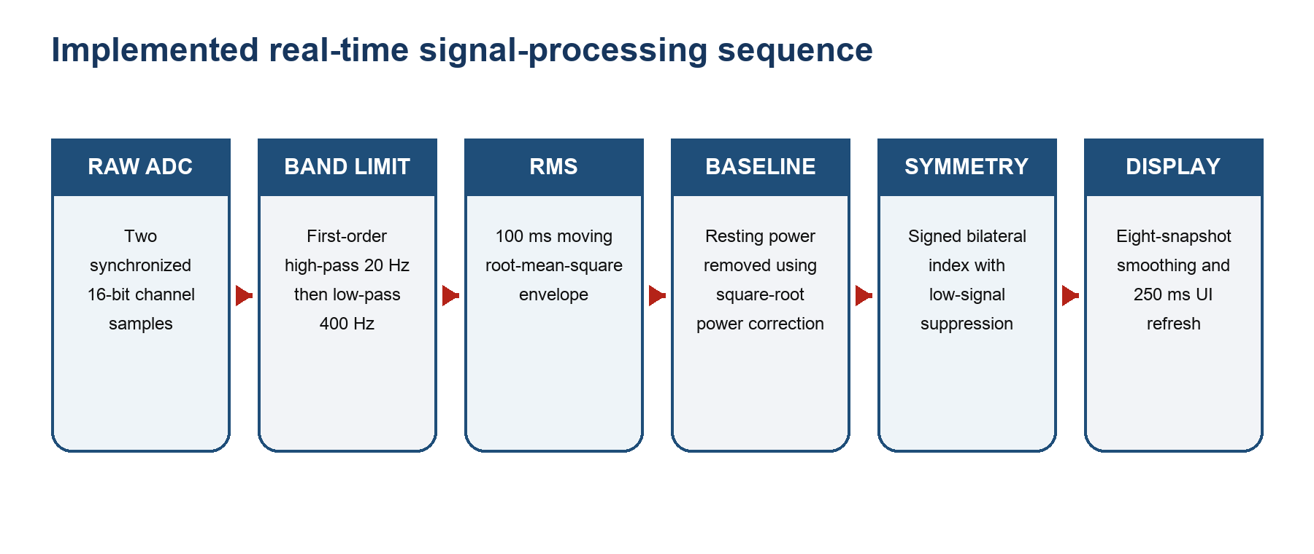
Figure 4. Implemented real-time sEMG processing pipeline.
Table 4. Implemented signal-processing parameters.
Stage | Implemented parameter | Purpose
Sampling request | 1000 Hz; channels 1 and 3; 16-bit sources | Native PLUX bridge.
Channel mapping | A/B assignment persisted as left/right | Correct mapping is confirmed during onboarding.
High-pass stage | First-order RC high-pass, nominal 20 Hz | Reduces midpoint/DC and low-frequency movement content.
Low-pass stage | First-order RC low-pass, nominal 400 Hz | Reduces content above the intended surface-EMG band.
RMS envelope | 100 samples = 100 ms at 1000 Hz | Short-window magnitude estimate.
Resting correction | sqrt(max(RMS² − baseline², 0)) | Subtracts estimated baseline power without negative activity.
Symmetry index | 100 × (R − L)/(R + L) | Signed difference relative to combined corrected activity.
Low-signal gate | R + L must exceed 1.0 corrected ADC-RMS unit | Avoids unstable division near zero.
Display smoothing | Mean of up to eight 250 ms snapshots | Approximately two seconds of display smoothing.
UI refresh | 250 ms | Maximum four presentation updates per second.

The native stream contains raw ADC counts. Raw values are retained in bounded buffers for the researcher waveform view, while participant-facing activation and symmetry are computed from the filtered RMS path. The UI therefore does not display unprocessed values as muscle activation.

5.2 Symmetry index and display mapping
For corrected left activity L and right activity R, SymSync calculates SI = 100(R − L)/(R + L). The theoretical range is −100% to +100%; zero represents equal activity, negative values indicate higher left activity, and positive values indicate higher right activity. The Balance Monitor maps this complete SI range linearly to a centred track. Its tick labels are −100%, −50%, 0%, +50%, and +100%. Earlier design concepts used degrees, but the implementation correctly states that the marker represents EMG imbalance and not measured body angle.
Participant-facing activity percentages are within-session relative values. Each side’s average corrected activity is divided by that side’s session peak. This creates a 0–100 visual scale but does not equal %MVC and should not be compared as an absolute physiological quantity across participants, devices, or electrode placements.

5.3 Scientific interpretation boundaries
- The symmetry thresholds used for labels and notifications are operational interface thresholds, not clinically validated diagnostic cut-offs.
- A high bilateral value may indicate genuine co-contraction, motion artefact, cable movement, or poor contact; colour alone cannot resolve the cause.
- The current filters are lightweight first-order stages and have not been compared against an offline reference pipeline.
- Within-session peak normalization supports visual feedback but is sensitive to the activity performed during the session.
- The system should be described as an awareness and research tool until convergent validation is completed.

6 Interaction Design and Accessibility

6.1 Anatomical heatmap
The Anatomical View is the primary live interface because it directly reflects the strongest focus-group preference. A posterior clinical silhouette provides anatomical context. Two radial gradients are centred over the left and right upper-trapezius regions. Both radius and opacity increase with relative activation, and a marker remains visible at each sensor location. The legend is labelled “Relative Activation” with 0%, 50%, and 100% anchors.
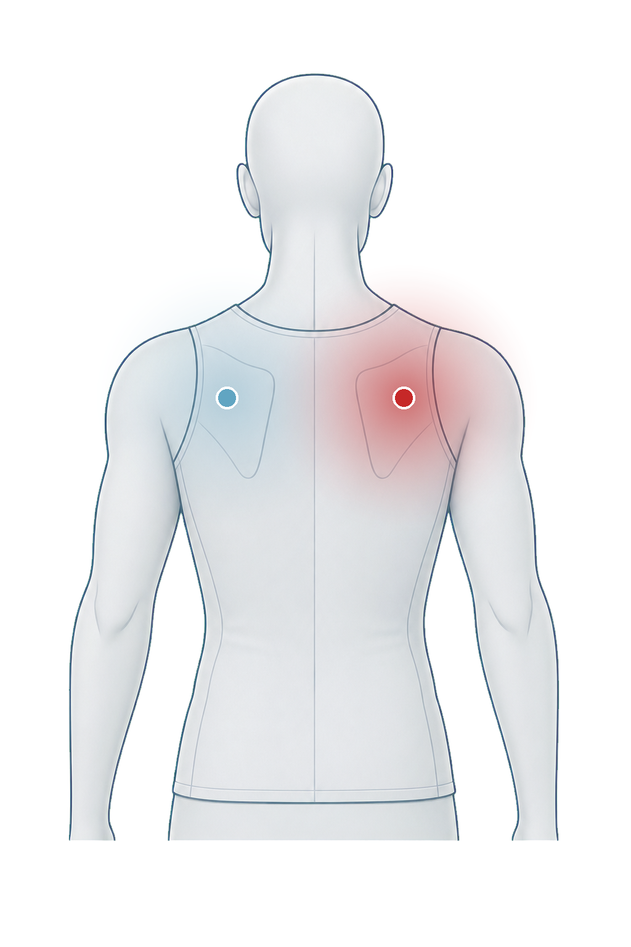
Figure 5. Illustrative anatomical heatmap generated from the implemented mapping.
Figure 5 is illustrative and was generated from the implemented geometry and palette; it is not participant data. The standard sequential palette progresses from blue through yellow and orange to red. The optional accessible palette follows a viridis-like purple–blue–green–yellow sequence, whose monotonic lightness and colour-vision robustness are preferable to rainbow encodings [10].

6.2 Balance monitor
The Balance Monitor complements, rather than replaces, the anatomical representation. The track uses a symmetric gradient around the centre, and the thumb position is derived directly from the signed SI. A two-update hysteresis stabilises categorical labels. Channel cards show relative left and right activation, while a corrective sentence communicates direction in plain language.

6.3 Summary, guidance, and accessibility
Activation Summary filters the active participant’s history by Today, 7 Days, or 30 Days. It reports session count, change in absolute imbalance relative to the preceding session, average deviation, and primary imbalance. Three educational video cards are opened externally on YouTube; the application warns users to stop if exercise causes pain and to seek clinical advice when needed.
- Persistent light/dark themes and persistent colour-blind mode.
- Non-colour X-pattern on heatmap markers in colour-blind mode.
- Semantic text description of left and right heatmap values for assistive technology.
- Plain-language glossary covering symmetry, deviation, relative activation, calibration, filtering, and RMS.
- Onboarding and Profile access to a mirrored upper-trapezius sensor-placement diagram.
- Unsupported muscle groups are visibly unavailable rather than silently showing trapezius data under another label.

7 Data Management, Privacy, and Research Controls
All signal processing, participant context, and session-summary persistence occur locally. The application does not create an account, request a participant name, upload EMG, or depend on Firebase. This design responds to the focus-group preference for local processing and follows the principle of data minimisation in the General Data Protection Regulation [11]. It does not, by itself, establish legal compliance; the study still requires an appropriate information sheet, lawful basis, retention policy, access control, and institutional procedure.
Table 5. Research-data separation and deletion controls.
Control | Behaviour | Research purpose
Create participant | Assigns the next unused sequential code (P001, P002, …). | No name or account is collected.
Switch participant | Changes the active code when no recording is running. | Dashboard and summary use participant-filtered history.
Delete participant | Removes the selected code and its associated sessions. | Other participants remain intact.
Clear session history | Deletes all recorded session summaries. | Participant registry and preferences are retained.
Reset research data | Deletes all participants, sessions, scenarios, and notification preferences. | Intended before real recruitment after dummy testing.
Session cap | Stores at most 500 summaries. | Limits uncontrolled local growth; raw streams are not persisted.

Corrective notifications are local. They require explicit permission, an enabled preference, a signed SI whose magnitude exceeds the configured threshold, persistence for at least the greater of the user setting and the scenario-specific minimum, and completion of the cooldown. The notification states which side is working harder and includes the corrective instruction.

8 Evaluation Methodology

8.1 Study design
The proposed evaluation is a within-participant, single-session HCI prototype study with 5–10 healthy adult volunteers. It evaluates usability, comprehension, perceived usefulness, and technical feasibility; it is not designed to test clinical efficacy. The everyday task is stair ascent, as requested in the project brief. Office/Desk and Gym/Exercise can be evaluated as short scenario probes, but each recorded session must be tagged with the scenario actually used.
Ethics and safety
The statement “ethical approval is not required” should not appear in the final submission unless confirmed by the module lead or institutional process. Researchers should obtain informed consent, screen for contraindications defined by the study, protect participant codes, and document any skin reaction or adverse event.

8.2 Procedure and measures
- Provide the participant information, obtain consent, and assign an anonymous in-app participant code.
- Select the intended scenario and document the planned task.
- Prepare intact skin; locate C7 and both acromia; place mirrored sensors at the 50% points; secure cables.
- Connect the device, confirm channel mapping, and complete the relaxed calibration procedure.
- Record a short unilateral shoulder-shrug check on each side to verify direction and channel assignment.
- Complete three to five stair ascents at a natural, safe pace while the researcher observes signal quality and interface comprehension.
- Stop recording, review the participant-specific Activation Summary, and administer SUS and TAM items.
- Conduct a short debrief on heatmap interpretation, notification usefulness, colour meaning, sensor burden, and trust.
Table 6. Planned evaluation measures and interpretation.
Measure | Operationalisation | Analysis
Task completion | Connection, calibration, recording, summary review | Completed independently / with assistance / not completed.
Comprehension | Identify which side is more active | Correct response and explanation without prompting.
SUS | Ten standard 5-point items | Score 0–100; report distribution and adjective interpretation [7], [12].
TAM-PU | Perceived usefulness items | Mean and standard deviation; report item wording and reliability.
TAM-PEOU | Perceived ease-of-use items | Mean and standard deviation; report item wording and reliability.
Technical timing | Connection, calibration, and session completion | Median, range, failure reason.
Signal observations | Dropout, simultaneous saturation, unstable baseline | Count and contextual field notes.
Qualitative debrief | Understanding, trust, burden, and desired use | Thematic summary with de-identified quotations.

8.3 Analysis plan
Given the anticipated sample size, the report should emphasise descriptive statistics and individual observations rather than inferential claims. Report SUS median, mean, standard deviation, and range; TAM construct means and item-level distributions; task completion; connection and calibration failures; and comprehension accuracy. Adapted TAM items should be presented transparently and internal consistency reported only when the sample size makes the estimate meaningful. Qualitative comments should be coded against the established themes while remaining open to new themes.

9 Verification and Current Results
The current evidence concerns software verification, not participant outcomes. On 20 June 2026, the project completed Flutter static analysis with no issues and executed 21 automated tests successfully. These tests provide regression evidence for deterministic logic but do not replace hardware-in-the-loop or user evaluation.
Table 7. Verification evidence for the current prototype.
Verification area | Method | Current result
Static analysis | `flutter analyze` | No issues found.
Signal index | Equal, left-dominant, and right-dominant inputs | Signed SI matches expected values.
Low-signal suppression | Combined level below threshold | SI is not emitted.
Baseline correction | Known RMS and baseline powers | Power-domain subtraction matches expected result.
Filter behaviour | DC input and 100 Hz sinusoid | DC rejected; EMG-band waveform retained.
Participant isolation | P001 and P002 histories | Active history contains only the selected participant.
Research persistence | Participant, scenario, notification settings | Round-trip persistence succeeds.
Deletion | History clear and complete research reset | Stored data is removed safely.
Accessibility | Standard and accessible palettes | Mode changes palette and preserves centred balance mapping.
History aggregation | Empty, bounded, and multi-session inputs | Dimensions, count, averaging, and clamping verified.

Required next verification includes real-device confirmation of the requested 1000 Hz rate, channel ordering, frame loss, reconnection, long-session stability, Android notification behaviour, and comparison of online RMS/SI values with an offline reference implementation using the same raw data.

10 Discussion
RQ1 is addressed through a documented transformation from raw ADC samples to filtered RMS, baseline-corrected relative activation, and a signed bilateral index. The transformation is technically coherent for a prototype and is tested with synthetic inputs. Its principal strength is transparency: the interface labels distinguish relative activation, imbalance, and visual position rather than presenting an unsupported clinical score.
RQ2 is addressed through direct traceability to the focus groups. The Anatomical View is the default, raw data is hidden from lay participants, the Balance Monitor remains available as a secondary representation, and requests for notifications, video guidance, accessibility, and plain-language terms are implemented. The design also recognises wearability as a likely adoption barrier that software polish cannot remove.
RQ3 is addressed through participant-specific local storage and explicit research controls. The absence of accounts and cloud synchronization reduces collection, but local biometric data still requires governance. Anonymous-looking participant codes can become identifiable when combined with recruitment schedules or researcher notes; procedural separation is therefore as important as the application design.
A key design correction is the removal of degrees from the live balance scale. The focus-group prototype used degrees as an intuitive metaphor, but the hardware configuration contains no inertial sensor and cannot measure body tilt. Presenting SI percentages and an explicit “not body angle” explanation improves construct validity while retaining the centred visual metaphor.

11 Limitations and Future Work
Table 8. Known limitations and mitigation strategy.
Limitation | Impact | Recommended next step
No physiological ground truth | The system has not been compared with a validated offline pipeline or clinical EMG system. | Export synchronized raw samples and compare RMS/SI under controlled contractions.
Within-session normalization | Relative activation depends on the session peak and cannot be interpreted as %MVC. | Add a validated reference contraction protocol if cross-session physiological comparison is required.
Simplified filters | First-order filters do not reproduce a higher-order laboratory band-pass. | Implement and validate a numerically stable higher-order filter or document the PLUX hardware filtering.
Hardware transport and device binding | One MAC address is configured and transport details are delegated to the PLUX API. | Add discovery, pairing, device metadata, and hardware-in-the-loop tests.
Motion artefact | Stair climbing and cable movement may dominate low-frequency signal. | Improve cable fixation, add artefact flags, and record synchronized observational markers.
Small study | Five to ten participants can reveal usability problems but not establish clinical validity. | Treat findings as formative and recruit a larger sample for confirmatory work.
Educational videos | External videos are generic and not individualized treatment. | Review content with a qualified clinician and document selection criteria.
Accessibility validation | Palette and semantics are implemented but not yet tested with users with colour-vision deficiency or screen readers. | Conduct dedicated accessibility evaluation.
Platform scope | Real hardware integration is Android-first; other platforms use simulation. | Evaluate a supported iOS hardware path only after Android validation.

Future work should prioritise hardware and methodological validity over expanding to additional muscle groups. The trapezius flow should first be validated end-to-end with repeatable placement, raw-data export, offline comparison, and participant testing. Additional muscles should only be introduced with dedicated anatomical assets, placement protocols, channel configurations, and interpretation rules.

12 Conclusion
SymSync demonstrates how bilateral upper-trapezius sEMG can be translated into a coherent mobile biofeedback experience grounded in user research. The final prototype goes beyond the original three views by adding anonymous participant management, scenario-tagged history, sustained local notifications, an accessible palette, sensor-placement guidance, a glossary, educational videos, and research-data deletion. Its signal path processes raw device samples into filtered, baseline-corrected RMS activity and a signed bilateral symmetry index, while the interface avoids claiming that this index measures posture angle or clinical impairment.
The project is therefore substantially ready for a structured HCI evaluation, but not for clinical deployment. The strongest next step is empirical validation: confirm the hardware stream, compare online processing with an offline reference, and evaluate whether participants correctly understand and can act on the feedback. Maintaining this distinction between functional completeness and scientific validity is what makes the project credible as a rigorous semester research prototype.

References
[1] J. Karolus, F. Bachmann, T. Kosch, A. Schmidt, and P. W. Woźniak, “Facilitating bodily insights using electromyography-based biofeedback during physical activity,” in Proc. 23rd Int. Conf. Mobile Human-Computer Interaction, 2021, pp. 1–15. https://doi.org/10.1145/3447526.3472027
[2] H. J. Hermens, B. Freriks, C. Disselhorst-Klug, and G. Rau, “Development of recommendations for SEMG sensors and sensor placement procedures,” J. Electromyogr. Kinesiol., vol. 10, no. 5, pp. 361–374, 2000. https://doi.org/10.1016/S1050-6411(00)00027-4
[3] C. Jensen, O. Vasseljen, and R. H. Westgaard, “The influence of electrode position on bipolar surface electromyogram recordings of the upper trapezius muscle,” Eur. J. Appl. Physiol., vol. 67, pp. 266–273, 1993. https://doi.org/10.1007/BF00864227
[4] D. Farina, P. Madeleine, T. Graven-Nielsen, R. Merletti, and L. Arendt-Nielsen, “Standardising surface electromyogram recordings for assessment of activity and fatigue in the human upper trapezius muscle,” Eur. J. Appl. Physiol., vol. 86, no. 6, pp. 469–478, 2002. https://doi.org/10.1007/s00421-001-0574-0
[5] C. J. De Luca, L. D. Gilmore, M. Kuznetsov, and S. H. Roy, “Filtering the surface EMG signal: Movement artifact and baseline noise contamination,” J. Biomech., vol. 43, no. 8, pp. 1573–1579, 2010. https://doi.org/10.1016/j.jbiomech.2010.01.027
[6] S. E. Mathiassen, J. Winkel, and G. M. Hägg, “Normalization of surface EMG amplitude from the upper trapezius muscle in ergonomic studies—A review,” J. Electromyogr. Kinesiol., vol. 5, no. 4, pp. 197–226, 1995. https://doi.org/10.1016/1050-6411(94)00014-X
[7] J. Brooke, “SUS: A ‘quick and dirty’ usability scale,” in Usability Evaluation in Industry, P. W. Jordan, B. Thomas, B. A. Weerdmeester, and I. L. McClelland, Eds. London, U.K.: Taylor & Francis, 1996, pp. 189–194. https://digital.ahrq.gov/sites/default/files/docs/survey/systemusabilityscale%2528sus%2529_comp%255B1%255D.pdf
[8] F. D. Davis, “Perceived usefulness, perceived ease of use, and user acceptance of information technology,” MIS Q., vol. 13, no. 3, pp. 319–340, 1989. https://doi.org/10.2307/249008
[9] K. H. Cheah et al., “Mobile technology in medicine: Development and validation of an adapted System Usability Scale questionnaire and modified Technology Acceptance Model to evaluate user experience and acceptability of a mobile application,” Indian J. Radiol. Imaging, vol. 33, no. 1, pp. 36–45, 2023. https://doi.org/10.1055/s-0042-1753403
[10] F. Crameri, G. E. Shephard, and P. J. Heron, “The misuse of colour in science communication,” Nat. Commun., vol. 11, art. no. 5444, 2020. https://doi.org/10.1038/s41467-020-19160-7
[11] European Parliament and Council of the European Union, “Regulation (EU) 2016/679 (General Data Protection Regulation),” Apr. 27, 2016. https://eur-lex.europa.eu/eli/reg/2016/679/oj
[12] A. Bangor, P. Kortum, and J. Miller, “Determining what individual SUS scores mean: Adding an adjective rating scale,” J. Usability Stud., vol. 4, no. 3, pp. 114–123, 2009. https://uxpajournal.org/wp-content/uploads/sites/7/pdf/JUS_Bangor_May2009.pdf
[13] PLUX Wireless Biosignals S.A., “OpenSignals (r)evolution user manual,” 2022. https://support.pluxbiosignals.com/knowledge-base/opensignals-revolution/

Appendix A Electrode Placement Protocol
This protocol standardises placement for the research prototype. It should be adapted if the sensor manufacturer specifies a different reference-electrode configuration.
- Seat or stand the participant comfortably with the head neutral and shoulders relaxed.
- Locate C7, the prominent spinous process at the base of the neck, and the lateral acromion on each shoulder.
- Mark the 50% point on the line from C7 to each acromion.
- Prepare clean, dry, intact skin according to the sensor instructions; avoid irritated or broken skin.
- Place left and right electrodes at mirrored 50% points and orient both along the C7–acromion line.
- Attach the reference electrode according to the biosignalsplux/EMG sensor instructions; do not infer reference placement solely from this report.
- Secure cables to reduce swing and verify free movement.
- Confirm channel direction using separate left and right shoulder shrugs before recording the study task.
- Capture a relaxed baseline while the participant remains still.
- Document deviations, re-positioning, skin condition, and observed artefacts.

Appendix B Evaluation Instruments

B.1 System Usability Scale
Administer the ten standard SUS items immediately after the interaction. Response options range from 1 (strongly disagree) to 5 (strongly agree). Preserve the original positive/negative wording.
SUS response form.
No. | Statement | Rating (circle one)
1 | I think that I would like to use this system frequently. | 1 2 3 4 5
2 | I found the system unnecessarily complex. | 1 2 3 4 5
3 | I thought the system was easy to use. | 1 2 3 4 5
4 | I think that I would need the support of a technical person to be able to use this system. | 1 2 3 4 5
5 | I found the various functions in this system were well integrated. | 1 2 3 4 5
6 | I thought there was too much inconsistency in this system. | 1 2 3 4 5
7 | I would imagine that most people would learn to use this system very quickly. | 1 2 3 4 5
8 | I found the system very cumbersome to use. | 1 2 3 4 5
9 | I felt very confident using the system. | 1 2 3 4 5
10 | I needed to learn a lot of things before I could get going with this system. | 1 2 3 4 5

Scoring: for odd-numbered items subtract 1 from the response; for even-numbered items subtract the response from 5. Sum the adjusted values and multiply by 2.5 [7].

B.2 Technology Acceptance Items
Adapted TAM response form (1 = strongly disagree; 7 = strongly agree).
Code | Statement | Rating (circle one)
PU1 | Using SymSync would improve my awareness of bilateral upper-back muscle activity. | 1 2 3 4 5 6 7
PU2 | Using SymSync would make it easier to notice persistent left–right differences. | 1 2 3 4 5 6 7
PU3 | The real-time anatomical feedback would be useful during the selected activity. | 1 2 3 4 5 6 7
PU4 | The Activation Summary would help me reflect on changes across sessions. | 1 2 3 4 5 6 7
PEOU1 | Learning to use SymSync was easy for me. | 1 2 3 4 5 6 7
PEOU2 | The calibration process was clear. | 1 2 3 4 5 6 7
PEOU3 | The Anatomical View was easy to interpret. | 1 2 3 4 5 6 7
PEOU4 | It was easy to navigate between the live view and the summary. | 1 2 3 4 5 6 7

These TAM items are adapted for SymSync and are therefore not a validated standalone scale. Report the wording, descriptive results, and any reliability analysis transparently.

Appendix C Research Session Checklist
Research session checklist.
Check | Complete
Participant information and consent completed | □
Anonymous participant code confirmed | □
Scenario selected and task documented | □
Skin and contraindication screening completed | □
Mirrored upper-trapezius placement completed | □
Cable routing secured | □
Device connected and channels mapped | □
Left/right shrug direction check passed | □
Relaxed baseline calibration completed | □
Three to five task repetitions completed safely | □
Session saved under the correct participant | □
Summary comprehension question asked | □
SUS and TAM forms completed | □
Debrief and adverse-event check completed | □
Researcher notes stored separately from the app | □

