What Are Micro-services ?

In simple words microservices or microservices architectecture is a structural design or a practice of breaking down larger applications into smaller chunks which can be easily and independently maintained ,deployed and the whole application is not effected my failure of one or more services . Microservices are loosely coupled , In microservice architecture each service is self-contained and implements a single capability. These service can communicate witch each other using common interfaces such as APIs.

The central idea behind microservices is that some types of applications become easier to build and maintain when they are broken down into smaller, composable pieces which work together. Each component is continuously developed and separately maintained, and the application is then simply the sum of its constituent components. This is in contrast to a traditional, "monolithic" application which is all developed all in one piece.

To understand microservices better we will put it in contrast to old monolithic architecture , The visual displayed below highlights the difference between microservices and monolithic architecture.
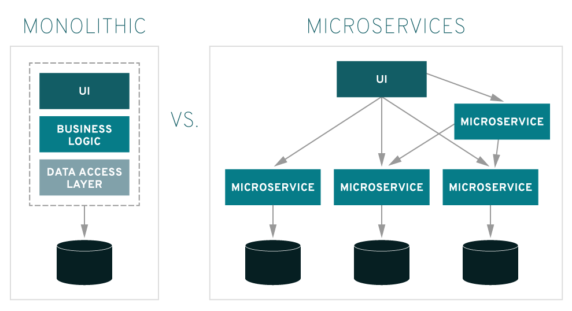

Now What Is Monolithic Architecture ?

Monolithic architecture is something build from single piece of material. Monolithic architecture has a single code base with multiple modules which are tightly coupled . It has a single build system which is build entire applications , It also has a single executable or deployed binary. Monolithic architecture is composed of a centralized system which bit hard to maintain and deployed as compared to microservices , all the modules in the system are dependent on each other which can cause a total failure of a system if some module goes down.

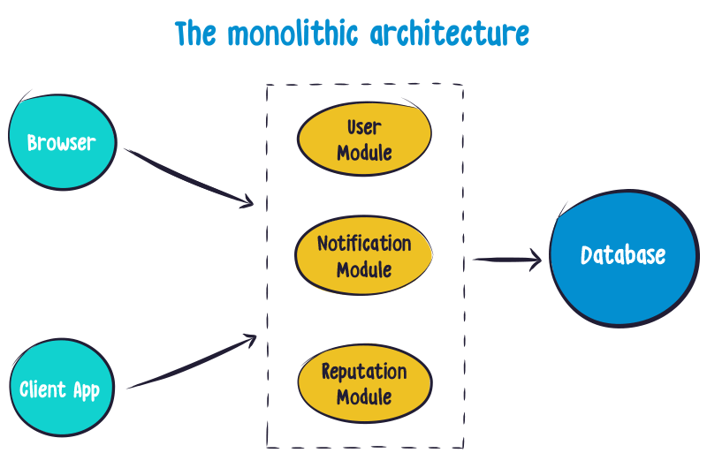

Benefits Of Microservices Architecture ,

Microservices give your teams and routines a boost through distributed development. You can also develop multiple microservices concurrently. This means more developers working on the same app, at the same time, which results in less time spent in development.
Some of the key benefits are mentioned below,

1.Ready For Market Faster

Since development cycles are shortened, a microservices architecture supports more agile deployment and updates.

2.Highly Scalable

As demand for certain services grows, you can deploy across multiple servers, and infrastructures, to meet your needs.

