

Department of Electrical and Electronics Engineering

Academic Year: 2025 - 2026

Mini Project Report

Title of the project
Design and Implementation of a Hybrid Intrusion Detection System Using Machine Learning Techniques

Submitted by:
Uzair Shaikh 1032240100

Abstract
With the rapid growth of internet-based services, network security has become a critical concern. Intrusion Detection Systems (IDS) are essential for identifying malicious activities and protecting systems from cyberattacks. Traditional signature-based IDS are effective for known threats but fail to detect unknown attacks. On the other hand, anomaly-based systems using machine learning can detect novel attacks but may suffer from false alarms.
This project presents a Hybrid Intrusion Detection System that combines signature-based detection with anomaly-based machine learning techniques. Three machine learning models were implemented and evaluated: Isolation Forest, Random Forest, and a Multi-Layer Perceptron (MLP) Neural Network. The system was trained and tested on a benchmark intrusion detection dataset. Performance was evaluated using metrics such as Accuracy, Precision, Recall, F1-score, Confusion Matrix, and ROC-AUC.
The Random Forest model achieved strong classification capability with an AUC of 0.94 and approximately 75% test accuracy. The Hybrid IDS further improved attack detection performance by combining rule-based and machine learning approaches. The proposed system demonstrates the effectiveness of hybrid detection techniques in improving intrusion detection robustness.

1. Introduction
Cybersecurity threats such as Distributed Denial of Service (DDoS), port scanning, brute force attacks, and unauthorized access are increasing rapidly. Organizations require reliable intrusion detection mechanisms to monitor and analyze network traffic.
Intrusion Detection Systems are generally classified into two categories:
- Signature-Based IDS
  - Detects known attacks using predefined rules.
  - Fast and accurate for known threats.
  - Cannot detect zero-day or unknown attacks.
- Anomaly-Based IDS
  - Uses machine learning to learn normal behavior.
  - Detects deviations from normal patterns.
  - Capable of detecting unknown attacks.
  - May produce false positives.
To overcome limitations of both methods, this project proposes a Hybrid IDS, combining signature-based detection with anomaly-based machine learning models.

2. Methodology
The system was developed in multiple stages:
2.1 Data Preprocessing
- The dataset was loaded and cleaned.
- Categorical features (protocol_type, service, flag) were encoded.
- Features were scaled using StandardScaler.
- The dataset was divided into training and test sets.
- Labels were converted into binary form:
  - 0 → Normal
  - 1 → Attack
2.2 Model Implementation
Three machine learning models were implemented:
2.2.1 Isolation Forest (Unsupervised)
- Used for anomaly detection.
- Does not use labeled data.
- Detects outliers based on isolation principle.
2.2.2 Random Forest (Supervised)
- Ensemble learning method.
- Uses multiple decision trees.
- Robust for structured tabular data.
- Provides feature importance analysis.
2.2.3 Multi-Layer Perceptron (Neural Network)
- Feedforward artificial neural network.
- Two hidden layers (100 and 50 neurons).
- Uses ReLU activation and Adam optimizer.
- Trained using backpropagation.

2.3 Hybrid Detection Logic
The Hybrid IDS combines:
- Random Forest prediction (anomaly-based)
- Rule-based signature simulation
Decision Logic:
If (ML prediction = Attack) OR (Signature rule triggered)
→ Final classification = Attack
This ensures that both known and unknown attacks are detected.
3. Results
3.1 Isolation Forest Performance
- Accuracy ≈ 56%
- Recall (Attack) ≈ 13%
- Very high false negatives
Isolation Forest performed poorly due to lack of supervised learning.
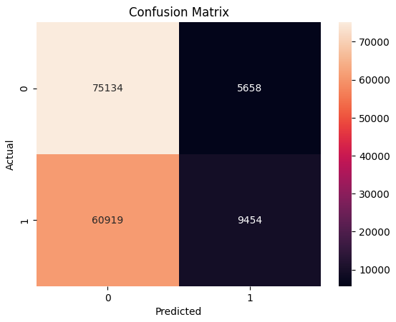

3.2 Random Forest Performance (Test Set)
Confusion Matrix:
- True Negative (TN) = 11339
- False Positive (FP) = 524
- False Negative (FN) = 9510
- True Positive (TP) = 13021
Metrics:
- Accuracy ≈ 75%
- Precision (Attack) ≈ 96%
- Recall (Attack) ≈ 58%
- F1-score ≈ 0.72
- AUC = 0.94
The high AUC indicates strong class separability.
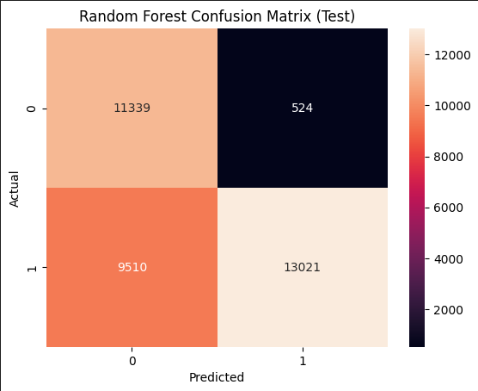

3.3 Neural Network (MLP) Performance
Confusion Matrix:
- TN = 11313
- FP = 550
- FN = 8402
- TP = 14129
Metrics:
- Accuracy ≈ 74%
- Precision (Attack) ≈ 96%
- Recall (Attack) ≈ 63%
- F1-score ≈ 0.76
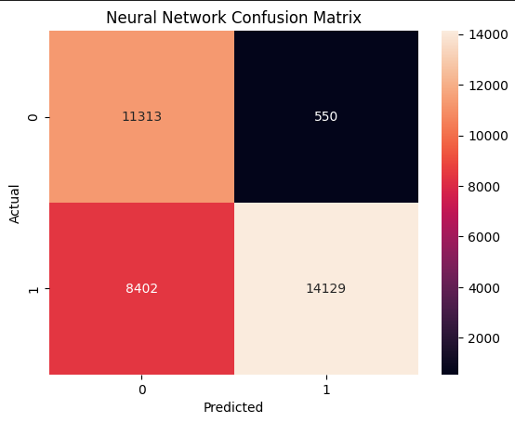

3.4 Hybrid IDS Performance
Confusion Matrix:
- TN = 11155
- FP = 708
- FN = 8006
- TP = 14525
Metrics:
- Accuracy ≈ 75%
- Precision (Attack) ≈ 95%
- Recall (Attack) ≈ 64%
- F1-score ≈ 0.77
The Hybrid IDS achieved improved recall compared to individual models.
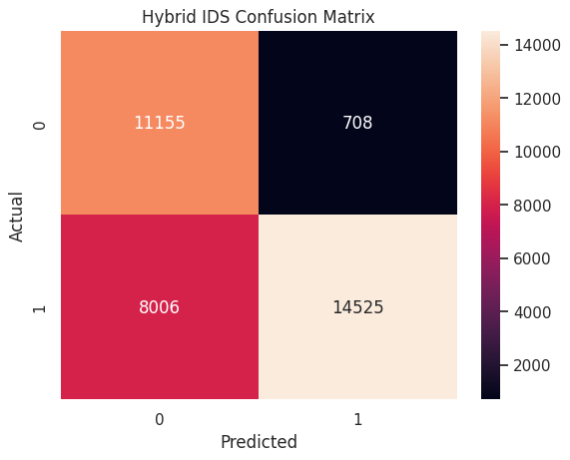

4. Performance Comparison Table
Model | Accuracy | Precision (Attack) | Recall (Attack) | F1-score
Isolation Forest | 56% | 63 | 13 | 0.22
Random Forest | 75% | 96 | 58 | 0.72
Neural Network (MLP) | 74% | 96 | 63 | 0.76
Hybrid IDS | 75% | 95 | 64 | 0.77

ROC Curve Analysis
The ROC curve measures the trade-off between True Positive Rate and False Positive Rate.
- AUC = 0.94
- Indicates excellent discrimination capability.
- The model can distinguish normal and attack traffic effectively.
Even though accuracy is moderate, high AUC shows strong model potential.
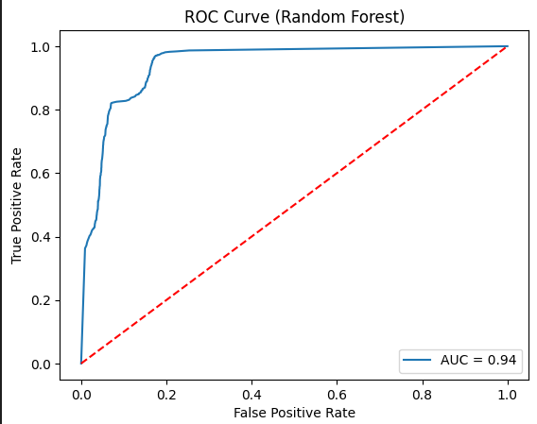

5. Discussion
Why Random Forest Was Selected
Although the Neural Network achieved slightly higher recall, Random Forest was selected as the primary anomaly-based model because:
- It achieved very high AUC (0.94).
- It is stable for structured tabular datasets.
- It requires less hyperparameter tuning.
- It is easier to interpret via feature importance.
- It showed strong generalization from training to testing.
Isolation Forest was rejected due to extremely poor recall and high false negative rate.
Hybrid System Advantage
The Hybrid IDS:
- Reduces dependency on single detection mechanism.
- Improves recall for attack detection.
- Provides layered security.
- Combines strengths of rule-based and ML-based systems.

6. Conclusion
This project successfully implemented a Hybrid Intrusion Detection System combining:
- Signature-based detection
- Anomaly-based machine learning detection
Among tested models:
- Isolation Forest performed poorly.
- Random Forest demonstrated strong performance with AUC = 0.94.
- Neural Network achieved similar results but required more tuning.
- Hybrid model improved recall and robustness.
The system demonstrates that combining rule-based and machine learning techniques improves detection reliability compared to standalone approaches.

7. Future Scope
To further improve performance and reduce false negatives:
- Adjust classification threshold to increase recall.
- Use cost-sensitive learning (higher weight for attack class).
- Apply hyperparameter tuning (GridSearchCV).
- Implement advanced models such as XGBoost.
- Perform feature engineering and feature selection.
- Integrate real-time packet capture for live deployment.
- Use adaptive learning for evolving attack patterns.
With these enhancements, the system can potentially achieve higher accuracy and lower false negative rates.
Details of student
Group No. | PRN No. | Name of Student | Class and Division | Contact No. | Signature
1 | 1032240100 | Uzair Shaikh | TY-AIML-C | 7720861777

Name and Signature of Guide/Co-guide:

